How to Connect Personal Android 13 Device to the URMC Network

- From the home screen swipe down to get your notification center.
- Then long press the “Internet” icon

- Tap UR_MCwireless5

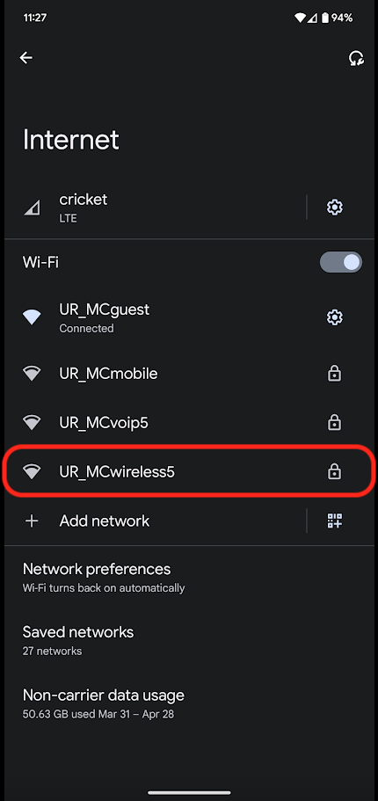

- Change the settings shown below.
- CA certificate needs to be set to “Use system certificates”
- For “Domain” set urmc-sh.rochester.edu
- Type in your URMC username into the “identity” field
- and your URMC password into the “Password” field
- Click “Connect”
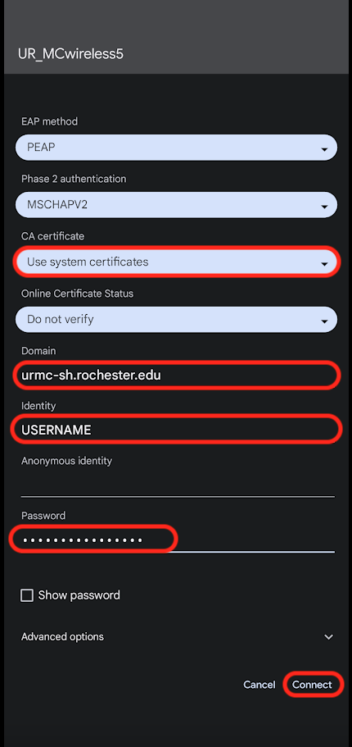
- Forget UR_MCguest Wifi
- Go back to your list of wifi networks.
- Long press “UR_MCguest”
- A drop-down menu will appear, tap “Forget”

