Presented by:
UR Medicine -- Injury Free Coalition for Kids of Rochester -- Monroe County Office of Traffic Safety

Young ROC Roadeo
Free Safe Driving Awareness Event
Targeting ages 14 to 21
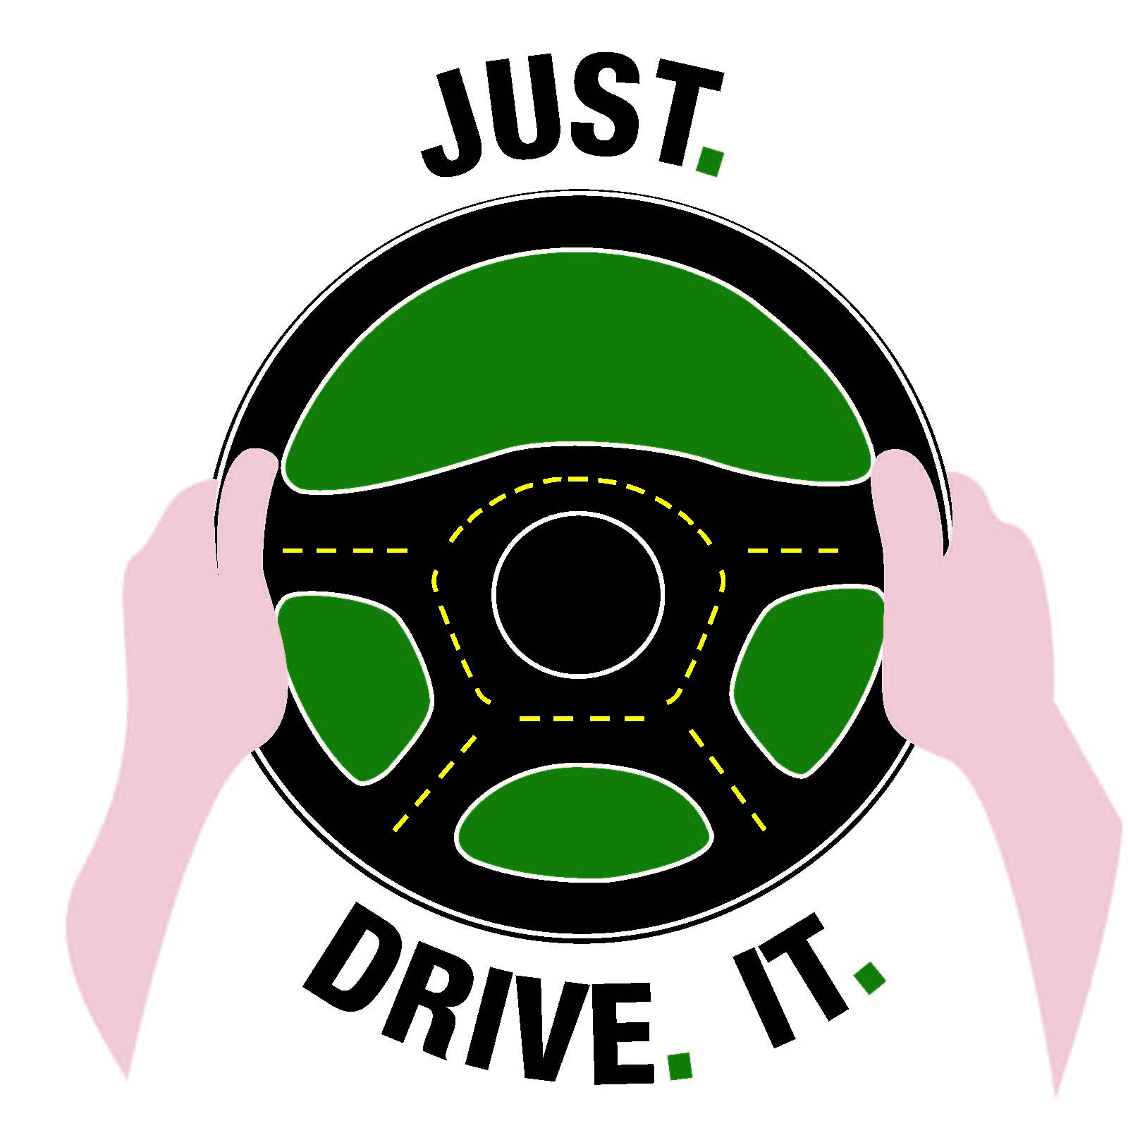

Saturday, October 4, 2014
11am to 2pm
Frontier Field
VIP Parking Lot
1 Platt Street
Rochester, NY 14608
(Parking available - Lot D, 222 Brown Street)

- Continuous Drawings and Prizes | - Allstate “X the Text”
- Interactive Safe Driving Demonstrations | - Information on “What to do in a Crash”
- Battle of the Belts Competition | - Simple Car Maintenance
- Rollover Crash Simulator | - Food Trucks
- Information on Sharing the Road with Bicyclists, Tractor Trailers and Motorcycles

