Please contact Becky Black, Hannah Pragle, or Sandy Bugbee by phone to arrange pickup or delivery times. Please have your donation ready 2 weeks prior to event. Thank you in advance for your kind-hearted contribution.

Becky & Jason Black
Coordinator/Parents of Baby Emerson
(585) 643-9851

Hannah Pragle
Pragle Photography
(585) 520-2572

Sandy Bugbee
Sunshyne Daycare
(585) 509-5551

Suggested Donations to Raffle:
*single item
*gift basket
*gift certificate
*monetary gift

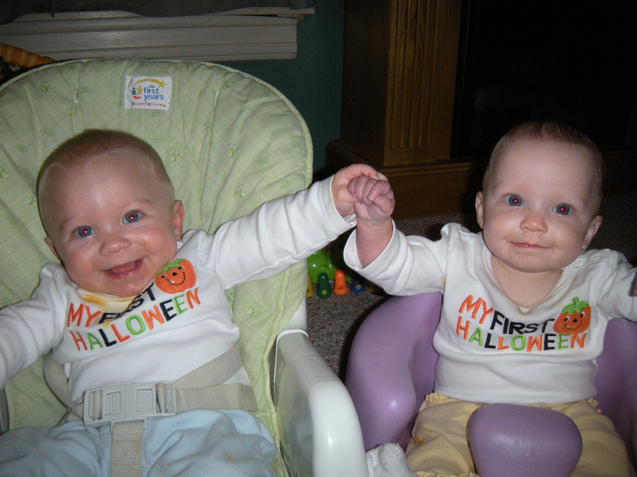
A benefit for
Golisano Children’s Hospital
In Memory of Emerson Black

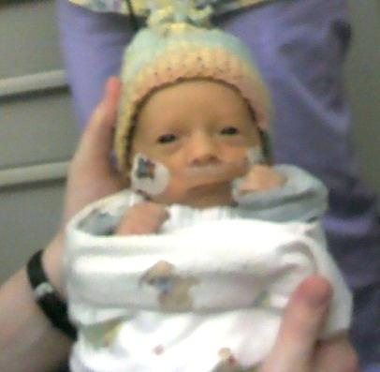

Triplet siblings, Landon & Sydney
We appreciate your generosity & support!
Embracing
Emerson
Fundraiser
Event

Saturday, May 18, 2013
Red Jacket High School
10-4

* Photography Sessions By:
Pragle Photography
Come make some great new memories in honor of baby Emerson!

* Have your picture taken by Pragle Photography, and receive the images by mail on CD!

* 20 minute mini sessions all day!

* Cost is $40 per session for the event!

* Cash or check accepted

Check me out at www.praglephotography.com
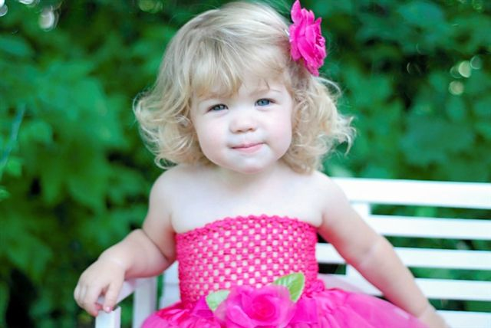

* Bake Sale * Wildlife Defenders
* Raffle * The Magic Guy
* Face Painting * Bounce Houses
* Zumba (2 hours of Zumba for only $10!!)
* Double D’s Chicken BBQ
($8.50 pre-sale tickets)
* Vendors include: Turtle Dove Creations, Initials, Inc, Scentsy, Thirty-One
& Much MORE!!

Please consider donating an item to the Embracing Emerson Fundraising Event taking place on Saturday, May 18, 2013. We would be honored if your business/company can be represented during our raffle. Your item will be on display throughout the day of the event. All proceeds will benefit the Golisano Children's Hospital and the NICU Social Work Program.

Our community relies highly on the professionals at Golisano Children’s Hospital. Golisano Children's Hospital serves more than 74,000 children from the 17-county Finger Lakes region and beyond every year – both as inpatients and outpatients. It houses 132 beds and 34 pediatric specialties and subspecialties, including Pediatric Gastroenterology, Neonatology, Pediatric Orthopaedics, Child Neurology and Pediatric Neurosurgery.
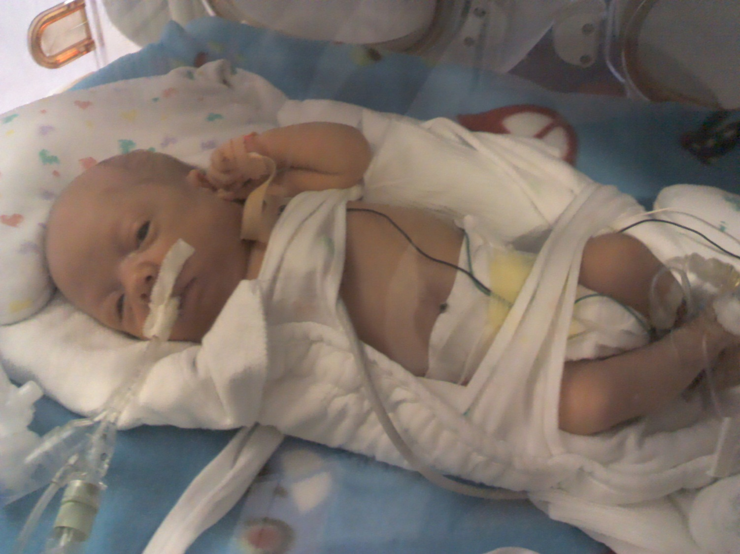



On March 25, 2012, our family was blessed with Triplets – Landon, Sydney, & Emerson Black of Manchester, NY. Our little Emerson unfortunately passed away May 8, 2012, at 6 weeks old due to a heart condition. Our community is so fortunate to have such high level care in our area. We cannot say “thank you” enough for the care that the Doctors, Nurses, and Staff provided not only to our Triplets, but to our whole family.

Becky & Jason Black
Olivia (Big Sister), Landon & Sydney
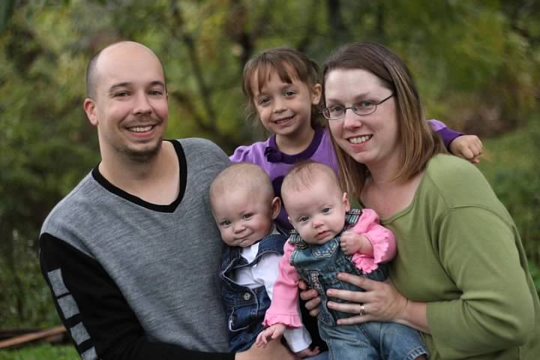
Photo by: Pragle Photography

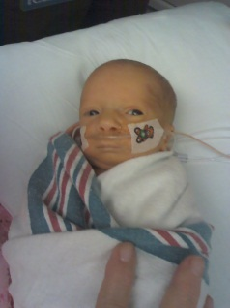
Emerson

