Facebook and Instagram Ad Copy and Images for IRB approval
Facebook ads contain the following elements:
- Primary Text: 90 characters max including spaces (the rest will be truncated)
- Title (Headline): 40 characters max including spaces; 25 recommended
- Emoji Use: All emojis
- Link Description: Optional field with 200 characters max including spaces (may be truncated)
- Call to Action (Button): Only certain labels are available; will link to landing page
- Images: May be scaled or cropped to fit ad size
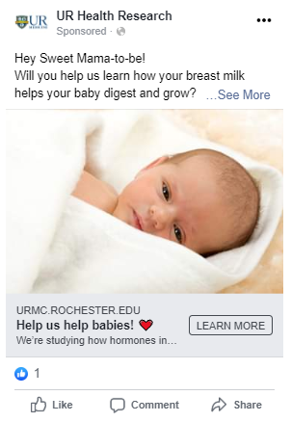

Primary Text

Image

URL for Landing Page
(displays automatically)
Title
Link Description
Call to Action
Primary Text – On Facebook, one of the following copy options will display above one image. (Possible images are included at the end of this document). On Instagram, this copy will display underneath the image.
- Researchers are studying how your breast milk helps your baby grow!
- U of R researchers are studying how your breast milk helps your baby grow!

Title (Headline) – For Facebook ads, this copy will display in bold underneath the picture.
- A Breastfeeding Study
- Join us!
- Help us help babies!

All Emojis – We may use any emoji(s) to compliment Primary Text or Title copy. All emojis can be found here: https://emojipedia.org/

Link Description - This is optional to include and will only appear in some larger Facebook ad placements, like within a user’s newsfeed. Smaller placements with truncate this copy or not use.
- As we research how to keep our babies healthy!
- As we research how to help babies grow and thrive!

Call to Action (Button) – This will link to our landing page: https://www.urmc.rochester.edu/research/health-research/clinical-trials/clinical-trials-details.aspx?q=10584
- Contact Us
- Learn More
- Sign Up
- Apply Now
- Request Time

Images – Facebook may use any one of these for an ad placement.
