Strong Memorial Hospital (AC-4) - Oral and Maxillofacial Surgery Clinic Referral Form
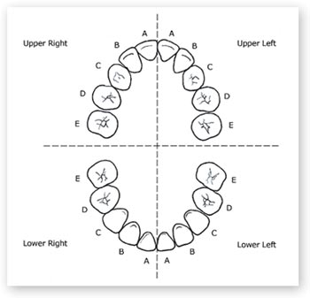
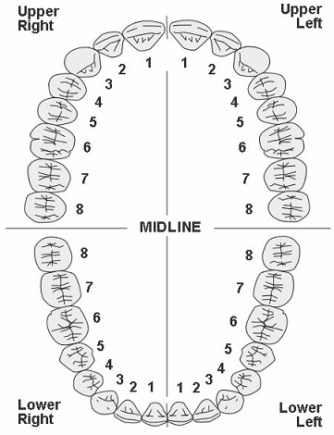
Patient’s information:
Name: ___________________________________
DOB: ____________________________________
Parent-Guardian name______________________
Primary phone number: _____________________
Date of last Panoramic X-Ray: ________________
Dental Insurance: _________________________
Subscriber ID: ____________________
Medical Insurance: ---------------------------------------
Subscriber ID: _____________________
Reason for referral:
Extraction of teeth: ____________________________________________________________ (please indicate on diagram)
Consultation for biopsy of lesion: _____________________________________________ please indicate site(s) on diagram)
Surgical Exposure of teeth: _____________________________________________________ (please indicate on diagram)
Consultation for placement of Implant: _______________________________________ (please indicate site(s) on diagram)
Consultation for pre-prosthetic surgery: _______________________________________ (please indicate site(s) on diagram)
Consultation for bone grafting/augmentation: __________________________________ (please indicate site(s) on diagram)
Consultation for soft tissue grafting/augmentation: _______________________________ (please indicate site(s) on diagram)
Consultation for orthognathic surgery____________________________________________________
Consultation for TMJ surgery___________________________________________________________
Consultation for other procedures (please be specific) ______________________________________
Referring Doctor’s information:
Name___________________________________ Date: ___________Facility Name__________________
Signature________________________________ Tel: ____________________Fax:__________________

Please fax completed form to 585-461-5420 or email omfs@urmc.rochester.edu

