Specimen Handling for Routine Laboratory Testing (not for Ebola Diagnosis)
Routine laboratory testing includes traditional chemistry, hematology, and other laboratory testing used to support and treat patients. Precautions as described above offer appropriate protection for healthcare personnel performing laboratory testing on specimens from patients with suspected infection with Ebola virus. These precautions include both manufacturer installed safety features for instruments and the environment as well as PPE specified in the box above.
When used according to the manufacturer’s instructions, Environmental Protection Agency (EPA)-registered disinfectants routinely used to decontaminate the laboratory environment (benchtops and surfaces) and the laboratory instrumentation are sufficient to inactivate enveloped viruses, such as influenza, hepatitis C, and Ebola viruses.

When Specimens Should Be Collected for Ebola Testing
Ebola virus is detected in blood only after onset of symptoms, most notably fever. It may take up to 3 days post-onset of symptoms for the virus to reach detectable levels. Virus is generally detectable by real-time RT-PCR from 3-10 days post-onset of symptoms, but has been detected for several months in certain secretions. Specimens ideally should be taken when a symptomatic patient reports to a healthcare facility and is suspected of having an EVD exposure; however, if the onset of symptoms is <3 days, a subsequent specimen will be required to completely rule-out EVD.
Top of Page

Preferred Specimens for Ebola Testing
A minimum volume of 4mL whole blood preserved with EDTA, clot activator, sodium polyanethol sulfonate (SPS), or citrate in plastic collection tubes can be submitted for EVD testing. Do not submit specimens to CDC in glass containers. Do not submit specimens preserved in heparin tubes. Specimens should be stored at 4°C or frozen. Specimens other than blood may be submitted upon consult with the CDC by calling the Emergency Operations Center at 770-488-7100.
Standard labeling should be applied for each specimen. The requested test only needs to be identified on the requisition and CDC specimen submission forms.

Storing Clinical Specimens for Ebola
Specimens should be stored at 4°C or frozen.

Diagnostic Testing for Ebola Performed at CDC
Several diagnostic tests are available for detection of EVD. Acute infections will be confirmed using a real-time RT-PCR assay (CDC test directory code CDC -10309 Ebola Identification) in a CLIA-accredited laboratory. Virus isolation may also be attempted. Serologic testing for IgM and IgG antibodies will be completed for certain specimens and to monitor the immune response in confirmed EVD patients (#CDC-10310 Ebola Serology).
Lassa fever is also endemic in certain areas of West Africa and may show symptoms similar to early EVD. Diagnostic tests including but not limited to RT-PCR, antigen detection, and IgM serology may be utilized to rule out Lassa fever in EVD-negative patients.
Top of Page

Transporting Specimens within the Hospital / Institution
In compliance with 29 CFR 1910.1030, specimens should be placed in a durable, leak-proof secondary container for transport within a facility. To reduce the risk of breakage or leaks, do not use any pneumatic tube system for transporting suspected EVD specimens.

Packaging and Shipping Clinical Specimens to CDC
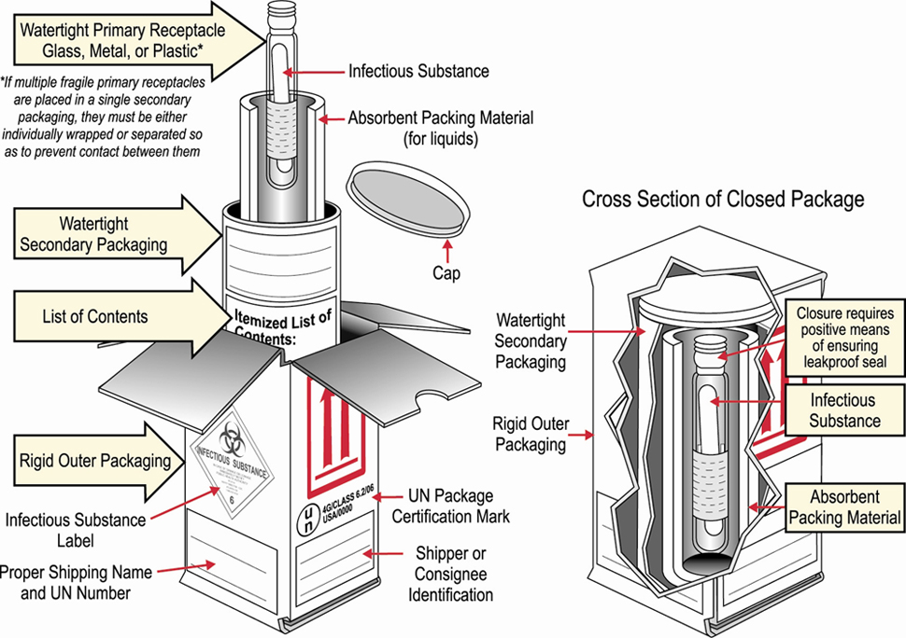

Packaging Diagram
Specimens collected for EVD testing should be packaged and shipped without attempting to open collection tubes or aliquot specimens. Specimens for shipment should be packaged following the basic triple packaging system which consists of a primary receptacle (a sealable specimen bag) wrapped with absorbent material, secondary receptacle (watertight, leak-proof), and an outer shipping package. See diagram »
The following steps outline the submission process to CDC.
- Hospitals should follow their state and/or local health department procedures for notification and consultation for Ebola testing requests and prior to contacting CDC.
- NO specimens will be accepted without prior consultation. For consultation call the EOC at 770-488-7100.
- Contact your state and/or local health department and CDC to determine the proper category for shipment based on clinical history and risk assessment by CDC. State guidelines may differ and state or local health departments should be consulted prior to shipping.
- Email tracking number to EOCEVENT246@CDC.GOV.
- Do not ship for weekend delivery unless instructed by CDC.
- Ship to:
Centers for Disease Control and Prevention
ATTN STAT LAB: VSPB, UNIT #70
1600 Clifton Road NE
Atlanta, GA 30333
Phone 770-488-7100
- Include the following information: your name, the patient's name, test(s) requested, date of collection, laboratory or accession number, and the type of specimen being shipped.
- Include the CDC Infectious Disease (CDC Form 50.34) and Viral Special Pathogens Branch[PDF - 2 pages] specimen submission forms.
- On the outside of the box, specify how the specimen should be stored: refrigerated or frozen.
Top of Page

