Ebola Social Media for NPHIC
Facebook:
- The current #Ebola outbreak is centered in West Africa. Ebola is spread through direct contact with blood or bodily fluids (blood, urine, feces, saliva & other secretions) of a person showing symptoms. It is also spread through exposure to objects (such as needles) that have been contaminated with infected secretions. Ebola is not transmitted through the air, food or water and does not pose a significant risk to the U.S. Get more facts at: http://www.cdc.gov/vhf/ebola/transmission/index.html
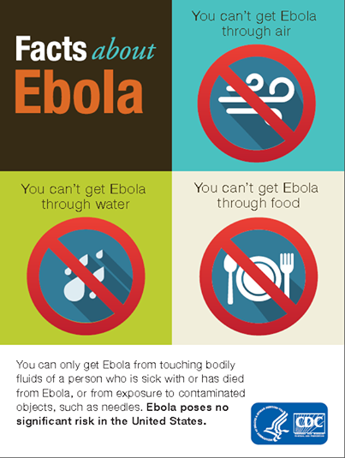

- Get the facts on #Ebola and find out about steps the CDC is taking to protect Americans: http://www.cdc.gov/vhf/ebola/outbreaks/guinea/qa.html
- CDC is currently assisting with active screening & education efforts in West Africa to prevent sick travelers from getting on planes. CDC is also working with partners at US airports to detect ill travelers who could have a contagious disease, like #Ebola. More information is available at: http://www.cdc.gov/vhf/ebola/outbreaks/guinea/qa.html
- CDC works closely with partners at US airports and land borders to detect ill travelers who could have a contagious disease, like #Ebola. Isolation and quarantine are used to protect the public by preventing exposure to infected persons or to persons who may be infected. While CDC has the authority to quarantine or isolate for certain diseases, this authority is rarely used. http://www.cdc.gov/quarantine/quarantinestations.html
- CDC has developed guidelines for healthcare workers on how to recognize cases of #Ebola and to prevent transmission in health care settings. The guidelines provide information for health care workers to allow them to recognize the symptoms and cases of Ebola, safely manage patients in US hospitals, infection control and lab guidance. Any US hospital that is following these guidelines can safely manage a patient with Ebola. http://www.cdc.gov/vhf/ebola/hcp/index.html

Twitter:
- #Ebola virus is spread by contact of infected person’s blood or body fluids. It is not spread by air, water, or food. [Infographic: http://www.cdc.gov/vhf/ebola/pdf/infographic.pdf]
- #Ebola poses no significant risk to the American public. Learn about steps @CDCgov is taking to protect Americans http://www.cdc.gov/vhf/ebola/outbreaks/guinea/qa.html

- #Ebola is spread by direct contact w/ blood or bodily fluids or exposure to contaminated objects, like needles. http://www.cdc.gov/vhf/ebola/transmission/index.html
- CDC is working w/ partners at US airports to detect ill travelers who could have a contagious disease, like #Ebola. http://www.cdc.gov/quarantine/quarantinestations.html
- CDC is assisting w/ active screening & education efforts in W Africa to prevent sick ppl from getting on planes. http://www.cdc.gov/vhf/ebola/outbreaks/guinea/qa.html
- CDC has developed resources for healthcare workers on how to recognize #Ebola cases & prevent transmission. http://www.cdc.gov/vhf/ebola/hcp/index.html

