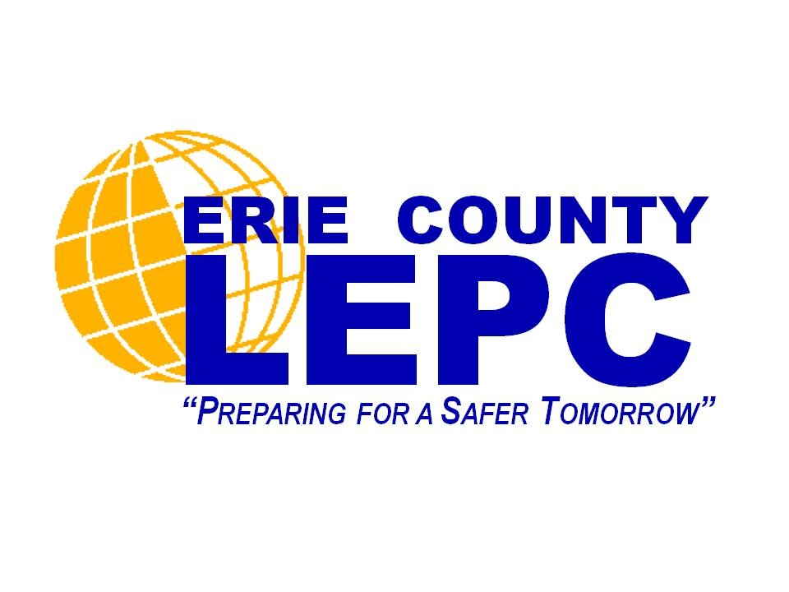
September is National Preparedness Month

Public Information Forum
The Erie County Local Emergency Planning Committee (LEPC)
is hosting a Public Information Forum on emergency preparedness
that includes presentations by local agencies and organizations.
Light refreshments will be served.

Public Information Forum
Wednesday, September 17, 2014
6:00pm – 8:00pm
Erie County Department of Emergency Services
Training and Operations Center Auditorium
3359 Broadway, Cheektowaga, NY 14227

We look forward to seeing you there!

Questions? Contact Nancy DiGiore at 716- 858-3928

