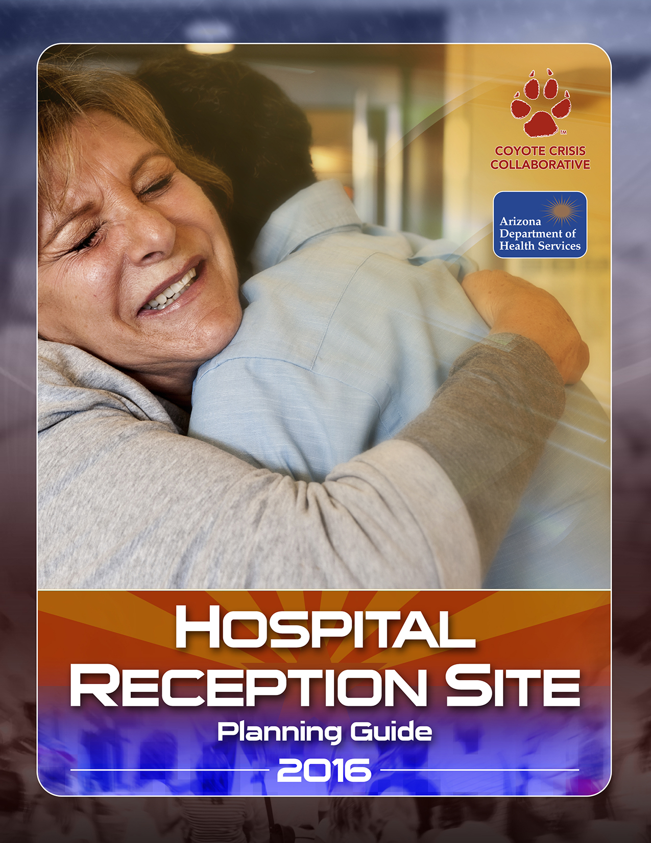

Much of this Guide was derived directly from the following the Los Angeles County Operational Area Family Reunification Center (FRC) Plan, Version 1, March 31, 2010; Http://www.apctoolkits.com/family-assistance-center; and the Seattle and King County Healthcare Coalition’s Family Reception Services Guidelines for Hospitals. Attachment O Version April 2012.

For additional information, contact:

Patty Seneski, Emergency Management Program Manager, Banner Desert Medical Center and Cardons Children’s Medical Center, and Chair of the Hospital Reception Center Planning Subcommittee in Arizona, at 480.412.3720 or Patty.Seneski@bannerhealth.com.

Deborah Roepke, Executive Director of Coyote Crisis Collaborative, at 480.861.5722 or Deborah.Roepke@coyotecrisis.org.
Hospital Reception Site Planning Guide

Mission: To provide a planning guide to assist hospitals in setting up Hospital Receptions Sites for families in case of a mass casualty incident.

Scope:
- Provide a private and secure place for families to gather, receive and provide information regarding loved ones involved in the incident.
- Provide a secure area away from the media and curiosity seekers.
- Provide a pediatric safe zone for unaccompanied minors.
- Facilitate information sharing with hospitals and other partners to support family reunification.
- Address psycho/social, spiritual, informational, medical and logistical needs to the best of the hospital’s ability.
- Coordinate death notifications when patients die at the hospital and the identity is known.
Planning Assumptions:
- Expect a minimum of eight to ten family members or loved ones to arrive or need assistance for each victim.
- After an incident, family members will immediately call or self- report to the hospital they believe their loved one may have been taken.
- Coordination among responding agencies about family members, missing persons, and patient tracking will be necessary.
- A Hospital Reception Site will be necessary to provide a safe place for families to convene until a Family Assistance Center or shelter is activated.
- Families will have high expectations regarding:
- Identification of the deceased,
- The return of loved ones and their belongings,
- Accurate and timely information and updates.
- Hospitals may not be able to meet those needs due to forensic issues or resource shortages.
- Victim identification may take multiple days, weeks, months or even years.
- Not all families will grieve or process information in the same way.
- Ethnic and cultural traditions will be important factors in the way families grieve or process information.
- Both Behavioral Health and Spiritual care resources should be available.
- Responding to a mass casualty or mass fatality incident can be overwhelming and lead to traumatic stress. Support for staff will be essential.
- A specific safe zone must be established for unaccompanied minors to ensure appropriate release to a custodial adult.
- All hospitals are part of a clearinghouse because families will self-refer to the hospital they think has their family member(s).
Definitions:
Family | Any individuals that consider themselves to be a part of the victim’s family, even if there is not a legal familial relationship. This could include friends, partners, caretakers and loved ones that have defined themselves or are indicated by other family members to be “family”.
Immediate Family | A defined group of relations, used in rules or laws to determine which members of a person's family are affected by those rules. It normally includes a person's parents, spouses, siblings and children.
Custodial Parent | The parent, also considered the primary care parent, with which a child resides full time. Most custodial parents have been awarded physical custody of a child by a court of law.
Legal Guardian | A person or entity who has been granted the legal authority (and the corresponding duty) to care for the personal and property interests of another person, called a ward.
Legal Next of Kin | The nearest blood relatives of a person who has died, including the surviving spouse.
Separated Children | Children who have been separated from both parents or from their previous legal or customary primary caregiver, but not necessarily from other relatives. These may, therefore, include children accompanied by other adult family members.
Unaccompanied Minors | Children who have been separated from both parents, legal guardians, and other relatives and are not being cared for by an adult who, by law or custom, is responsible for doing so.
Reunification | The process of reuniting family members with their missing or deceased loved one.
Call Center | Following a mass casualty or mass fatality incident, this designated space is activated as a communications hub to collect information from families and friends of possible victims (integrates Medical Examiner/Coroner interviews); to direct families and friends to appropriate Hospital Reception Sites, Family Reunification Centers, or Family Assistance Centers for reunification and assistance; and to direct other callers to appropriate recipients, such as Public Information Officers.
Family Assistance Center  (Long-Term) | Following a large mass casualty or mass fatality incident, this designated county or state space is established as a centralized location for families (and friends) to gather, receive information about the victims and grieve, protect families from the media and curiosity seekers, facilitate information sharing to support family reunification (e.g., direct families to Hospital Reception Sites if victims are known to have been transported to the location), and provide death notification when patients die and identity is known. This Center is long-term and may target delivery of a range of services and/or may focus on families and friends of missing or deceased victims.
Family Reunification Center  (Short-Term) | In the immediate hours after a mass casualty or mass fatality incident, this designated community space is established as a centralized location for families (and friends) to gather, receive information about the victims and grieve, protect families from the media and curiosity seekers, facilitate information sharing to support family reunification (e.g., direct families to Hospital Reception Sites if victims are known to have been transported to the location), and provide death notification when patients die and identity is known. This Center is short-term and may be replaced by a Family Assistance Center or shelter in the event the County or State or other jurisdiction deems this to be necessary.
Hospital Reception Site | A hospital space designated to provide a private and secure place for families to gather, receive information about the patients and grieve, protect families from the media and curiosity seekers, facilitate information sharing with other hospitals and partners to support family reunification (e.g., direct families to Family Reunification Centers if victims are missing), and provide death notification when patients die and identity is known.

Hospital Reception Site Check List:

- Location _______________. The location should be within the hospital or in close proximity. It should have the following:
    - Large enough area to handle a potentially large crowd.
    - Limited and controlled access.
    - Access to restrooms.
    - Sufficient seating (chairs and tables).
    - Areas close by for private conversation/notification (screens and curtains).
    - Access to media (TV monitor) for information.
    - Refreshments.
    - Activities and supplies to occupy the wait time.
    - Access to communications (Business Center).
    - Pediatric Safe Zone for unaccompanied minors.
    - Accessibility for Functional and Access Needs Populations.

- Communications:
  - Phones.
  - Phone translation services available.
  - Computer access (Computer on Wheels).
  - Access to social media sites, including Red Cross Safe and Well.
  - Google (offers a reunification “wall” during disasters).
  - External communications.
  - Radio back-up.
  - Runners.

- Staffing (Recommended Per Shift):
  - Family Reunification Unit Leader.
  - Family Registration personnel.
  - Child Life Specialists (or other appropriate, credentialed staff).
  - Runners.
  - Interpreters.
  - Communications.
  - Public Information Officer (PIO).
  - Security (Law Enforcement if necessary and available).
  - Crisis Support:
    - Chaplaincy.
    - Social Workers/Case Managers.
    - Behavioral Health Professionals.
    - Critical Incident Stress Management team if available.
    - Access to Employee Assistance Plan programs.
    - Hospital volunteers.
    - The Division of Child Safety and Family Services may be asked to assist and support unaccompanied minors.

- Procedure:
  - Upon request by the Hospital Incident Command System (HICS) command team will establish Hospital Reception Sites.
  - Set-up directional signs to identify location and path to it.
  - The Public Information Office, at the directions of the Incident Commander (IC), should communicate to the public as to where and how family members should go to inquire about potential family member victims/patients.
  - As family members arrive, register and gather information about family member(s) sought.
  - Determine needs for child care and accommodations for access/functional needs.
  - Notify and request information regarding possible victims/patients from the Hospital Command Center.
  - Provide frequent updates to family members on the status of the situation.
  - Provide notification to family members as to the status of “missing” family member(s), when available.
  - Facilitate reunification of family members with victim/patients either in treatment areas, patient rooms or at discharge.
  - If unable to locate victim/patients in facility, refer family members to Family Reunification Center(s) when it has/they have been established.
  - In the case of unaccompanied minors:
- Call law enforcement and the Department of Child Safety (DCS) Hot Line (1-888-767-2445) and do the following:
- When prompted, choose “mandated reporter” prompt. This will inform DCS the call is coming from a professional seeking help in a mass casualty incident.
- Notify the call taker:
- There is “no guardian able or willing to care for the child.”
- Of the location of the Hospital Reception Site.
- Of the child’s name, if known.
- Of the guardian’s(s’) name(s), if known. Any additional information available about the guardian is beneficial as well.
- DCS will complete a DCS Report and/or Action Request signifying “no legal allegations.”
- DCS will send support to accept the unaccompanied child.
- Upon arrival, DCS will obtain from law enforcement a signature authorizing “temporary custody notice.” Once signed, DCS will accept the unaccompanied child.
  - In the case of unaccompanied developmentally disabled:
- Locate the individual to a “safe” room that is as calming as possible and away from the general population. Make sure the individual is accompanied and supported. Call the Division of Developmental Disabilities’ (DDD) Hot Line (602.316.0405) to reach a senior manager for health and safety and do the following:
- Explain the situation.
- Notify the senior manager:
- Of the location of the Hospital Reception Site.
- Of the individual’s name, if known.
- Of any guardian’s(s’) name(s), if known.
- Any additional information available about the guardian is beneficial as well.
- DDD will send a member or members of a disaster response team to staff the room/individual and assist with relocation.
  - Communicate with other critical partners:
- City Emergency Operations Center: _______________________________
- Crisis Response Team: _________________________________________
- County Office of the Medical Examiner: ___________________________
- County Emergency Management: ________________________________
- County Public Health: __________________________________________

- Demobilization: Once patients are admitted, discharged, or sent to other sites for services, return equipment and report to the Incident Commander or Designee (see Job Action Sheet for HRS Division Supervisor.

Attachments:

A - Job Descriptions (Examples):
- Hospital Reception Site Division Supervisor
- Hospital Reception Site Child Care Area Unit Leader
- Refer to Resources above for additional guidance
B – Activation Checklist
C – Child Care Area (CCA) Checklist
D – Equipment and Supply Checklist
E – Psychological First Aid Tools
F – Intake Form
G – Child Identification Form
H – Demobilization Checklist
I – Instructions on Data Entry for EMTrack

Items Individual Can Get from Toolkit (reference string under resources, listed below):
- Support Agencies Contact Information.
- Child Care Area Checklist.

Statement about Resources
Much of this plan was excerpted directly from the Seattle and King County Healthcare Coalition’s Family Reception Services Guidelines for Hospitals. For additional information, refer to resources below:
- http://www.apctoolkits.com/family-assistance-center
- Seattle and King County Healthcare Coalition’s Family Reception Services Guidelines for Hospitals. Attachment O Version April 2012.
- CARE7 for information about the Family Reunification Center model and/or Crisis Response Team integration into the Center (Kris Scharlau, Director, 480.350.8004).
Attachment A - Job Action Sheets (Examples)
Customize these and other Job Action Sheets to integrate within your Hospital Incident Command (HICS) Plan.

HOSPITAL RECEPTION SITE (HRS)

DIVISION SUPERVISOR

JOB ACTION SHEET

YOU REPORT TO: _____________________________________________________________

HOSPITAL RECEPTION SITE LOCATION:____________________________________________

PHONE: ____________________
MISSION: Organize and manage the operations of the Hospital Reception Site.

 | Immediate (Operational Period 0-2 Hours) | Time | Initial
 | Receive appointment and briefing from the___________________________ (Hospital Incident Commander or other HICS Role).
 | Notify your usual supervisor of your HRS assignment.
 | Determine need for and appropriately appoint HRS division members, distribute corresponding Job Action Sheets. Complete unit assignments.
 | Complete Activation Checklist
 | Document all key activities, actions, and decisions in an Operational Log (refer to HICS).
 | Brief the HRS unit members on current situation; outline unit action plan and designate time for next briefing.
 | Confirm the designated HRS area is available, and begin distribution of personnel and equipment resources.
Communicate and coordinate with Behavioral Health/Spiritual Services Unit Leader to determine:
- Available staff (mental health, nursing, chaplains, experienced volunteers, etc.) that can be deployed to the HRS to provide psychological support, and intervention.
- Location and type of resources that can be used to assist with a mental health response, such as toys and coloring supplies for children, mental health disaster recovery brochures, fact sheets on specific hazards (e.g., information on chemical agents that include symptoms of exposure), private area in the facility where family members can wait for news regarding their family member, etc.
 | Regularly report HRS status to ____________________________(HICS role).
 | Assess problems and needs; coordinate resource management.
 | Instruct all HRS unit members to periodically evaluate equipment, supply, and staff needs and report status to you; address those needs with appropriate HRS unit staff; and report status.
 | Coordinate contact with external agencies with the Liaison Officer.
 | Coordinate information with the registration and patient tracking staff for the HRS.
 | Immediate (Operational Period 0-2 Hours) | Time | Initial
 | Document all communications (internal and external).
 | Intermediate (Operational Period 2-12 Hours) | Time | Initial
 | Talk regularly with the Hospital Incident Commander or Designee to report status and to gather information to relay important information to HRS unit staff.
 | Ensure patient data entry into EMTrack (first and last name, date of birth, and ethnicity) to accommodate family reunification. In the event the hospital receives Jane or John Does, ensure additional characteristics are identified for the patient(s) to help with identification.
 | Continue coordinating activities in the HRS.
 | Ensure prioritization of problems when multiple issues are presented.
 | Coordinate use of external resources; coordinate with Liaison Officer if appropriate.
 | Develop and submit a HRS action plan to the Hospital Incident Commander or Designee when requested.
 | Ensure documentation is completed correctly and collected.
 | Advise the Hospital Incident Commander or Designee immediately of any operational issue unable to be corrected or resolved.
 | Ensure staff health and safety issues being addressed; resolve with Employee Health and the Safety Officer.
 | Extended (Operational Period Beyond 12 Hours) | Time | Initial
 | Continue to monitor the HRS unit’s ability to meet workload demands, staff health and safety, resource needs, and documentation practices.
 | With the assistance of Human Resources, verify/credential external personnel sent to assist.
 | Work with the Hospital Incident Commander or Designee on the assignment of external resources. Coordinate assignment and orientation of external personnel sent to assist.
 | Rotate staff on a regular basis. Provide for staff rest periods and relief.
 | Document actions and decisions on a continual basis.
 | Continue to provide the Hospital Incident Commander or Designee with periodic situation updates.
 | Ensure your physical readiness through proper nutrition, water intake, rest, and stress management techniques.
 | Observe all staff and volunteers for signs of stress and inappropriate behavior.
 | Upon shift change, brief your replacement on the status of all ongoing operations, issues, and other relevant incident information.
 | Decentralize/Demobilize | Time | Initial
 | As needs for the HRS decrease, return staff to their normal jobs and combine or deactivate positions in a phased manner (Demobilize).
 | Ensure the return/retrieval of equipment/supplies/personnel.
 | Debrief staff on lessons learned and procedural/equipment changes needed.
Upon deactivation of your position, brief the Hospital Incident Commander or Designee on current problems, outstanding issues, and follow-up requirements.
Upon deactivation of your position, ensure all documentation and HRS Operational Logs are submitted to the Hospital Incident Commander or Designee.
Submit comments to the Hospital Incident Commander or Designee for discussion and possible inclusion in the after-action report; topics include:
- Review of pertinent position descriptions and operational checklists.
- Recommendations for procedure changes.
- Section accomplishments and issues.

Participate in stress management and after-action debriefings. Participate in other briefings and meetings as required.

HOSPITAL RECEPTION SITE (HRS)

CHILD CARE AREA (CCA) UNIT LEADER

JOB ACTION SHEET

YOU REPORT TO: _____________________________________________________________

CHILD CARE AREA LOCATION:___________________________________________________

PHONE: ____________________
MISSION: Ensure that the Child Care Area (CCA) is properly staffed and stocked for implementation during an emergency, and to insure the safety of children requiring the PSA until an appropriate disposition can be made.

Immediate (Operational Period 0-2 Hours) | Time | Initial
Receive appointment from _________________________ (HICS Role).
Ascertain that the pre-designated CCA is available.
Complete a CCA Checklist.
If not immediately available, take appropriate measures to make the area available as soon as possible.
Gather information about how many pediatric persons may present to the area.
Ensure enough staff is available for CCA.
Ensure enough security staff is available for CCA.
Ensure there is adequate communication in CCA.
Ensure there is a sign in/out log for CCA.
Ensure all items in CCA checklist have been met. If there are any differences, address them as soon as possible and report them.
Intermediate (Operational Period 2-12 Hours) | Time | Initial
Ascertain the need for ongoing staff for CCA.
Maintain registry of children in CCA as they arrive or are released to appropriate adult.
Determine estimated length of time for the expected operational period of CCA.
Maintain communication with Pediatric Services Unit Leader for planning needs.
Determine if there are any medical or non-medical needs specifically needed by pediatric persons in CCA.
Prepare an informational session for the pediatric persons in the CCA.
Prepare to make arrangements for sleeping capacities if needed.
Ascertain if there will be any additional needs required for this event (volunteers, staff, security, and equipment).
Make sure that pediatric persons have the appropriate resources (food, water, medications, age-appropriate reading materials) and entertainment for their safety.
Report frequently to _______________(HICS Role) concerning status of CCA.
Extended (Operational Period Beyond 12 Hours) | Time | Initial
Make sure that CCA staff has enough breaks, water, and food during their working periods.
Coordinate with Behavioral Health Support for ongoing evaluations of mental health of volunteers and pediatric persons in case of need for psychosocial resources.
Document all action/decisions with a copy sent to _________________ (HICS Role).

Attachment B – Activation Checklist
- The Hospital Incident Commander will activate the Hospital Reception Site (HRS) Plan
- Based on the incident size, number of victims, and other factors listed in the plan determine the approximate scale of the event:
Incident Type
Date Time
Approximate number of victims
Estimated number of family/friend to arrive at HRS
Estimated Incident size
- Logistics: review site assessment worksheets and select the location of the Hospital Reception Site (HRS).
HRS Site Activation Information:
Facility/Space Name Date
Street Address
City State Zip Code
Contact Person:
Phone Email
- Identify services that will be provided at HRS (check all that apply):
- Reception/Registration.
- Family Briefings.
- Victim Information Services.
- Health Services.
- Missing Persons Services.
- Medical Examiner Interviews.
- Support Services:
  - Child Care
  - Translation/Interpretation/Other Access and Functional Needs Accommodations.
  - Social Services (List Below):
- 6.
- 7.
- 8.
- 9.
- 10.
- Finance/Administration: Identify all staff and volunteers.
- Logistics: Identify and acquire all equipment and supplies needed for the HRS.
- Coordinate with partners and local agencies to fill any resource or staff needs.
- Set-up HRC.
- Ensure Information Technology needs are met and tested (Television/Cable, Phones, Internet, Cell Phones, Fax Machines, Radios).
- Law Enforcement/Security: Establish and implement tactical security plan for the facility.
- Open HRS and coordinate messaging with Public Information Officer; location, hours, and services.
- Once document is completed, forward a copy to the Document Unit Leader in Planning.
Social Services that may be required at an HRS:
- Animal Care
- Child/Youth and Family Services
- Communications (phone and internet)
- Food Services
- Foreign Nationals
- Health Care Information Services
- Therapy Dogs
- Transportation
- Unemployment benefits
- Translation/Interpretation Services

Attachment C – Child Care Area (CCA) Checklist

YES | NO | ITEM
 |  | Needle boxes are at least 48 inches off the floor?
 |  | Do the windows open?
 |  | Are the windows locked?
 |  | Do you have window guards?
 |  | Plug-in covers or safety wiring for electrical outlets?
 |  | Strangulation hazards removed (cords, wires, tubing, curtains/blinds drawstrings)?
 |  | Can you contain children in this area (consider stairwells, elevators, doors)?
 |  | Do you have distractions for the children (age and gender appropriate videos, games, toys)?
 |  | Poison-proof the area (cleaning supplies, Hemoccult developer, choking hazards, cords should be removed or locked)
 |  | Are your med carts and supply carts locked?
 |  | Do you need to create separate areas for various age groups?
 |  | Have you conducted drills of the plans for this area with all relevant departments?
 |  | Do you have a plan for security for the unit?
 |  | Do you have a plan to identify the children?
 |  | Do you have a plan for assessing mental health needs of these children?
 |  | Are there any fans or heaters in use? Are they safe?
 |  | Do you have an onsite or nearby daycare? Could they help you?
 |  | Do you have enough staff to supervise the number of children (Younger children will require more staff)?
 |  | Do you have a sign-in, sign-out sheet for all children and adults who enter the area?
 |  | Will children need to be escorted away from safe area to bathrooms?
 |  | Are age-appropriate meals and snacks available for children?
 |  | Are various-sized diapers available?
 |  | Does the CCA have hand hygiene supplies?
 |  | Are there cribs, cots or beds available for children who need to sleep?
 |  | Does the CCA have a policy/protocol for handling minor illness in children (Tylenol dosing, administering routine meds, etc.)?
 |  | Do you have an evacuation plan?
 |  | Consider food allergies, such as peanuts.
 |  | Contact the Division of Child Safety and Family Services and/or Law Enforcement, as necessary, for release procedures.

Attachment D – Equipment and Supply Checklist

SUGGESTED SUPPLIES/EQUIPMENT | IDENTIFY WHERE ITEMS WERE OBTAINED,  IF NECESSARY
Administrative Supplies
Age Appropriate Toys
Badges
Cell phone charging station
Chairs
Clipboards (1 per client at registration)
Computers
Cribs
Flip Charts
Folding Screens/Partitions
Hygiene Supplies (Tissues and Hand Sanitizers)
Internet
Internet and Power Cables
Maps (local area, facility, incident site)
Paper (boxes)
Parking/Food Passes (If applicable)
Podium
Printers
Radio (2 way radios)
Spiritual Resources
Security Desk Outside Space
Signs to HRS and Press Area
Tables
Telephone Lists
Telephones
Televisions
Trash Cans
Window Covering

Attachment E – Psychological First Aid Tools

    - Psychological First Aid for Disaster Survivors:

Re-create sense of safety:

  - Provide for basic needs (food, clothing, medical care),
  - Ensure that survivors are safe and protected from reminders of the event,
  - Protect them from on-lookers and the media, and
  - Help them establish a “personal space” and preserve privacy and modesty.

Encourage social support:

  - Help survivors connect with family and friends (most urgently, children with parents), and
  - Educate family and friends about survivors’ normal reactions and how they can help.

Re-establish sense of efficacy:

  - Give survivors accurate simple information about plans and events,
  - Allow survivors to discuss events and feelings, but do not probe,
  - Encourage them to re-establish normal routines and roles when possible,
  - Help resolve practical problems, such as getting transportation or relief vouchers,
  - Discuss self-care and strategies to reduce anxiety, such as grounding and relaxation techniques, and
  - Encourage survivors to support and assist others.

For children under age 5:

- Ask what makes them feel better, and
- Give plenty of hugs and physical reassurance.

For children older than age 5:

- Don’t be afraid to ask them what is on their mind and answer their questions honestly,
- Talk to them about the news and any adult conversations they have heard,
- Make sure they have opportunities to talk with peers if possible,
- Set gentle but firm limits for acting out behavior, and
- Listen to child’s repeated retelling of the event.

2. Normal Reactions to Disaster for Adults and Children:

Emotional:
Shock, fear, grief, anger, guilt, shame helplessness, hopelessness, numbness, emptiness. Decreased ability to feel interest, pleasure, love.
Cognitive:
Confusion, disorientation, indecisiveness, worry, shortened attention span, poor concentration, memory difficulties, unwanted memories, self-blame.
Physical:
Tension, fatigue, edginess, insomnia, generalized aches and pains, starling easily, rapid heartbeat, nausea, decreased appetite and sex drive.
Interpersonal:
Difficulties being intimate, being over-controlling, feeling rejected or abandoned.
Children’s age-specific disaster response

Pre-school:
Separation fears, regression, fussiness, temper tantrums, somatization. Sleep disturbances including nightmares, somnambulism and night terrors.
School-Age:
May still have the above, as well as excessive guilt and worries about others safety poor concentration and loss of school performance, repetitious re-telling or play related to trauma.
Adolescent:
Depression, acting out, which for revenge, sleeping and eating disturbances, altered view of the future.

Attachment F – Hospital Reception Services Sign-In Sheet
(Example; Not intended to Replace Medical Examiner Interview)
INCIDENT NAME:
OPERATIONAL PERIOD:
# | DATE  Of Arrival | TIME  Of Arrival | VISITOR :  NAME RELATIONSHIP CONTACT # |  |  | Legal Next of Kin  (YES/NO) | X Person Seeking Information On:  NAME DOB/AGE SEX
1
2
3
4
5
6
7
8
9
10

Attachment G – Child Identification Form

Name of child:

Age: __DOB: ________ Male: ______ Female:_____________________

Address, if available _______________________________________Phone:_______________

If unaccompanied minor, circumstances (who, where, when, clothing, etc.)

Eye color:_________________ _________ Hair color:______________________________

Distinguishing Marks____________________________________________________________

_____________________________________________________________________________

_____________________________________________________________________________

Name of accompanying adult:

Age: DOB: Male: Female:_____________________

Relationship to Child:___________________________________________________________

Accompanying adult treated for illness or injury? Yes__ No___

Admitted? Yes___ No__ If so, where? _____________________________________________

Child treated for illness or injury? Yes__ No__

Admitted? Yes__ No__ If so, where? ____________________________________________

If so, describe illness or injury: ____________________________________________________

_____________________________________________________________________________

If “No,” disposition (include Child Care Area): _________________________________________

Identification bands placed:

- Child (initial when completed)

- Adult (initial when completed)

Unaccompanied minor:

- Photographed and catalogued (initial when completed)

- Reported to EOC (initial when completed)

Attachment H – Demobilization Checklist

General Guidelines that should be considered:
- # clients seen/day
- # victims still to identify/locate
- Ability for other organization to handle current operation needs off site
- Need for daily briefings
Criteria to consider for demobilization:
- Family briefings are no longer needed
- Rescue, recovery investigations and identification have decreased to be able to be handled by another ongoing operation
- Less than 5 clients per day register at the FAC three days in a row
- Memorial services have been arranged for family and friends
- Provision for the return of personal effects has been arranged
- Ongoing case management and/or hotline number has been established if needed
Reason for demobilization: ____________________________________
Location/Name of HRS: ____________
Date/Time of Demobilization: ____________
Demobilization Tasks:
- Create a demobilization plan for the HRS and get approval
- Set a date and time for closure and communicate this with all partners and client’s families
- Address outstanding case management needs and long-term follow-up with families
- Coordinate final meeting with partners and government agencies
- Coordinate messaging for public about demobilization
- Update missing persons call center or recorded message
      - Break down the HRS facility (assign partners to demobilization tasks)
    - Follow-up report of HRC operations
    - Debrief staff and volunteers

Attachment I – Instructions on Data Entry for EMTrack

Quick Reference Guide to new EMTrack Version 3
Starting a New Patient Record at Hospital

Logging in to EMTrack

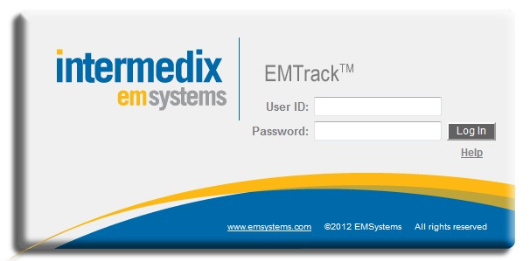
URL: emtrack.emsystem.com
Username:
Passwor
New EMTrack Version “Add Patient”

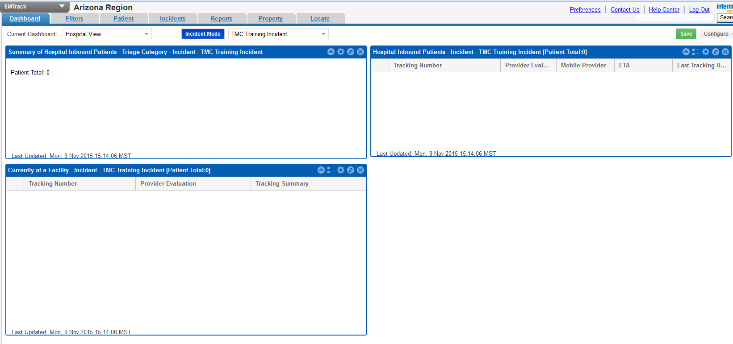
Select “Patient” Tab
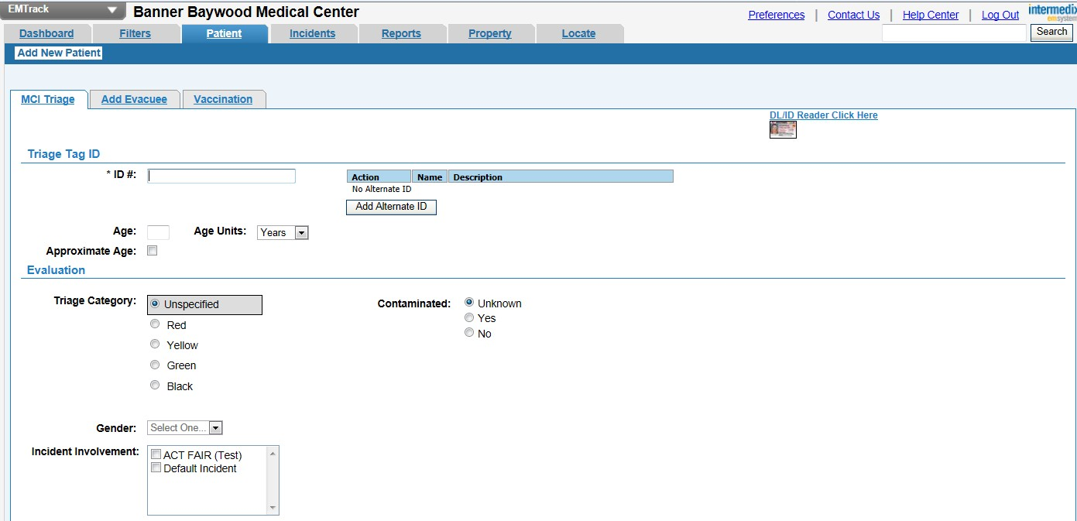
“Add New Patient”

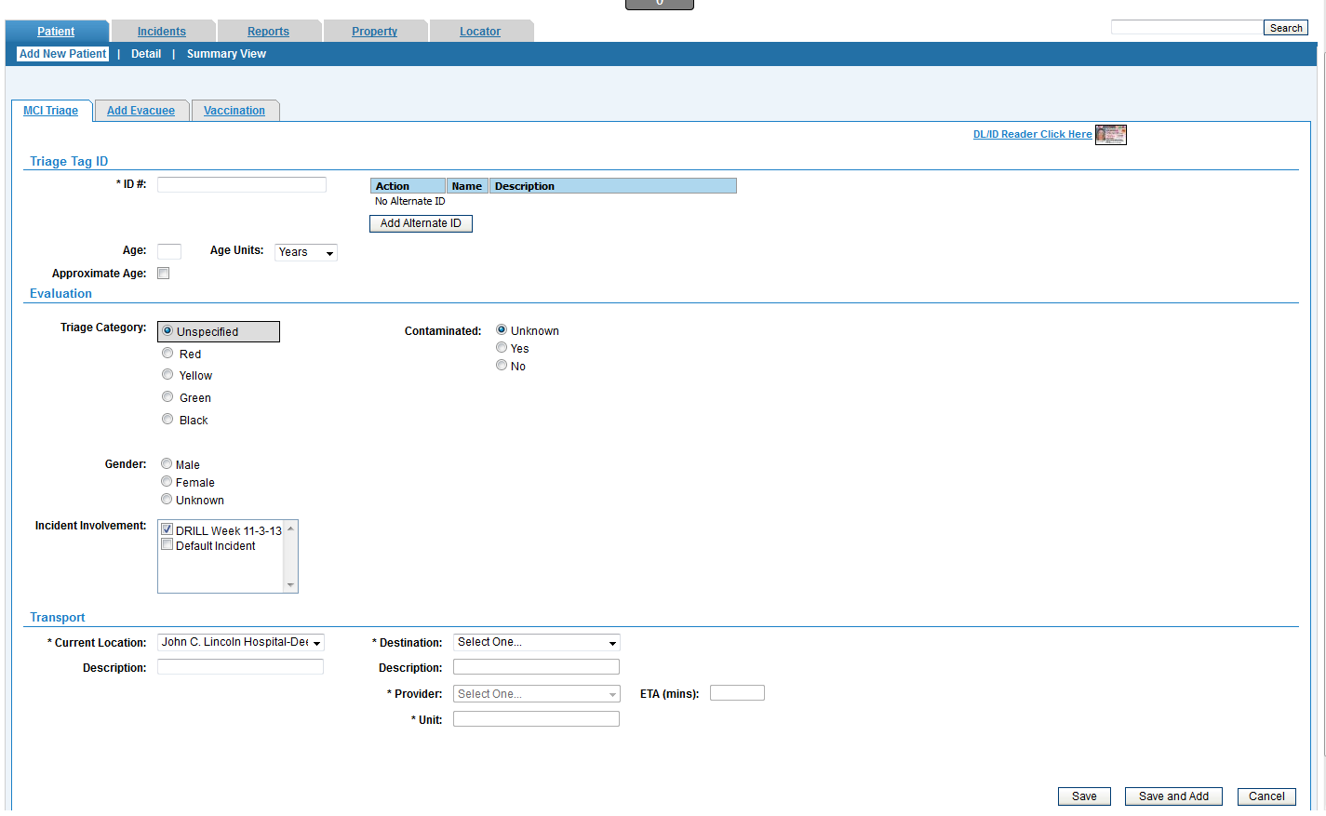
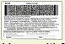
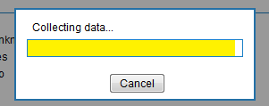
Completing Initial Patient Record

- Scan Patient Wristband (ID)

- If Drive License available (if not move to Step 3)

- Enter any available information

- Select “Incident”

- Select “Save”.

- If you are ready to enter another patient - Select “Save and Add”

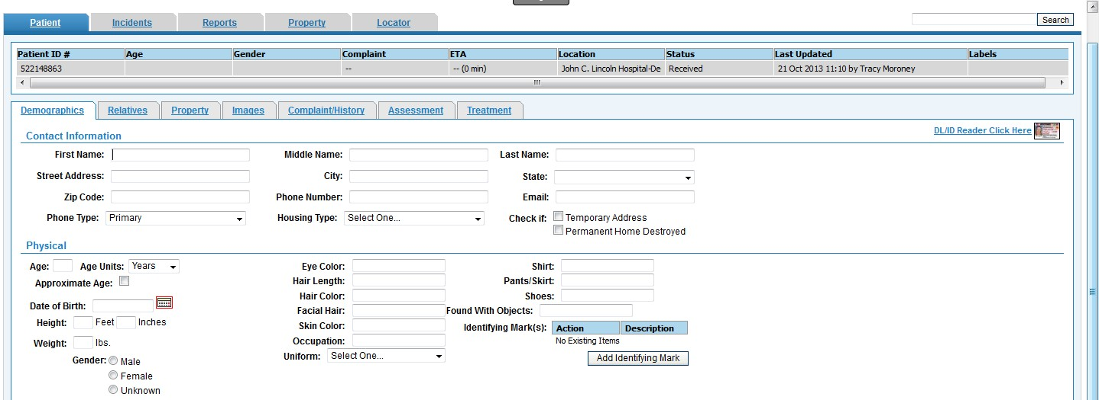
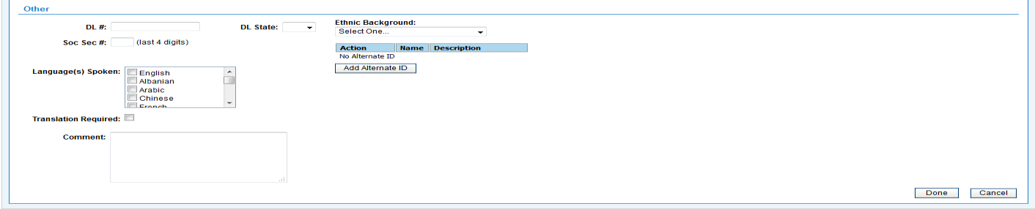
Entering “Demographics” into a newly Created EMTrack Patient Record

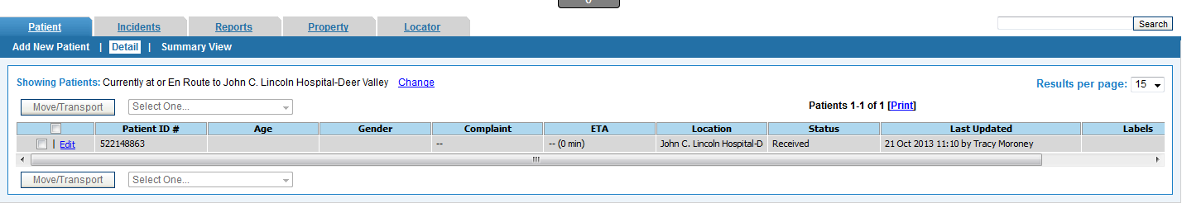
Select “Edit”

Select “Done” when complete

New EMTrack Version “Edit Patient” Demographics

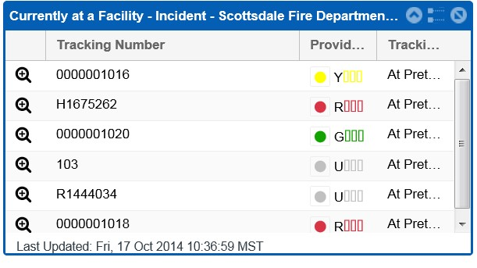
Select a Patient From the “Currently at a Facility” area.

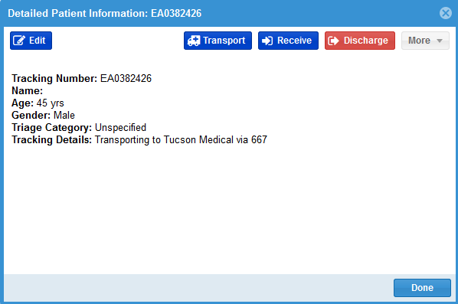
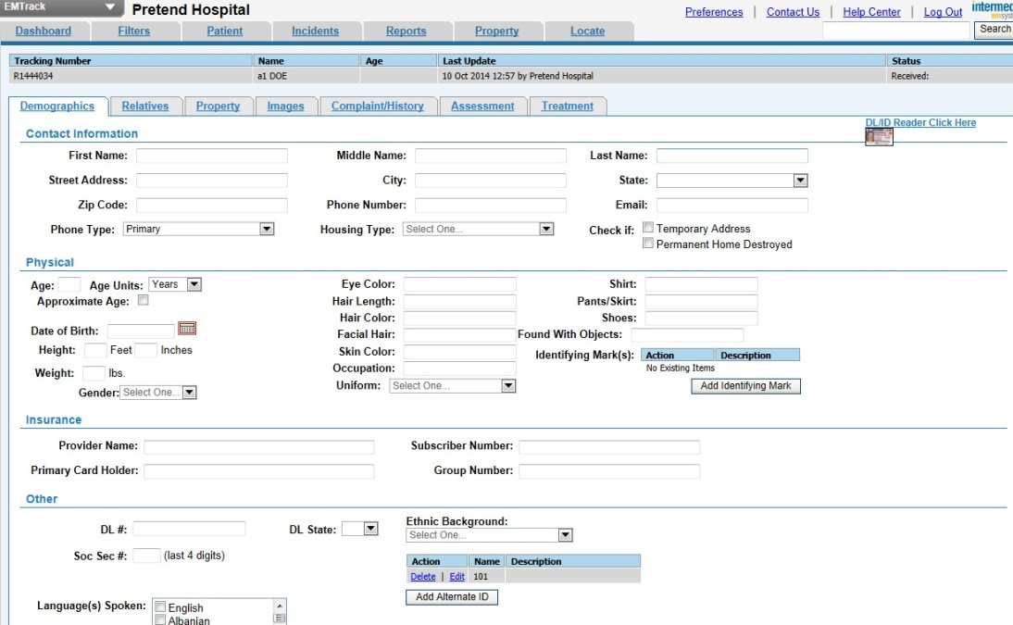
Click onicon Then select “Edit”
I
(Edit Demographics as usual)

New EMTrack “Transfer”, “Edit” or “Discharge” Patient

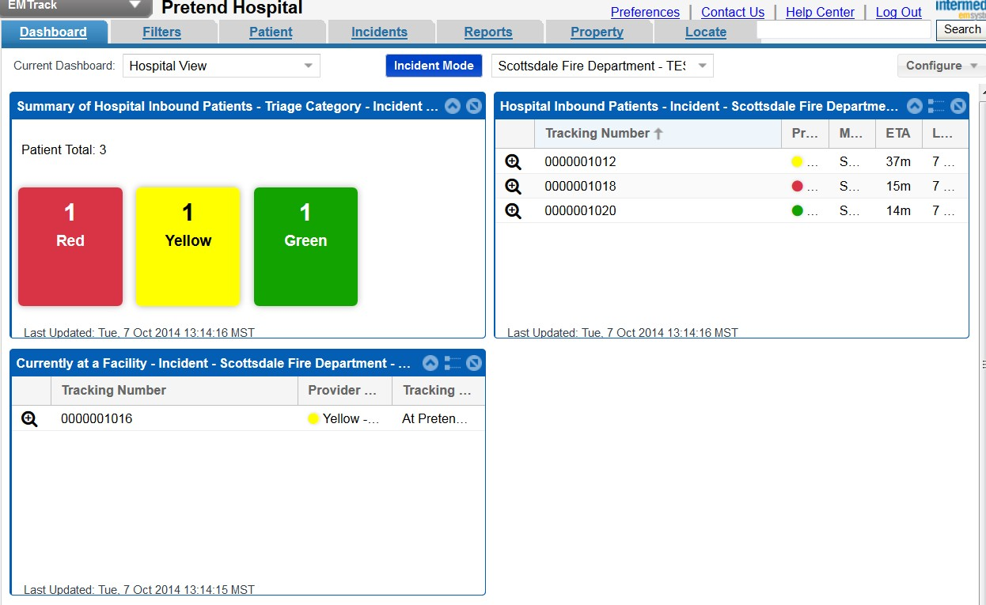
To Transfer, Edit or Discharge patient
“Click” on
Ic
Select Action Then “Done”

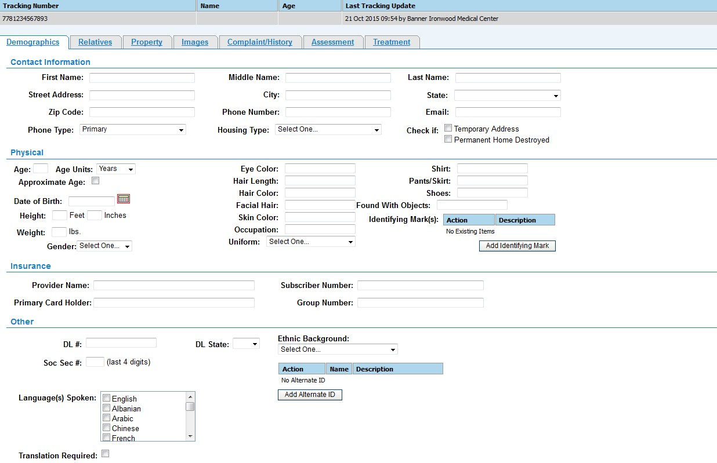
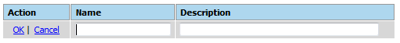
Adding “Alternate ID” (after initial registration)

Enter the Name (ID #) (Scan in Alternate ID)
Enter Description (i.e. Medical Record #)

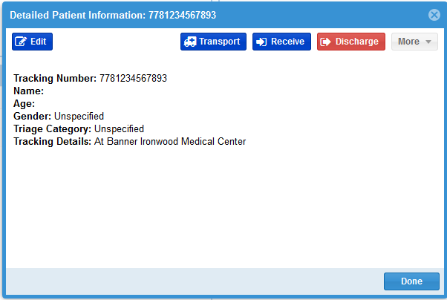
Select existing record Select “Edit”

Adding “Identifying Mark(s)” in Patient Demographics

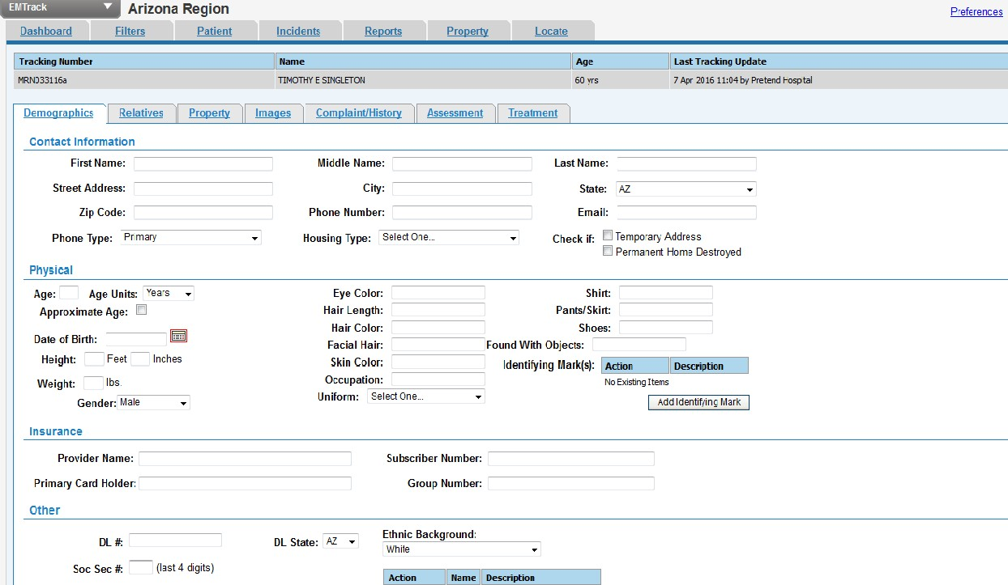
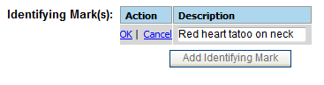

Select “Add Identifying Mark”

Type in Description

Then select OK

Emtrack Tethered USB Scanner

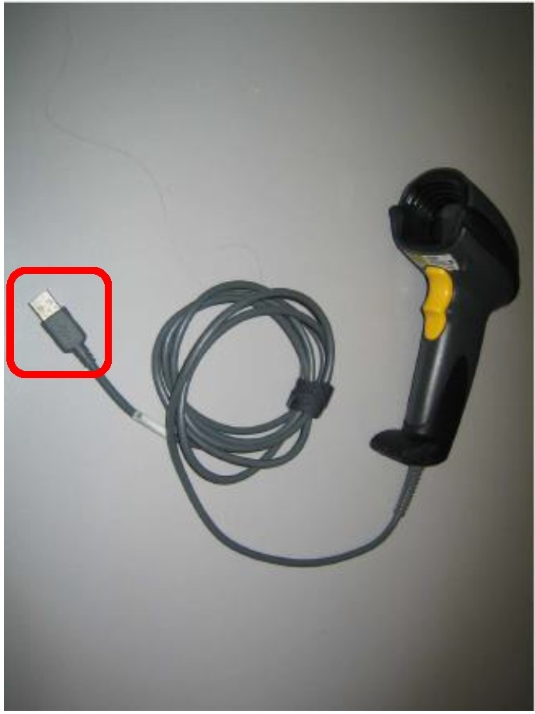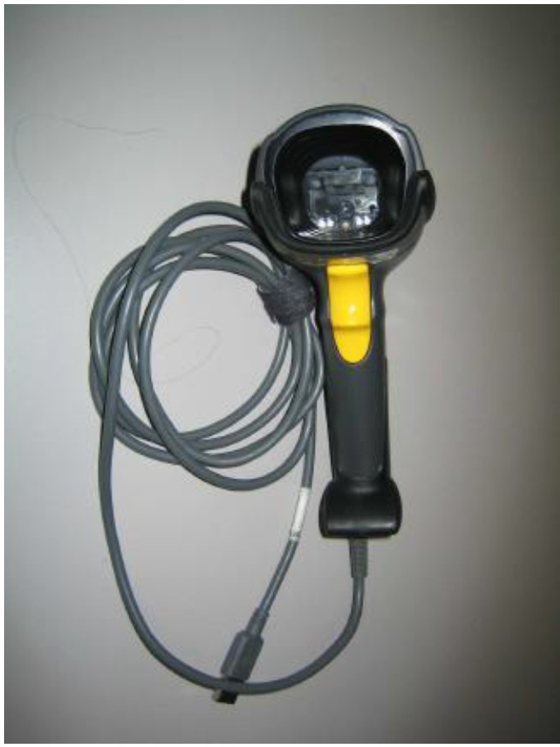

Plug into any USB port on Computer

