Trauma Nursing Core Course (TNCC)
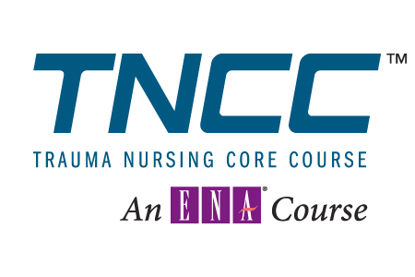
TNCC provides you with core-level trauma knowledge and skills in an interactive format. The cognitive portion presents a systematic standardized approach to nursing care of the patient. The hands-on skill stations give you the opportunity to practice and apply new concepts in a safe learning environment.

The Emergency Nurses Association is accredited as a provider of nursing continuing education
by the American Nurses Credentialing Center’s Commission on Accreditation.

March 14 & 15, 2015
Rochester General Hospital
Portland Ave, Rochester, NY
Registration fee:
$250 ENA member (To qualify for the member rate, ENA members must submit a photocopy of their current
ENA’s membership card with the application)
$300 Non ENA member (Cost includes manual and indirect fee)

Registration deadline: February 16, 2015

*If you are unable to attend, notification must be received 1 week prior to course (March 6) to receive a refund. A $100.00 fee will be withheld from your registration refund to cover materials and mailing costs. No refunds for absences or no shows. (ENA and the chapter are not responsible for the outcome if a person requests registration after the deadline and has not prepared adequately for the course.)

“In accordance with the Americans with Disabilities Act, please advise if you have any disability that requires special materials
and/or services so that appropriate personnel can be advised.”

The URMC Finger Lakes Regional Training Center will be providing “scholarships” for up to 2 individuals per hospital per year to cover the cost of registration. Regional Training Center “scholarships” (grant funds) cannot be used to supplant costs for training that is a condition of employment or is a requirement for professional certification, recertification, or licensure. If you qualify and would like to request a scholarship, please contact your hospital EP coordinator to ensure availability. If a scholarship is available, please indicate on the registration form and include the name of your department supervisor and hospital’s emergency preparedness coordinator.

Request For Finger Lakes Regional Training Center Scholarship (Limited to 2/hospital /year)

NOTE: Payment via personal check is still due with registration as outlined above. The Genesee Valley Chapter ENA will return the check to qualified scholarship recipients on the last day of the course. No refunds will be provided for absences or no shows.

Send registration to: Sue Knapp
7754 Roder Parkway, Ontario, NY 14519
rknapp5@rochester.rr.com 315-524-4883

Name___________________________________________________________________

Address _________________________________________ Phone_________________

City/State/Zip _____________________________________ ENA # _______________

Employer ___________________________ Email _____________________________

If requesting RTC scholarship funds, please complete the following:

Supervisor Name________________________________________________________

Hospital Emergency Preparedness Coordinator______________________________

Make check payable to: Genesee Valley Chapter –ENA
Directions, Schedule, and Manual for TNCC will be sent ~3-4 weeks prior to course

