Caffeine and Neural Fatigue Answer Sheet

1.1) When you are suffering from muscle fatigue, which of the following parts isn’t working? The brain, the upper motor neuron, the lower motor neuron or the muscle?

____________________________

1.2) When you are suffering from neural fatigue, which of the following parts isn’t working? The brain, the upper motor neuron, the lower motor neuron or the muscle?

____________________________

1.3) Define the term, “neuromodulator”

______________________________________________________________________________

______________________________________________________________________________

1.4) When the ion receptor is activated, does it result in more or less neurotransmitters being released?

____________________________

1.5) When the adenosine receptor is activated, does it result in more or less neurotransmitters being released?

____________________________

2.1) What are the coaches concerned about?

______________________________________________________________________________

______________________________________________________________________________

2.2) What does Marion want to know?

______________________________________________________________________________

______________________________________________________________________________

2.3) What do you need to know to answer Marion’s question?

_____________________________________________________________

_____________________________________________________________

2.4) Based on your personal experience, do you think caffeine can improve athletic performance? Why or why not?

______________________________________________________________________________

______________________________________________________________________________

2.5) Do you think caffeine acts as an inhibitor or activator of the adenosine receptor? Why or why not?

______________________________________________________________________________

______________________________________________________________________________

2.6) Do you think caffeine acts as an inhibitor or activator of the ion receptor? Why or why not?

______________________________________________________________________________

______________________________________________________________________________

______________________________________________________________________________

______________________________________________________________________________

3.1) If you add adenosine to the AR cell culture, would you see a flash of light? Explain.

______________________________________________________________________________

3.2) If caffeine were an inhibitor of the adenosine receptor, would you see a flash of light if you added caffeine to the AR cell culture? Explain.

______________________________________________________________________________

3.3) If caffeine were an activator of the adenosine receptor, would you see a flash of light if you added caffeine to the AR cell culture? Explain.

______________________________________________________________________________

3.4) What happened with you dropped adenosine onto the square of AR cells?

______________________________________________________________________________

3.5) What happened when you dropped caffeine onto the square of AR cells?

______________________________________________________________________________

3.6) (Only answer this if you are completing step 4, if you are not completing step 4, write in your lab notebook, “Not doing this step”) What happened when you added a drop of adenosine to the AR cells that have caffeine on them?

____________________________

3.7) Is caffeine an activator or inhibitor of the adenosine receptor? Why do you conclude this?

______________________________________________________________________________

______________________________________________________________________________

3.8) Could caffeine be acting as a performance enhancing drug through its effect on the adenosine receptor? Why do you think so?

______________________________________________________________________________

______________________________________________________________________________

4.1) If you add ryanodine to the IR cell culture, would you see a color change? Explain.

____________________________

4.2) If caffeine were an activator of the ion receptor, would you see a color change if you added caffeine to the IR cell culture? Explain.

____________________________

4.3) If caffeine were an inhibitor of the ion receptor, would you see a color change if you added caffeine to the IR cell culture? Explain.

____________________________

4.4) What happened with you dropped ryanodine onto the square of IR cells?

______________________________________________________________________________

4.5) What happened when you dropped caffeine onto the square of IR cells?

______________________________________________________________________________

4.6) (Only answer this if you are completing step 4, if you are not completing step 4, write in your lab notebook, “Not doing this step”) What happened when you added a drop of ryanodine to the IR cells that have caffeine on them?

____________________________

4.7) Is caffeine an activator or inhibitor of the ion receptor? Why do you conclude this?

____________________________

4.8) Could caffeine be acting as a performance enhancing drug through its effect on the ion receptor? Why do you think so?

______________________________________________________________________________

______________________________________________________________________________

5.T
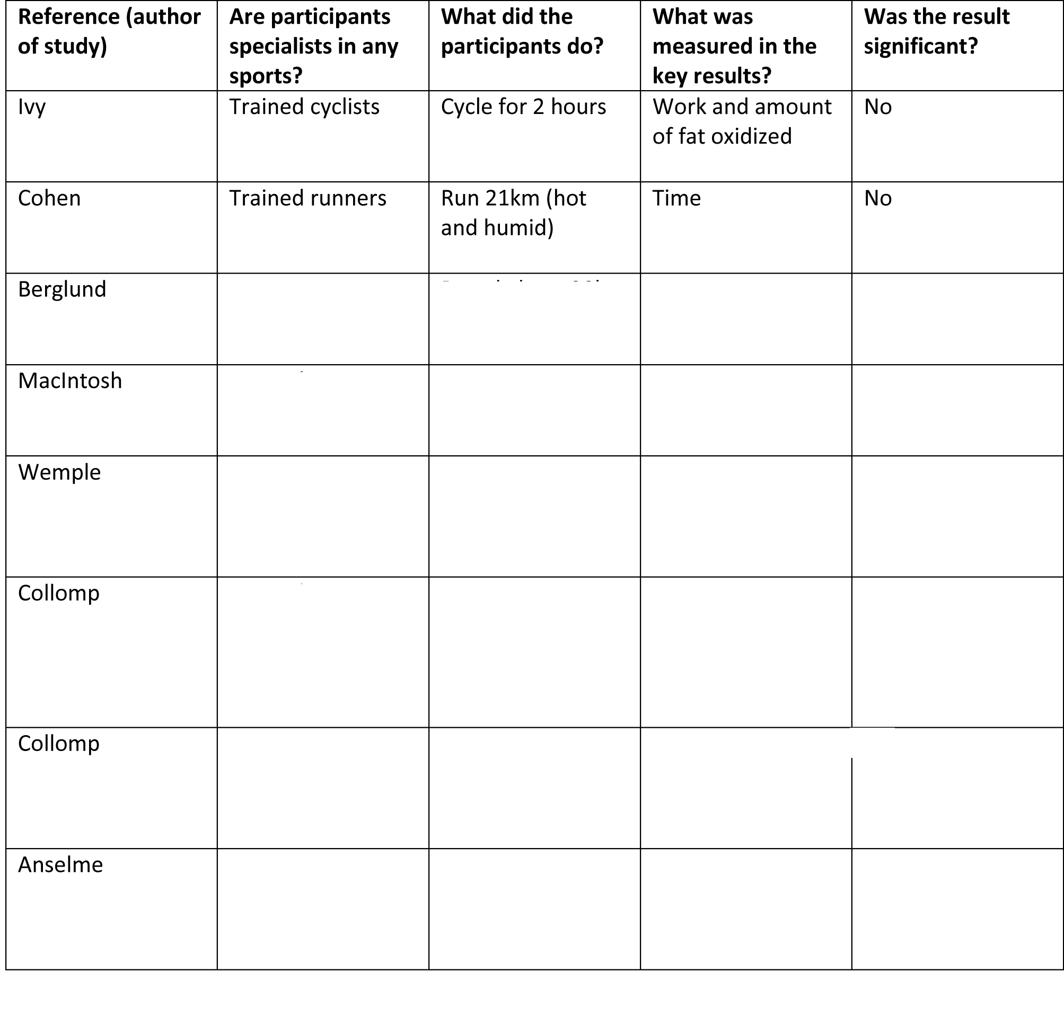

5.1) What is the main purpose of the table?

______________________________________________________________________________

______________________________________________________________________________

5.2) How many studies looked at both male and female athletes?

____________________________

5.3) Based on the information in the table, what conclusions can be drawn about how caffeine affects the performance of trained athletes?

______________________________________________________________________________

______________________________________________________________________________

5.4) Based on the information in the table, what conclusions can be drawn about how caffeine affects the performance of untrained, but active individuals?

______________________________________________________________________________

______________________________________________________________________________

5.5) Caffeine is no longer banned by the world anti doping agency. Do you think it should be banned? Why or why not? Write a one paragraph explanation.

______________________________________________________________________________

______________________________________________________________________________

______________________________________________________________________________

______________________________________________________________________________

______________________________________________________________________________

______________________________________________________________________________

______________________________________________________________________________

______________________________________________________________________________

5.6) What do you think about this statement from Terry Graham (shown below)? Write a one paragraph response.

“Athletes who ingest caffeine are using a drug for the express purpose of gaining an advantage. As such, the author considers it to be doping and unethical. If an athlete has made a conscious decision to take caffeine for the purpose of gaining an advantage and enhancing performance, this could be the first of a series of similar decisions for other drugs.”

______________________________________________________________________________

______________________________________________________________________________

______________________________________________________________________________

______________________________________________________________________________

______________________________________________________________________________

______________________________________________________________________________

______________________________________________________________________________

______________________________________________________________________________

