The Effects of Environmental Lead Poisoning on Human Health

Developed by
James Buckley Jr.
Edwards-Knox Central School
Russell, New York

For the

My Environment, My Health, My Choices project



University of Rochester

Rochester, NY

Abstract:
This learning experience develops student understanding of lead poisoning. Students investigate sources of lead exposure in the home and health problems caused by these exposures. Students will also examine issues relating to the historical use of lead and ways to reduce exposure to lead in older homes. The learning experience includes: a directed PBL, a PowerPoint lesson, a home lead assessment, and a web quest. Practice questions incorporating graphing and graph analysis are also included.
Table of Contents

Pre/Post Test | 3-4
Teacher: Pre/Post Test Answer Key | 5-6
Learning Context | 7
Procedure: Overview and Timeline | 8-9
Student Handouts: Trouble in the Country | 10-13
Teacher Information: Trouble in the Country | 14-21
Home Lead Hazard Assessment | 22-26
Lead WebQuest | 27-36
Practice Questions - Graphing and Reading | 37-42
New York State Learning Standards | 43-44

Teachers, we would appreciate your feedback. Please complete our brief, online Environmental Health Science Activity Evaluation Survey after you implement these lessons in your classroom.
The survey is available online at: www.surveymonkey.com/s.asp?u=502132677711
(Pre/Post Test)
Student Name: _________________________
Directions: For each statement or question, choose the number of the word or expression that, of those given, best completes the statement or answers the question.

1. What is a common cause of lead poisoning?
1. Ingesting paint used in older homes
2. Drinking water from areas having alkali (basic) soils
3. Frequent use of lead pencils
4. Eating foods with lots of calcium and phosphorus.

2. Which problem is most associated with children having high lead levels?
1. abnormally fast growth rates
2. high blood sugar levels
3. difficulty paying attention in school
4. increased thirst and urination
3. By adding lead to commercial products such as gasoline and paint,
humans have

1. caused unintended consequences to human health and safety
2. enhanced global stability
3. established dynamic equilibrium in ecosystems
4. replaced nonrenewable resources

4. Which group of individuals are most at risk for lead poisoning?
1. People living in rural communities
2. People living in urban communities
3. People living in houses with plastic water pipes
4. People living in housing built before 1978
5. Which technique is most commonly used to diagnose lead poisoning?
1. paper chromatography
2. a blood test
3. gel electrophoresis
4. an X-ray
6. Lead additives were placed in gasoline and other commercial products in the
first part of the 1900's. It is now known that this had harmful health effects
on some people. This situation is an example of

1. the negative result of pesticides use
2. the recycling of a renewable resource in an ecosystem
3. the flow of energy in the ecosystem
4. an unintended consequence of chemical use

7. During home renovation, lead paint dust and flakes may be safely
removed from the home using a
1. broom and dustpan
2. clean dry rag with filtering material
3. vacuum cleaner with a HEPA filter
4. paint scraper

8. Which statement best describes the effects of lead poisoning?
1. They are not as serious as they were thought to be ten years ago.
2. These effects can be completely reversed with proper medical care.
3. Lead poisoning is a problem for toddlers, not older children or adults.
4. The effects of lead poisoning are often permanent
9. Lead is able to reach the fetus and cause problems for its
development because it diffuses into the fetus through the
1. amniotic fluid
2. placenta
3. fallopian tubes
4. ovaries
10. Children living in older homes can help protect themselves from lead
poisoning by
1. brushing and flossing their teeth after eating
2. washing their hands after playing
3. helping to dust their rooms dry dust cloth
4. playing near open windows or shades to get more ventilation.
Pre and Post Test Questions – Answer Key
1. What is a common cause of lead poisoning?
1. Ingesting paint used in older homes
2. Drinking water from areas having alkali (basic) soils
3. Frequent use of lead pencils
4. Eating foods with lots of calcium and phosphorus.

2. Which problem is most associated with children having high lead levels?
1. abnormally fast growth rates
2. high blood sugar levels
3. difficulty paying attention in school
4. increased thirst and urination
3. By adding lead to commercial products such as gasoline and paint,
humans have

1. caused unintended consequences to human health and safety
2. enhanced global stability
3. established dynamic equilibrium in ecosystems
4. replaced nonrenewable resources

4. Which group of individuals are most at risk for lead poisoning?
1. People living in rural communities
2. People living in urban communities
3. People living in houses with plastic water pipes
4. People living in housing built before 1978

5. Which technique is most commonly used to diagnose lead poisoning?
1. paper chromatography
2. a blood test
3. gel electrophoresis
4. an X-ray
6. Lead additives were placed in gasoline and other commercial products in the
first part of the 1900's. It is now known that this had harmful health effects
on some people. This situation is an example of

1. the negative result of pesticides use
2. the recycling of a renewable resource in an ecosystem
3. the flow of energy in the ecosystem
4. an unintended consequence of chemical use

7. During home renovation, lead paint dust and flakes may be safely
removed from the home using a
1. broom and dustpan
2. clean dry rag with filtering material
3. vacuum cleaner with a HEPA filter
4. paint scraper

8. Which statement best describes the effects of lead poisoning?
1. They are not as serious as they were thought to be ten years ago.
2. These effects can be completely reversed with proper medical care.
3. Lead poisoning is a problem for toddlers, not older children or adults.
4. The effects of lead poisoning are often permanent

9. Lead is able to reach the fetus and cause problems for its
development because it diffuses into the fetus through the
1. amniotic fluid
2. placenta
3. fallopian tubes
4. ovaries

10. Children living in older homes can help protect themselves from lead
poisoning by
1. brushing and flossing their teeth after eating
2. washing their hands after playing
3. helping to dust their rooms dry dust cloth
4. playing near open windows or shades to get more ventilation.
Learning Context
Subject Area: Living Environment/Biology
Learning Objectives:
Upon the completion of these learning activities the student will:
- List 3 major sources of lead contamination in and around the home.

- Describe 2 techniques for dealing with lead contamination in the home.
Discuss 2 major ways lead interferes with normal early human development.

- List two major routes by which lead is absorbed into the body.

- Explain why lead tends to be found in higher concentrations in children
than in adults.

- Explain why it is easier to prevent lead poisoning than to treat this condition.
- Discuss ways that earlier generations used lead in commercial products and
explain the reasons for its use.
Procedure
An Overview of Unit Activities:
The activities in this unit on the effects of lead on human development and health have been designed to be implemented either individually or as a unit. Most of the activities will act as stand-alone activities if the teacher wishes to do only parts of the learning experience.

The Unit includes the following components:

- Pre-test
- Trouble in the Country problem-based learning (PBL) scenario
- Lead Hazards PowerPoint
- Home Lead Hazards Assessment
- Lead WebQuest
- Practice Questions
- Post-test

The Trouble in the Country is an introductory problem-based learning (PBL) activity designed to engage students and to explain some of the problems associated with lead contamination in the home and lead poisoning, especially in children.

The Lead Hazards PowerPoint and Home Lead Hazards Assessment encourage students to explore lead hazards in their home environment. The PowerPoint provides background information on what students should examine when they take the survey home or into their neighborhood. Do not use the Home Lead Hazards Assessment survey without getting permission from the appropriate administrators in a school! The topic of this survey is potentially controversial and should be used on a voluntary basis with appropriate administrative permission. An alternative to the survey is provided if needed.
The Lead WebQuest requires that students have access to computers and the internet, either at home or in school. This activity may be completed either at home, in school, or in a combination of both places. This will allow the students to explain and elaborate upon their explanations on a variety of topics pertaining to topic of lead in the environment.
The post-test for this section, the PBL culminating experience, and the practice questions will allow teachers to evaluate the learning outcomes of student engagement in this learning experience.

Classroom Timeline:
Student Activity | Approximate Time Frame in 40 minute class periods
Administer Pre-test | 5 min
Trouble in the Country PBL activity | 1 1/2 periods
Lead Hazards PowerPoint | 1/2 period
Lead Home Hazards Assessment ** (see note below) and Discussion | Overnight Assignment plus 1/2 period in class discussion
Lead WebQuest | 2 periods
Practice Questions (graphing and reading passage assessment based on lead and the human health) | 1 period
Administer Post-test | 5 min
** Teachers should receive permission from the appropriate school authorities before conducting this assessment in any actual homes to avoid any controversial situations. An alternative paper option for assessing different home situations is provided if teachers feel that the Lead Hazards Assessment might be problematic in their community.
Equipment and Supplies:
Computer and LCD projector setup for showing the Lead Home Survey PowerPoint, as well as student paper copies of the unit activities and the resources listed in the PBL activity.

(Student Version)

Trouble in the Country
Part I: The Home and Amanda
The Yobgib family home lies on a 110 acre plot in the country. The family lives in a wood frame two story home which was built in the late 1800's. The Yobgib family home was extensively renovated three years ago. The deteriorated windows have been replaced in the home and the bathroom has been completely redone. Additionally, new floors have been installed in the kitchen and living room. Dad is very proud of these renovations, having done much of this work on his own.

The happily married couple has two girls, ages 7 and 2. Amanda, the older of the two children, is frequently in ill health. She often suffers from upper respiratory infections. Amanda is a picky eater and often complains of stomach cramps.
The Mother is worried about Amanda's health. Mom has recently had a conference with Amanda's second grade teacher. Her teacher stated that she could not stay on task and was extremely disruptive in the classroom. She brings Amanda to the family doctor.
Questions to Consider
1. While there may be other causes for Amanda's symptoms, the
family doctor suspects that lead poisoning might be the cause of Amanda's
health problems. List Amanda’s symptoms that may be caused by lead poisoning.

2. What conditions in Amanda’s home environment might provide support for the
doctor's hypothesis that the home was a high lead environment?

3. What additional evidence should the doctor collect to confirm this hypothesis?
Part II: Dad and the Toddler
The doctor examined the family medical and anecdotal records and had other
concerns as well. Dad has recently complained of bone and muscle pains, increasing irritability, and increasing difficulties with his memory.
The youngest child, Meredith, is always putting dirt or other non-food objects in her mouth. She is a very energetic toddler that just can't seem to sit still. She also seemed to be quite delayed in her language development.
The family doctor suggests that each member of the family have a blood test to check for the levels of lead in the blood.
Questions to Consider
1. What are some other pieces of evidence which might support the doctor’s
hypothesis that the family is being lead poisoned?
2. Which family member do you believe had the highest concentration of lead
in the blood? Support your answer.
Part III: The Blood Test
The family doctor arranged to have the blood lead levels of each member of the family tested. The results of the blood test, with blood lead levels listed in micrograms per deciliter are listed in the table below.

Family Member | Age | Blood Lead Level in ug/dL*
Dad | 32 | 10.2
Mom | 28 | 6.0
Amanda | 7 | 29.3
Meredith | 2 | 41.8
* The US Centers for Disease Control and Prevention has determined that the “level of concern” for blood lead levels for children below age 14 is 10.0 micrograms per deciliter or higher. A blood lead level of more than 10.0 micrograms per deciliter is cause for concern. For individuals 15 and older, a blood lead level of 25.0 micrograms per deciliter or higher is cause for concern.
Questions to Consider
1. Why could Dad have a higher concentration of blood lead than Mom?
2. State two reasons why Meredith would have a higher concentration of
blood lead than Amanda.
Part IV: Call in the Consultant
After the family doctor reviewed the results of the blood test, he calls the family in for an appointment. He suggested the family address lead hazards in their home by seeking the advice of the respected environmental firm, JMB Environmental Consultants. This company specializes in lead testing in the home and making lead abatement (reduction) recommendations to owners of properties with lead contamination. The Yobgib family agreed to hire this firm to test the home for lead and make recommendations to reduce the lead problem.
Some Possible Projects:
1. Complete a poster listing several major sources of lead in the Yobgib home
and listing several major recommendations JMB Environmental Consultants
should make to reduce this problem.
2. Write a letter as the chief consultant from JMB Environmental Consultants
to the Yobgib family. Include in your letter a discussion of the lead hazards
in their home, as well as some steps they can take to reduce their risks
from this exposure.
3. Write a sequel to this story. State what would happen to the home and family
in the five years following the events described in this story.
4. Design a video to act out this story. This video would need at least six cast members (one for each family member, the doctor, and an environmental consultant)
________________________________________________________________________
Teacher Information: Trouble in the Country

This Problem Based Learning (PBL) activity provides a scenario about lead poisoning, a common problem in older homes. The scenario introduces the issues that emerge when family members visit their family doctor to find out the cause for health problems they are experiencing. The activity concludes with a choice of individual assignments that will provide students with an opportunity to learn about and address an environmental issue that may influence many of them.
Classroom Timeline:
Approximately 65 minutes with for the entire PBL without the culminating experience at the end of part IV of the PBL. See the suggested timeline for this PBL activity under instructions for implementing this activity.

Equipment and Supplies:
Print out enough copies of the student handout for this activity for your class. In addition, print out sufficient copies of the suggested student resources so each group has one copy of the listed handouts at the URL's indicated.
Instructions for Implementing the Activity:
Assign students to work in teams of 4 students and discuss team member roles. Some possible student roles for working in groups could be the following:
Facilitator/Timekeeper: Makes certain group members are following their assigned roles, makes certain students in the group are aware of the available and remaining time for each task, and contributes to the research and information the group must collect to answer each question with the assigned portion of the PBL.
Recorder: Writes information provided by group members for each question on the paper provided in the PBL or on a group poster as preferred by the teacher.
Reader: Reads the passage at the start of the assigned portion of the PBL. Contributes to the research and information the group must collect to answer each question with the assigned portion of the PBL.

Spokesperson: Reports team findings to the class. Contributes to the research and information the group must collect to answer each question with the assigned portion of the PBL.

If you are going to use the PBL Teamwork and Team Processing Rubric provided to guide or assess student work, discuss this with the class.
Note: If you and your students are experienced with problem-based learning you may make this activity more student-centered by having students create a PBL Chart like the one below.

What do you know about this case? | What questions do you have about this case? | What have you learned from your research?

Timeline: 65 minute approach
Time needed in minutes and activity | Materials needed for students | Student Tasks to be Completed | Comments
Pre-PBL 10 min | Pass out research articles from the suggested student resource URL's listed below | Introduce PBL roles and rubric. Pass out research articles, and assign groups and group roles to students | Pre-print sufficient research articles from the internet for each student group.  Assigned time needed will vary depending upon class experience with PBL activities and group work.
PBL Part I 10 min | Pass out part I of the PBL to each student | Read the PBL and work to answer the assigned questions following part I of the PBL using the research articles provided | Guide students to do research and be sure the activity is completed in the time frame allowed.  Assist students having difficulty with the information in the articles without providing the answers.
PBL Part I 5 min | No new materials unless an optional poster is created | Spokesperson reports research findings to the class. | Make sure all groups can hear the spokesperson for each group. Encourage students to modify the answers they have written based on the report of each spokesperson as needed.
PBL Part II 5 min | Pass out Part II of the PBL to each student | Read the PBL and work to answer the assigned questions following part I of the PBL using the research articles provided.  Have the students rotate roles within the group. | Guide the students to do the research required to answer the questions.

PBL Part II 5 min | No new materials unless an optional poster is created | Spokesperson reports research findings to the class. | Make sure all groups can hear the spokesperson for each group. Encourage students to modify the answers they have written based on the report of each spokesperson as needed.  If evaluation of the PBL activity is going to involve a grade, rubrics for PBL evaluation follow this timeline/approach. This is also an appropriate time to collect the work/answers from each group at the end of part II of the PBL for overnight evaluation if so desired.
PBL Part III 10 min | Pass out part III of the PBL to each student | Read the PBL and work to answer the assigned questions following part I of the PBL using the research articles provided.  Have the students rotate roles within the group. | Guide the students to do the research required to answer the questions.
PBL Part III 5 min | No new materials unless an optional poster is created | Spokesperson reports research findings to the class | Make sure all groups can hear the spokesperson for each group. Encourage students to modify the answers they have written based on the report of each spokesperson as needed.
PBL Part IV 5 min | Pass out part IV of the PBL to each student | Read part IV of the PBL in student groups. | No additional comments, but be ready to prepare students for a culminating experience following the PBL.
PBL Closure Activity 10 min |  | Discuss possible closure activities with the class. Some possible options for closure activities are listed below. | Design evaluation rubric for the closure activity chosen or activities indicated based on teacher preferences.

PBL TEAMWORK AND TEAM PROCESSING RUBRIC

Team  Members: | 1  Limited | 2  Developing | 3  Proficient | 4  Advanced | 5  Exemplary | Self | Team
Distribute  Tasks | Do not distribute tasks equally. |  | Distribute tasks equally. |  | Distribute tasks based on team members’ skills.
Collaborate  & Contribute Equitably | Let one or two team members do most of the work. |  | Ensure that all team members contribute fully. |  | Know and encourage each other’s strengths to do quality work.
Manage  Conflict | Do not recognize or take action to reduce conflict |  | Resolve conflicts to continue to stay “on task.” |  | Identify and actively use “win-win” solutions to manage conflict.
Use Brainstorm  “Rules” | Do not use brainstorm “rules”; allow others to block the process. |  | Follow brainstorming “rules” and contribute ideas equally. |  | Develop new “rules” as needed to facilitate the brainstorming process.
Effectively Reflect on Teamwork | Do not contribute to discussions about their work as a team. |  | Use the results of this rubric to suggest ways to improve teamwork. |  | Regularly monitor and assess teamwork of individuals and group as a whole.
Build Consensus | Do not attempt consensus process. |  | Use consensus process to work effectively. |  | Seek out feedback and process this information to improve teamwork.
Manage  Time | Do not monitor their progress or recognize time constraints. |  | Use time efficiently and complete all tasks on time. |  | Regularly monitor and assess progress to exceed task expectations.
Produce Quality Work | Show no, or limited, attention to making quality products. |  | Create high school products that meet expectations |  | Create products that resemble practicing professionals “in the field.”
Stay on Task | Are easily distracted or frequently go “off task.” |  | Use time in focused & productive ways. |  | Create work-plan agenda and monitor progress.
Come Prepared | Are not consistently prepared with needed materials. |  | Are consistently prepared with needed materials. |  | Take time daily to assure that materials are ready for next work session.
Maintain Positive Attitude | Exhibit negative behaviors; use “put down” expressions. |  | Exhibits positive attitudes/behaviors towards work and others. |  | Assist others in maintaining positive attitudes and behaviors..

Suggested Student Resources for PBL:
EPA Lead Information Publication
http://www.epa.gov/lead/pubs/leadinfo.htm

CNN Lead Poisoning Article
http://www.cnn.com/HEALTH/library/FL/00068.html
University of Maryland Environmental Studies Lead Fact Sheet
http://www.des.umd.edu/os/rest/lead.html
JAMA Patient Page/Lead Poisoning
http://www.medem.com/MedLB/article_detaillb.cfm?article_ID=ZZZ0MHMXMAC&sub_cat=29
MEDEM Medical Library: Lead in Paint, Dust, and Soil
http://www.medem.com/MedLB/article_detaillb.cfm?article_ID=ZZZIPHA8AJC&sub_cat=29
Some Developmental Effects of Lead
http://www.ekcsk12.org/science/regbio/leaddevelopmenteffects.htm
Trouble in the Country - Teacher Answer Key

Part I: The Home and Amanda
1. While there may be other causes for Amanda's symptoms, the
family doctor suspects that lead poisoning might be the cause of Amanda's
health problems. List Amanda’s symptoms that may be caused by lead poisoning.
Amanda's digestive problems and behavior problems in school are frequent symptoms of high lead levels in children and lead poisoning.
2. What conditions in Amanda’s home environment might provide support for the
doctor's hypothesis that the home was a high lead environment?
The home is old (built in the 1800's) and is probably full of lead based paint and may have lead piping or lead soldered pipes for its water. The recent renovations in the home have likely stirred up the old lead based paint in the home and created chips and dust the family can take in, thus making both children (and the parents) more vulnerable to the absorption of lead.
3. What additional evidence must the doctor collect to confirm this hypothesis?
The best way for the doctor to confirm the hypothesis is to take a blood test using a sample of venous blood fluid to check Amanda for her lead level.

Part II: Dad and the Toddler
1. What are some other pieces of evidence to make the doctor suspect the
family is being lead poisoned?
Dad's memory problems and bone and muscle aches, as well as Meredith's hyperactivity as well as apparent decreased intelligence due to the delay in language development.
2. Which family member do you believe had the highest concentration of lead
in the blood? Support your answer.
Meredith's young age, because she has less body mass and will be equally exposed to the poison, making her tend to have a higher concentration of poison in her tissues. Additionally, she tends to put objects in her mouth which may be covered in lead dust or paint chips if this house indeed was contaminated with lead based paint.
Part III: The Blood Test
1. Why could Dad have a higher concentration of blood lead than Mom?
Dad was directly exposed to more dust during the home renovations.
2. State two reasons Meredith would have a higher concentration of
blood lead than Amanda.
Again, Meredith's young age, because she has less body mass and will be equally exposed to the poison, making her tend to have a higher concentration of poison in her tissues. Additionally, she tends to put objects in her mouth which may be covered in lead dust or paint chips if this house indeed was contaminated with lead based paint. Another factor increasing the concentration of lead in Meredith's body could have been diffusion of lead from her Mom's blood through the placenta to her blood when her Mom was pregnant for her, especially if the home renovations were occurring when her Mom was pregnant with her.
Teacher Information: Lead Hazards PowerPoint and Home Lead Hazards Assessment

Introduction
The Lead Hazards PowerPoint and the Home Lead Hazards Assessment are designed to have students explore aspects of their environment in reference to this common environmental hazard which may be directly relevant to them. These activities require no additional instructions, but it is suggested that the teacher show the PowerPoint to the students so they will know what to examine when they take the survey home or into their neighborhood. This PowerPoint lesson also provides a logical transition for discussion of common lead hazards in and around the home following the completion of the Trouble in the Country Lead PBL. Do not use the survey without getting permission from the appropriate administrators in a school! The topics this survey addresses are potentially very controversial and at best the survey should be used on a voluntary basis with appropriate administrative permission.
The Power Point may be used effectively with students to teach them about common sources of lead contamination in and around older homes, without having them complete the lead survey. An alternative lead risk assessment worksheet is provided if teachers wish to substitute a paper and pencil simulation of the lead assessment survey to avoid potential controversial assessment of lead risks in an actual home.
Home Lead Hazard Assessment
Student Name _______________________ Date ___________________
Risk Factor for Lead | Condition observed within  the home | High, Medium,  or Low Risk
Age of Home | Built Before 1950 ______  Built 1950-1977 ______  Built in 1978 or Later ______ | High  Medium  Low
Walls | Peeling, chipped, or cracked  old paint or a recent  remodeling has disturbed  paint in a pre-1950 home ______  Intact paint which is lead  based or completely covered  lead based paint ______  No lead based interior paint  used ______ | High  Medium  Low
Windows and Doors | Peeling, chipped, or cracked  old paint or a recent  remodeling has disturbed  paint in a pre-1950 home ______  Intact paint which is lead  based or lead based paint  completely covered by a  non-lead based paint ______  No lead based interior paint  used ______ | High  Medium  Low
Water Supply | Lead plumbing or lead solder  in plumbing and water not  tested professionally in the  past two years _______  Lead in plumbing, but water  has been tested in the past  two years professionally  and declared safe ________  No lead water pipes nor  leaded solder used in the  plumbing ________ | High  Medium  Low
Water pH | pH less than 6.0 ________  pH 6.0 to 7.5 ________  pH 7.5 to 8.5 ________ | High  Medium  Low

Identification of 1 or more medium or high risk factors for lead contamination may indicate the home being checked upon may have possible lead contamination.

Alternative
Lead Risk Assessment Student Worksheet
Name ________________________________
Scenario # 1: This home uses a city water supply, which is chlorinated and has a near neutral pH. This home was built in the early 1920’s. The family which is renting this home has taken the pictures which appear below within and outside the home.

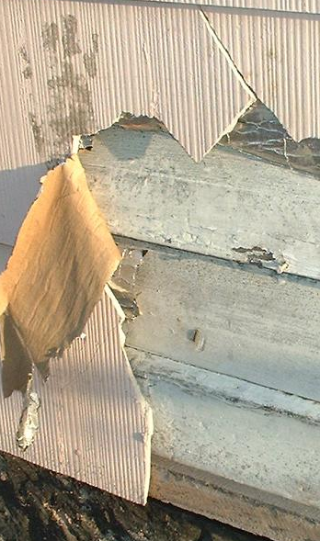 | 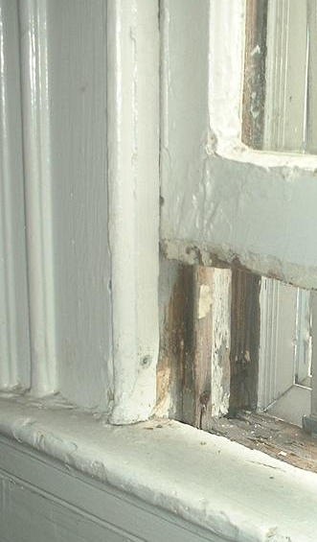

1. Is this home at high, low, or medium risk for lead contamination?
2. List three reasons justifying the answer you gave for question # 1.
a.

b.

c.

Scenario # 2: The home was built in the 1930’s and has much of the original water plumbing intact from that time. The home uses well water which has a pH of 5.8. The windows have all been replaced and modernized, with the window casings painted. The home walls have either been painted in the last five years or have received new wooden paneling. The outside of the home has been recently sided. Pictures of a window in the home and its exterior are seen below.

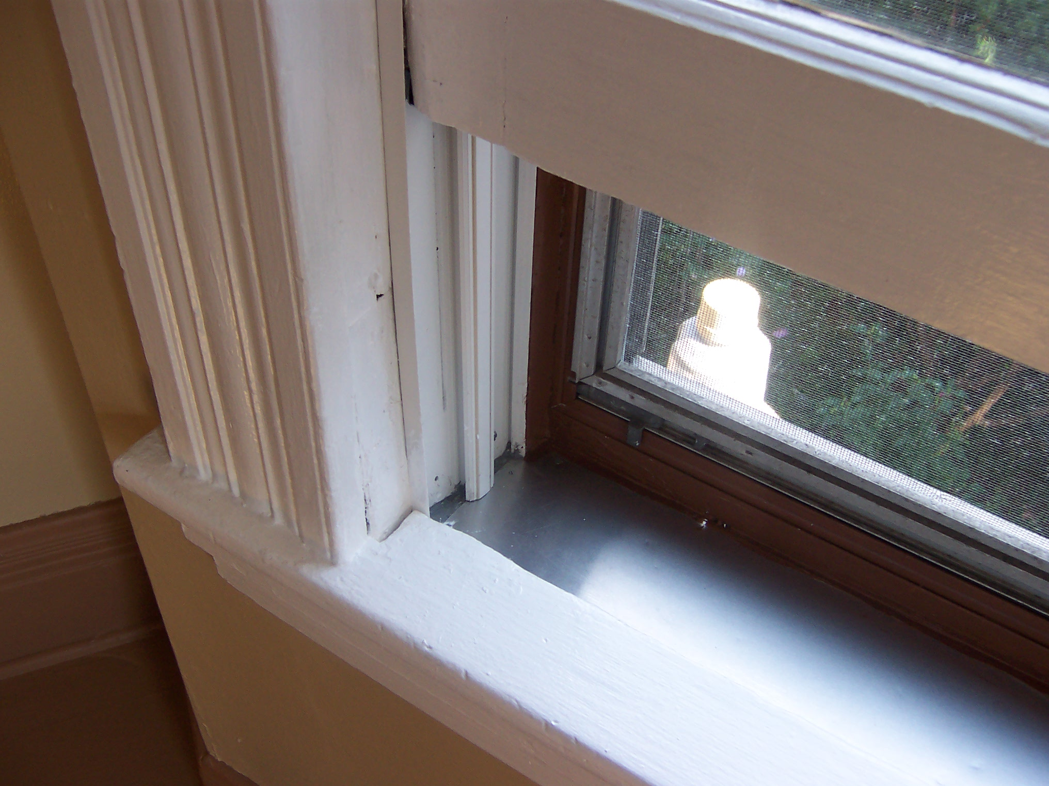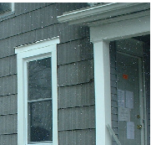

3. Is this home at high, low, or medium risk for lead contamination?
4. List four reasons justifying the answer you gave for question # 3.
a.

b.

c.

d.

5. Explain why homes built more recently than the late 1970’s have a much reduced risk
for lead contamination than older homes.

Sample Answers for Lead Risk Assessment Student Worksheet
Scenario # 1:

1. Is this home at high, low, or medium risk for lead contamination? High risk
2. List three reasons justifying the answer you gave for question # 1.
a. The home is old being built well before lead began to be reduced in paint in the 1950’s.

b. Lead paint is clearly peeling from the outside of the home.

c. Lead paint is peeling and flaking from frictional surfaces on the window.

Scenario # 2:

3. Is this home at high, low, or medium risk for lead contamination? Medium risk
4. List four reasons justifying the answer you gave for question # 3.
a. New siding and freshly painted windows have reduced what was a high lead risk.

b. The home was built prior to all lead paint being banned in the US for sale in 1978.

c. The home has its original plumbing, which may include lead soldered joints in the pipes
and even perhaps some lead pipes.

d. The slight acidity of the home water supply makes it more likely some lead will leach
into the drinking water supply if the plumbing contains it.

5. Explain why homes built more recently than the late 1970’s have a much reduced risk
for lead contamination than older homes.

Lead based paints were banned from being sold in the U.S. after 1978.
Lead WebQuest Student Worksheet
Name ______________________________________________________________

Use the information found at the following URL’s to assist you in answering the following
questions.
http://www.epa.gov/lead/pubs/leadrev.pdf
1. List three major ways people can take lead into their bodies.
a.
b.
c.
2. List five problems high concentrations of lead can cause in children.
a.
b.
c.
d.
e.
Use the information found at the following URL to assist you in answering the following question.
http://en.wikipedia.org/wiki/Paracelsus#Contributions_to_toxicology
3. Explain what is meant by the statement "the dose makes the poison".

Use the information found at the following URL to assist you in answering the following question.
http://www.aclppp.org/documents/lead_poisoning_brochure.pdf
4. One reason that young children tend to have higher concentrations of lead in their bodies is that they get more lead proportionately in their tissues, because their bodies are smaller. Speculate on another reason that young children tend to get more lead into their bodies than adults.

Use the information found at the following URL to assist you in answering the following questions.
http://www.epa.gov/lead/pubs/leadinfo.htm#health
5. List 5 adverse (bad) health effects high concentrations of lead can cause in adults.
a.
b.
c.
d.
e.
Use the information found at the following URL to assist you in answering the following
question.
http://www.idph.state.il.us/public/hb/hblead.htm
6. High lead levels and lead poisoning in children has been associated with behavioral and learning problems. Explain why this is the case.
Use the information found at the following URL to assist you in answering the following question.

http://www.utexas.edu/safety/ehs/msds/lead.html

7. Why it is easier to prevent lead poisoning than to treat this condition. How is the condition treated?
Use the information found at the following URL to assist you in answering the following questions.
http://www.pueblo.gsa.gov/cic_text/housing/finlead/leadhelp.html

8. Lead is no longer used as an additive to gasoline in the United States.
Still lead is frequently found in homes, especially those built before
1978. List four major areas where lead is often found in older homes.
a.
b.
c.
d.
9. What is the only way to know for sure if a child has been exposed to lead?
10. List five ways children can be protected from lead exposure in older homes.
a.
b.
c.
d.
e.

Use the information found at the following URL to assist you in answering the following
questions.
http://www.ekcsk12.org/faculty/jbuckley/leclass/leaddevelopmenteffects.htm

11. The fetuses of pregnant women are greatly affected if there is an exposure to lead during the pregnancy. How does the lead get from the Mother to the fetus?

Use the information below and the following URL to assist you in answering the following
questions.
http://corrosion-doctors.org/Elements-Toxic/Lead-history.htm
Even the ancient Romans were aware that lead could cause serious health problems. And
even death. However, they used lead for so many different things that they minimized
the hazards it posed. They believed in error like Americans before recent decades that
limited lead exposure carried limited risk.
12. One use of lead in the ancient Roman empire was to use it for plumbing.
What did the Latin word plumbum mean?

Use the following URL to research question 13.
http://en.wikipedia.org/wiki/Gasoline#Tetraethyl_lead
13. Discuss the chief use of lead (tetraethyl lead) prior to the last portion of the 1980's in
motor vehicles and explain why this compound was used for that purpose.

Use the information found at the following URLs to assist you in answering the following
questions.
http://www.chemcases.com/converter/converter-19.htm
http://www.chemcases.com/converter/converter-20.htm
14. Catalytic converters were developed in the 1970's. They achieved a great reduction in air pollution, but could not be used with leaded gasoline. Explain why the catalytic converter could not be used with leaded gasoline.
15. Compare the change in average American blood lead levels between 1978 and 1991
to the change in the levels of lead in the American gasoline supply.

http://www.chemcases.com/converter/converter-19.htm
http://www.chemcases.com/converter/converter-20.htm

16. Catalytic converters were developed in the 1970's. They achieved a
great reduction in air pollution, but could not be used with leaded
gasoline. Explain why the catalytic converter could not be used with
leaded gasoline.

17. Compare the change in average American blood lead levels between 1978
and 1991 to the change in the levels of lead in the American gasoline supply.

Teacher Information: Lead WebQuest
Purpose: The purpose of this web quest is to allow the student to obtain recent information concerning the historical use of lead and the human health risks associated with this use. This research will also make the student aware of the special risks lead poses for very young children. Some techniques for reducing the amount of lead in homes and treating humans with lead poisoning will also be researched.
Classroom Timeline: This activity may be completed in class if the classroom has sufficient computer equipment or given as an outside assignment. The estimated completion time for this web quest is 2 forty minute class periods.
Equipment and Supplies: Computer with internet access and web browser and
web quest handout are needed.
Lead WebQuest - Suggested Answers

Use the information found at the following URL’s to assist you in answering the following
questions.
http://www.epa.gov/lead/pubs/leadrev.pdf
1. List three major ways people can take lead into their bodies.
a. Putting their hands or other objects covered with lead dust in their mouths.

b. Eat paint chips or soil that contains lead

c. Breathe in lead dust (a special risk during renovations that disturb painted surfaces).
2. List five problems high concentrations of lead can cause in children.
a. Damage to the brain and nervous system

b. Behavior and learning problems (such as hyperactivity)

c. Slowed growth

d. Hearing problems

e. Headaches
Use the information found at the following URL to assist you in answering the following question.
http://en.wikipedia.org/wiki/Paracelsus#Contributions_to_toxicology
3. Explain what is meant by the statement "the dose makes the poison".
The amount of a substance a person is exposed to is as important as the nature of the substance. For example, small doses of aspirin can be beneficial to a person, but at very high doses, it can be deadly.

Use the information found at the following URL to assist you in answering the following question.
http://www.aclppp.org/documents/lead_poisoning_brochure.pdf

4. One reason that young children tend to have higher concentrations of lead in their bodies is that they get more lead proportionately in their tissues, because their bodies are smaller. Speculate on another reason that young children tend to get more lead into their bodies than adults.
Young children often play close to the floor and put things in their mouths. These natural behaviors make them much more likely to be exposed if there are lead hazards around them.

Use the information found at the following URL to assist you in answering the following questions.
http://www.epa.gov/lead/pubs/leadinfo.htm#health
5. List 5 adverse (bad) health effects high concentrations of lead can cause in adults.
a. Difficulties during pregnancy and other reproductive problems (in both men and women)

b. High blood pressure

c. Digestive problems

d. Nerve disorders and muscle and joint problems and pain

e. Memory and concentration problems
Use the information found at the following URL to assist you in answering the following
question.
http://www.idph.state.il.us/public/hb/hblead.htm
6. High lead levels and lead poisoning in children has been associated with behavioral and learning problems. Explain why this is the case.
Lead poisoning can damage a young child's developing brain, causing learning and behavioral disabilities.

Use the information found at the following URL to assist you in answering the following question.

http://www.utexas.edu/safety/ehs/msds/lead.html

7. Why it is easier to prevent lead poisoning than to treat this condition. How is the condition treated?
Medical treatment and reducing lead exposure cannot undo the harm caused by past lead exposures. Lead in the body can have permanent harmful effects.
Use the information found at the following URL to assist you in answering the following questions.
http://www.pueblo.gsa.gov/cic_text/housing/finlead/leadhelp.html

8. Lead is no longer used as an additive to gasoline in the United States.
Still lead is frequently found in homes, especially those built before
1978. List four major areas where lead is often found in older homes.
a. paint

b. water pipes

c. gasoline

d. pottery and other places
9. What is the only way to know for sure if a child has been exposed to lead?

Children with too much lead in their bodies may not look or feel sick. A simple blood test is the only way to know if your child is being exposed to lead.
10. List five ways children can be protected from lead exposure in older homes.
a. Wash children’s hands and face often with soap and water, especially before they
eat. Wash toys every week.

b. Keep down lead- based paint dust with housekeeping. Wipe window sills, floors,
and other surfaces with paper towels, warm water and soap once a week. Rinse
well. Never sweep, vacuum or dry dust in a room that has lead dust. You will
not remove the harmful dust and can stir it up. This includes porches which
were often painted with lead paint.

c. Don’t let children chew on, or put their mouths on window sills. Keep cribs
away from window sills and walls.

d. If any remodeling is being done, never dry scrape or dry sand lead paint. Don’t try
to burn it. Children and pregnant women should stay away while work takes
place. Test dust for lead around the remodeling area afterwards.

e. If you have lead pipes, or pipes joined with lead solder, you can take steps to
reduce the lead in your water such as by running your water for several
minutes before using it.

Use the information found at the following URL to assist you in answering the following
questions.
http://www.ekcsk12.org/faculty/jbuckley/leclass/leaddevelopmenteffects.htm

11. The fetuses of pregnant women are greatly affected if there is an exposure to lead during the pregnancy. How does the lead get from the Mother to the fetus?
The fetuses of pregnant women are greatly affected by lead exposure since lead can pass through the placenta directly into the baby.

Use the information below and the following URL to assist you in answering the following
questions.
http://corrosion-doctors.org/Elements-Toxic/Lead-history.htm
Even the ancient Romans were aware that lead could cause serious health problems. And
even death. However, they used lead for so many different things that they minimized
the hazards it posed. They believed in error like Americans before recent decades that
limited lead exposure carried limited risk.
12. One use of lead in the ancient Roman empire was to use it for plumbing.
What did the Latin word plumbum mean?
Plumbum is the Latin word for lead.

Use the following URL to research question 13.
http://en.wikipedia.org/wiki/Gasoline#Tetraethyl_lead

13. Discuss the chief use of lead (tetraethyl lead) prior to the last portion of the 1980's in
motor vehicles and explain why this compound was used for that purpose.
Lead was added to gasoline in the form tetraethyl lead to improve engine performance and reduce engine knock. It worked better than many other elements and compounds
which had been researched as gasoline additives for that purpose.

Use the information found at the following URLs to assist you in answering the following
questions.
http://www.chemcases.com/converter/converter-19.htm
http://www.chemcases.com/converter/converter-20.htm
14. Catalytic converters were developed in the 1970's. They achieved a great reduction in air pollution, but could not be used with leaded gasoline. Explain why the catalytic converter could not be used with leaded gasoline.
Leaded gasoline would deactivate the chief component which took away air
pollution in the catalytic converter. This was the element platinum.
15. Compare the change in average American blood lead levels between 1978 and 1991
to the change in the levels of lead in the American gasoline supply.

The phase-out of lead had tremendous results in the U.S. Before it took place, 88 percent of children had blood lead levels higher than 10 ug/dl. Afterwards, only 9 percent had elevated blood lead levels. The blood lead levels of all Americans declined 78 percent between 1978 and 1991, falling in exact proportion to the declining levels of lead in the overall gasoline supply.

Use the information found at the following URLs to assist you in answering the following questions.

http://www.chemcases.com/converter/converter-19.htm
http://www.chemcases.com/converter/converter-20.htm
16. Catalytic converters were developed in the 1970's. They achieved a
great reduction in air pollution, but could not be used with leaded
gasoline. Explain why the catalytic converter could not be used with
leaded gasoline.
Leaded gasoline would deactivate the chief component which took away air
pollution in the catalytic converter. This was the element platinum.
17. Compare the change in average American blood lead levels between 1978
and 1991 to the change in the levels of lead in the American gasoline supply.
The phase-out of lead had tremendous results in the U.S. Before it took place, 88 percent of children had blood lead levels higher than 10 ug/dl. Afterwards, only 9 percent had elevated blood lead levels. The blood lead levels of all Americans declined 78 percent between 1978 and 1991, falling in exact proportion to the declining levels of lead in the overall gasoline supply.
Practice Questions - Graphing and Reading Interpretation
Student Name ________________________________________
The following information was obtained from a graphing tutorial at Florida International University. The data used in this exercise was posted on this website from a database from a long-term study that is open to the public. The database was created and maintained by the Coalition For Children's Health (CCH).
The data presented in this table is from a long term study conducted by the Coalition for Children’s Health. It compares IQ as measured for 8 different first grade children by the Standardized Stanford-Binet IQ test with the amount of lead in each child's blood in micrograms per deciliter.
Lead Level and IQ Relationship of Some First Grade Children:
Child | micrograms per deciliter of lead in blood | Measured IQ
1 | 2 | 120
2 | 5 | 108
3 | 9 | 100
4 | 15 | 93
5 | 19 | 92
6 | 27 | 87
7 | 33 | 79
8 | 46 | 75

Using the information in the data table, construct a line graph on the grid provided on the next page, following the directions below.
1. Mark an appropriate scale on each axis.
2. Plot the data for lead levels and IQ from your data table. Surround each point
with a small circle and connect the points.
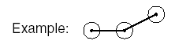
3. Provide an appropriate title for this graph.
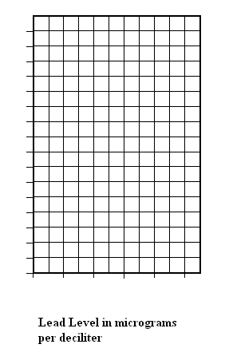
4. State one valid conclusion based on the information in this graph that relates
lead level in the blood to IQ.
______________________________________________________________
5. Identify the independent and dependent variables in this investigation.
______________________________________________________________
6. State a way to make the results of this investigation more valid.
______________________________________________________________
Use the following reading passage and your knowledge of biology to answer the questions which follow.
GET THE LEAD OUT
Researchers have recently determined that children scored better in intelligence tests after the amount of lead in their blood was reduced. This study offers hope that the effects of lead poisoning can be reversed. Lead poisoning can cause mental retardation, learning disabilities, stunted growth, hearing loss, and behavior problems. Scientists estimate that at least 3 million children in the United States have blood lead concentrations above the danger level of 10 micrograms per deciliter of blood. Researchers found an average increase of one point on an index scale for intelligence for every decrease of 3 micrograms per deciliter blood concentration. A common source of lead poisoning is peeling or chipping paint in buildings constructed before 1960. Also, soil near heavily traveled roads may have been contaminated by the exhaust from older cars burning leaded gasoline.
In another study, a group of researchers concluded that removing lead contaminated soil does not reduce blood lead levels enough to justify its cost. The children in the study began with blood levels 7 to 24 micrograms per deciliter. Replacing the lead contaminated soil resulted in a reduction in blood lead levels of 0.8 to 1.6 micrograms per deciliter in 152 children under the age of 4. This study is not conclusive, and more recent experimental work by other scientists does not support these results. This indicates a need for further studies to determine if reducing environmental lead levels will significantly reduce lead levels in the blood.
7. Besides learning disabilities, list three problems lead poisoning can cause
in children.
______________________________________________________________
______________________________________________________________
______________________________________________________________
8. State two things which can be done to reduce the amount of lead exposure
some children must face.
______________________________________________________________
______________________________________________________________
______________________________________________________________
9. Describe an example of a trade-off discussed in the reading passage.
______________________________________________________________
______________________________________________________________
______________________________________________________________
______________________________________________________________

Sample Answers for Practice Questions
Teacher Note: The information in the data table was obtained from a graphing tutorial at Florida International University. The data used in this exercise was posted on this website from a database from a long-term study that is open to the public. The database was created and maintained by the Coalition For Children's Health (CCH). The data presented below is part of a statistical sample from that database. It compares IQ as measured for 8 different first grade children by the Standardized Stanford-Binet IQ test with the amount of lead in each child's blood in micrograms per deciliter.
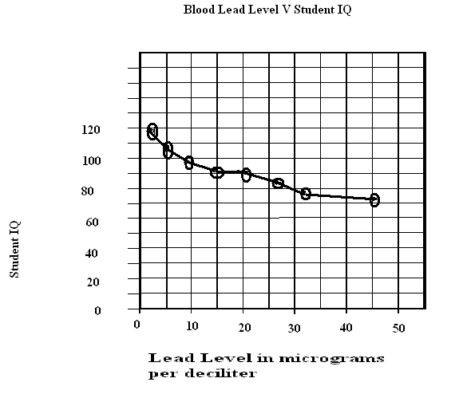
4. State one valid conclusion based on the information in this graph that relates
lead level in the blood to IQ.
As blood level increases, the IQ of the students decreases.
5. Identify the independent and dependent variables in this investigation.
The independent variable in this investigation is lead level in the blood. The dependent variable in this investigation is student IQ.
6. State a way to make the results of this investigation more valid.
Having more trials by gathering data from more students would make the results of this investigation more valid.
GET THE LEAD OUT
7. Besides learning disabilities, list three problems lead poisoning can cause
in children.
Acceptable answers include, but are not limited to:
-- mental retardation -- hearing loss
-- stunted growth -- behavior problems
8. State two things which can be done to reduce the amount of lead exposure
some children must face.
Remove lead contaminated soil near the home and remove peeling and flaking lead paint in the home.
9. Describe an example of a trade-off discussed in the reading passage.
Some researchers concluded that the slight reduction in blood lead levels by removing contaminated soil was not worth the great cost of removing the soil. (More recent experimental work does not support these researchers.) This is an example of a trade-off where risks and benefits are assessed.
New York State Learning Standards and Performance Indicators:
Standard 1: Living Environment Core Curriculum
PERFORMANCE INDICATOR 1.2 - Hone ideas through reasoning, library research, and discussion with others, including experts.
Major Understandings:
1.2a Inquiry involves asking questions and locating, interpreting, and processing
information from a variety of sources.

PERFORMANCE INDICATOR 2.1 - Devise ways of making observations to test proposed explanations.

Standard 4: Living Environment Core Curriculum
PERFORMANCE INDICATOR 2.1 - Explain how the structure and replication of genetic material result in offspring that resemble their parents.
Major Understandings:
2.1a Genes are inherited, but their expression can be modified by interactions with the environment.
PERFORMANCE INDICATOR 4.1 - Explain how organisms, including humans, reproduce their own kind.

Major Understandings:
4.1e Human reproduction and development are influenced by factors such as gene
expression, hormones, and the environment. The reproductive cycle in both males and females is regulated by hormones such as testosterone, estrogen, and progesterone.

4.1h In humans, the embryonic development of essential organs occurs in early stages of pregnancy. The embryo may encounter risks from faults in its genes and from its mother's exposure to environmental factors such as inadequate diet, use of alcohol/drugs/tobacco, other toxins, or infections throughout her pregnancy.

PERFORMANCE INDICATOR 5.2 - Explain disease as a failure of homeostasis.
5.2h Disease may also be caused by inheritance, toxic substances, poor nutrition, organ malfunction, and some personal behavior. Some effects show up right away; others may not show up for many years.

5.2j Biological research generates knowledge used to design ways of diagnosing,
preventing, treating, controlling, or curing diseases of plants and animals.
PERFORMANCE INDICATOR 7.2 - Explain the impact of technological development and growth in the human population on the living and nonliving environment.

Major Understandings:

7.2a Human activities that degrade ecosystems result in a loss of diversity of the living and nonliving environment. For example, the influence of humans on other organisms occurs through land use and pollution. Land use decreases the space and resources available to other species, and pollution changes the chemical composition of air, soil, and water.

PERFORMANCE INDICATOR 7.3 - Explain how individual choices and societal actions can contribute to improving the
environment.

Major Understandings:
7.3a Societies must decide on proposals which involve the introduction of new
technologies. Individuals need to make decisions which will assess risks, costs, benefits, and trade-offs.
7.3b The decisions of one generation both provide and limit the range of possibilities open to the next generation.
Appendix A - Laboratory Checklist Skills
-- Differentiates between independent and dependent variables
-- Identifies the control group and/or controlled variables
-- Collects, organizes, and analyzes data, using a computer and/or other
laboratory equipment
-- Organizes data through the use of data tables and graphs
-- Analyzes results from observations/expressed data

