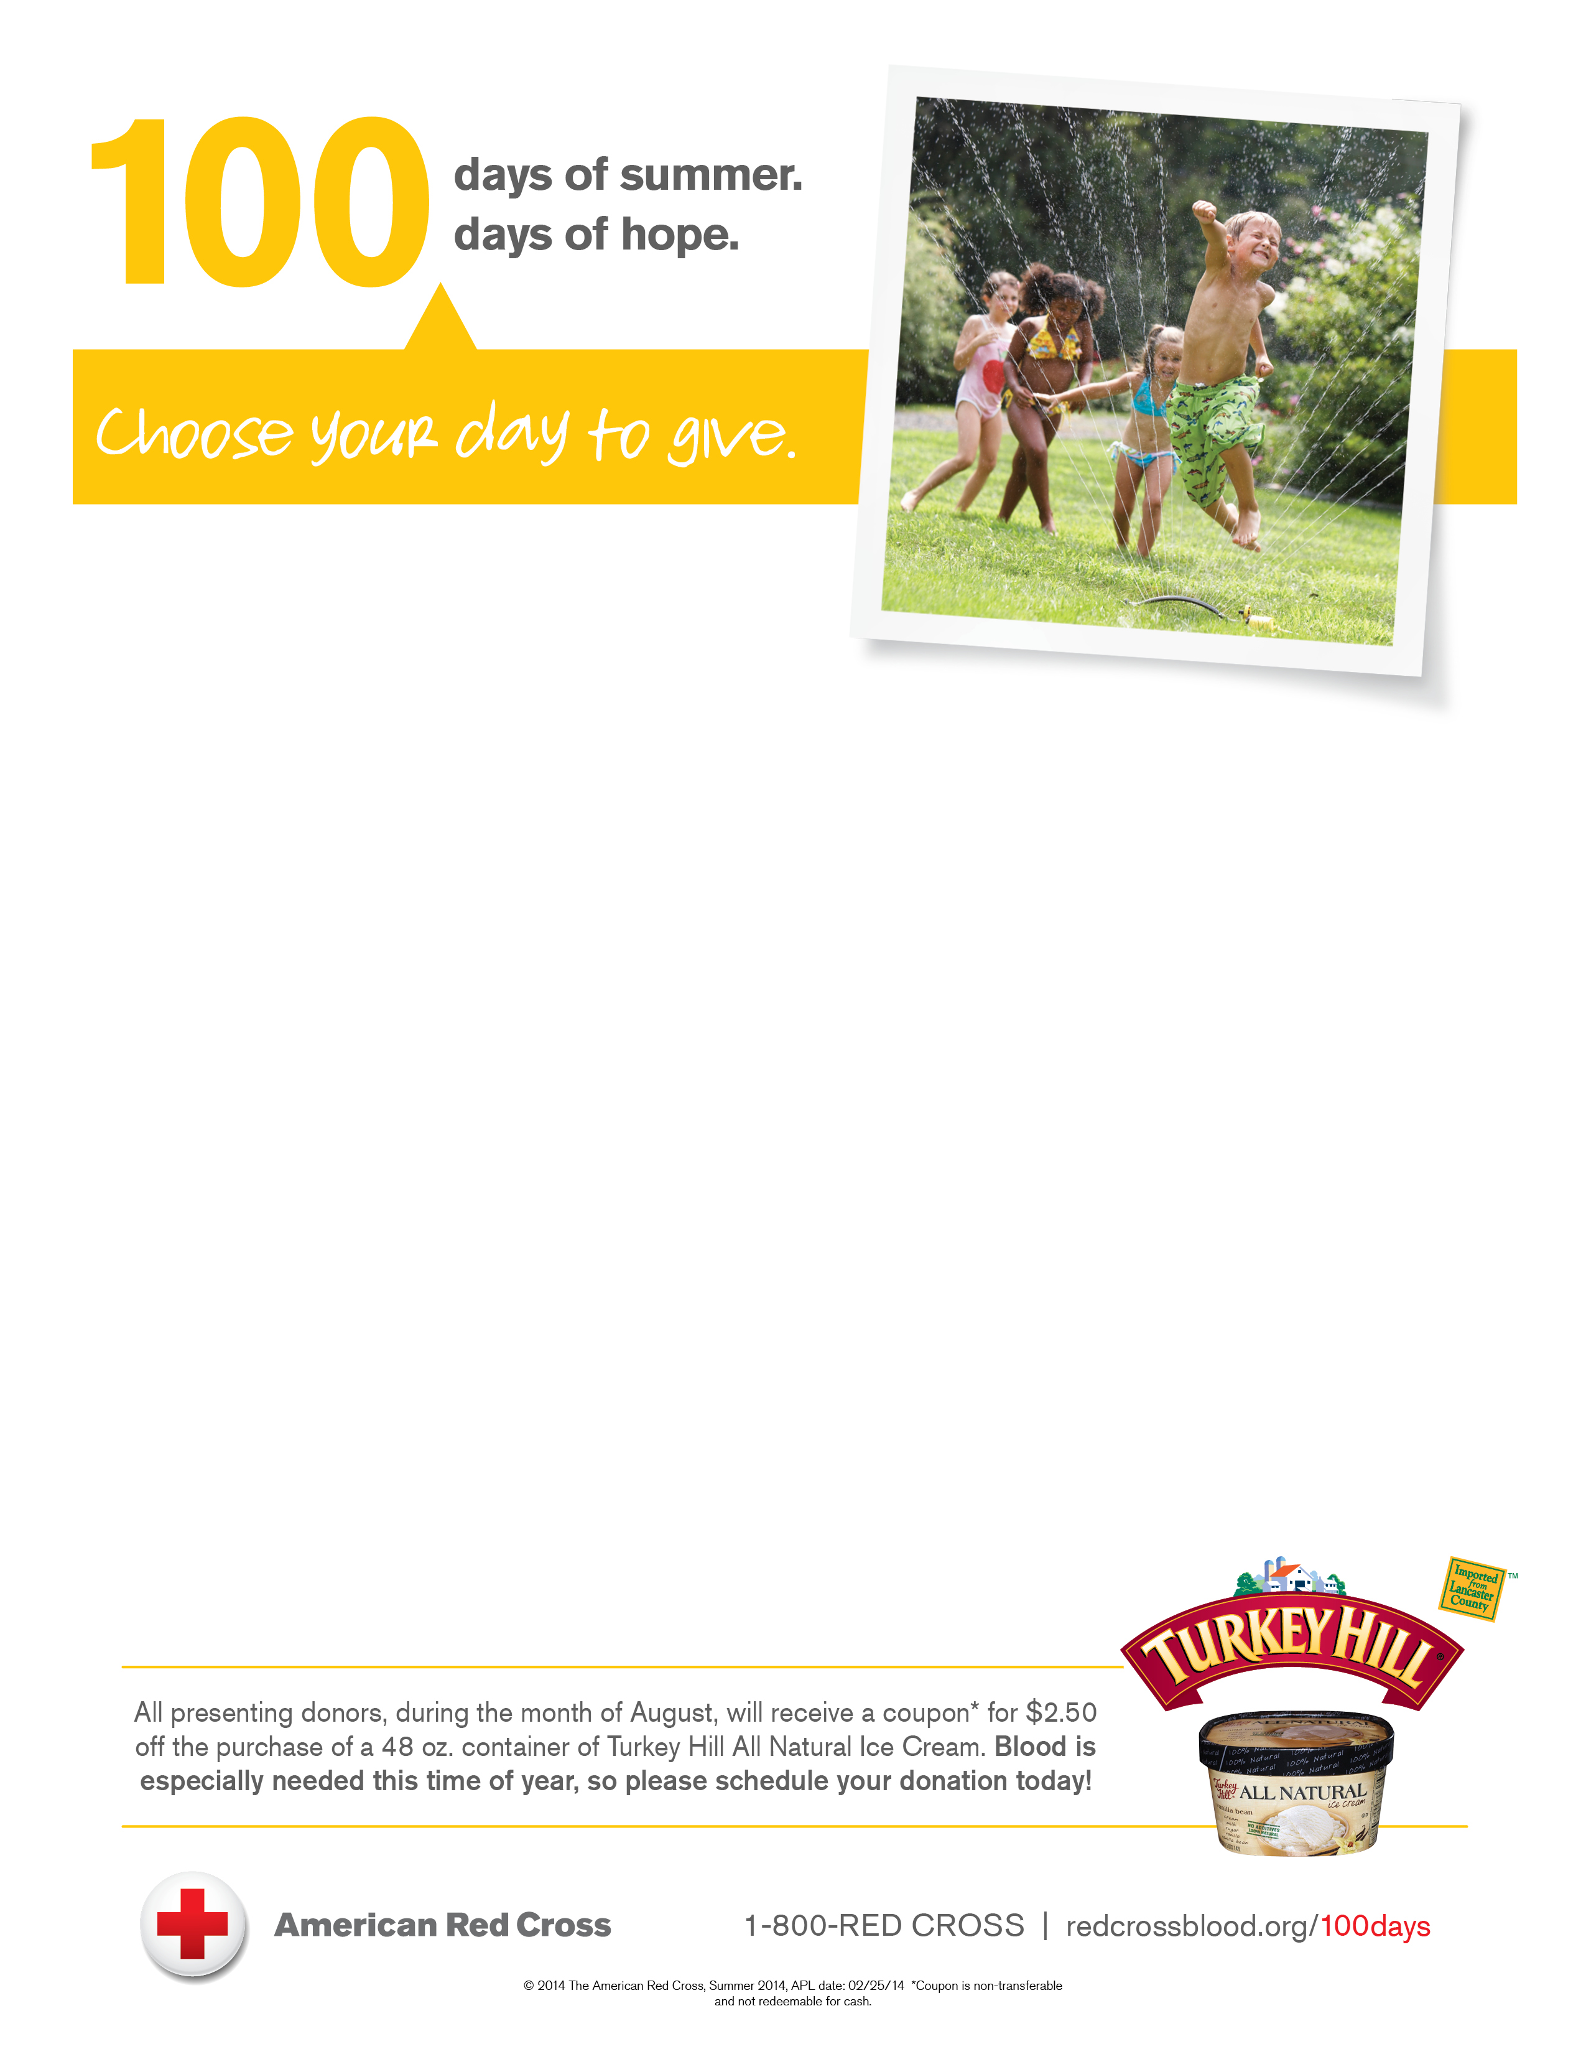
UNIVERSITY OF ROCHESTER
MEDICAL CENTER

BLOOD DRIVE

TUESDAY, AUGUST 12, 2014
9:00 AM – 5:00 PM
WEDNESDAY, AUGUST 13, 2014
8:00 AM – 4:00 PM
THURSDAY, AUGUST 14, 2014
8:00 AM – 4:00 PM
Located at Café 601 @ Strong

To schedule an appointment go to
REDCROSSBLOOD.ORG or CALL 1-800-REDCROSS

All presenting donors will receive ONE FREE movie ticket
or coupon for Finger Lakes Roaster Coffee!!!

If you donated on or before JUNE 17, JUNE 18, or JUNE 19,
you will be eligible to donate.

