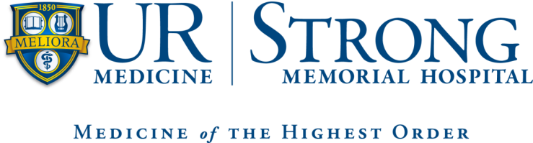

Advanced Practice Provider

Orthopedic Surgery

Fellowship Program Application

2024-2025
About UR Medicine
- Serves over 100,000 patients annually from the greater Rochester area.
- NP/PA will work with faculty with a wide variety of expertise in Orthopedics. Fellows will be on the cutting edge of health care delivery as they train to work within the University Of Rochester Medical Center Department Of Orthopedics.
Goal of the Fellowship Program
- It is anticipated that the fellows will show clinical growth, improved clinical confidence and increased preparedness to care for patients in all of these settings, by the completion of the fellowship.
- Our post graduate NP/PA Fellowship will provide additional skills training, as well as independent mentorship experience in the Orthopedic Department for the duration of 12 months.
- This will be an intensive clinical program which will prepare NP's and PA's to meet the needs of culturally diverse and clinically complex patients that are typical of the Orthopedic Department.
- Fellows will be employees of URMC and will comply with all patient care policies.
Training Methods
- Hands on training in all of the following areas:
In-patient orthopedic unit
Musculoskeletal radiology
Orthopedic Urgent Care
OR (Sawgrass, Highland Hospital, SMH)
Trauma
Sports
Hand
Foot/ Ankle
Spine
Metabolic Bone
Wound care/ Plastics
Pediatric Orthopedics
Adult Reconstruction
Training Methods
- Cadaver Lab Experiences
- Casting and splint labs
Required Certifications
- BLS
Program Outline
- Applications will begin to be accepted January 8th 2024
- Applications deadline: March 4th 2024
- Interviews conducted March 11th-April 8th 2024
- Application acceptance notification mid to late April 2024
- Projected program start date: September 2024
- 12 month program
Benefits
- Competitive Fellowship salary
- Health insurance coverage
- Dental insurance coverage
- Life insurance policy
- Disability insurance coverage
- 5 weeks vacation/year
- 1 week CME time/year
- $1250 CME annually (subject to change due to COVID-19)
- DEA coverage

The APP Fellow MUST meet the following qualifications:
- Nurse Practitioner
  - Master’s degree in Nursing
  - Active New York State licensure as Registered Nurse and Nurse Practitioner in good standing
  - Current national certification as a Nurse Practitioner (upon start of program)
- Physician Assistant
  - Completion of an AMA approved Physician Assistant program
  - Active New York State Physician Assistant licensure in good standing
  - Current national certification as a Registered Physician Assistant
Applicants for the Orthopedic APP Fellow position should demonstrate clinical competence as well as excellent verbal and written communication skills. The APP Fellow should have excellent customer relation skills, a passion for Orthopedic Medicine and an active desire to learn.
Application Process:
- Complete the on-line job application for the Orthopedic Department – Nurse Practitioner/Physician Assistant Fellow position located on the Human Resources/Office of Nursing Recruitment website:
  - http://www.rochester.edu/people/nursing

Helpful Hints:
- Our software works with a variety of web browsers including, Mozilla Firefox, Opera, and Safari. We recommend you use the most current version of these browsers since using old versions may create problems when applying for jobs. If you encounter any technical problems, applicants can contact our Help Desk at (585) ASK-URHR – (585) 275-8747, Mondays through Fridays, 8:00 am – 5:00 pm.
  - Please review the completed online application carefully – the system reads your resume and attempts to automatically populate your application for you, please ensure the information was populated correctly. If you encounter problems trying to upload your resume or cut and paste your resume you may want to manually complete the application and then forward your resume to NursingRecruitment@urmc.rochester.edu Both the application and resume are required to apply.
  - While answering the questions on the 4th page, the screen refreshes after each entry you make. Please go slowly and wait 5-10 seconds after each click to allow the page to refresh before answering the next question.
- Current University of Rochester Employees do not need to complete an online application. Simply forward your resume to NursingRecruitment@urmc.rochester.edu
- Use the side bar on left to navigate through the system (i.e. Job Search Tips)

- Please send the following items to the APP Orthopedic Fellowship Director, Garin Smith MPAS, PA-C
  - Current Resume or Curriculum Vitae
  - Official academic transcript to date
  - Submit 2 professional references:
    - Request a confidential recommendation from a Nurse Practitioner/Physician Assistant/Physician clinical preceptor during your academic program.
    - Request a confidential recommendation from a Faculty member from your academic program.
  - Letter of Interest:
    - Provide a letter of interest which reflects on your interest in the Orthopedic APP Fellowship program, your passion for Orthopedics and how this opportunity will impact your future as an Orthopedic APP. Please also comment on why you think this program will be a good fit for you.
- Completed applications for consideration for the 2024-2025 fellowship program are due by March 4th, 2024.
- Candidates will be contacted in March 2024 to arrange for interview
- Return complete application, references and transcripts to:
  - Garin Smith MPAS, PA-C
Garin_Smith@URMC.Rochester.edu
- Please e-mail Garin Smith MPAS, PA-C with any questions or concerns about this application and the application process.

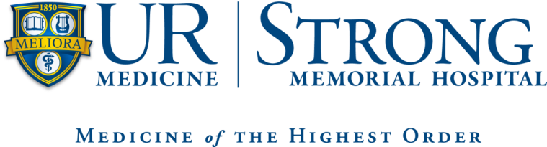

Orthopedic Advanced Practice Provider

Fellowship Program

Reference Form
Nurse Practitioner/Physician Assistant Program: ________________________________________________
Date:________________________
_________________________________ (name of applicant) has applied for a position in the Orthopedic APP Fellowship Program at Strong Memorial Hospital in Rochester, NY.
We would appreciate your evaluation of this applicant’s general ability and professional proficiency in academic and clinical practice. We would like to know what you consider the applicant’s strengths and weaknesses to be. You can be assured that all information will be treated confidentially.
Please be advised that all recommendations are to be completed confidentially and recommender should be provided an envelope to enclose their recommendation which must have a signature across the seal of the envelope and can be submitted with the application.

I hereby authorize the release of my academic/clinical record to Strong Memorial Hospital, Orthopedic Department.
Applicant Signature: _________________________________________
Applicant Printed Name: ______________________________________
******************************************************************************************
The above APP was a student in your academic/clinical setting during what period of time? ________________________
In comparison with the other students in the class, how would your rank this student academically?
Upper 10% ( ) Upper 25% ( ) Middle ( ) Lower 25% ( ) Lower 10% ( ) N/A ( )
In comparison with the other students you have worked with clinically, how would you rank this student clinically?
Upper 10% ( ) Upper 25% ( ) Middle ( ) Lower 25% ( ) Lower 10% ( ) N/A ( )

Please Rate the Applicant on the Following:

 | Above Average | Average | Below Average
Critical Thinking Skills

Organizational Skills

Leadership Potential

Flexibility/Adapts to Change

Professional Attitude

Clinical Competence

Appropriately selects and interprets diagnostic testing findings
Medical Decision Making Process

Demonstrates therapeutic communication with patients & families
Demonstrates professional communication with other professionals
Works in a collaborative fashion with health care team
Appropriate documentation

Procedural skills

Appearance/Grooming

Attendance/Punctuality

Overall Recommendation

Please include a statement about the applicant’s strengths/weaknesses and whether you feel this applicant will be a good fit for our Orthopedic APP Fellowship program. Please feel free to provide any additional comments.
Recommender Signature: _________________________________________________________
Recommender Title: _____________________________________________________________
Date: ____________________
Contact Information: ______________________________________________________________

