What in the w rld is going on???

You may hear adults say that we have to be quarantined 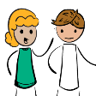 .

What does this mean?
Quarantine means that you have to stay at home and not go out.

It also means that your school and other things like after school programs or respite are closed.
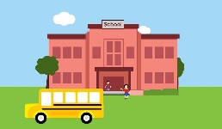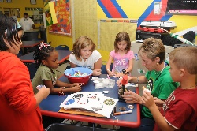

This may make you feel sad or frustrated because you enjoy doing these things.
While at home you can do fun things with your family. 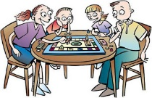

You could play games or do puzzles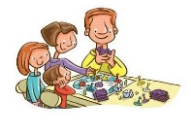

You might be able to go outside for a walk, play basketball in the yard, or play outside. If not, you can still exercise at home by doing activities like jumping jacks, sit ups, or push-ups. 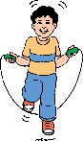

You can do all the things that you usually do while at home. 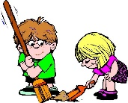

Adults are not sure how long you will have to stay at home, but they will tell me as soon as they know when I can go back to school.

While at home you should do your best to stay calm and follow your new schedule. 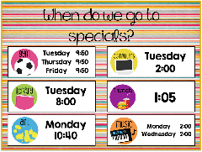

You’re doing great! Keep up the good work.

