iPhone Wifi Connectivity

For best performance with clinical applications while on-site at a URMC facility. It is recommended that your iPhone or Android be connected to UR_MCwireless5.

To make sure you are connected to UR_MCwireless5 go into IOS settings.

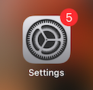

Select Wi-Fi

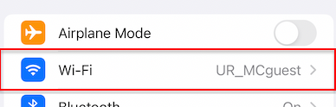

On the next screen you will see the current network connected to (UR_MCguest) and “My networks” (networks you have successfully connected to before) and “Other networks” (other networks within range that you could connect to if authorized). Select UR_MCwireless5 from where it appears in the list.

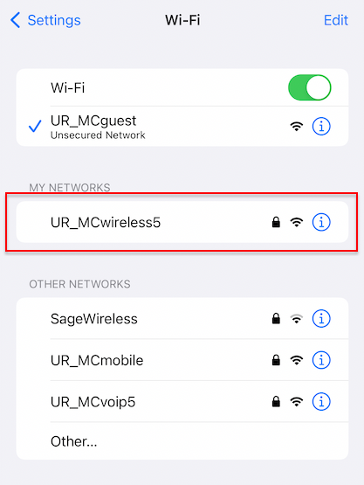

Next you will be prompted to sign in using your URMC username and password. This would be the same as what you use to sign into computers or eRecord. You may not be prompted if you have connected to the network before.

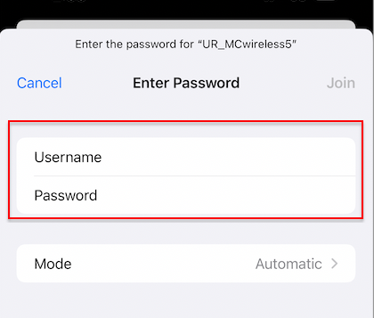

When successfully signed in you will be asked to trust a certificate. Just select Trust to move on. You will not be prompted for this if you have already signed in and trusted before.

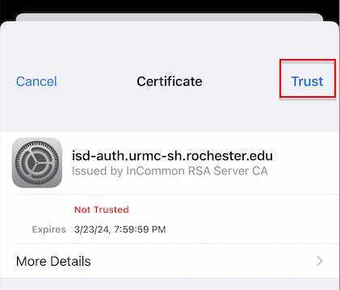

Back in settings under Wi-Fi you should now see a checkmark next to UR_MCwireless5 confirming you are connected.
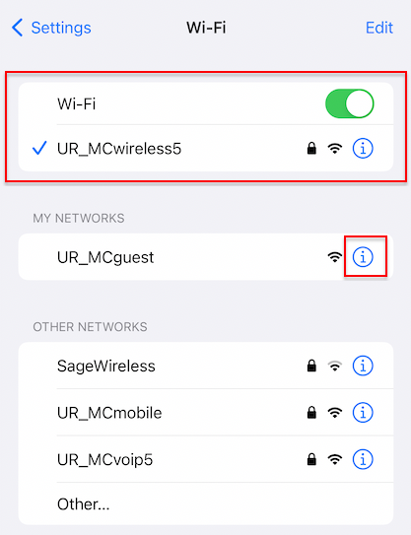

To make sure you don’t re-connect to UR_MCguest when at a URMC facility go back into Wi-Fi settings and find UR_MCguest from your “My Networks” list. Select the i symbol to the right (see above).

On the next screen select “Forget This Network” and deselect Auto-join

