POST-IT FLAG IDENTIFICATION

Flags stocked in animal housing rooms
PINK = cage contains newly-weaned mice on Hydropac pouch
NOTE: PI may use pink pre-printed Animal Resource card instead of flag
- PI places flag on the cage; DOB or weaning date must be written on the cage card
- Animal care staff pull labeled cages out daily and remove the flag after 14 days
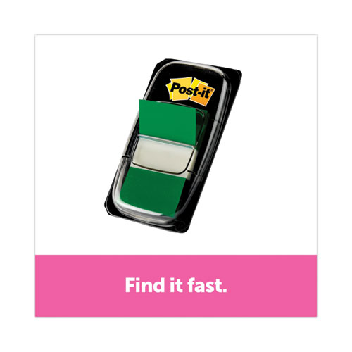
Green = special request submitted to Animal Resource Office
NOTE: PI may substitute request-specific, pre-printed Animal Resource card
- PI must place the flag on the cage
- If PI has multiple special requests, PI must write the Record ID # on flag
Blue = cage has been reported for overcrowding
- The date and information explaining the problem are written on the flag by Vivarium staff
- PI removes the flag after the indicated problem has been resolved
- PI must notify Animal Resource Office when problem is resolved
Yellow = cage has been reported to DCM for a health concern

Red = DCM has evaluated the animal/s; the cage is on clinical rounds
- PI may remove flag only if animal/s have been euthanized or if instructed to do so by DCM
Orange = cage contains diabetic animal/s
- PI should place flag on cage
- Vivarium staff will monitor closely for increased urine production and water consumption
BLACK = cage contains animal/s with chronic, long-term conditions
- the date and condition/s are written on the flag
- animal/s should be reported if the condition worsens, or a new condition is observed
PURPLE = Animal Resource managed colony
- Refer to UR Animal Resource SOP# V-99 for information
STICKERS

Special Request NOT Required
Stickers obtained by PI from Animal Resource Office

ACID WATER
Animals receive ACID WATER NOTE: alternate labeling is a salmon-colored cage card

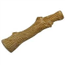 Cage receives a gnaw stick
TUMOR
Animal/s are expected to develop tumors

Animal/s have an osmotic pump
OSMOTIC PUMP

PUMP

Special Request Required Stickers obtained by PI from UCAR Office

ENRICH
SOLO

SINGLE HOUSED NO ENRICHMENT

ANIMAL RESOURCE CARD IDENTIFICATION
PI obtains from Animal Resource Office
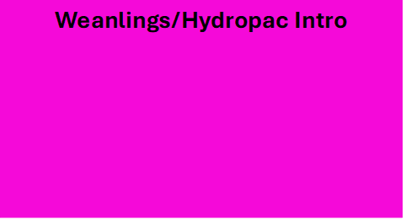
Cage contains newly weaned or new to Hydropac mice
- PI places card on cage
- PI writes DOB or weaning date on cage card
- Animal care staff pull cages out daily; remove card after 14 days

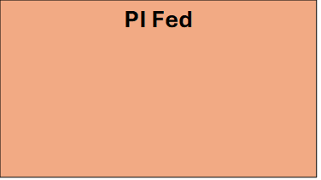
PI is providing food to the cage- SPECIAL REQUEST REQUIRED
- Refer to UR Animal Resource SOP# V-102 Investigator-Provided Husbandry Services for detailed labeling and documentation requirements
- Animal care staff check, water, and change cage; transfer food
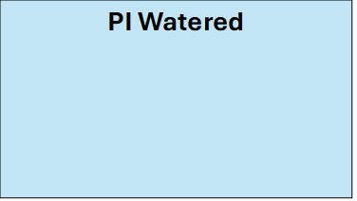
PI is providing water to the cage- SPECIAL REQUEST REQUIRED
- Refer to UR Animal Resource SOP# V-102 Investigator-Provided Husbandry Services for detailed labeling and documentation requirements
- Animal care staff check, feed, and change cage; transfer water

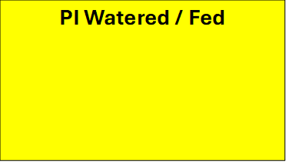
PI is providing water AND food to the cage- SPECIAL REQUEST REQUIRED
- Refer to UR Animal Resource SOP# V-102 Investigator-Provided Husbandry Services for detailed labeling and documentation requirements
- Animal care staff check and change cage; transfer food and water

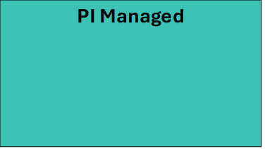
PI is providing water, food, AND cage change- SPECIAL REQUEST REQUIRED
- Refer to UR Animal Resource SOP# V-102 Investigator-Provided Husbandry Services for detailed labeling and documentation requirements
- Animal care staff check cage

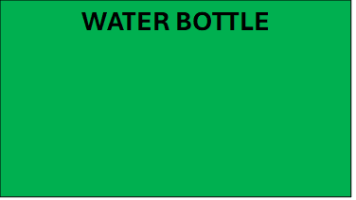
Cage is to receive a water bottle- SPECIAL REQUEST REQUIRED *additional charge may apply
- Refer to UR Animal Resource SOP# V-102 Investigator-Provided Husbandry Services for detailed labeling and documentation requirements

ANIMAL RESOURCE CARD IDENTIFICATION
PI obtains from Animal Resource Office

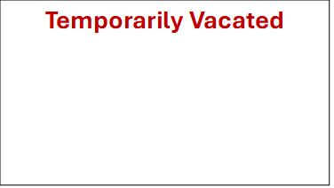
Cage is empty as animal is out for experiment or breeding

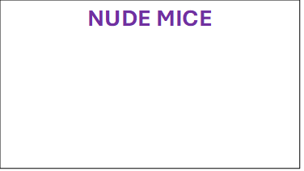
Cage contains nude mice
- Mice cannot be exposed to Nestlets
- Give cage 1 Enviropac as a substitute
- Cage receives standard red house unless a special request states otherwise

GIVE ENVIRO-PAK
NO NESTLET
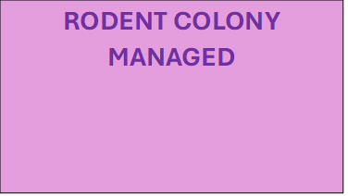
Animal Resource managed colony
- Refer to UR Animal Resource SOP# V-99 Animal Resource Rodent Colony Management for detailed information


A move form has been submitted requesting Vivarium staff move the cage
- Refer to UR Animal Resource SOP# V-18 Processing Special Requests and Move Forms by Animal Care Staff for detailed information

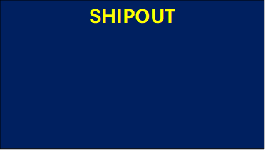
A shipout form has been submitted to export the cage out of the University

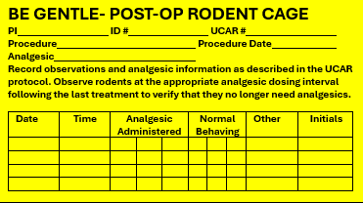
Animal/s have undergone a surgical procedure
- PI is providing analgesics and checking animals per UCAR protocol
- Vivarium staff use palm of hand or transfer tube to handle animal/s

ANIMAL RESOURCE CARD IDENTIFICATION
PI obtains from Animal Resource Office

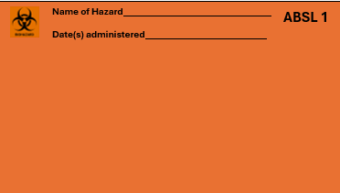
Cage contains animal/s exposed to an ABSL 1 hazard
- PI follows ABSL 1 hazard administration as detailed in their approved UCAR protocol and EHS letter
- For information on handling hazard-dosed cages, refer to UR Animal Resource SOP# V-58 Handling Hazard-labeled Soiled Cages and Bedding

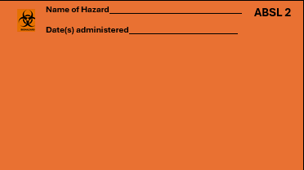
Cage contains animal/s exposed to an ABSL 2 hazard
- PI follows ABSL 2 hazard administration as detailed in their approved UCAR protocol and EHS letter
- For information on handling hazard-dosed cages, refer to UR Animal Resource SOP# V-58 Handling Hazard-labeled Soiled Cages and Bedding

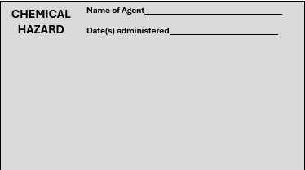
Cage contains animal/s exposed to a Chemical hazard
- PI follows chemical hazard administration as detailed in their approved UCAR protocol and EHS letter
- For information on handling hazard-dosed cages, refer to UR Animal Resource SOP# V-58 Handling Hazard-labeled Soiled Cages and Bedding

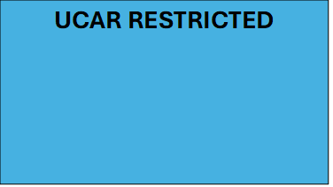
Cage/animal has been restricted by UCAR
- PI is restricted from handling all cages/animals marked with this card
- Vivarium staff continue to check, feed, water, and change cage

