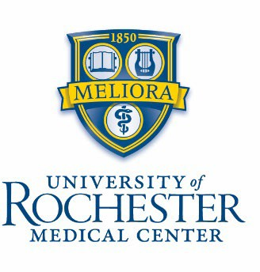
TENURE TRACK FACULTY POSITION DEPARTMENT OF BIOCHEMISTRY & BIOPHYSICS UNIVERSITY OF ROCHESTER MEDICAL CENTER

The Department of Biochemistry & Biophysics invites applications for a tenure-track position, preferably at the ASSISTANT PROFESSOR level. We are seeking outstanding candidates holding a PhD and/or an MD degree(s) and at least two years of post-doctoral training, with research interests in modern applications of biochemistry and biophysics to significant problems in health and disease across any groups within society, without regard to age, gender, or genetic background. Applicants with interests in any area of biochemistry and biophysics are encouraged to apply, especially those employing structural and/or computational methods, and those using genomic and/or metabolomic approaches. The successful applicant will be expected to develop an independent, externally funded research program and to contribute to graduate and medical school teaching.
The University of Rochester Medical Center and the adjacent College of Arts, Sciences and Engineering comprise a world-class research campus, providing excellent opportunities for interactions and collaborations, with numerous programs to encourage summer and academic year research among undergraduates and students from underrepresented backgrounds, and several programs focused on fostering diversity, equity, and inclusion. The department offers an outstanding research environment with established strengths in RNA biology, structural and functional characterization of molecular interactions, computational biology, genomics, biophysical chemistry, and metabolomics. In addition, the department has an outstanding record of mentoring young faculty and trainees.
The Rochester, NY area is an exceptional place to live, featuring highly affordable housing, many local parks and recreation areas, several outstanding school districts, close proximity to Lake Ontario and several of the Finger Lakes, and excellent cycling and hiking trails.
Candidates should apply through Interfolio by following this link: https://apply.interfolio.com/151007. Please submit a cover letter; a curriculum vitae; a 3-page summary of research accomplishments and future research plans; and a description of mentoring philosophy related to advancing equity, diversity, and inclusion. In addition, applicants should also arrange for three letters of recommendation to be submitted by referees through the Interfolio link, or by email to Susan Muscato-Smith (susan_muscatosmith@urmc.rochester.edu). For full consideration, applications should be submitted by November 15, 2024, although applications will be accepted after this date until the position is filled.

