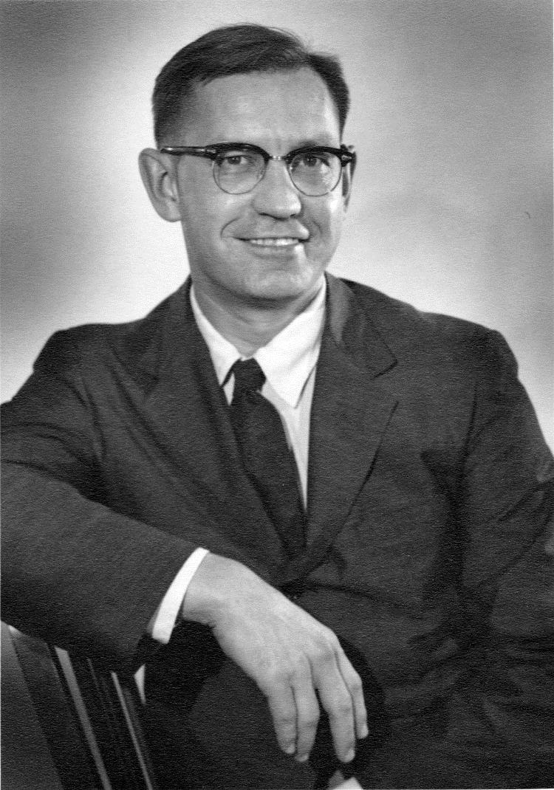
William F. Neuman PhD
https://www.atomicheritage.org/profile/william-f-neuman https://www.urmc.rochester.edu/biochemistry-biophysics/awards/neuman-award.aspx
https://www.nytimes.com/1981/01/06/obituaries/dr-william-f-neuman-authority-on-bone-tissue.html

Bill Neuman got his degree in 1942 at the University of Rochester in the laboratory of Harold Hodge PhD. He became head of the biochemistry section of the Atomic Energy Project, eventually becoming the co-director of the program and co-chair of this large department with Aser Rothstein. He published more than two hundred publications, including a landmark text with his wife Dr. Margaret Neuman with whom he collaborated in many endeavors. Margaret Neuman (1917-2015) was the first PhD in Pharmacology from the University of Rochester, publishing more than 30 papers and a book:

Neuman, William F.; Margaret W. (1958). The Chemical Dynamics of Bone Mineral. Chicago: The University of Chicago Press. ISBN 0-226-57512-8. [1]

Bill made a wide variety of seminal contributions to bone biochemistry of bone seeking isotopes, osteoblasts and osteoclasts, and vitamin, mineral and hormonal regulation of bone homeostasis. There were multiple important foci of interest, including
- parathyroid hormone [2-35]
- uranium [36-54]
- strontium e.g. [55, 56] (note senate hearings)
- beryllium [57-65]
- thorium [66]
- yttrium [67]
- vitamin D [18, 20, 68-73]

He was radiological monitor for the Bikini bomb tests, represented the Atomic Energy Commission in visits to European installations in 1952, and was scientific adviser to the State Department at the 1955 Geneva Conference on
Atoms for Peace. [74] He received the Eli Lilly award in 1955 for research in biochemistry, the Claude Bernard Medal of the University of Montreal in 1962, the Kappa Delta research award of the American College of Orthopedic Surgeons in 1964 and the Mineralization award from the International Association for Dental Research in 1965. The American Society for Bone and Mineral Research recognized his accomplishments by establishing the William F. Neuman Award in 1981.

A subsequent Neuman award recipient, Herbert Fleisch MD , was a 1962 postdoctoral fellow and collaborated with Bill for two decades, including a sabbatical at the University of Berne. They studied inhibitors of mineralization in bodily fluids led that led to work on polyphosphate inhibition of hydroxyapatite crystal growth [75] and the eventual development of bisphosphonates as medications [76-85].
Radioactive Fallout and the nuclear test ban treaty
The Atomic Energy Project had an intense focus on describing the toxic hazards of nuclear weapons manufacture including the toxicokinetics of the radionuclides, new hazards about which nothing was known but were being spewed into the atmosphere during atmospheric testing. Bill testified before the Joint Congressional Subcommittee on Atomic Energy in 1957 [86] and 1959 [87], scholarly work with a major focus on strontium 90 that eventually led to the nuclear test ban treaty in 1963. Bill argued repeatedly that

“Our ignorance in this field is so great that we cannot say with any certainty that we have not already put so much strontium-90 into the stratosphere that harmful fall-out is now inevitable.”

Test Moratorium Extended; Geneva Negotiations Analyzed in Senate
A glimpse into what confronted mankind at the time appeared in the January 1958 Bulletin of the Atomic Scientists is a special volume on Radiation and Man . He contributed two of the articles: Somatic Effects of Fission Products [88] and Uncertainties in Evaluating Effects of Fall-out from Weapons Tests [89] .

Convinced that the public needed to know, he wrote extraordinary public outreach articles:

- Why nuclear bomb tests must cease. Unitarian Register 136:6, 1957. (Bill was a trustee of the First Unitarian Congregational Society of Rochester.) [74]

“…Atom testing is immoral
How does the atom-testing program improve our true defense? I can only conclude it is quite impractical.
And it is immoral. The radioactive ashes that we scatter into the air fall to earth and concentrate in the bones of growing children. Children will be the first to show ill effects from fall-out. Not only our children are exposed, but children all over the world - irrespective of nationality, color, or creed.
We all thrill at the self-sacrifice of our forefathers in the causes of liberty and freedom. Will future generations thrill at the stories of how we valued freedom and liberty so highly that we were willing to risk injury to the world's children?
Here is an immoral act of truly great proportions. If we choose to destroy ourselves - all well and good. If we choose to pollute our own cities, towns, and fields - well and good. But have we the right, in our own self-interest, to pollute the atmosphere of the world? Has any one nation such a right?
If we stop testing now, little harm can have been done. But if we contribute, by word and deed, to the continuance of this pollution of the biosphere, we shall be held responsible in the judgment of all nations, in the eyes of the injured and malformed children, in the memories of the dead.
I propose for these reasons and for reasons unsaid that the United States join other nations in pressing for an international ban on nuclear tests. The chance to lead, to initiate, has already slipped away.
I propose that every conceivable effort be made to reach agreements on disarmament. No nation on earth can carry the economic burden of an arms race. In this area, we cannot afford to be headstrong and militant. Of course we can do everything better than the Russians. We can outbuild them. We can even knock ourselves out better than they can. Literally.
I feel that we should do all we can to create under UN jurisdiction a police force powerful enough to meet armed aggression anywhere in the world. Until such a force is available, we should rely less on atom weapons, more on a highly mobile, professional police force of our own. We should place more emphasis on interception and on truly defensive measures -on civilian defense.

“…The long-range problem
Over-riding these important problems is the battle for men's minds, the minds of uncommitted millions the world over. We must:
- Clean house at home. Freedom and opportunity must be available to all. Integration must be made a reality, not a dream.
- We must improve our educational system. Our hope for the future lies in our children. We will need more and better scientists and engineers. More sociologists, economists. More thinkers.
- We need to embark, on an unprecedented scale, to promote cultural exchange with the non-western world; economic aid in the form of men, money and equipment to backward economies to help themselves, help them build schools, and train teachers. Encourage free trade….”

- To test or not to test. New Republic 138: 17, 1958 [90]
“…Tests are clearly immoral, are clearly hazardous (though not frighteningly so), and are instrumental in increasing the likelihood of global conflict because they serve to increase the pace of a fantastic arms race. For these reasons, all good men can hope that our elected government will show the good sense to strive to bring these tests under an international control with adequate safeguards. The world today needs a program of action, of workable ideas by which the march toward near-global suicide can be averted (Teller and Latter’s book) Our Nuclear Future does not offer such a program….”

- 23 Went Fishing. New Republic 138:20, 1958 [91]
“…Plagued by engine trouble, storms, loss of fishing lines and poor catches, the fishermen worked their way "across thousands of miles of the vast Pacific to [their] date with destiny near a tiny atoll." There, through a caprice of nature, an unexpected shift of wind, the trawler was thoroughly dusted with intense fallout from the superbomb exploded almost ninety miles away by the Atomic Energy Commission in cooperation with the US Armed Services…
“…The moral of the fishermen's story is that war must be banned. But how many more "fishermen" will become dusted with ""Shi No Hai" before men, in sufficient numbers to break the web of fate, are moved to action? …”

- Fallout Fable: Thus spake the magician. New Republic 138:8, 1959 [92] The fable concludes:
“…The man who wielded the sword unwisely does not suddenly become wise when given a more powerful weapon. On the other hand, the hazards to man of oobleck (fallout) cannot be judged. With several kingdoms causing oobleck to fall, who in one kingdom can say how much oobleck will come from the several? We do not know how oobleck makes men sick and, therefore, also we know not how much oobleck will cause how much harm. To choose a road of unknown dangers which returns again to the starting place, is an action born of compulsion, the folly of an animal devoid of wit." "Is it not strange," thought the archeologists, "that a people having such wise and perceptive writings should have vanished from the earth?"

- A sponsor of SANE, National Committee for a Sane Nuclear Policy

There was intense internal controversy about the use of scientific programs of the agency in support of nuclear weapons development. This was captured by Dr. Neuman, quoted on page 665 of the Final Report of the Advisory Committee on Human Radiation Experiments in correspondence between Dr. Neuman and Dixie Lee Ray, the last AEC chairman in which he captured internal opposition during the Eisenhower administration to providing “…biological justification for some other agency’s political decision… (and hence their responsibility to) … convince the public that fallout was good for them and environmental Sr-90 contamination was accordingly expressing in ‘Sunshine Units’ if you recall…” The internal disquiet dissipated with the passage of the Nuclear Test Ban Treaty:

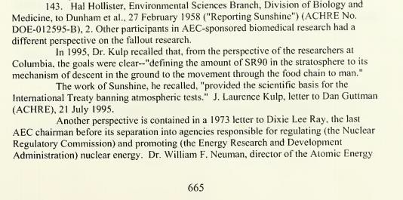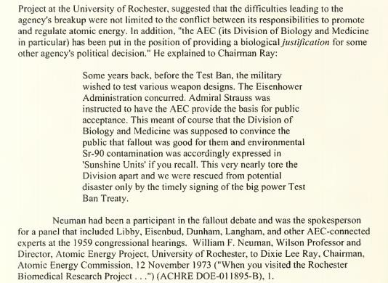

Bill was a member of a team of scientists that studied the effects of space flight on the muscles and bones of the astronauts Frank Borman and James A. Lovell Jr. during the 14-day flight of Gemini 7 in 1965. [93, 94]

Development of two pioneering graduate degree programs
There was a national shortage of talent in industrial hygiene, health physics, and toxicology and training personnel emerged as a national priority. The nation’s first toxicology training program was established at the University of Rochester during his tenure, evolving into the division of toxicology and eventually the department of environmental medicine. The NIEHS-funded Toxicology training program continues to this day, and is an active component of the NIEHS Environmental Health Sciences Center. The nation’s first degree program in Radiation Biology also was established in this interval. Dr. Neuman captured the first three decades of the Department of Radiation Biology and Biophysics in his chapter in To Each His Farthest Star [95].

Sustained work at Rochester in the interest of national security from World War II to the present day
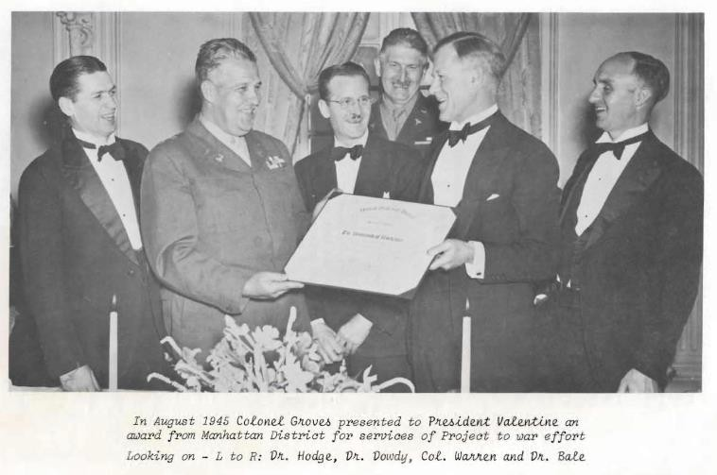
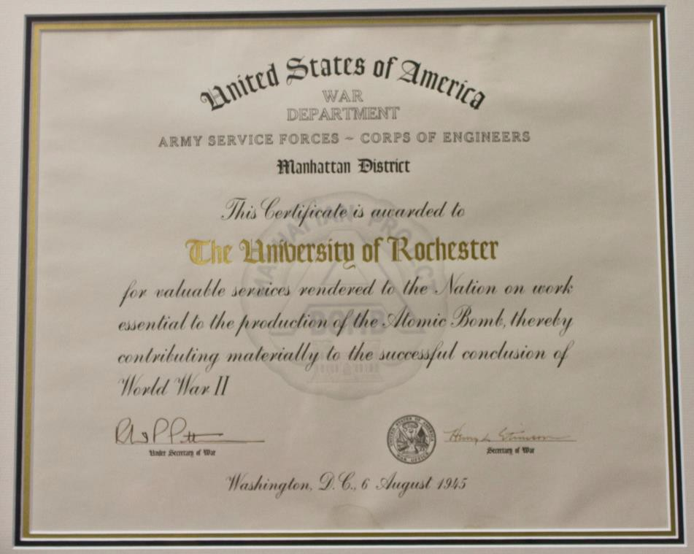

1919 | George Hoyt Whipple appointed Dean  UCSF (Berkley and SF)
1920 | Flexner and Rush Rhees approach George Eastman with a plan for a new medical school and hospital | 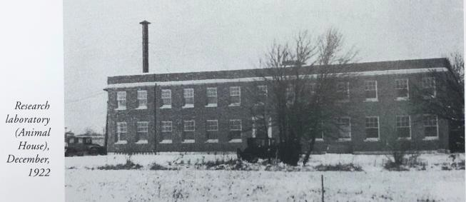  https://www.urmc.rochester.edu/about-us/history-of-urmc.aspx
1921-1922 | Whipple recruited as first Dean; Whipple moves laboratory animals from California to first building | Pp 379-380 [96]
1925 | Hospital opens | https://www.urmc.rochester.edu/about-us/history-of-urmc.aspx
1922-1931 | Roentgen irradiation dog studies by Whipple and Stafford Warren | [97-104]
1929-1930 | E. O. Lawrence invents cyclotron at UC Berkley | Nobel Prize in Physics 1939
1934 | Whipple Nobel Prize  Rush Rhees brings Lee A. DuBridge to Rochester as first chair of physics. EO Lawrence suggests DuBridge build a cyclotron… | https://www.aip.org/history-programs/niels-bohr-library/oral-histories/4583
1936 | DuBridge and Barnes cyclotron operational | http://www.rochester.edu/pr/releases/phys/mand.htm
1937-1939 | Radioactive iron experiments commence by P. F. Hahn, W. F. Bale, E. O. Lawrence, and GH Whipple | [105, 106]
1941-1942 | Wallace Osgood Fenn uses potassium isotopes from UR cyclotron | [107, 108]
1942 | Million volt Xray facility in new A wing to examine castings for armed forces | 9700 square feet

February-March 1943 | Kodak VP invites Stafford to lunch at Rochester Club with General Groves  Rochester Manhattan Project commences | “… The primary reasons for choosing Rochester as a  research center were that Drs. George Whipple and Stafford Warren had done pioneer work on the injurious effects of X-rays in dogs some 15 years previously and that early applications of cyclotron-produced radioactive isotopes to biological problems had been made in the Medical School, especially through the efforts of Dr. William Bale who had developed the necessary instrumentation. The new program in Rochester was called the Manhattan Project, a name designed to conceal  its mission, which was very highly classified in those days, and a name already adopted by the Manhattan District for the same reason….”[109]
June 2 -  September 1943 | B Wing (the Annex) constructed | 15,000 square feet
November 3,  1943 | Dr. Warren commissioned Colonel and appointed Chief of the Medical Section of the Manhattan District with headquarters in Oak Ridge., Tennessee. Dr. Andrew Dowdy succeeds Warren as head of Project. | “… In its service function the Rochester group analyzed the periodic reports on medical examinations of personnel in the Manhattan District plants all over the country. It also advised these plants on how to protect their employees by: (a) determining "tolerance standards" for exposure to radiation and toxic chemicals; (b) developing instruments to measure exposure; (e) measuring intensities of radiation and concentrations of toxic dusts in plants; and (d) suggesting measures to make operations safer..”[109]
1944 | C-Wing constructed | 19,000 square feet
1946 | Division of Pharmacology transferred from Biochemistry to Manhattan Project | Dr. Harold Hodge, Director
January 1, 1947 | Atomic Energy Commission takes control, Rochester activity renamed Atomic Energy Project (AEP)
January 1948 | Henry Blair appointed chair of the new Department of Radiation Biology and Director of AEP | Fellowship program in Health Physics inaugurated.
1949-1950 | Industrial medicine | AEC fellowship; program in collaboration with Eastman Kodak and other industries
1958 | Department of Pharmacology formed from Division | Dr. Harold Hodge, Chair  Industrial Medicine moved to Dept. of Preventive Medicine
1960 | O- Wing (6700) constructed | 53,000 square feet

1961 | Index of reports and publications by the University of Rochester Atomic Energy Project [110] | Index of declassified and unclassified work of the  University of Rochester Atomic Energy Project from its beginning in 1943 until July 1960. Contains titles of the work described in Manhattan District and Atomic Energy Commission reports as well as of material published in books and journals.
1962 | Third floor added to B-Wing
June 1965 | Drs. William F. Neuman and Aser Rothstein succeed Blair on his retirement as co-chairs and co-directors
1966 | OO-Wing (6800) constructed  Toxicology Graduate Program commences  Reports continue with UR report numbers acknowledging AEC/ERDA/DOE contracts through late 1970s, overlapping with the creation of the Laboratory for Laser Energetics.  (exact termination date TBD) | By 1967, a total of 160,000 square feet.  All additions were built by the Atomic Energy Commission.
1970 | The Laboratory for Laser Energetics (LLE) of the University of Rochester is a unique national resource for research and education in science and technology. LLE was established in 1970 as a center for the investigation of the interaction of intense radiation with matter.  The Department of Energy’s National Nuclear Security Administration funds LLE as part of its Stockpile Stewardship  Program. | http://www.rochester.edu/news/show.php?id=2153 http://www.lle.rochester.edu/timeline/

University research infrastructure enhancements from AEC/ERDA/DoE prior to 1970

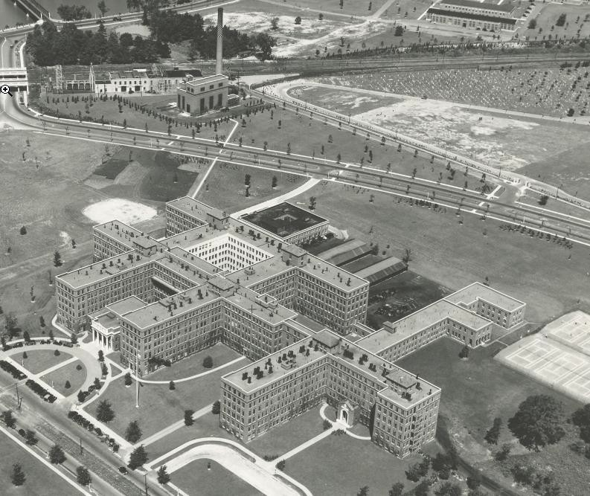
Aerial view of medical center 1931. Low building with black roof is the first medical center building, the animal house for laboratory animal colony of Dr.
Whipple, moved from UCSF/UC Berkely

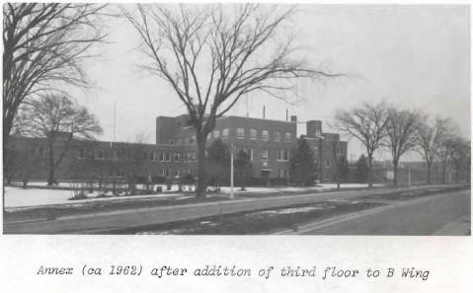
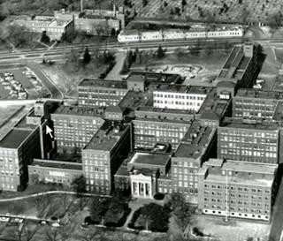
The triangular land bordered by the power plant, cemetery, and Elmwood Avenue was developed as the Manhattan Project (Annex Wings A,B,C). Wing A (left) was built a year earlier to accommodate a million volt X-ray instrument for inspection of military castings.
After WWII, high voltage source was mothballed and space used for project photography and illustration studio before repurposing as 9.4T MR preclinical imaging facility.

1967 Aerial photograph shows footprint of AEP after AEC construction of O Wing (top right), before OO wing construction

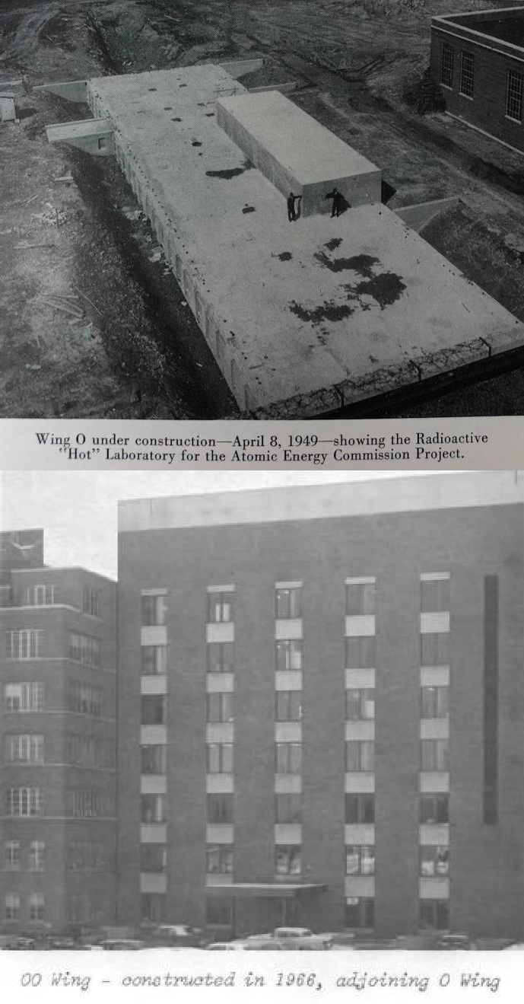
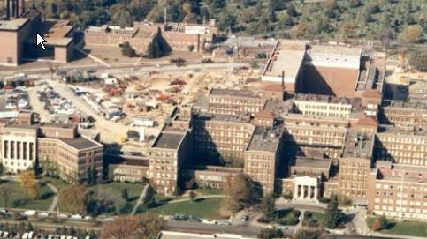
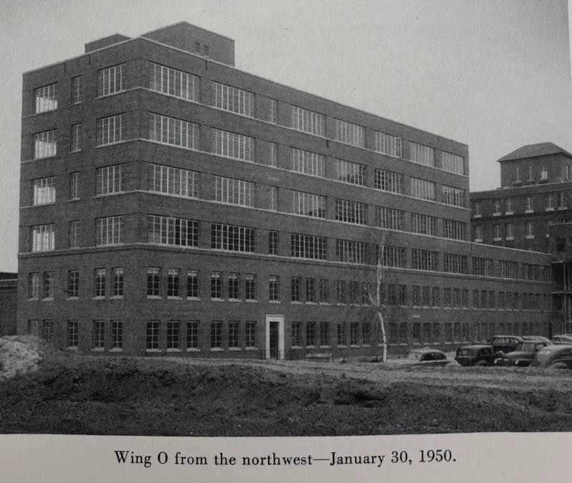
Foundation of 0-Wing during construction Cesium source location, adjacent to tunnel excavation crossing Elmwood Avenue. Vault for Cobalt 60 source constructed off tunnel under parking lot. Source failed to return to enclosure on first pneumatic activation, required robotic intervention and removal by Oak Ridge years later.

1967 aerial photograph was taken as construction of the education (S) wing was getting underway. The Radiation Oncology clinical operation was built in the courtyard between O and GG wings; note there was no construction over this courtyard facility. GG wing adjacent to OO was built as a new animal research facility

References
- Neuman, W.F. and M.W. Neuman, The chemical dynamics of bone mineral. 1958, Chicago: University of Chicago Press. 209 p.
- Neuman, W.F., et al., On the Mechanism of Action of Parathormone. Journal of the American Chemical Society, 1956. 78(15): p. 3863-3864 <Go to ISI>://WOS:A1956WB83800089
https://pubs.acs.org/doi/pdfplus/10.1021/ja01596a088.
- Firschein, H., et al., Concerning the Mechanism of Action of Parathyroid Hormone-I Ion-Gradients. Journal of the American Chemical Society, 1958. 80(7): p. 1619-1623 <Go to ISI>://WOS:A1958WB38200028
https://pubs.acs.org/doi/pdf/10.1021/ja01540a028.
- Firschein, H.E., et al., Mechanism of Action of Parathyroid Hormone. Federation Proceedings, 1958.
17(1): p. 219-219 <Go to ISI>://WOS:A1958WP93600865.
- Martin, G.R., et al., Concerning the Mechanism of Action of Parathyroid Hormone .2. Metabolic Effects. Journal of the American Chemical Society, 1958. 80(23): p. 6201-6204 <Go to ISI>://WOS:A1958WB39800014
https://pubs.acs.org/doi/pdf/10.1021/ja01556a014.
- Neuman, W.F., The mechanism of parathyroid function. J Lancet, 1958. 78(5): p. 190-6 https://www.ncbi.nlm.nih.gov/pubmed/13525858.
- Firschein, H.E., et al., Studies on the Mechanism of Action of the Parathyroid Hormone. Recent Progress in Hormone Research, 1959. 15: p. 427-454 <Go to ISI>://WOS:A1959WN14900013.
- Neuman, W.F., Experimental biology of the parathyroid secretions. Acta Endocrinol Suppl (Copenh), 1960. 34(Suppl 50): p. 109-12 https://www.ncbi.nlm.nih.gov/pubmed/14479205.
- Terepka, A.R., C.M. Dowse, and W.F. Neuman, Unifying concepts of parathyroid hormone action. UR Rep, 1960. UR-577: p. 1-28 https://www.ncbi.nlm.nih.gov/pubmed/24546289.
- Neuman, W.F. and C. Overslaugh, The effects of parathyroid hormone on phosphate transport. ORINS Rep US At Energy Comm, 1961. UR-589: p. 1-13 https://www.ncbi.nlm.nih.gov/pubmed/15445256.
- Borle, A.B., H.T. Keutmann, and W.F. Neuman, Role of parathyroid hormone in phosphate transport across rat duodenum. Am J Physiol, 1963. 204: p. 705-9 https://www.ncbi.nlm.nih.gov/pubmed/14013996
https://www.physiology.org/doi/pdf/10.1152/ajplegacy.1963.204.4.705.
- Egawa, J. and W.F. Neuman, Effects of Parathyroid Hormone on Phosphate Turnover in Bone and Kidney. Endocrinology, 1963. 72(3): p. 370-+ <Go to ISI>://WOS:A19631303B00007
https://academic.oup.com/endo/article-abstract/72/3/370/2703009?redirectedFrom=fulltext.
- Egawa, J. and W.F. Neuman, Effect of Parathyroid Extract on the Metabolism of Radioactive Phosphate in Kidney. Endocrinology, 1964. 74: p. 90-101 https://www.ncbi.nlm.nih.gov/pubmed/14114675
https://academic.oup.com/endo/article-abstract/74/1/90/2702404?redirectedFrom=fulltext.
- Borle, A.B. and W.F. Neuman, Effects of Parathyroid Hormone on Hela Cell Cultures. J Cell Biol, 1965. 24: p. 316-23 https://www.ncbi.nlm.nih.gov/pubmed/14326116
http://jcb.rupress.org/content/jcb/24/2/316.full.pdf.
- Sammon, P.J., et al., Metabolism of labeled parathyroid hormone. I. Preparation of biologically active I-125-labeled parathyroid hormone. Endocrinology, 1973. 92(6): p. 1596-603 https://www.ncbi.nlm.nih.gov/pubmed/4707255
https://academic.oup.com/endo/article-abstract/92/6/1596/3041580?redirectedFrom=fulltext.
- Sammon, P.J., et al., Metabolism of Parathyroid-Hormone. Journal of Dental Research, 1974. 53(Feb):
p. 118-118 <Go to ISI>://WOS:A1974S159900253.
- Neuman, M.W., W.F. Neuman, and K. Lane, The metabolism of labeled parathyroid hormone. VII Attempts to modify hormone deposition. Calcif Tissue Res, 1975. 19(3): p. 169-78 https://www.ncbi.nlm.nih.gov/pubmed/1212631.

- Neuman, M.W., W.F. Neuman, and K. Lane, The metabolism of labeled parathyroid hormone. VI. Effects of vitamin D status. Calcif Tissue Res, 1975. 18(4): p. 289-95 https://www.ncbi.nlm.nih.gov/pubmed/1182584.
- Neuman, M.W., W.F. Neuman, and K. Lane, Metabolism of Labeled Parathyroid-Hormone .7. Attempts to Modify Hormone Deposition. Calcified Tissue Research, 1975. 19(3): p. 169-178 <Go to ISI>://WOS:A1975BB74200001
https://link.springer.com/content/pdf/10.1007%2FBF02564001.pdf.
- Neuman, M.W., W.F. Neuman, and K. Lane, Metabolism of Labeled Parathyroid-Hormone .6. Effects of Vitamin-D Status. Calcified Tissue Research, 1975. 18(4): p. 289-295 <Go to ISI>://WOS:A1975AV84100005
https://link.springer.com/content/pdf/10.1007%2FBF02546247.pdf.
- Neuman, W.F., et al., Metabolism of Labeled Parathyroid-Hormone .5. Collected Biological Studies.
Calcified Tissue Research, 1975. 18(4): p. 271-287 <Go to ISI>://WOS:A1975AV84100004 https://link.springer.com/content/pdf/10.1007%2FBF02546246.pdf.
- Neuman, W.F., et al., The metabolism of labeled parathyroid hormone. IV. Autoradiographic studies.
Calcif Tissue Res, 1975. 18(4): p. 263-70 https://www.ncbi.nlm.nih.gov/pubmed/1182582.
- Neuman, W.F., et al., Metabolism of Labeled Parathyroid-Hormone .4. Autoradiographic Studies.
Calcified Tissue Research, 1975. 18(4): p. 263-270 <Go to ISI>://WOS:A1975AV84100003 https://link.springer.com/content/pdf/10.1007%2FBF02546245.pdf.
- Neuman, W.F., et al., Metabolism of Labeled Parathyroid-Hormone .2. Methodological Studies.
Calcified Tissue Research, 1975. 18(4): p. 241-250 <Go to ISI>://WOS:A1975AV84100001 https://link.springer.com/content/pdf/10.1007%2FBF02546243.pdf.
- Neuman, W.F., et al., Metabolism of Labeled Parathyroid-Hormone .3. Studies in Rats. Calcified Tissue Research, 1975. 18(4): p. 251-261 <Go to ISI>://WOS:A1975AV84100002
https://link.springer.com/content/pdf/10.1007%2FBF02546244.pdf.
- Barrett, P.Q. and W.F. Neuman, The cleavage and adsorption of parathyroid hormone at high dilution: implications for receptor binding studies. Biochim Biophys Acta, 1978. 541(2): p. 223-33 https://www.ncbi.nlm.nih.gov/pubmed/27231
https://ac.els-cdn.com/0304416578903951/1-s2.0-0304416578903951-main.pdf?_tid=80648aa4-4b63-4013-9f34-4855a02c704e&acdnat=1534687199_638b18864053ad5573e9a224e9673a9f.
- Barrett, P.Q., A.P. Teitelbaum, and W.F. Neuman, Heterogeneity of Radioiodinated Parathyroid-Hormone in Rat Plasma. Metabolic Bone Disease & Related Research, 1978. 1(3): p. 263-267 <Go to ISI>://WOS:A1978GQ43600011.
- Neuman, M.W., W.F. Neuman, and K. Lane, Formation and Serum Disappearance of Fragments of Parathyroid-Hormone in the Infused Dog. Calcified Tissue International, 1979. 28(1): p. 79-81 <Go to ISI>://WOS:A1979HL31000011
https://link.springer.com/content/pdf/10.1007%2FBF02441221.pdf.
- Nielsen, S.T., et al., The electrolytic preparation of bioactive radioiodinated parathyroid hormone of high specific activity. Anal Biochem, 1979. 92(1): p. 67-73 https://www.ncbi.nlm.nih.gov/pubmed/426289
https://ac.els-cdn.com/0003269779906262/1-s2.0-0003269779906262-main.pdf?_tid=03b05e87-deae-4572-b197-57680a24c73b&acdnat=1534687213_cea617c955974f2e2d41536050a7967c.
- Nielsen, S.T., et al., Electrolytic Preparation of Bioactive Radioiodinated Parathyroid-Hormone of High Specific Activity. Analytical Biochemistry, 1979. 92(1): p. 67-73 <Go to ISI>://WOS:A1979GJ04200010
https://ac.els-cdn.com/0003269779906262/1-s2.0-0003269779906262-main.pdf?_tid=3a79490c-9c6e-47d4-beff-76a808ba19cb&acdnat=1534689433_80462d1d8b77fe039a28527e0f8e4bcd.
- Teitelbaum, A.P., N. Schneider, and W.F. Neuman, Relation between Peripheral Cleavage of Parathyroid-Hormone and Its Biological-Activity in Kidney. Metabolic Bone Disease & Related Research, 1979. 2(1): p. 25-31 <Go to ISI>://WOS:A1979HY07000004.

- Teitelbaum, A.P., N.A. Schneider, and W.F. Neuman, Relation between Peripheral Cleavage of Parathyroid-Hormone and Its Biological-Activity. Calcified Tissue International, 1979. 28(2): p. 171-171 <Go to ISI>://WOS:A1979HU33600109.
- Neuman, W.F. and N. Schneider, The parathyroid hormone-sensitive adenylate cyclase system in plasma membranes of rat liver. Endocrinology, 1980. 107(6): p. 2082-7 https://www.ncbi.nlm.nih.gov/pubmed/7428706
https://academic.oup.com/endo/article-abstract/107/6/2082/2592077?redirectedFrom=fulltext.
- Schneider, N., A.P. Teitelbaum, and W.F. Neuman, Tissue Deposition and Metabolism of I-125-Labeled Synthetic Amino-Terminal Parathyroid-Hormone Bpth(1-34). Calcified Tissue International, 1980. 30(2): p. 147-150 <Go to ISI>://WOS:A1980JS55100007
https://link.springer.com/content/pdf/10.1007%2FBF02408619.pdf.
- Nichols, F.C. and W.F. Neuman, Lactic acid production in mouse calvaria in vitro with and without parathyroid hormone stimulation: lack of acetazolamide effects. Bone, 1987. 8(2): p. 105-9 https://www.ncbi.nlm.nih.gov/pubmed/3593606.
- Neuman, W.F., R.W. Fleming, and et al., The distribution and excretion of uranium following intravenous injection. Fed Proc, 1947. 6(1): p. 360 https://www.ncbi.nlm.nih.gov/pubmed/20249605.
- Allen, R.P. and W.F. Neuman, The treatment with 2,3-dimercaptopropanol of acute systemic uranium intoxication in rats. Nucl Sci Abstr, 1948. 1(6): p. 272 https://www.ncbi.nlm.nih.gov/pubmed/18886205.
- Neuman, M.W. and W.F. Neuman, The deposition of uranium in bone; radioautographic studies. J Biol Chem, 1948. 175(2): p. 711-4 https://www.ncbi.nlm.nih.gov/pubmed/18880766.
- Neuman, W.F., et al., The Fluorophotometric Determination of Uranium in Biological Material. Journal of Biological Chemistry, 1948. 173(1): p. 41-52 <Go to ISI>://WOS:A1948UB73600006.
- Neuman, W.F., R.W. Fleming, and et al., The distribution and excretion of injected uranium. J Biol Chem, 1948. 173(2): p. 737-48 https://www.ncbi.nlm.nih.gov/pubmed/18910729.
- Neuman, W.F., R.W. Fleming, and et al., The fluorophotometric determination of uranium in biological material. J Biol Chem, 1948. 173(1): p. 41-52 https://www.ncbi.nlm.nih.gov/pubmed/18902369.
- Neuman, W.F., M.W. Neuman, and et al., The deposition of uranium in bone; the effect of diet. J Biol Chem, 1948. 175(2): p. 715-9 https://www.ncbi.nlm.nih.gov/pubmed/18880767.
- Neuman, W.F., et al., The Deposition of Uranium in Bone .3. The Effect of Diet. Journal of Biological Chemistry, 1948. 175(2): p. 715-719 <Go to ISI>://WOS:A1948UB74200020.
- Neuman, W.F., M.W. Neuman, and B.J. Mulryan, The deposition of uranium in bone; animal studies. J Biol Chem, 1948. 175(2): p. 705-9 https://www.ncbi.nlm.nih.gov/pubmed/18880765.
- Neuman, W.F. and R.P. Allen, The failure of 2,3 dithiopropanol to affect acute, systemic uranium poisoning. J Pharmacol Exp Ther, 1949. 96(1): p. 95-8 https://www.ncbi.nlm.nih.gov/pubmed/18150738
http://jpet.aspetjournals.org/content/jpet/96/1/95.full.pdf.
- Neuman, W.F., M.W. Neuman, and et al., The deposition of uranium in bone; ion competition studies. J Biol Chem, 1949. 179(1): p. 341-8 https://www.ncbi.nlm.nih.gov/pubmed/18119247.
- Neuman, W.F., M.W. Neuman, and et al., The deposition of uranium in bone; ion exchange studies. J Biol Chem, 1949. 179(1): p. 335-40 https://www.ncbi.nlm.nih.gov/pubmed/18119246.
- Neuman, W.F., M.W. Neuman, and et al., The deposition of uranium in bone; adsorption studies in vitro. J Biol Chem, 1949. 179(1): p. 325-33 https://www.ncbi.nlm.nih.gov/pubmed/18119245.
- Neuman, W.F., et al., The Deposition of Uranium in Bone .6. Ion Competition Studies. Journal of Biological Chemistry, 1949. 179(1): p. 341-348 <Go to ISI>://WOS:A1949UC17000038.
- Neuman, W.F., et al., The Deposition of Uranium in Bone .4. Adsorption Studies Invitro. Journal of Biological Chemistry, 1949. 179(1): p. 325-333 <Go to ISI>://WOS:A1949UC17000036.
- Neuman, W.F., et al., Bone Deposition of Uranium. Federation Proceedings, 1949. 8(1): p. 363-364 <Go to ISI>://WOS:A1949UG28301278.
- Neuman, W.F., et al., The Deposition of Uranium in Bone .5. Ion Exchange Studies. Journal of Biological Chemistry, 1949. 179(1): p. 335-340 <Go to ISI>://WOS:A1949UC17000037.

- Neuman, W.F., M.W. Neuman, and B.J. Mulryan, A Note on the Failure of Non-Isotopic Uranium to Inhibit Resorptive Processes in the Rat Femur. Journal of Biological Chemistry, 1950. 182(1): p. 151-152 <Go to ISI>://WOS:A1950UB74600018.
- Neuman, W.F., General comments on urinary uranium analysis. HASL Rep, 1959. 58: p. 139-40 https://www.ncbi.nlm.nih.gov/pubmed/14426689.
- Harrison, G.E., et al., On the Mechanisms of Skeletal Fixation of Strontium .1.2. Archives of Biochemistry and Biophysics, 1959. 80(1): p. 97-113 <Go to ISI>://WOS:A1959WE02500014
https://ac.els-cdn.com/0003986159903479/1-s2.0-0003986159903479-main.pdf?_tid=a6ec0177-1046-4f7f-8a8e-e61e1042d83e&acdnat=1534689254_7efe68ca2ce35537691275248052a041.
- Neuman, W.F., R. Bjornerstedt, and B.J. Mulryan, Synthetic Hydroxy Apatite Crystals .2. Aging and Strontium Incorporation. Archives of Biochemistry and Biophysics, 1963. 101(2): p. 215-& <Go to ISI>://WOS:A19635228A00017
https://ac.els-cdn.com/S0003986163800053/1-s2.0-S0003986163800053-main.pdf?_tid=2c1f4754-59e5-4fec-a742-ae6663194d2b&acdnat=1534689338_71fa307c02477bd170e1c2be1a70c356.
- Cucci, M.W., W.F. Neuman, and B.J. Mulryan, Quantitative Study of Reaction between Beryllium and Quinizarin-2-Sulfonic Acid. Analytical Chemistry, 1949. 21(11): p. 1358-1360 <Go to ISI>://WOS:A1949UK53700014
https://pubs.acs.org/doi/pdfplus/10.1021/ac60035a015.
- Toribara, T.Y., et al., Determination of Beryllium in Biological Material. Federation Proceedings, 1949.
8(1): p. 339-339 <Go to ISI>://WOS:A1949UG28301191.
- Underwood, A.L. and W.F. Neuman, Color Reaction of Beryllium with Alkannin and Naphthazarin - Spectrophotometric Studies. Analytical Chemistry, 1949. 21(11): p. 1348-1352 <Go to ISI>://WOS:A1949UK53700011
https://pubs.acs.org/doi/pdfplus/10.1021/ac60035a012.
- Kosel, G.E. and W.F. Neuman, Color Reaction between Beryllium and Aurin Tricarboxylic Acid - Quantitative Studies. Analytical Chemistry, 1950. 22(7): p. 936-939 <Go to ISI>://WOS:A1950UK54500027
https://pubs.acs.org/doi/pdfplus/10.1021/ac60043a028.
- Underwood, A.L., T.Y. Toribara, and W.F. Neuman, Beryllium Complexes with Naphthazarin and Alkannin. Journal of the American Chemical Society, 1950. 72(12): p. 5597-5602 <Go to ISI>://WOS:A1950UB71600066
https://pubs.acs.org/doi/pdfplus/10.1021/ja01168a066.
- Feldman, I., et al., The Beryllium Citrate System .1. Dialysis Studies in Alkaline Solution. Journal of the American Chemical Society, 1951. 73(10): p. 4775-4777 <Go to ISI>://WOS:A1951UB20600089
https://pubs.acs.org/doi/pdfplus/10.1021/ja01154a089.
- Underwood, A.L., W.F. Neuman, and G.L. Rouser, Studies on renal excretion of beryllium. Proc Soc Exp Biol Med, 1952. 79(1): p. 97-9 https://www.ncbi.nlm.nih.gov/pubmed/14892051.
- Feldman, I., J.R. Havill, and W.F. Neuman, The state of beryllium in blood plasma. Arch Biochem Biophys, 1953. 46(2): p. 443-53 https://www.ncbi.nlm.nih.gov/pubmed/13092987
https://ac.els-cdn.com/000398615390215X/1-s2.0-000398615390215X-main.pdf?_tid=e77063e2-6521-48f8-af33-0d7eaa8137a1&acdnat=1534687133_04cde819d67b93c0aeaf5ffadec2ea23
https://ac.els-cdn.com/000398615390215X/1-s2.0-000398615390215X-main.pdf?_tid=5674ff56-d378-4fe4-853d-e43f5344a35e&acdnat=1534703472_daae63cda204d1bd30019218563df485.
- Feldman, I., et al., The Beryllium-Citrate System .2. Ion-Exchange Studies. Journal of the American Chemical Society, 1955. 77(4): p. 878-881 <Go to ISI>://WOS:A1955WB85100018
https://pubs.acs.org/doi/pdfplus/10.1021/ja01609a018.
- Scott, J.K., W.F. Neuman, and J.F. Bonner, The distribution and excretion of thorium sulphate. J Pharmacol Exp Ther, 1952. 106(3): p. 286-90 https://www.ncbi.nlm.nih.gov/pubmed/13000624
http://jpet.aspetjournals.org/content/jpet/106/3/286.full.pdf.
- Egawa, J., R. Gaunder, and W.F. Neuman, Interaction of Yttrium with Physiological Ligands. Radiation Research, 1964. 23(4): p. 503-& <Go to ISI>://WOS:A19642496C00001.

- Lamm, M. and W.F. Neuman, On the role of vitamin D in calcification. AMA Arch Pathol, 1958. 66(2):
p. 204-9 https://www.ncbi.nlm.nih.gov/pubmed/13558832.
- Canas, F., et al., Some Effects of Vitamin D3 on Collagen Synthesis in Rachitic Chick Cortical Bone.
American Journal of Physiology, 1969. 216(5): p. 1092-& <Go to ISI>://WOS:A1969D202900014 https://www.physiology.org/doi/pdf/10.1152/ajplegacy.1969.216.5.1092.
- Brommage, R. and W.F. Neuman, Mechanism of mobilization of bone mineral by 1,25-dihydroxyvitamin D3. Am J Physiol, 1979. 237(2): p. E113-20 https://www.ncbi.nlm.nih.gov/pubmed/464089
https://www.physiology.org/doi/pdf/10.1152/ajpendo.1979.237.2.E113.
- Somerman, M., W.F. Neuman, and C.R. Myers, Effect of Vitamin-D Metabolites on Ion Fluxes to and from Bone. Journal of Dental Research, 1979. 58: p. 429-429 <Go to ISI>://WOS:A1979GJ45701341.
- Brommage, R. and W.F. Neuman, Growth failure in vitamin D-deficient rat pups. Calcif Tissue Int, 1981. 33(3): p. 277-80 https://www.ncbi.nlm.nih.gov/pubmed/6268261.
- Somerman, M.J. and W.F. Neuman, Relative Effectiveness of Vitamin-D Metabolites in Increasing Bone-Mineral Solubility. Calcified Tissue International, 1981. 33(2): p. 159-165 <Go to ISI>://WOS:A1981LH52700011
https://link.springer.com/content/pdf/10.1007%2FBF02409429.pdf.
- Neuman, W.F., Why nuclear bomb tests must cease, in The Unitarian Register. 1957. p. 6-7
- Fleish, H. and W.F. Neuman, Mechanisms of calcification: role of collagen, polyphosphates, and phosphatase. Am J Physiol, 1961. 200: p. 1296-300 https://www.ncbi.nlm.nih.gov/pubmed/13700202
https://www.physiology.org/doi/pdf/10.1152/ajplegacy.1961.200.6.1296.
- Fleisch, H. and W.F. Neuman, On the Role of Phosphatase in the Nucleation of Calcium Phosphate by Collagen. Journal of the American Chemical Society, 1960. 82(14): p. 3783-3784 <Go to ISI>://WOS:A1960WB34100075
https://pubs.acs.org/doi/pdfplus/10.1021/ja01499a076.
- Fleisch, H. and W.F. Neuman, Quantitative Aspects of Nucleation in Calcium Phosphate Precipitation. Journal of the American Chemical Society, 1960. 82(4): p. 996-997 <Go to ISI>://WOS:A1960WB33100056
https://pubs.acs.org/doi/pdfplus/10.1021/ja01489a056.
- Fast, D.K., et al., Effect of Diphosphonates on Cartilage Cells in Culture. Israel Journal of Medical Sciences, 1976. 12(12): p. 1483-1483 <Go to ISI>://WOS:A1976CS18600033.
- Fast, D.K., et al., The effect of diphosphonates on cells in culture. Calcif Tissue Res, 1977. 22 Suppl: p. 449-51 https://www.ncbi.nlm.nih.gov/pubmed/410487.
- Felix, R., et al., Effect of Diphosphonates on Cells in Culture. Calcified Tissue Research, 1977. 24: p. R8-R8 <Go to ISI>://WOS:A1977DW78900030.
- Felix, R., W.F. Neuman, and H. Fleisch, Lactic-Acid Production by Rat Calvaria Cells in Culture.
Experientia, 1977. 33(6): p. 791-791 <Go to ISI>://WOS:A1977DK58600124.
- Bisaz, S., et al., Quantitative-Determination of Inhibitors of Calcium-Phosphate Precipitation in Whole Urine. Mineral and Electrolyte Metabolism, 1978. 1(2): p. 74-83 <Go to ISI>://WOS:A1978ET35300003.
- Fast, D.K., et al., The effects of diphosphonates on the growth and glycolysis of connective-tissue cells in culture. Biochem J, 1978. 172(1): p. 97-107 https://www.ncbi.nlm.nih.gov/pubmed/656078
https://www.ncbi.nlm.nih.gov/pmc/articles/PMC1185667/pdf/biochemj00486-0107.pdf.
- Felix, R., W.F. Neuman, and H. Fleisch, Aerobic glycolysis in bone: lactic acid production by rat calvaria cells in culture. Am J Physiol, 1978. 234(1): p. C51-5 https://www.ncbi.nlm.nih.gov/pubmed/23680
https://www.physiology.org/doi/pdf/10.1152/ajpcell.1978.234.1.C51.
- Neuman, M.W., W.F. Neuman, and H. Fleisch, The influx of pyrophosphate ions into calvaria in vitro.
Calcif Tissue Res, 1978. 25(1): p. 19-21 https://www.ncbi.nlm.nih.gov/pubmed/206321.
- The nature of radioactive fallout and its effects on man. 1957, US Government Printing Office: Washington DC https://purl.stanford.edu/bq825sp4198.
- Fallout from nuclear weapons tests 1959, US Government Printing Office: Washington DC https://purl.stanford.edu/wr029sz0509.

- Neuman, W.F., The Somatic Effects of Fission-Products. Bulletin of the Atomic Scientists, 1958. 14(1):
p. 15-18 <Go to ISI>://WOS:A1958CFH5800005
https://www.tandfonline.com/doi/abs/10.1080/00963402.1958.11453785.
- Neuman, W.F., Uncertainties in Evaluating the Effects of Fallout from Weapons Tests. Bulletin of the Atomic Scientists, 1958. 14(1): p. 31-34 <Go to ISI>://WOS:A1958CFH5800009
https://www.tandfonline.com/doi/abs/10.1080/00963402.1958.11453789.
- Neuman, W.F., To Test or Not to Test. New Republic, 1958. 138(14): p. 17-19 http://search.ebscohost.com/login.aspx?direct=true&db=fjh&AN=14437628&site=ehost-live.
- Neuman, W.F., 23 Went Fishing. New Republic, 1958. 138(12): p. 20-21 http://search.ebscohost.com/login.aspx?direct=true&db=fjh&AN=14437268&site=ehost-live.
- Neuman, W.F., THUS Spake the Magician. 1958, TNR II, LLC. p. 8-11 http://search.ebscohost.com/login.aspx?direct=true&db=fjh&AN=14433470&site=ehost-live.
- Neuman, W.F., Calcium metabolism under conditions of weightlessness. Life Sci Space Res, 1964. 2: p. 299-304 https://www.ncbi.nlm.nih.gov/pubmed/11881648.
- Neuman, W.F., Calcium metabolism in space flight. Life Sci Space Res, 1970. 8: p. 309-15 https://www.ncbi.nlm.nih.gov/pubmed/11826890.
- Neuman, W.F., An Horatio Alger Story: From War Work Orphan to Academic Heavyweight in Three Decades, in To Each His Farthest Star: University of Rochester Medical Center 1925-1975, J. Romano, Editor. 1975, University of Rochester Medical Center. p. 278-291
- Miller, L.L., George Hoyt Whipple August 28, 1878 - February 2, 1976, in Biographical Memoirs. 1995, National Academy of Sciences: Washington DC. p. 370-393 http://nap.edu/4961.
- Shouse, S.S., S.L. Warren, and G.H. Whipple, Ii. Aplasia of Marrow and Fatal Intoxication in Dogs Produced by Roentgen Radiation of All Bones. J Exp Med, 1931. 53(3): p. 421-35 https://www.ncbi.nlm.nih.gov/pubmed/19869855
http://jem.rupress.org/content/jem/53/3/421.full.pdf.
- Warren, S.L. and G.H. Whipple, Roentgen Ray Intoxication : Iii. Speed of Autolysis of Various Body Tissues after Lethal X-Ray Exposures. The Remarkable Disturbance in the Epithelium of the Small Intestine. J Exp Med, 1922. 35(2): p. 213-24 https://www.ncbi.nlm.nih.gov/pubmed/19868600
http://jem.rupress.org/content/jem/35/2/213.full.pdf.
- Warren, S.L. and G.H. Whipple, Roentgen Ray Intoxication : Ii. A Study of the Sequence of Clinical, Anatomical, and Histological Changes Following a Unit Dose of X-Rays. J Exp Med, 1922. 35(2): p. 203-11 https://www.ncbi.nlm.nih.gov/pubmed/19868599
http://jem.rupress.org/content/jem/35/2/203.full.pdf.
- Warren, S.L. and G.H. Whipple, Roentgen Ray Intoxication : I. Unit Dose over Thorax Negative-over Abdomen Lethal. Epithelium of Small Intestine Sensitive to X-Rays. J Exp Med, 1922. 35(2): p. 187-202 https://www.ncbi.nlm.nih.gov/pubmed/19868598
http://jem.rupress.org/content/jem/35/2/187.full.pdf.
- Warren, S.L. and G.H. Whipple, Roentgen Ray Intoxication : Iv. Intestinal Lesions and Acute Intoxication Produced by Radiation in a Variety of Animals. J Exp Med, 1923. 38(6): p. 741-52 https://www.ncbi.nlm.nih.gov/pubmed/19868825
http://jem.rupress.org/content/jem/38/6/741.full.pdf.
- Warren, S.L. and G.H. Whipple, Roentgen Ray Intoxication : Iii. The Path of a Beam of Hard Rays in the Living Organism. J Exp Med, 1923. 38(6): p. 731-9 https://www.ncbi.nlm.nih.gov/pubmed/19868824
http://jem.rupress.org/content/jem/38/6/731.full.pdf.
- Warren, S.L. and G.H. Whipple, Roentgen Ray Intoxication : Ii. The Cumulative Effect or Summation of X-Ray Exposures Given at Varying Intervals. J Exp Med, 1923. 38(6): p. 725-30 https://www.ncbi.nlm.nih.gov/pubmed/19868823
http://jem.rupress.org/content/jem/38/6/725.full.pdf.
- Warren, S.L. and G.H. Whipple, Roentgen Ray Intoxication : I. Bacterial Invasion of the Blood Stream as Influenced by X-Ray Destruction of the Mucosal Epithelium of the Small Intestine. J Exp Med, 1923. 38(6): p. 713-23 https://www.ncbi.nlm.nih.gov/pubmed/19868822

http://jem.rupress.org/content/jem/38/6/713.full.pdf.
- Hahn, P.F., et al., Radioactive iron and its metabolism in anemia. Journal of the American Medical Association, 1938. 111(25): p. 2285-2286 http://dx.doi.org/10.1001/jama.1938.02790510033008.
- Hahn, P.F., et al., Radioactive Iron and Its Metabolism in Anemia : Its Absorption, Transportation, and Utilization. J Exp Med, 1939. 69(5): p. 739-53 https://www.ncbi.nlm.nih.gov/pubmed/19870874.
- Dean, R.B., et al., Permeability of Erythrocytes to Radioactive Potassium. J Gen Physiol, 1941. 24(3): p. 353-65 https://www.ncbi.nlm.nih.gov/pubmed/19873221
http://jgp.rupress.org/content/jgp/24/3/353.full.pdf.
- Fenn, W.O., W.F. Bale, and L.J. Mullins, The Radioactivity of Potassium from Human Sources. J Gen Physiol, 1942. 25(3): p. 345-53 https://www.ncbi.nlm.nih.gov/pubmed/19873278
http://jgp.rupress.org/content/jgp/25/3/345.full.pdf.
- Blair, H.A., A brief history of the University of Rochester Atomic Energy Project from 1943 -1968. 1968, University of Rochester: Rochester NY
- Blair, H.A., R. University of, and U.S.A.E. Commission, Index of reports and publications by the University of Rochester Atomic Energy Project. UR (Series) ;585. 1961, Washington, D.C.: Office of Technical Services, Department of Commerce. 263 pages //catalog.hathitrust.org/Record/101701740
http://hdl.handle.net/2027/mdp.39015095061753.

