V I N C E N T D U V I G N E A U D

A trail of sulfa research: from insulin to oxytocin
Nobel Lecture, December 12, 1955

It is a pleasure to have the opportunity of discussing with this Academy some of the researches that I have been interested in during the past thirty years. I am deeply grateful to the Academy for the recognition, as expressed in the terms of the citation, of our work on "biochemically important sulfur compounds". You have also noted in the citation "the first synthesis of a polypeptide hormone". This hormone, oxytocin, the principal uterine-con-tracting and milk-ejecting hormone of the posterior pituitary gland, is a sulfur-containing compound, and its synthesis was the culmination of many experiences along a trail of research stemming from my original interest in sulfur and in insulin.
It would seem proper, therefore, with the citation in mind, that I should discuss with you a "trail of sulfur research". I shall try to unravel some of the stepwise evolvement of our researches from insulin to oxytocin. I shall also try to bring out the background of the research findings and the think-ing behind the researches.
I have had the pleasure of following this trail of research in the company of a group of graduate students and postdoctoral associates, without whose loyal and effective collaboration this trail I am going to present could not have been worked out.
I have also been fortunate in the kind of support that I have received from various foundations, such as the Rockefeller Foundation; from indus-trial firms, such as Parke, Davis and Company, Eli Lilly and Company, and the Lederle Laboratories Division of the American Cyanamid Company; from a governmental agency, namely the National Institutes of Health; and from the universities where I have had the pleasure of working. All of this support was unrestricted, allowing us to explore whatever trail we wished. This trail becomes apparent only in retrospect. Obviously, I did not start out to study sulfur as my life’s work. And yet, as I look back over the trail of many years, I encounter the fact that this thread of sulfur has been the thread of continuity running through practically all of my research en-
deavors .

I find it intriguing to contemplate how one starts out on a trail of ex-ploration in the laboratory, not knowing where one is eventually going, starting out, to be sure, with some immediate objective in mind, but also having a vague sense of something beyond the immediate objective towards which one is striving. The thrill of this kind of research, albeit at a sublimated level, is analogous, I am sure, to the thrill that explorers like the Vikings of old experienced in breaking through the confines of the known world. As one looks back on a trail of research, the continuity is sometimes greater than one may have imagined at the time. As I look back, it seems almost inevitable that I should have proceeded from the pancreatic hormone, insulin, to the posterior pituitary hormone, oxytocin, via sulfur. Again, in looking back, I now realize that there were times when we stopped to work out more fully the chemistry of other sulfur-containing compounds, such as cystine, homocystine, and methionine, and to study their metabolic signif-icance in transsulfuration and transmethylation. These researches diverted us into interesting by-paths. However, strangely enough, as I shall try to bring out, many of these experiences, particularly the cystine peptide work and the knowledge of certain reactions involving sodium and liquid am-monia which we gained along the route, were vital when we came to study
the posterior pituitary hormones.
Now where did the sulfur trail start?
I think it started at the University of Illinois, where my first teacher in biochemistry was the late Professor H. B. Lewis, who was extremely enthu-siastic about sulfur. It was his enthusiasm that undoubtedly aroused my interest in the biochemistry of sulfur compounds.
In my work in organic chemistry at that same university with Professor
C. S. Marvel, I developed a strong interest in the relationship of organic chemical structure to biological activity. The continuing interest in this relationship has also influenced greatly the direction of this trail of research. The work I did with Professor Marvel was concerned with the synthesis of compounds which we hoped would have a local anaesthetic effect accom-panied by an epinephrine-like effect. As I look back over the trail, I find this theme - the relation between biological activity and organic chemical structure - recurring again and again.
My interest in insulin was initiated through a lecture given by Professor
W. C. Rose, who succeeded Lewis as Professor of Biochemistry at Illinois. On his return from a meeting in Toronto in 1923, he gave an account of the exciting discovery of insulin by Banting and Best. I will recall the thrill of

listening to Professor Rose and my curiosity as to the chemical nature of a compound that could bring, about the miracles he described. Little did I know at that time that insulin would eventually turn out to be a sulfur compound.
Some two years later, I received an invitation from Professor J. R. Murlin at the University of Rochester, Medical School, to come and work on the chemistry of insulin in his department, a department devoted mainly to endocrinology and metabolism. The chance to work on the chemistry of insulin transcended all other interests for me, and I accepted Professor Mur-lin’s invitation.
While there, I became intrigued with the fact that all of our preparations contained sulfur, and most of my efforts over the next two years were devoted to studying the sulfur of these insulin preparations. From these stud-ies I came to the conclusion that the sulfur was present in the form of the disulfide linkage and that insulin was most likely a derivative of the amino acid cystine, and the suggestion was made that the cystine in insulin was linked to the rest of the molecule by peptide linkages1.
The following year, while working in Professor Abel’s laboratory at Johns Hopkins University, I took up the isolation of cystine from crystalline insulin, because the conclusive proof of the presence of cystine in insulin had to rest on the isolation of the cystine in pure form. This isolation was even-tually accomplished2. As I continued work at Hopkins on insulin in collabo-ration with Jensen and Wintersteiner, we could find nothing but ordinary amino acids and ammonia in acid hydrolysates of insulins3,4.
The presence of cystine in insulin naturally brought many questions to mind. One of the first questions that occurred to me was whether various combinations of cystine with other amino acids in peptide linkage might affect the lowering of blood sugar. It was then realized that as yet no peptide of cystine linked through the carboxyl group of cystine had been prepared. No method was available at the time for the synthesis of this type of peptide. Therefore, while the researches on insulin were continued over the next several years, parallel studies were carried out with several graduate students on the synthesis of peptides of cystine.
Although the peptides we eventually made did not have hypoglycemic activity, the work thereon gave us valuable experience in the synthesis of cystine peptides and also led to a synthesis of the biologically important compound, glutathione, a tripeptide of glutamic acid, cysteine, and glycine. This work on cystine peptides led to the development by us of several reac-

tions involving sodium and liquid ammonia, which, almost twenty years later, played a vital role in our synthesis of oxytocin, which will be discussed subsequently. One of these reactions was the removal of a carbobenzoxy group by sodium in liquid ammonia, and another was the utilization of a benzyl group to cover the sulfur of cysteine during certain synthetic steps and its final removal by means of sodium in liquid ammonia.
As is well known, Bergmann and Zervas introduced in 1932 the now classical method of protecting an amino group during the course of peptide synthesis with what they called a carbobenzoxy groups. Their procedure led to the carbobenzoxy derivative of the peptide, and the carbobenzoxy group was removed by catalytic reduction with hydrogen. However, their proce-dure did not lend itself to the preparation of cysteine or cystine peptides.
Two years after the appearance of the Bergmann-Zervas method, it oc-curred to me that the carbobenzoxy group might possibly be cleaved from the amino group of cystine by reduction with sodium in liquid ammonia. If so, a very convenient method for the synthesis of cystine peptides might result. In work with Audrieth and Loring6, we had already prepared cysteine from cystine by this method of reduction.
The reduction of dicarbobenzoxycystine was therefore attempted in work with Sifferd7. The compound was dissolved in liquid ammonia and sodium was added until a permanent blue color was obtained. After evaporation of the ammonia and subsequent oxidation of the cysteine by aeration of the slightly alkaline solution, cystine was obtained in almost quantitative yield. In our earlier work on the preparation of cysteine, it had occurred to us that it might be possible to benzylate the sulfhydryl group of cysteine by adding benzyl chloride to the liquid ammonia solution of the sodium salt of cysteine produced by the reduction of cystine with metallic sodium. An
excellent yield of S-benzylcysteine was obtained. Although the latter reac-tion was carried out in 1930 with Loring and Audrieth, it was not until sometime later that the possibility of cleaving a benzyl thio ether by this same means occurred to us in our work with Sifferd. S-Benzylcysteine was cleaved to cysteine in liquid ammonia with metallic sodium, cystine being isolated after oxidation7.
This same reductive procedure was also applied to the preparation of cystinylbisglycine from dicarbobenzoxycystinylbisglycine and of cysteinyl-glycine from S-benzylcysteinylglycine8.
The effectiveness of these reactions impressed us with their potentialities as possible key reactions for a synthesis of glutathione, the structure of which

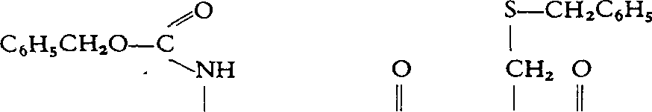
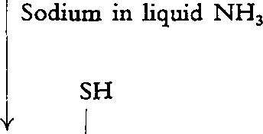
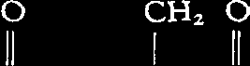
Fig.1. A synthesis of glutathione.

was believed, through the work of Hopkins9 and of Kendall, Mason, and McKenzie10 to be γ -L-glutamyl-L-cysteinylglycine. If we could synthesize N-carbobenzoxy-γ -glutamyl-S-benzylcysteinylglycine, we felt that its re-duction with sodium in liquid ammonia should yield glutathione.
This approach to glutathione would have a particular advantage in that the sulfhydryl group would be covered by a benzyl radical up to the final step, and thus, during the course of the various reactions that might be employed up to this point, the likelihood of partial oxidation of the sulfhy-dry1 group and its attendant difficulties would be eliminated.
In work with Miller11, we were able to obtain this desired intermediate by the coupling of suitable derivatives of the three amino acids involved. As shown in Fig. 1, reduction of this intermediate with sodium in liquid ammonia gave glutathione, which, upon isolation in crystalline form, was shown to be identical with the natural product. Our synthesis followed shortly after the first synthesis of glutathione by Harington and Mead by a somewhat different approach12.
While this synthetic work was going on, we continued our work on insu-lin, along mainly two lines. One was concerned with whether the cystine content accounted for all of the sulfur, and the second with the behavior of insulin upon reduction of the disulfide groups. After some seven years of work, we finally were able to account for the sulfur of insulin entirely on the basis of cystine1 3, and we could obtain no evidence for any sulfur com-pound other than cystine in insulin14,15 .
The study of the reduction of insulin led directly to our work on the

posterior pituitary hormones. With such a gentle reducing agent as cysteine or glutathione acting at room temperature and at a neutral pH, insulin be-came inactivated, reduction of the disulfide linkages being undoubtedly the cause of the inactivation16-18 . Reoxidation did not restore activity.
This work on insulin aroused our interest in other protein or protein-like hormones. We turned to the examination of oxytocin, the uterine-contract-ing hormone, and vasopressin, the blood-pressure-raising hormone, of the posterior pituitary gland. There were some indications in the literature that these hormones might be polypeptide-like substances of lower molecular weight than insulin. Furthermore, there was evidence that partially purified preparations of these hormones contained sulfur, but the nature of the sulfur was unknown. We thought it would be interesting to investigate these hor-mones in comparison with insulin, and in 1932 we made some preliminary explorations on these hormones. In this discussion I will confine my attention mainly to oxytocin with only occasional reference to vasopressin.
Kamm and Grote of Parke, Davis and Company kindly placed at our disposal some of their partially purified oxytocin, and we were able to show that, upon hydrolysis, the samples contained approximately 9 per cent cys-tine19. Of course we couldn’t tell at that time whether the cystine was present in the hormone or in the impurities. Nevertheless, in work with Sealock20, we decided to treat the partially purified oxytocin with cysteine and find out whether this hormone lost its activity like insulin. Much to our surprise, the oxytocic activity remained. Oxidation, by aeration of an aqueous solu-tion until the sulfhydryl test was negative, did not cause loss of activity. The question then occurred, had we really reduced the hormone by the cysteine treatment? It appeared possible to us that if the hormone were a disulfide and had been reduced, then treatment with benzyl chloride might cover the sulfhydryl group with a benzyl radical and inactivation might take place. When the reduced oxytocin preparation was treated with benzyl. chloride, inactivation did result. On the other hand, treatment of the non-reduced material with benzyl chloride did not cause inactivation. These results made us fairly certain that the oxytocic principle contained sulfur in the form of a disulfide linkage20.
We also investigated the behavior of the vasopressin preparation upon cysteine treatment and found it quite parallel to that of the oxytocin prep-aration. This aroused in us the desire to see what the pure compounds themselves would be like. What manner of compounds were they? Were they, like insulin, also simply made up of amino acids and ammonia? Since

we had reason to believe that they were smaller molecules than insulin, it seemed to me that they might lend themselves to an organic chemical ap-proach. If we could isolate them, we thought we might be able to work out their structure and perhaps synthesize them.
The purification was a slow process, as the amount of active principles in the gland is extremely small, they are unstable, and the bioassays involved are very time-consuming. Hundreds of thousands of hog and beef glands were used during the course of the investigations. Up to the time of World War II, we made considerable progress in collaboration with Sealock, Irving, Dyer, and Cohn on the purification of the principles, mainly through elec-trophoretic techniques, and learned much about the behavior of the hor-mone s21-26 .
We laid aside the problem during the war period for certain assignments, particularly on penicillin, but thereafter the isolation of oxytocin was under-taken in collaboration with Livermore2 7. Since the countercurrent distribu-tion technique developed by Craig2 8 for the purification of organic com-pounds had played a helpful role in our isolation of synthetic penicillin, we naturally thought of using countercurrent distribution on partially purified oxytocin fractions, prepared by the method of Kamm and co-workers29. The source material for preparation of the oxytocin fractions was a commercial extract provided by Dr. Kamm of Parke, Davis and Company. The counter-current distribution between 0.05 per cent acetic acid and secondary butyl alcohol proved to be highly effective. We obtained a fraction that appeared to behave like a pure compound by this criterion, and through application of the elegant starch-column chromatographic method of Moore and Stein30 we were able, with Pierce31, to show that an acid hydrolysate of oxytocin consisted of eight amino acids and ammonia.
It was then of importance to determine whether, starting from the glands themselves, material of the same potency and properties would be obtained. Therefore the oxytocin was isolated from lyophilized posterior lobes of beef pituitary glands3 2. A preparation was obtained which had approximately the same distribution curve and the same potency as the preparation obtained from the concentrate. The two preparations likewise showed the same amino acid composition. The chromatogram of the amino acids is shown in Fig. 2. The amino acids were present in a molar ratio to each other of 1:1, and the molar ratio of ammonia to any one amino acid was 3:1. Molecular weight determinations indicated a molecular weight in the neighborhood of 1,000. The sulfur content of oxytocin could be entirely accounted for by cystine.

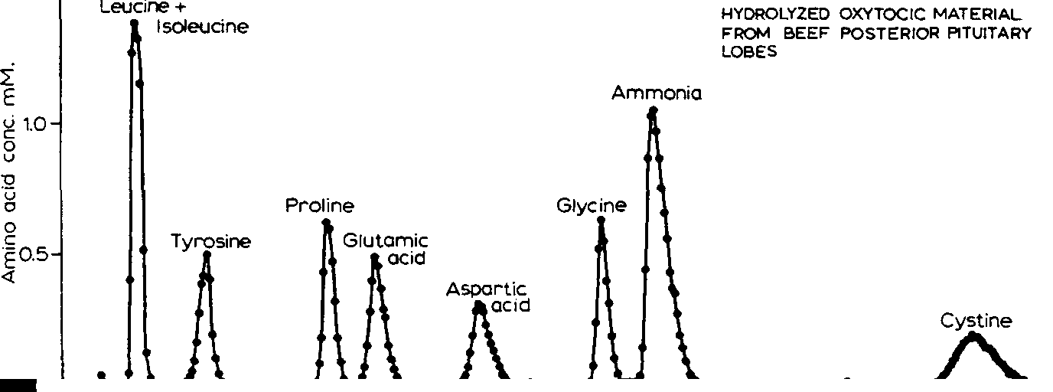
1.5

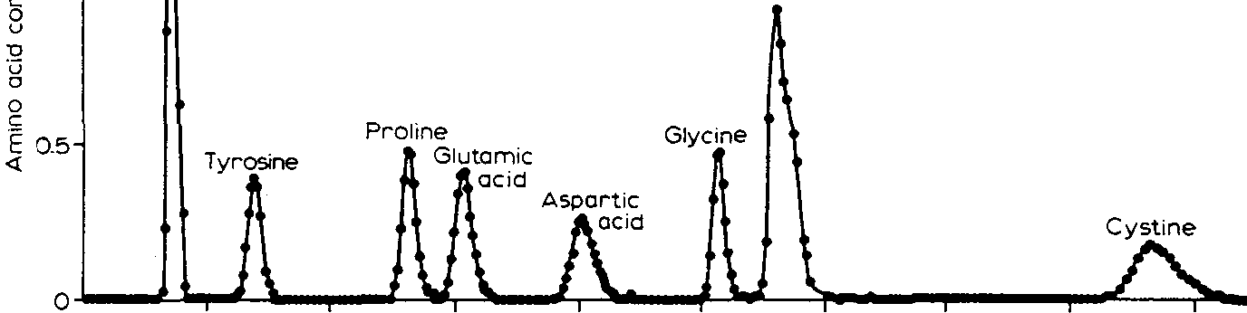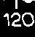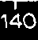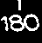
Fig. 2.Separation of amino acids from a hydrolysate of oxytocin (upper chromatogram) and from an artificial mixture of amino acids simulating the composition of oxytocin (lower chromatogram). Solvents, 1:2: 1 n- butyl alcohol - n- propyl alcohol - 0.1 N HCl followed by 2:1 n- propyl alcohol - 0.5 N HCl.

Knowing the cystine content of the purified hormone, it becomes evident, from the sulfur content of all of the pre-war preparations including those of Kamm and co-workers and our preparations, that none of these prepara-tions could have been more than 50 per cent pure, regardless of the unitage ascribed to them on an arbitrary basis by reference to a standard powder. No greater purity than 50 percent could be attributed to these early preparations, even if the sulfur of the preparations were due entirely to the presence of oxytocin, which is somewhat unlikely since sulfur-containing impurities may well have been present.
Further countercurrent distribution of the purified oxytocin involving 1,000 transfers resulted in no change in composition, and this work33 cul-minated in 1952 in the isolation of a crystalline flavianate of oxytocin

with Pierce, the first crystalline derivative of this hormone to be isolated. It is of interest that an oxytocic fraction was also obtained from hog posterior pituitary glands which had a distribution curve approximately the same as that from the beef glands3 3. In addition, the oxytocin obtained from the hog pituitary had the same amino acid composition and potency as that
obtained from beef.
During the course of these studies on the oxytocic hormone, the pressor hormone, vasopressin, was also isolated from beef glands and shown to con-tain six of the same amino acids as oxytocin. In place of the leucine and isoleucine in oxytocin, vasopressin contained phenylalanine and arginine.
With the isolation of what appeared to be the pure hormones and the establishment of their composition, we were for the first time in a position, on a chemical basis, to be quite certain that the oxytocin was free of vaso-pressin, and therefore it was possible to ascertain the biological effects of oxytocin itself.
Before going into this, it might be well to mention a few of the biological activities that have been attributed to the posterior pituitary gland. I would recall to you that it was just sixty years ago that the first biological effect of the pituitary gland was discovered by Oliver and Schäfer34. They found that extracts of the pituitary when injected into mammals raised their blood pres-sure - the pressor effect. Howell showed a few years later that this activity resided in the posterior lobe3 5. Since that time, other biological activities of posterior pituitary extracts were noted, particularly the uterine-contracting, or oxytocic, effect by Dale36 in 1906; the milk-ejecting effect by Ott and Scott37 in 1910; the blood-pressure-lowering effect in birds, the so-called avian depressor effect, by Paton and Watson38 in 1912; and the inhibition of urine excretion in man, the antidiuretic effect, by Von den Velden39 in 1913. As to the biological effects of the purified oxytocin, it was assayed for avian depressor effect against a standard powder according to the method of
Coon as described in the U.S. Pharmacopoeia40 and found to possess this activity33 to the extent of 450 to 500 units per mg. In addition to the avian depressor effect, the oxytocin was found to have the same potency, relative to the standard powder, in bringing about contractions of the isolated rat uterus - the uterine-contracting activity.The oxytocin also showed the same potency (450 to 500 units per mg, relative to the standard powder) in bring-ing about the ejection of milk. This milk-ejecting activity of oxytocin was demonstrated by tests of our purified material in sows by Whittlestone41, in rabbits by Cross and Van Dyke32, and in recently parturient women, the

latter testing having been carried out in a collaborative study with Douglas, Nickerson, and Bonsnes of our Department of Obstetrics and Gynecology43. We thought at first that oxytocin was devoid of pressor and antidiuretic activity. However, we placed at Van Dyke’s disposal samples of our purified oxytocin which he and his colleagues assayed by refined techniques. They found 7 units of pressor and 3 units of antidiuretic activity per mg. These activities have been confirmed qualitatively and quantitatively with our syn-thetic oxytocin, so there is no longer any question that they are inherent
properties of the oxytocin molecule44. It might be mentioned that vaso-pressin, in addition to its pressor and antidiuretic effects (500 to 600 units per mg, relative to the standard powder), also possesses avian depressor, uterine-contracting, and milk-ejecting activity, but the potency of vasopressin with respect to the latter three activities is only a fraction of the potency of oxy-tocin.
With the purified oxytocin at hand and its composition established, we then turned to the problem of how the component amino acids were linked. Of course there were many structures that could be written involving the eight amino acids and ammonia. The greatest difficulty in the degradative work was the scarcity of material. To obtain enough purified hormones was truly a prodigious task, as has already been mentioned. The various degrada-tive steps were perforce carried out on milligrams of material, and in most instances, the methods had to be adapted to this scale.
Since I am attempting in this presentation to focus attention on the syn-thesis of oxytocin in relation to this trail of sulfur research, I shall not present the studies involving a variety of procedures in our gradual elucidation of the structure of the hormone. These researches over the course of several years with Pierce, Mueller, Turner, Davoll, Taylor, and Kunkel45-50, and the final decisive experiments with Ressler and Trippett51,52 on the cleavage of performic acid-oxidized oxytocin with bromine water and on the partial hydrolysis and identification of peptide fragments, brought us to a clear-cut concept 52,53 of the structure of oxytocin, a new type of cyclic polypeptide amide shown in Fig. 3.
Although this structure was the only one that we could arrive at through the rationalization of our data, we felt that synthetic proof of this structure was mandatory because of certain assumptions involved in postulating it.
It is of Considerable interest that Tuppy, on the basis of data we had published along with some data of his own, arrived at the same structure independently 54. Tuppy’s proposal was based on the data from our labora-

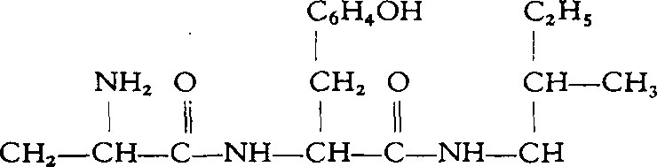
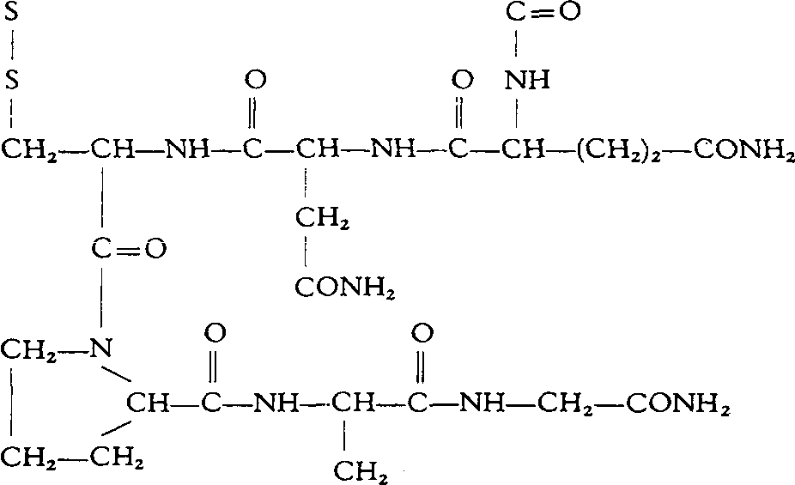

Fig. 3. Oxytocin.

tory on composition, molecular weight, terminal groups, as worked out by our use of the Sanger dinitrophenyl end group procedure55, and on the cyclic structure involving the disulfide linkage which we had established, along with his independent studies on the sequence of amino acids involving partial hydrolysis with acid and with an enzyme. The interpretation of the data and the assumptions made were quite parallel in both laboratories.
As already mentioned, we felt that synthetic proof of the structure we had arrived at had to be adduced; that is, of course, if the synthesis were within the range of possibility. I might point out that the synthesis of this structure meant the synthesis of an octapeptide of eight different amino acids, one of them being cystine. In addition, this desired octapeptide contained three amide groups and was a cyclic polypeptide for which no known synthetic methods were available - a cyclic pentapeptide with a tripeptide side chain. To add to the challenge was the fact that we knew the final product was relatively unstable and easily inactivated. Gentle means would therefore have to be employed.
The clue to the synthetic approach to this compound rested on our work with Sealock, carried out in the 1930’s, on the reduction of oxytocin and the oxidation of the reduced oxytocin without appreciable inactivation at either step, which has already been discussed2 0. On the basis of our postulated struc-

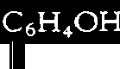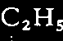
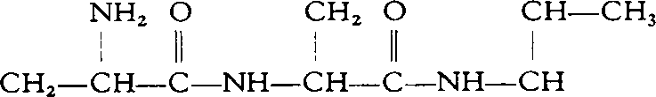
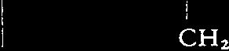
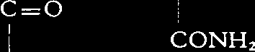


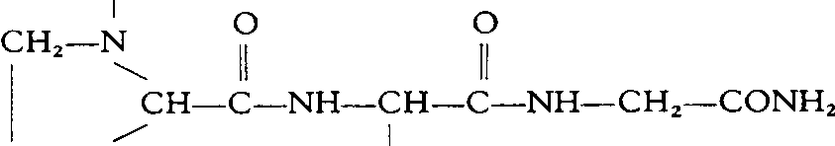
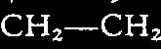
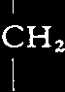

Fig. 4. Benzylated derivative of reduced oxytocin.

ture for oxytocin (Fig.3), the reduction of oxytocin and subsequent oxida-tion could be interpreted as involving the opening and closing of the 20-membered ring. The reduced oxytocin would then have a linear structure containing two sulfhydryl groupings in place of the disulfide linkage in oxy-tocin. Furthermore, if the proposed structure for oxytocin were correct, reduction of oxytocin with sodium in liquid ammonia followed by addition of benzyl chloride should give rise to the S,S’-dibenzyl derivative of reduced oxytocin, possessing the structure shown in Fig. 4.
Since benzylation of reduced oxytocin had led to inactivation in the earlier study, the expectation was that this benzylated derivative of reduced oxy-tocin would be biologically inactive. With what we now knew of the struc-tures involved, we could see no reason why treatment of the S,S’-dibenzyl derivative of reduced oxytocin with sodium in liquid ammonia should not lead to the biologically active, reduced oxytocin; oxidation of the sulfhydryl form by aeration should then lead to the regeneration of oxytocin itself, if our concepts and line of reasoning were valid.
We therefore decided to investigate the benzylation and debenzylation using highly purified oxytocin preparations in work with Gordon56. Our best sample of natural oxytocin was treated with sodium in liquid ammonia followed by the addition of benzyl chloride to the liquid ammonia solution.

From this reaction mixture, a product was obtained, which on amino acid analysis had the expected composition, containing two moles of S- benzyl-cysteine along with one mole of each of the other seven amino acids present in oxytocin.
This material was biologically inactive. The isolated dibenzyl derivative was then dissolved in liquid ammonia and metallic sodium was added. After removal of the ammonia, the product was dissolved in water and oxidized by passing air through the solution at a pH close to neutral; a biologically active product was obtained. From a comparison of the physical, chemical, and biological properties of the starting and regenerated material, we were convinced that oxytocin had been regenerated from its S,S’-dibenzyl deriva-tive. With this result, I was confident that the door was opened to a synthetic attack on oxytocin.
If the linear dibenzyl nonapeptide shown in Fig. 5, which possesses a car-bobenzoxy group on the ammo group of one of the cysteine residues, could be synthesized, it should be possible to convert this protected nonapeptide by reduction to the reduced form of oxytocin and by subsequent oxidation to oxytocin (see Fig. 5).
The parallelism between this approach to the synthesis of reduced oxytocin and the approach to the synthesis of glutathione, which I have already dis-cussed, is at once apparent. In both cases, the cysteine residue(s) present in the intermediates for the syntheses were protected by carbobenzoxy and benzyl groups, which were to be removed in the last synthetic step by so-dium in liquid ammonia.
After a consideration of the many ways in which the synthesis of the inter-mediate for oxytocin might be approached, and after exploratory synthetic studies, it was decided to attempt to prepare the compound by combining the tetrapeptide amide, S-benzyl- L-cysteinyl- L-prolyl- L-leucylglycinamide, through appropriate means with L-isoleucyl- L-glutaminyl- L-asparagine to obtain the heptapeptide amide, L-isoleucyl- L-glutaminyl- L-asparaginyl-S-benzyl-L-cysteinyl- L-prolyl-L-leucylglycinamide, and to condense the latter with N- carbobenzoxy-S-benzyl- L-cysteinyl- L-tyrosine, thus forming the desired nonapeptide amide, and we concentrated on this line of approach. In this work I should like to acknowledge the splendid collaboration of Ressler, Swan, Roberts, and Katsoyannis53,57 .
In addition to the classical methods for the formation of peptides, other recently developed procedures were employed. We were able to utilize to particular advantage the contributions of Vaughan and Osato58 and of An-

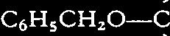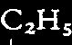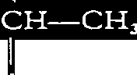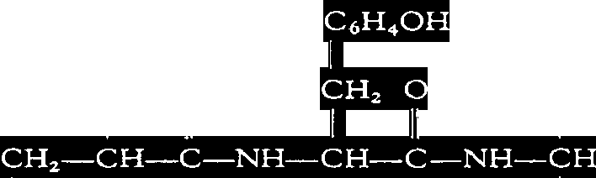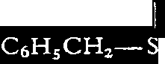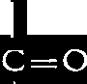
I

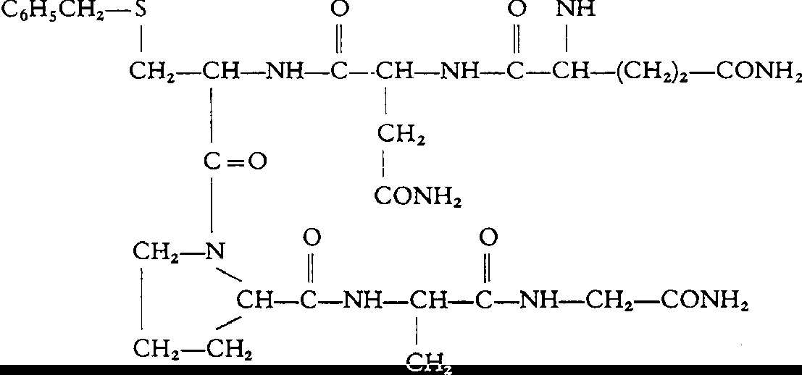
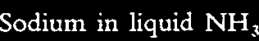
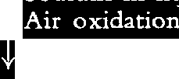
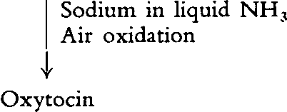

Fig. 5. Proposed intermediate leading to the synthesis of oxytocin.

derson, Blodinger, and Welcher5 9. In the former case, the mixed anhydride of an N-substituted amino acid, with, for example, isovaleric acid, is used for the preparation of the peptide in the latter method, tetraethyl pyrophos-phite is the condensing agent.
In addition to using the carbobenzoxy group as a protective grouping for the amino group, we have also employed the tosyl group for this purpose. Removal of the tosyl grouping was accomplished by the use of sodium in liquid ammonia, as utilized in our work with Behrens60 on the synthesis of
α-amino-N-methyl-L-histidine. The tosyl group as a protective group in peptide synthesis was first used by Schoenheimer61, who employed a hy-driodic acid-phosphonium iodide cleavage.
As to the specific steps in our attempted synthesis of the hormone, the tetrapeptide amide was prepared with Ressler53,57,62 . Ethyl carbobenzoxy-L-leucylglycinate was synthesized by the mixed anhydride procedure of Vaughan and Osato 5 8. After catalytic removal of the carbobenzoxy group,

according to the procedure of Bergmann and Zervas5, the ethyl-L-leucyl-glycinate was condensed with carbobenzoxy-L-proline, again by use of the mixed anhydride procedure with isovaleryl chloride.
After removal of the carbobenzoxy group by reduction with hydrogen in the presence of palladium catalyst, the ethyl L-prolyl-L-leucylglycinate was converted to the tetrapeptide, S-benzyl-L-cysteinyl-L-prolyl-L-leucylglycine via the dicarbobenzoxy-L-cystinyl derivative. Ethyl dicarbobenzoxy-L-cysti-nyl-bis(L-prolyl-L-leucylglycinate) was saponified in aqueous dioxane at
+5ºC in the presence of I equivalent of sodium hydroxide to yield the corresponding acid. The latter was converted to S-benzyl-L-cysteinyl-L-pro-lyl-L-leucylglycine according to our procedure for the removal of carbo-benzoxy groups in cystine-containing compounds by the use of sodium in liquid ammonia7 followed by benzylation6 of the sulfur of the reduced com-pound in the same medium. The crude tetrapeptide was readily converted, with the use of benzyl alcohol and dry hyd rogen chloride, to the crystalline benzyl ester hydrochloride, benzyl S-benzyl- L-cysteinyl- L-prolyl- L-leucyl-glycinate hydrochloride. Amination was accomplished by allowing the free base obtained from the benzyl ester hydrochloride to stand in solution in methanolic ammonia for several days at room temperature. S-Benzyl- L-cysteinyl-L-prolyl-L-leucylglycinamide was isolated from its benzyl ester hydrochloride as a crystalline hydrate.
A novel method was devised for the synthesis of glutaminyl-asparagine with Swan53,57,63 . Harington and Moggridge64 had already shown that heating of tosyl-L-glutamic acid under reflux with acetyl chloride gave the mixed anhydride of I-tosylpyroglutamic acid and acetic acid, which on hy-drolysis in aqueous dioxane gave I-tosylpyroglutamic acid, and that this compound with phosphorus pentachloride gave I-tosylpyroglutamyl chlo-ride. They had shown that the pyrrolidone ring in these compounds could be opened with aqueous alkali but was stable to anhydrous ammonia. In our work, tosyl-L-glutamic acid was treated directly with phosphorus pentachlo-ride. The reaction product was then coupled with L-asparagine in the pres-ence of aqueous magnesium oxide as the condensing agents to give I-tosyl-pyroglutamyl- L-asparagine. The latter compound with concentrated aque-ous ammonia yielded tosyl-L-glutaminyl-L-asparagine, the pyrrolidone ring having been opened by addition of the elements of ammonia. Detosylation of the tosyl dipeptide by treatment with sodium in liquid ammonia gave
L-glutaminyl- L-asparagine.
For the preparation of tosyl-L-isoleucyl- L-glutaminyl- L-asparagine with

Katsoyannis 53,57,65 , tosyl-L-isoleucine was converted to the corresponding acid chloride and the latter was then coupled with L-glutaminyl- L-asparagine in the presence of magnesium oxide to give the tosyl tripeptide.
Condensation of this tripeptide with the tetrapeptide was effected by the use of tetraethyl pyrophosphite according to the general procedure of An-derson, Blodinger, and Welcher59. Removal of the tosyl group from the protected heptapeptide amide was effected with sodium in liquid ammonia, by which the benzyl group was also removed. The resulting reduced com-pound was then benzylated with benzyl chloride in the same medium to yield the heptapeptide amide.
Finally, the heptapeptide amide was condensed with S-benzyl-N-carbo-benzoxy-L-cysteinyl- L-tyrosine66, a dipeptide which had originally been prepared by Harington and Pitt Rivers6 7. The condensation was brought about in the presence of tetraethyl pyrophosphite to yield N-carbobenzoxy-S- benzyl-L-cysteinyl-L-tyrosyl-L-isoleucyl-L-glutaminyl-L-asparaginyl-S-benzyl-L-cysteinyl- L-prolyl-L-leucylglycinamide.
This was the compound we had set about to prepare as our proposed intermediate for the synthesis of oxytocin. If our structure for oxytocin were correct, we had every reason to believe that this compound, on reduction with sodium in liquid ammonia, followed by appropriate oxidation, would give us oxytocin (see Fig. 5).
This intermediate was therefore treated with sodium in liquid ammonia, by which both the benzyl and carbobenzoxy groups were removed. The reduced material obtained after evaporation of the ammonia was oxidized by aeration in dilute aqueous solution at pH 6.5 and tested for biological activity by the rat uterine strip method68,69 and by the chicken vasodepressor method of Coon70, which utilizes the property of oxytocin of lowering the blood pressure of the fowl and has been adopted by the United States Pharmacopoeia as the method of assay for oxytocin40. Based on the assump-tion that the synthetic material has a potency equivalent to that of the puri-fied natural material (500 units per mg), the yield of biologically active ma-terial, as determined by the two types of assay, ranged in several runs from 20 to 30 per cent of the calculated amount from the protected nonapeptide intermediate. The yield approximated closely the yield of oxytocic activity obtainable under similar conditions from the S,S’ -dibenzyl derivative of re-duced natural oxytocin56.
The purified synthetic product isolated by countercurrent distribution and our best sample of natural oxytocin were assayed against each other fol-

lowing rigorously the procedures outlined by the U. S. Pharmacopoeia. The results indicated that the activity of the synthetic material53,57 was in-deed very close to that of the natural oxytocin33.
This synthetic material and natural oxytocin were then compared by a battery of tests - physical and chemical53,57. They both had the same amino acid composition. They showed, within experimental error, the same optical activity, partition coefficient (in two different solvent systems), electro-phoretic mobility (at two different hydrogen ion concentrations), infrared pattern, ultraviolet spectrum, and effluent pattern from an IRC-50 resin71.
The synthetic material formed an active flavianate which had the same crystalline form (fine, silky needles) and the same melting point as the fla-vianate obtained from natural oxytocin.
On treatment with bromine water, the synthetic material underwent the cleavage into two fragments encountered with natural oxytocin, both giving rise to and a sulfonic acid heptapeptide51.
Sedimentation studies on the molecular weight of natural oxytocin and the synthetic material were kindly made by Schachman and Harrington of the University of California. The natural and synthetic materials behaved identically, and the values obtained were in the expected range.
We were fortunate at this stage that we had the collaboration arranged with the Lying-In Hospital group of our Medical Center on the use of our highly purified natural oxytocin in induction of labor and in milk ejection, for the natural and synthetic material were then compared on human sub-jects. The synthetic product was fully effective in stimulating labor in the human and in milk ejection and could not be distinguished from the natural oxytocin in its action. Approximately 1 microgram of either the natural oxy-tocin or the synthetic material given intravenously to recently parturient women induced milk ejection in 20 to 30 seconds43.
These comparisons of the physical, chemical, and biological properties of the synthetic product with those of the purified natural oxytocin justified in our estimation the conclusion that the synthetic octapeptide amide is oxytocin and that the structure shown in Fig. 3 represents that of the hor-mone57.
With the establishment of the structure of oxytocin, a new ring system, that is, a 20-membered ring involving a disulfide linkage, was for the first time recognized in nature. Our studies have indicated that this same sized ring is present in vasopressin, the blood-pressure-raising and antidiuretic hormone of the posterior pituitary7 2. Recently it has been shown by Sanger

and co-workers73 that a ring of the same size involving a disulfide linkage occurs in the insulin molecule, as part of a more involved structure.
The establishment of the structure of oxytocin and vasopressin will un-doubtedly open the door to a better understanding of these hormones by the biochemist, the physiologist, the pharmacologist, and the clinician. More-over, it should provide a suitable basis for the study of the relationship of chemical structure to biological activity in these protein-like substances. The synthesis of oxytocin will afford a means of obtaining the compounds nec-essary to the study of this relationship and may, in addition, point the way to the synthesis of more complex sulfur-containing polypeptides.

- V. du Vigneaud, J. Biol. Chem., 75 (1927) 393.
- V. du Vigneaud, H. Jensen, and O. Wintersteiner, J. Pharmacol. Exptl. Therap., 32
(1928) 367.
- H. Jensen, O. Wintersteiner, and V. du Vigneaud,J. Pharmacol. Exptl. Therap., 32
(1928) 387.
- O. Wintersteiner, V. du Vigneaud, and H. Jensen, J. Pharmacol. Exptl. Therap., 32
(1928) 397.
- M. Bergmann and L. Zervas, Ber., 65 (1932) 1192.
- V. du Vigneaud, L. F. Audrieth, and H. S. Loring, J. Am. Chem. Soc., 52 (1930)
4500.
- R. H. Sifferd and V. du Vigneaud, J. Biol. Chem., 108 (1935) 753.
- H. S. Loring and V. du Vigneaud, J. Biol. Chem., III (1935) 385.
- F. G. Hopkins, J. Biol. Chem., 84 (1929) 269.
- E. C. Kendall, H. L. Mason, and B. F. McKenzie, J. Biol. Chem., 88 (1930) 409.
- V. du Vigneaud and G. L. Miller, J. Biol. Chem., 116 (1936) 469.
- C. R. Harington and T. H. Mead, Biochem. J., 29 (1935) 1602.
- G. L. Miller and V. du Vigneaud, J. Biol. Chem., 118 (1937) 101.
- V. du Vigneaud, G. L. Miller, and C. J. Rodden, J. Biol. Chem., 131 (1939) 631.
- V. du Vigneaud, R. H. Sifferd, and G. L. Miller, Proc. Soc. Exptl. Biol. Med., 33
(1935) 371.
- V. du Vigneaud, A. Fitch, E. Pekarek, and W. W. Lockwood, J. Biol. Chem., 94
(1931) 233.
- V. du Vigneaud, J. Wash. Acad. Sci., 27 (1937) 365.
- V. du Vigneaud, Cold Spring Harbor Symp. Quant. Biol., 6 (1938) 275.
- V. du Vigneaud, R. R. Sealock, R. H. Sifferd, O. Kamm, and I. W. Grote, J. Biol. Chem., 100 (1933) xciv.
- R. R. Sealock and V. du Vigneaud, J. Pharmacol. Exptl. Therap., 54 (1935) 433.
- V. du Vigneaud, G. W. Irving, Jr., H. M. Dyer, and R. R. Sealock, J. Biol. Chem.,
123 (1938) 45.
- G. W. Irving, Jr. and V. du Vigneaud, J. Biol. Chem., 123 (1938) 485.

- G. W. Irving, Jr. and V. du Vigneaud, J. Am. Chem. Soc., 62 (1940) 1080.
- M. Cohn, G. W. Irving, Jr., and V. du Vigneaud, J. Biol. Chem., 137 (1941) 635.
- G. W. Irving, Jr., H. M. Dyer, and V. du Vigneaud, J. Am. Chem. Soc., 63 (1941)
503.
- V. du Vigneaud and G. W. Irving, Jr., Ann. N.Y. Acad. Sci., 43 (1943) 273.
- A. H. Livermore and V. du Vigneaud, J. Biol. Chem., 180 (1949) 365.
- L. C. Craig, J. Biol. Chem., 155 (1944) 519.
- O. Kamm, T. B. Aldrich, I. W. Grote, L. W. Rowe, and E. P. Bugbee, J. Am. Chem. Soc., 50 (1928) 573.
- S. Moore and W. H. Stein, J. Biol. Chem., 178 (1949) 53.
- J. G. Pierce and V. du Vigneaud, J. Biol. Chem., 182 (1950) 359.
- J. G. Pierce and V. du Vigneaud, J. Biol. Chem., 186 (1950) 77.
- J. G. Pierce, S. Gordon, and V. du Vigneaud, J. Biol. Chem., 199 (1952) 929.
- G. Oliver and E. A. Schäfer, J. Physiol., (London), 18 (1895) 277.
- W. H. Howell, J. Exptl. Med., 3 (1898) 215,245.
- H. H. Dale, J. Physiol., (London), 34 (1906) 163.
- I. Ott and J. C. Scott, Proc. Soc. Exptl. Biol. Med., 8 (1910) 48.
- D. N. Paton and A. Watson, J. Physiol., (London), 44 (1912) 413.
- R. von den Velden, Klin. Wochschr., 50 (1913) 2083.
- The Pharmacopoeia of the United States of America, 14th revision, Mack Printing CO., Easton, Pa., p. 475.
- W. G. Whittlestone, J. Endocrinol., 8 (1952) 89.
- B. A. Cross and H. B. van Dyke, J. Endocrinol., 9 (1953) 232.
- K. Nickerson, R. W. Bonsnes, R. G. Douglas, P. Condliffe, and V. du Vigneaud,
Am. J. Obstet. Gynecol., 67 (1954) 1028.
- H. B. van Dyke, K. Adamsons, Jr., and S. L. Engel, Recent Progr. Hormone Res.
11 (1955) I.
- J. M. Mueller, J. G. Pierce, H. Davoll, and V. du Vigneaud, J. Biol. Chem., 191
(1951) 309.
- R. A. Turner, J. G. Pierce, and V. du Vigneaud, J. Biol. Chem., 193 (1951) 359.
- H. Davoll, R. A. Turner, J. G. Pierce, and V. du Vigneaud, J. Biol. Chem., 193
(1951) 363.
- J. M. Mueller, J. G. Pierce, and V. du Vigneaud, J. Biol. Chem., 204 (1953) 857.
- H. G. Kunkel, S. P. Taylor, Jr., and V. du Vigneaud, J. Biol. Chem., 200 (1953) 559.
- S. P. Taylor, Jr., V. du Vigneaud, and H. G. Kunkel, J. Biol. Chem., 205 (1953) 45.
- C. Ressler, S. Trippett, and V. du Vigneaud, J. Biol. Chem., 204 (1953) 861.
- V. du Vigneaud, C. Ressler, and S. Trippett, J. Biol. Chem., 205 (1953) 949.
- V. du Vigneaud, C. Ressler, J. M. Swan, C. W. Roberts, P. G. Katsoyannis, and S. Gordon, J. Am. Chem. Soc., 75 (1953) 4879.
- H. Tuppy, Biochim. Biophys. Acta, II (1953) 449.
- F. Sanger, Biochem. J., 39 (1945) 507.
- S. Gordon and V. du Vigneaud, Proc. Soc. Exptl. Biol. Med., 84 (1953) 723.
- V. du Vigneaud, C. Ressler, J. M. Swan, C. W. Roberts, and P. G. Katsoyannis, J. Am. Chem. Soc., 76 (1954) 3115.
- J. R. Vaughan, Jr. and R. Osato, J. Am. Chem. Soc., 73 (1951) 5553.

- G. W. Anderson, J. Blodinger, and A. D. Welcher, J. Am. Chem. Soc., 74 (1952) 5309
- V. du Vigneaud and O. K. Behrens, J. Biol. Chem., 117 (1937) 27.
- R. Schoenheimer, Z. Physiol. Chem., 154 (1926) 203.
- C. Ressler and V. du Vigneaud, J. Am. Chem. Soc., 76 (1954) 3107.
- J. M. Swan and V. du Vigneaud, J. Am. Chem. Soc., 76 (1954) 3 110.
- C. R. Harington and R. C. G. Moggridge, J. Chem. Soc., (1940) 706.
- P. G. Katsoyannis and V. du Vigneaud, J. Am. Chem. Soc., 76 (1954) 3113.
- C. W. Roberts and V. du Vigneaud, J. Biol. Chem., 204 (1953) 871.
- C. R. Harington and R. V. Pitt Rivers, Biochem. J., 38 (1944) 417.
- J. H. Bum, Quart. J. Pharm. Pharmacol., 4 (1931) 517.
- J. H. Bum, D. J. Finney, and L. G. Goodwin, Biological Standardization, 2nd ed., Oxford University Press, New York, 1950, p. 180.
- J. M. Coon, Arch. Intern. Pharmacodyn., 62 (1939) 79.
- S. P. Taylor, Jr., Proc. Soc. Exptl. Biol. Med., 85 (1954) 226.
- V. du Vigneaud, H. C. Lawler, and E. A. Popenoe, J. Am. Chem. Soc., 75 (1953) 4880.
- F. Sanger, L. F. Smith, and R. Kitai, Biochem. J., 58 (1954) vi.

