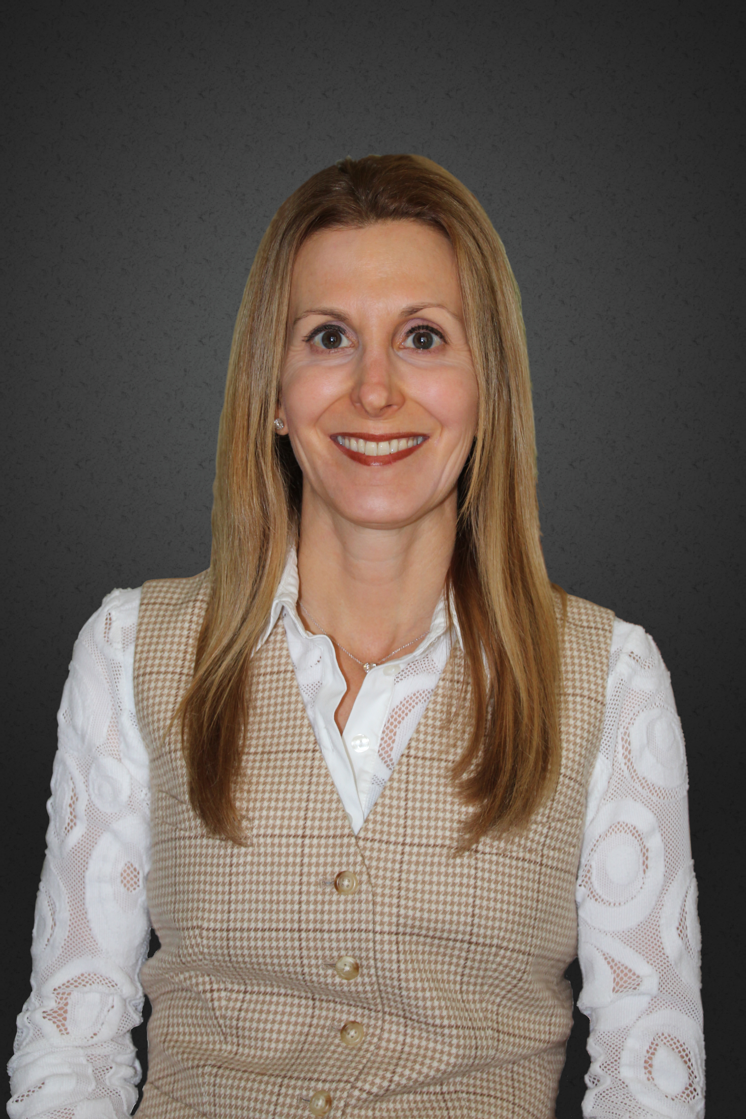

**Robyn Goldberg RDN, CEDRD**

Robyn began her career at Cedars-Sinai Medical Center in Los Angeles and was the Nutritional Counselor for the Susan Krevoy Eating Disorders Program at the Wright Institute. She is the Director of Nutrition Service for The Control Center an Addiction IOP. She has been a contributing author, appeared on national television as the eating disorder expert on The Insider and quoted in The New York Times, Shape, Fitness, Diabetes Forecast and other publications. Robyn teaches nutrition classes for the Motion Picture Industry and has a practice in Beverly Hills, CA specializing in eating disorders and other medical conditions.

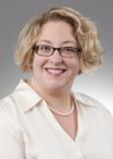

**Chevese Turner BA**

Recognizing the need for an organization to advocate on behalf of affected individuals and the providers who treat them, Chevese Turner founded the Binge Eating Disorder Association (BEDA) in June 2008 and is currently President & CEO. Her well-rounded career in both the non-profit and industry healthcare sectors, including a variety of leadership roles in the areas of advocacy, educational development, marketing, and government affairs, prepared her to serve the under recognized Binge Eating Disorder community. She is a strong advocate who engages in awareness creation, social action, education and outreach. Turner holds a BA in political science from Temple University and lives outside of Washington, DC with her husband and two children.

**WORKSHOP DATE: FRIDAY, MARCH 31, 2017**

**Breakfast: 8:00 a.m. - 8:30 a.m. /Presentation: 8:30 a.m. – 12:30 p.m.**

**UNIVERSITY OF ROCHESTER SCHOOL OF NURSING AUDITORIUM (1W304)**

**FREE AND OPEN TO THE COMMUNITY**

**RSVP: Jennifer Dry DeSanto at 585-276-6102 or** [**jennifer_desanto@urmc.rochester.edu**](mailto:jennifer_desanto@urmc.rochester.edu)

**Sponsored by the Western NY Comprehensive Care Center for Eating Disorders**

**University of Rochester School of Nursing**

**SPONSORED BY THE WESTERN NY COMPREHENSIVE CARE CNETER FOR EATING DISORDERS**

**The inclusion of Binge Eating Disorder (BED) in the DSM5 broadened the face of the eating disorders community. This workshop utilizes case studies to stimulate group discussion related to the best practices and nuances of treating BED, the role of the dietitian in treatment, the pursuit of weight loss as it pertains to recovery for those in higher weight bodies (including weight loss surgery), and how weight biases inform the determination of a treatment and recovery paradigm for both clinicians and clients. The workshop challenges participants to consider how this long overdue diagnosis is one of many steps toward a more inclusive eating disorder community that embraces its intersections with marginalized communities including race, culture, socio-economic status, body size and weight, sexual orientation, gender identity, etc.**