University of Rochester Medical Center
OFFICE FOR INCLUSION AND CULTURE DEVELOPMENT
DIVERSITY SEMINAR SERIES

Wednesday, May 16, 2018 / 12:00–1:00pm
Natapow Room- 1-(9545)
A Common Understanding
Strategies to Improve Health Literacy
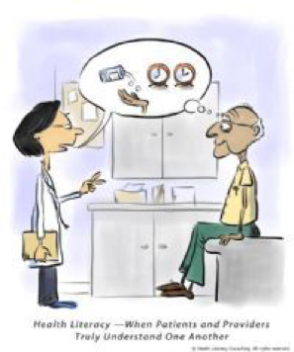
Presented by:
Mark W. Nickels, MD
Professor of Clinical Psychiatry
URMC Dept. of Psychiatry
University of Rochester Medical Center
Karen Liljequist, MLIS, AHIP
Interim Director, Institute for Innovation Education: Miner Libraries
University of Rochester Medical Center

This workshop reviews how Low health literacy has significant impact on patient care. A minority of patients have adequate health literacy, which can be influenced by stress, bias, cultural issues, literacy, numeracy and other factors. Understandable communication is crucial, and providers have an important role in this by using plain language and teach-back in dealings with all patients.

All faculty, fellows, residents, students and staff are welcome!
A light lunch will be provided.

Sponsor: URMC Office for Inclusion and Culture Development

To RSVP for this workshop, please email: Janice_Barnum@urmc.rochester.edu

You may direct any questions to the Office for Inclusion and Culture
Development at: inclusion@urmc.rochester.edu

ACCREDITATION
The University of Rochester School of Medicine and Dentistry is accredited by the Accreditation Council for Continuing Medical Education to provide continuing medical education for physicians.

CERTIFICATION
The University of Rochester School of Medicine and Dentistry designates this live educational activity for a maximum of 1 AMA PRA Category 1 Credit(s)TM. Physicians should claim only the credit commensurate with the extent of their participation in the activity.

