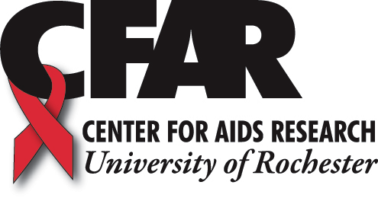

CALL FOR POSTERS!
2016 World AIDS DAY
Scientific Poster Session

The Center for AIDS Research invites you to submit
posters for the HIV/AIDS Poster Session to be held
December 1st, from 11 – 12:30

POSTER PRIZES
Cash prizes will be awarded for graduate student and post-doctoral poster presenters. Presenters should plan to attend the poster session to present their poster.

***REGISTRATION & ABSTRACT DEADLINE***
Monday November 21st

Please submit your registration form by email to
Laura_Enders@urmc.rochester.edu

World AIDS Day Scientific Symposium
Registration Form

Complete ALL of the following information and return via email
NO LATER THAN NOVEMBER 21 to Laura_Enders@urmc.rochester.edu

Presenter name(s):
Please indicate if you are: Undergraduate Graduate Student Post-doc

Is your research is related to a CFAR pilot or supplement award: Yes No

Title:

Abstract:

Author(s):

Department (please list the departments associated with this poster as they should appear in the program):

E-mail: | Phone:

Questions? Please contact:
Laura Enders @ 585- 273-2939 or (585) 729-2532

