Opioids - Morphine, Oxycodone, Methadone, Codeine, Tramadol, Fentanyl patches

Medication
Lockboxes

What should I store in the Lockbox?

Over the counter - Pain/fever meds, Benadryl,
Cough syrup,
Tylenol, Motrin

Cannabis - gummies, candy, flower/bud, tinctures

Where can I obtain one?
SMH
Outpatient Pharmacy

Prescription meds - Cardiac, blood pressure, depression/mental health meds, gastrointestinal meds, etc.

Stimulants - Methylphenidate (Ritalin, Concerta) and amphetamines (Adderall, Vyvanse)

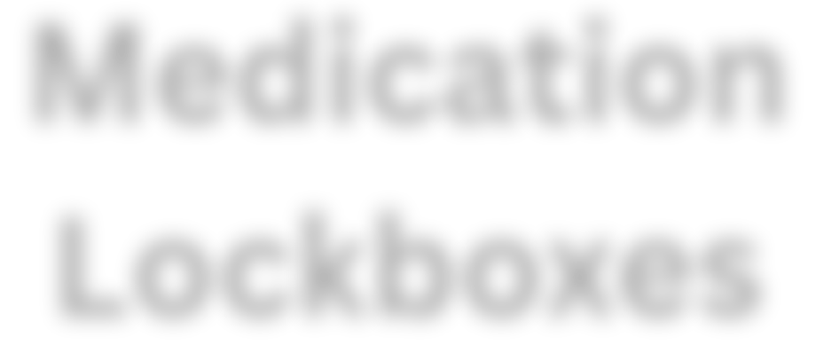
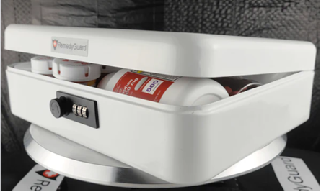
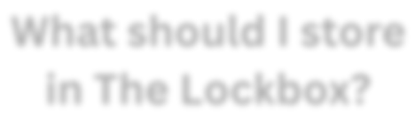
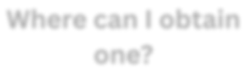
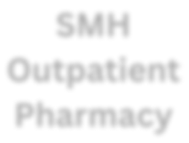

Smart Storage Tips:
- Lock them up - Store medications in a safe place only you know about (Not the medicine cabinet).
- No loose pills - Opioids should only be kept in the bottle provided by your pharmacy.
- Secure after use - After taking your medication, return to locked/secure space.
- Track quantities - Always know how many pills remain in the bottle.
- Safely dispose - Dispose of old or unused prescriptions properly.
- Pay attention - Know where your medications are stored or locked up at all times.

