
Case
Consultation
Policy
Staff
Clinical ^{Support}
Ethics
Community
Engagement Education
CLINICAL BIOETHICS PROGRAM NEWSLETTER
Vol. 3, Issue 2 November 2025

Message from the Director Registration/Enrollment Opens

As we prepare for the Spring Paul M. Schyve, MD, Center for Bioethics conference, AI and Healthcare: Minds, Morals, and Machines, it is an ideal moment to reflect on one of the most enduring questions in medicine and the humanities alike: What does it mean to be human in an age of intelligent machines? And, perhaps more urgently, how can we use technology to enhance, rather than erode, our ability to care for and about one another?

Scientific and technological advances have always created both promise and tension in patient care. Innovation brings new possibilities for healing and life prolonging therapies, but it also challenges us to remain attentive to the ethical, emotional, and relational dimensions of medicine. Technology can help us analyze data, find patterns, predict risks, and save lives, but it cannot feel, comfort, or bear witness to suffering. Taking care of patients requires uniquely human acts.

The humanities remind us of this truth. Novels such as Machines Like Me by Ian McEwan and Klara and the Sun by Kazuo Ishiguro imagine futures where human emotion and artificial consciousness intersect, prompting us to ask where empathy truly resides. Films like M3GAN and Her explore similar tensions between innovation and intimacy, efficiency, and empathy. These works invite us to reflect on the boundaries between machine intelligence and moral
- Spring 2026 Course registration began on Monday, November 10

4th Annual Paul M. Schyve, MD, Center for Bioethics Conference: AI in Healthcare: Minds, Morals and Machines- May 1-2, 2026.
  - Registration opens December 1, 2025

Debunking Common Myths About Ethics
Myth: In New York State, an incapacitated patient’s healthcare agent can make any medical decision.
Fact: The healthcare agent, a person designated by a patient on the healthcare proxy form, is supposed to make decisions that align with the patient’s values and preferences. When designating a healthcare agent, a patient can give that person as much or as little authority as they choose. Healthcare agents are permitted to interpret how a patient’s wishes apply as their medical condition changes. However, health agents are not permitted to overrule a patient’s wishes or prior treatment instructions unless they have a good faith basis for believing that the patient’s wishes have changed. The belief that a healthcare agent can make any medical decisions despite a patient’s stated wishes or treatment decisions is a common misconception of the agent’s ethical responsibility to the patient. When counseling patients on assigning a healthcare agent, encourage them to discuss with their potential agent their wishes, values, and preferences so their autonomy is preserved

imagination, and what those boundaries mean for our
shared humanity.

As technology continues to transform healthcare, our task
and respected.
New York State Department of Health. (2023, March). Choosing y our health care agent.

Ask Jane / Ask Alice


as clinicians, educators, and ethicists is to preserve the essence of care—the recognition of each patient as a person with a story, not simply a case with data. Whether through literature, music, film, theater, ethics, or everyday clinical (human) encounters, we are called to keep the human at the center of medicine. Mark your calendars and join us in May as we explore the complex ethical dilemmas and questions related to AI and healthcare!

– Dr. Margie Hodges Shaw
Both Ask Jane and Ask Alice provide the URMC community with an interface for non-urgent clinical ethical questions. The archived questions and answers are great to use in small group ethics discussions.

How to Call an Ethics Consult A New Way to Contact Ethics

Clinical ethics consults are available 24 hours a day, 7 days a week: Web Paging - Located under Ethics
SMH Operator/Paging Service -
(585) 275-2222 & ask them to page the Clinical Ethics Consultant on call.
Working nights & have a non-urgent ethical issue? Want to schedule an ethics education session?
We have an email for that!
clinical_ethics@urmc.rochester.edu


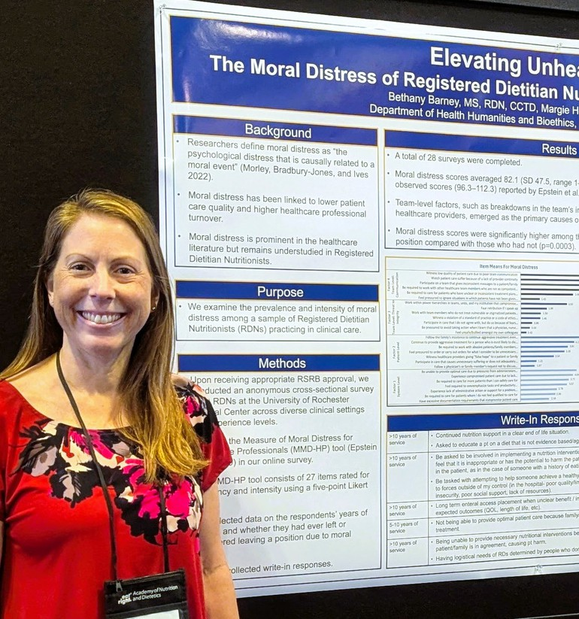
Featured Presentations
Upcoming HHBe Department Events
November 19, 2025 | 8:00-9:00 AM
Pediatric Grand Rounds, Forbes Lectureship: Lainie Ross
November 19, 2025 | 5:30-7:15 PM
The George Washington Corner Society for the History of Medicine: Mary Fissell
November 20, 2025 | 12:00-1:00 PM
Health Humanities and Bioethics Grand Rounds: Mary Fissell
December 4, 2025 | 12:00-1:00 PM
Health Humanities and Bioethics Grand Rounds: Mildred Cho
December 5, 2025 | 3:30-4:30 PM
12th Annual Lecture on Biomedical & Health Science Research Ethics: Mildred Cho
January 15, 2026 12:00-1:00 PM
Health Humanities and Bioethics Grand Rounds: Sarah Hagaman
January 29, 2026 | 12:00-1:00 PM
Health Humanities and Bioethics Grand Rounds: Laura Whitebell
February 5, 2026 | 12:00-1:00 PM
Health Humanities and Bioethics Grand Rounds: Angira Patel
February 19, 2026 | 12:00-1:00 PM
Health Humanities and Bioethics Grand Rounds: Alexander Parry
February 25, 2026 | 5:30-7:15 PM
The George Washington Corner Society for History of Medicine: Andrew Lea
March 5, 2026 | 12:00-1:00 PM
Health Humanities and Bioethics Grand Rounds: Jennifer Blumenthal-Barby

MS Graduate, Bethany Barney, MS RDN CCTD,
presented her research, “Elevating Unheard Voices: The Moral Distress of Registered Dietitian Nutritionists in Interprofessional Practice,” at the 2025 Food & Nutrition Conference & Expo (FNCE).

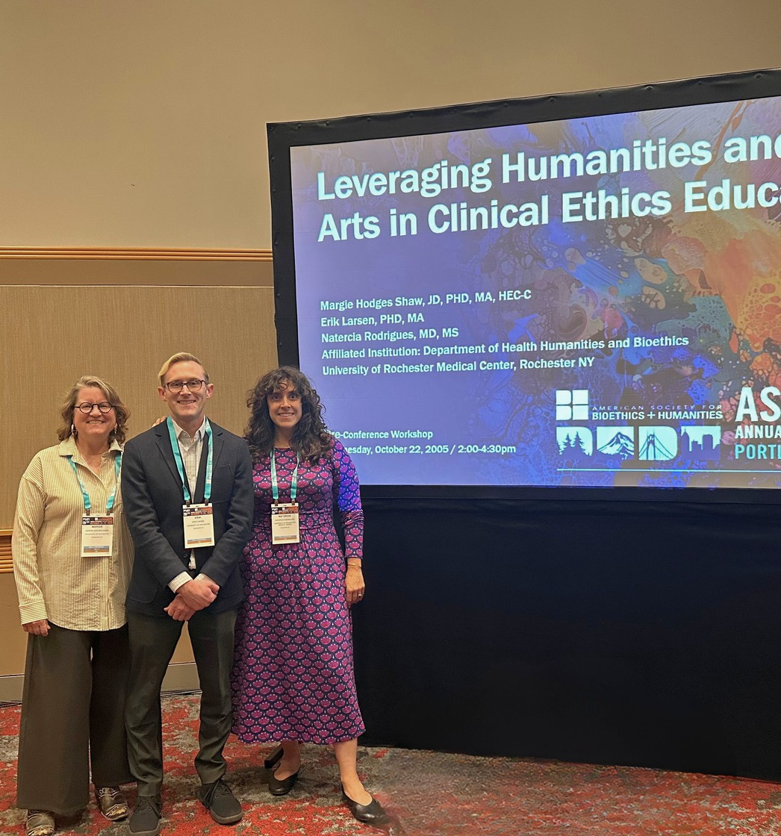
Margie Hodges Shaw, JD, PhD presented “Leveraging Humanities and Arts in Clinical Ethics Education” with Erik Larsen, MA, PhD, and Natercia Rodrigues, MD, MS, at the Annual American Society for Bioethics and Humanities Conference in Portland, OR.


In Case You Missed It

Scan the QR Code to review our
recorded Grand Rounds and see upcoming presentation content!

What You Should Know About the Consult Service
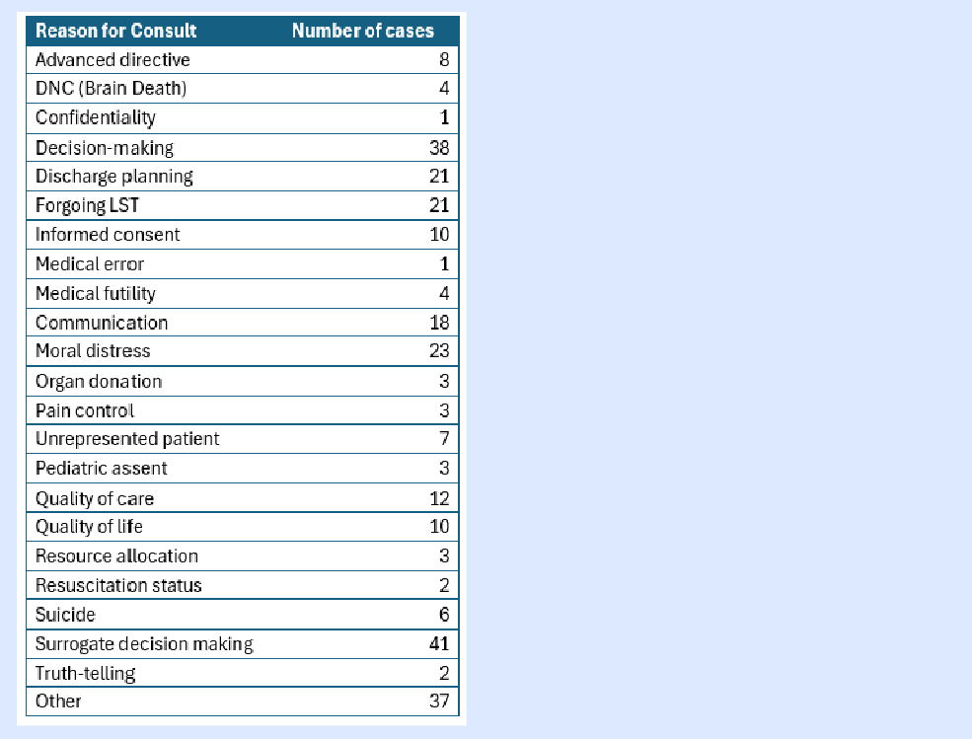
I am most proud of the collaborative, interprofessional, and transdisciplinary nature of our clinical ethics team and consultation service. While we have a single consultant model, which means one ethics consultant is on call at a time, we routinely include our colleagues when the ethical issues are controversial, especially if we know one of our colleagues might disagree with our ethical analysis; and if the consultant on call may have a perceived perspective (because of their specialty). We discuss every consult with the broader ethics team weekly to ensure consistency in ethical approach independent of the consultant on call. As the table demonstrates teams consult with us to help with a range of ethical issues. In addition to the categories identified, reasons (in the other category) include treatment over objection, team dynamics, visitation, and
This dataset reflects the diverse and complex reasons clinicians, patients, and families request ethics consultations. The most common consults center on surrogate decision making (41 cases) and decision-making capacity and authority (38 cases).
Together, these categories represent a substantial proportion of the total consults and highlight the ethical challenges that arise when patients are unable to speak for themselves or when there is uncertainty or disagreement about who should make medical decisions and how those decisions should be guided. Complementing these findings, moral distress among clinicians (23 cases) emerged as another frequent reason for consultation, indicating that bedside teams often seek ethical guidance when experiencing internal conflict or distress about the care being delivered.
safety concerns. ~ Margie


Nursing Ethics Council News
To change your subscription preferences to our newsletter, please email
olivia_harrington@urmc.rochester.edu
Stay updated with the Nursing Ethics Council: a sub-council of the Professional Nursing Council
Miss something? View past newsletters here

