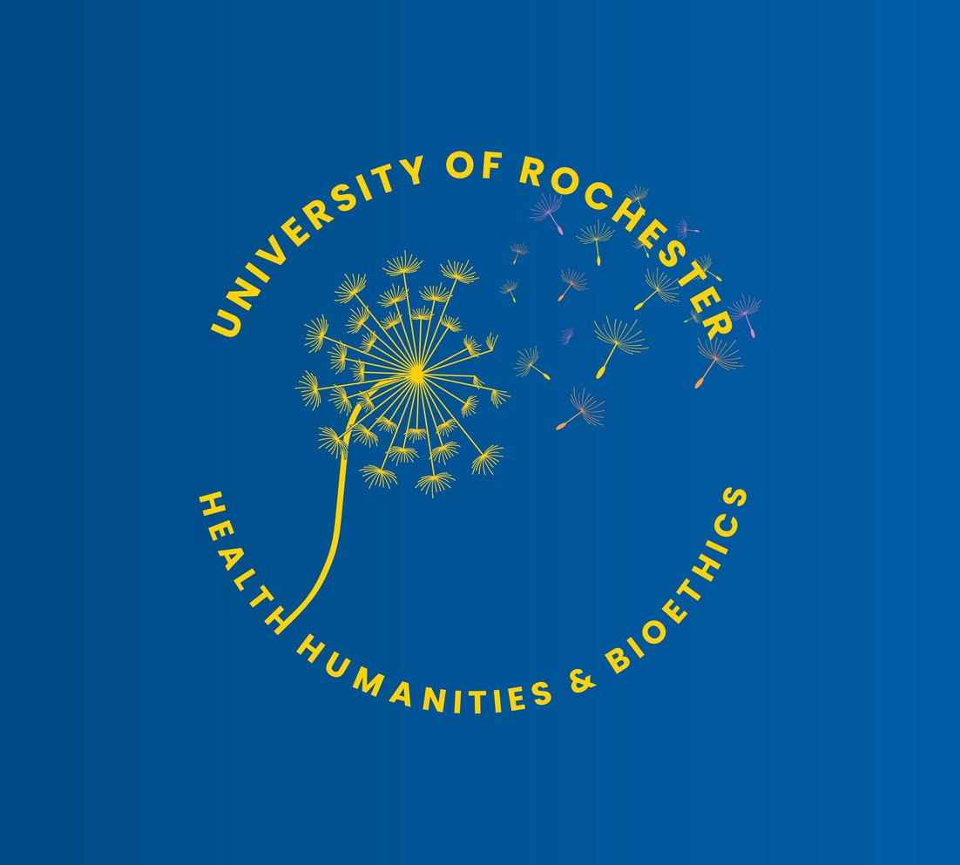
CLINICAL BIOETHICS PROGRAM NEWSLETTER
Vol. 2, Issue 2, May 2024
Case Consultation
Staff
Policy
Clinica
l
Support
Ethics
Community Engagement
Education

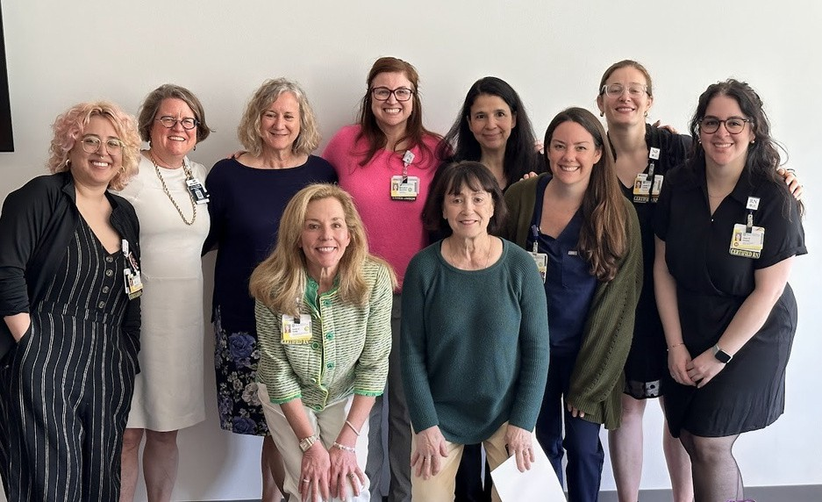
ETHICS LIAISON PROGRAM NOW ACCEPTING APPLICATIONS!
MESSAGE FROM THE DIRECTOR
“Good leaders inspire people to have confidence in their leader. Great leaders inspire people to have confidence in themselves.” Eleanor Roosevelt

We have packed this newsletter with exciting news and helpful information – new programs to support clinical teams, links to clinical ethics educational opportunities, ethics resources, a tip for elevating patient autonomy, and celebrations! I say we because this is a team effort, and we are a community of great leaders, leaders who are inspiring and elevating others. We have lots to celebrate! So many of us are attending to ethical practice and engaging in activities focused on the moral issues in patient care. As you may remember, we surveyed nurses and APPs about the ethical climate across the UR enterprise. We listened to those who answered our questions and are working diligently to intentionally infuse ethics into everyday practice. We hope you will continue to support your team members to raise ethical questions and request ethics support/education/debriefing.
The ethics team is growing to meet your needs. We welcome those who are interesting in getting more involved to reach out. If you want to learn more about the Department of Health Humanities & Bioethics, including the Schyve Center for Bioethics and our Clinical Ethics Program, check out our new promotional video.
If you haven’t noticed, the theme of this newsletter is elevating others. Our clinical tip is about how to empower patients who have preferences about who they want to serve as their agent after their death, if they prefer someone other than their next of kin.
--Dr. Margie Hodges Shaw
We are now accepting applications for the 2024-2025 Ethics Liaison program. The deadline to apply is June 23rd.
Questions? Ask Shelly_Baker@urmc.rochester.edu or Laine_Dinoto@urmc.rochester.edu
Congratulations Ethics Liaison Class of 2024!!

ADVANCED CERTIFICATE IN CLINICAL ETHICS NOW ACCEPTING APPLICATIONS!
Our Advanced Certificate in Clinical Ethics is now accepting applications! The application deadline is June 15th. Questions? Ask Margie_Shaw@urmc.rochestere.edu

ELEVATING AUTONOMY
by Dr. Anna Kenny
When patients die, NY law requires that the legal next of kin (NOK) be notified and charged with decisions about their remains, even if they are estranged (first NOK excluded if active order of protection from patient, or concern for NOK involvement in cause of death).
The NYS DOH 5211 form
This form allows a person to designate an agent other than NOK to serve this role, which includes such decisions as preferred funeral home, cremation versus burial, and wish for or against an autopsy (if not legally required, as in Medical Examiner cases).
The form is straight forward, and does not require a lawyer or notary public, but simply the patient’s name and signature, their designated agent’s name, and two adult witnesses’ signatures. The agent must sign before death to enact them as agent but can be at a different time than when witnessed. If never co-signed, patient's wishes about burial/autopsy would stand but the agent election portion would not be valid.

Nurses Week May 6-12, 2024

We are still celebrating you
Thank you to all nurses!
We deeply appreciate all that you do every day of the year!

ETHICS SUPPORT

What is a Code Lavender?
by Lauren Curren, NP
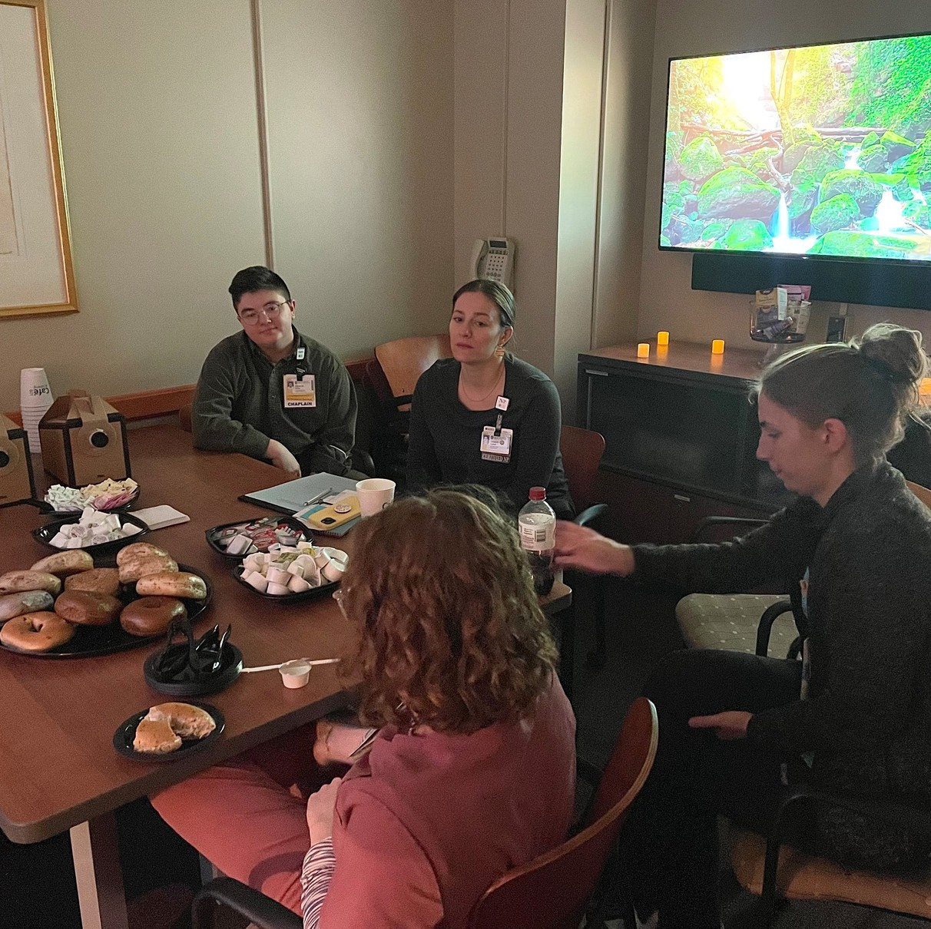
A code lavender is a response to a crisis, or tragic event (death, code), or any other significant clinical event. It is a crisis intervention for the members of the health care team. Support includes purposeful physical presence, individual and/or team support, debriefing and follow-up care, integrative therapies, prayer, or other healing interventions. 412-00 will pilot this process, with the hopes of disseminating it throughout the hospital. .
Developed by Lauren Curren, NP in Inpatient Palliative Care and Ethics Champion, with special thanks to Dr. Rachel Diamond, Dr. Margie Shaw, and 412 nursing leadership for their support.

WHO IS JANE?
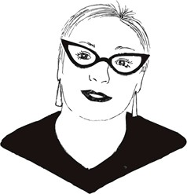
Have a non-urgent ethics question?
Ask Jane! This service honors Professor Emeritus Jane Greenlaw’s extraordinary contributions to ethics education, medical humanities, and the URMC clinical ethics consult service. HHBe Is expanding this service. Stay tuned to meet Jane’s friend Alice!

UPCOMING UR EVENTS
June 5, 2024
12:00-1:00PM Bioethics Grand Rounds: Epistemic Humility & Rational Disagreement
Richard Feldman, PhD
Philosophy Department, University of Rochester
June 14, 2024
12:00-1:00PM Health Humanities Grand Rounds: Why They Blow the Whistle
Carl Elliott, MD, PhD
Bioethics & Philosophy, University of Minnesota
September 4, 2024
How to Call an Ethics Consult
Clinical ethics consults are available 24 hours a day, 7 days a week:
Web Paging - Located under Ethics
SMH Operator/Paging Service -
(585) 275-2222 & ask them to page the Clinical Ethics Consultant on call.
12:00-1:00PM Bioethics Grand Rounds: Robert Swindler, PhD Former General Counsel, St. Peter’s Health
Partners; General Counsel, St. Joseph’s Health; New York State Task Force on Life and the Law

Miss something? View past newsletters here

ELEVATING ETHICS

FF Thompson Ethics Collaboration
The FF Thompson Board of Directors approved appointment of Dr. Nicholas R. Mercado, Assistant Professor of Health Humanities and Bioethics, to the FF Thompson Ethics Committee effective May 1st, 2024. He and Dr. OJ Sahler serve on both FF Thompson and SMH ethics committees.

2ND ANNUAL ETHICS IN HEALTHCARE CONFERENCE
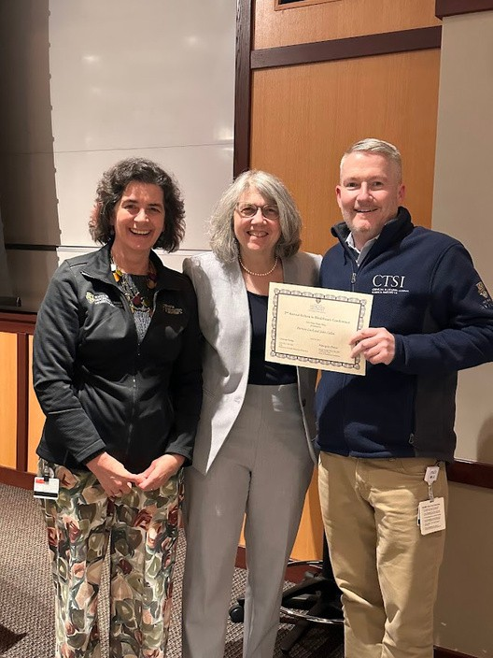
Thank you to everyone who attended our Ethics in Healthcare Conference!
With over 100 attendees, we are looking forward to breaking that record next year!
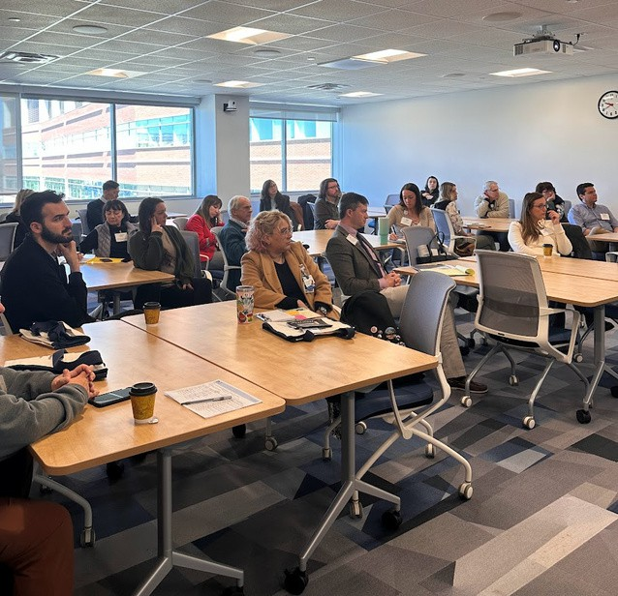
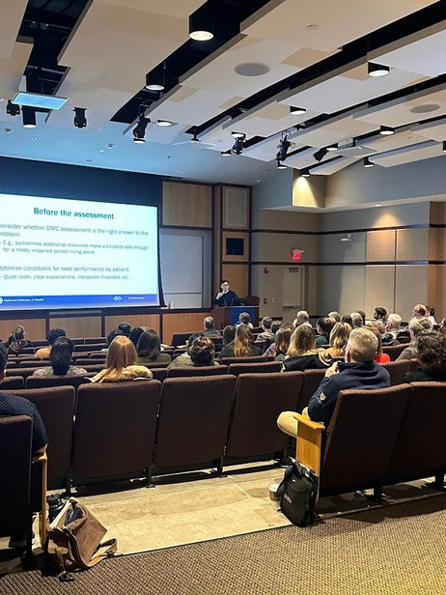
Please save the date for next year!
Friday, May 2nd, 2025

ELEVATING JUSTICE
In this latest issue of the Health Equity Update, a panel of 15 high-school students recruited by URMC’s Office of Health Equity Research discuss child-health issues and inform the work of scientists.

To subscribe or unsubscribe to our newsletter, please email
erin_lee@urmc.rochester.edu

