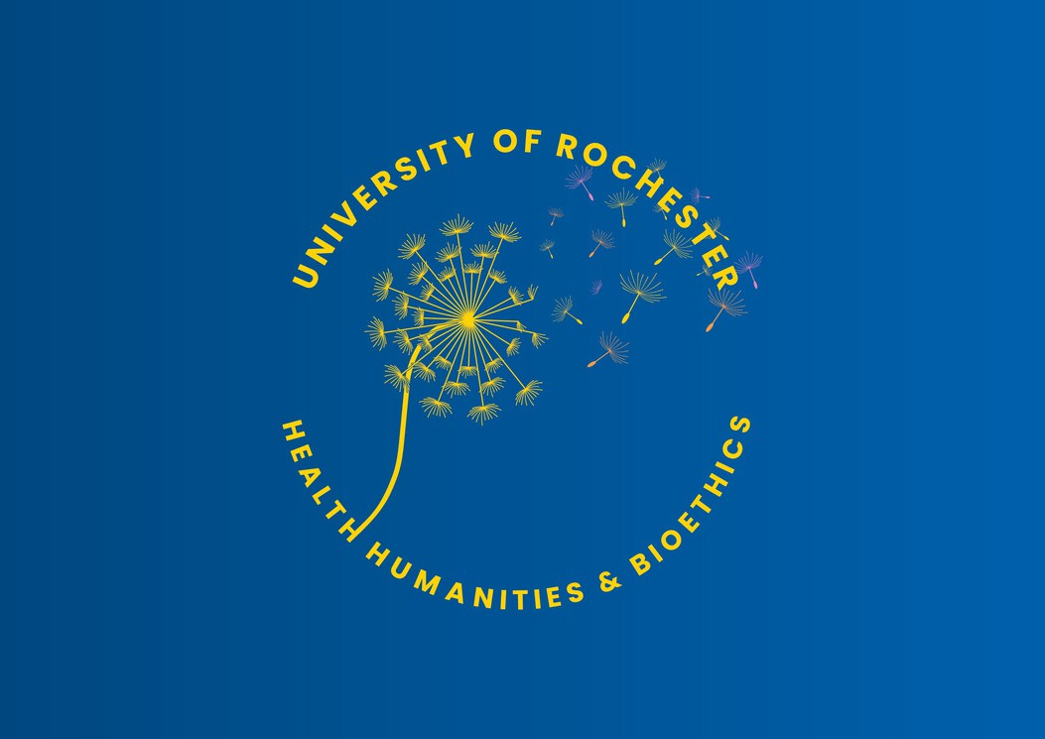
CLINICAL BIOETHICS PROGRAM NEWSLETTER

Vol. 2, Issue 1, February 2024

Message from the Director
“The first point he [poet Loren Eiseley] wishes to make [in his book the Star Thrower] is that in order to be a scientist, an artist, a doctor, a lawyer, or what-have-you, one has first to be a human being.”
W.H. Auden citing Eiseley, Loren C. The Star Thrower. New York: Times Books, 1978.
Most of you have heard me say, multiple times – maybe too often, that taking care of patients is a moral endeavor. Your clinical judgment includes moral judgment.
Our knowledge comes from laboratory experiments and lived experiences, from what we see and what we read, from the people around us, including our family members, our teachers, our friends. As the political commentator, David Brooks, recently observed: Science helps us explore the natural world; the social sciences help us consider population level behaviors and systems; the humanities and arts help us develop the capacity to imagine the world of others. “[P]erception is a creative act. You take what you’ve experienced during the whole course of your life, the models you’ve stored up in your head, and you apply them to help you interpret all the ambiguous data your senses pick up, to help you discern what really matters in a situation, what you desire, what you find admirable and what you find contemptible.” He goes on to say that perception is a moral act, something Philosopher Nancy Sherman explains in The Fabric of Character: Aristotle's Theory of Virtue: “It is that our judgement of particular cases and our knowledge of how to 'compose the scene' is itself a part of the moral response In this sense, character is expressed in what one
sees as much as in what one does.”
Seeing differently, or at least curiosity about how others see differently, is important in clinical practice. The question “how can they possibly think this (whatever this is) is okay?”, should led to questions, an attempt to understand, rather than explanations, an attempt to explain.
Spring is the season of growth, a terrific time to expand one’s capacity and curiosity, further develop the skills to see and think differently. We have expanded our educational offerings in the Department of Health Humanities & Bioethics (open to URMC employees). Explore the courses in our MS program in Health Humanities, such as Stories in Healthcare: Clinicians, Patients, and Narrative Medicine; or Visual Arts and Healthcare: Framing the Field. Apply for the Ethics Liaison Program! Sign up for our new Advanced Certificate Program in Clinical Ethics! If your schedule currently only permits one day, attend the 2nd Annual Paul M. Schyve Center for Bioethics Conference, where you will meet other clinicians who are curious about, and committed to, continuing to develop and refine their knowledge and skills necessary to appropriately respond to the moral and ethical issues that arise in the care of patients.
--Dr. Margie Hodges Shaw, J.D., Ph.D.
Case

Our Mission
The program for Clinical Ethics supports ethical education in the hospital. Clinical & translational research involves ethical cases, the SMH ethics committee, and the SMH ethics consultation service.

2nd Annual Schyve Center for Bioethics Conference
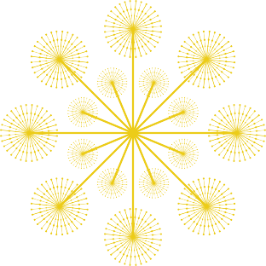
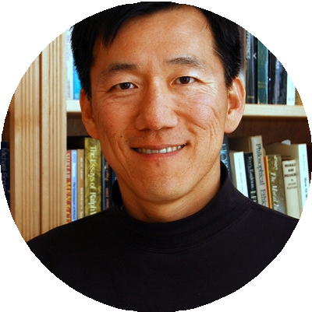
Registration will be opening soon!
Consultation
Policy
Ethics
Community Engagement
Clinical S Staff rt
uppo

Education
Please join us for CME/CNE workshops, poster session, networking opportunities and plenary sessions featuring Dr. Scott Kim, MD, PhD, from the Department of Bioethics at NIH.

The Sovie Center is delighted to extend an APP-sponsored registration opportunity for this year's conference (valued at $75). A recipient will be randomly chosen on Sunday, February 25th, providing a generous 60-day notice for any necessary schedule adjustments. To qualify, applicants are required to offer a meaningful response to the question, "Why do you wish to attend?" and must maintain a positive employment status.
Please submit the form to participate!
Want to get an email when the ethics liaison program application process opens? Please email christine_donnelly@urmc.rochester.edu

Ethics Essentials Elevating Ethics

This past fall, URMC nurses & APPs participated in a survey addressing our current ethical climate. The Nursing Ethics Sub Council will use the results to help guide impact. This quality improvement work will be ongoing, and staff will be resurveyed over time to track the impact of interventions.
Thank you to all who participated!
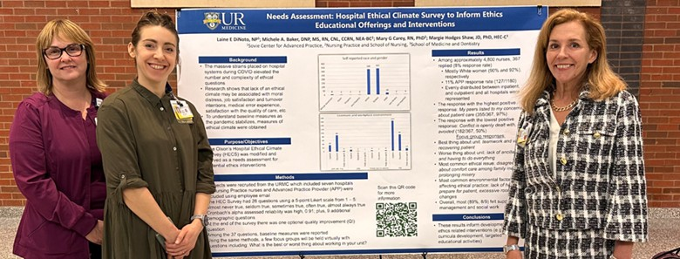

How to Call an Ethics Consult
Clinical ethics consults are available 24 hours a day, 7 days a week:
Web Paging - Located under Ethics
SMH Operator/Paging Service -
(585) 275-2222 & ask them to page the Clinical Ethics Consultant on call.

UPCOMING UR EVENTS
February 21, 2024 Examining the Past: The Strugg le for Racial Equity
5:30-8:00PM at URMC
Wendy Gonaver, PhD
February 28, 2024 -
6:00PM Paul M. Schyve, MD Center for Bioethics Grief Series Reel Mind Film Screening: Evelyn

PNC Sub Council: Nursing Ethics
We are ecstatic to share URMC’s Professional Nursing Council voted unanimously in December 2023 to approve the addition of a Nursing Ethics Sub council. Members of this council are active or previous graduates of the Ethics Liaison internship or the advanced certificate in ethics course. The inaugural meeting was held in January. Initial work fill focus on reviewing results from the Fall 2023 Ethical Climate Survey with subsequent recommendations for potential interventions.
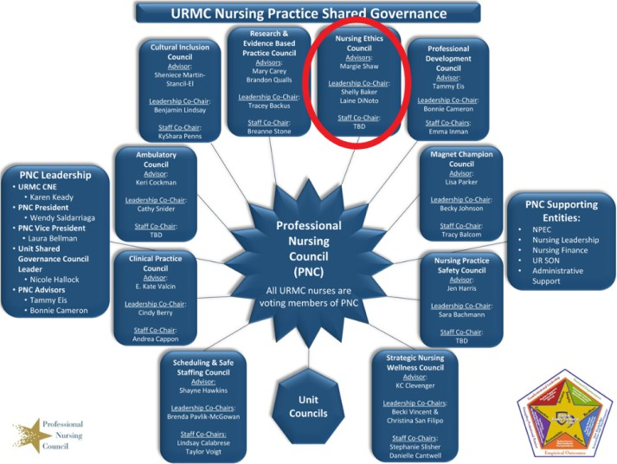
Carly Eiduson, MS4 will present at the Pediatric Academic Society Annual National Conference in Toronto on May 5th! Nurses’ Experiences Influence Their Opinions on the Ethical
Use of Pediatric Dialysis

Did You Know...
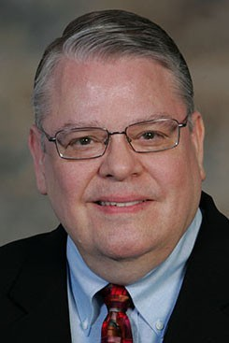
Dr. Paul M. Schyve, MD, made his visionary gift to start the Paul M. Schyve, MD Center for Bioethics 10 years ago. Thank you, Dr. Schyve, for your continued support of clinical ethics at URSMD and URMC!

March 6 2024 -
12:00-1:00PM Bioethics Grand Rounds: Jessica Shand, MD, MHS Associate Chief Wellbeing Officer, University of
Rochester
March 11, 2024 - Paul M. Schyve, MD Center for Bioethics Grief Series 5:00 PM Thomas Lynch, Poetry Reading of Bone Rosary
March 12, 2024 - Paul M. Schyve, MD Center for Bioethics Grief Series 12:00-1:00 PM Department of Medicine Sussman Lecture
Thomas Lynch, Essayist, Poet & Funeral Director
The Depositions
April 3, 2024 - Bioethics Grand Rounds: Richard Demme, MD
12:00-1:00PM Department of Medicine, Nephrology, University of Rochester
April 16, 2024 - Paul M. Schyve, MD Center for Bioethics Grief Series Juliet Hook, PhD
Why Erica Garner Also Couldn’t Breathe: Maternal Grief & Black Politics

Miss something? View past newsletters here

Examining the Past: The Struggle for Racial Equity at URMC
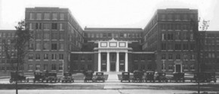
Uncover URMC’s past & work to build a more equitable future. You’re invited to a powerful evening exploring systemic racism at the university of Rochester Medical Center. Presented by Wendy Gonaver, PhD, Postdoctoral Associated in the Department of Health Humanities & Bioethics.
Register here

Read the most recent Health Equity Update
Faculty and staff members across URMC are working to reduce health inequities through research, education, and improved access to care. These updates provide snapshots of our work with community partners toward the ultimate goal of equal life expectancy for all.
To subscribe or unsubscribe to our newsletter, please email
erin_lee@urmc.rochester.edu

