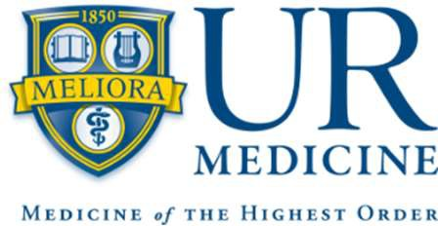

Nursing Practice, Sovie Center, and Department of Health Humanities & Bioethics Ethics Liaison Program 2025/2026
Eligibility
- Any person employed by URMC in good standing
- Minimum of 1.5 years employment at Strong Memorial Hospital or its related affiliates
- Given the demands, students are not eligible for this program. We welcome you to apply once you have completed your program of study.

Purpose
The purposes of this program are to:
- Improve knowledge of basic ethics standards in common scenarios in the clinical practice setting.
- Ability to recognize and address moral distress and cases that require early intervention to minimize future ethical problems.
- Apply a standard format to analyze an ethical dilemma.
- Develop skills to facilitate small group discussions in 2 types of settings— discuss current concerns with team AND debrief staff about difficult cases.
- Recognize the available resources at SMH for ethics-related concerns and access them as appropriate.

Program Components
- Paid time for participation at educational sessions and work on ethics-related project (approved by the Director of the Clinical Ethics program and applicant’s supervisor).
- Collaborative teamwork to complete a project using team science.
- Development of project (i.e., abstract and poster) for presentation.
- Attend all nine classes held on the 2nd Wednesday of the month from 0800-1200, devoted to study and application of content (Contact Hours = 36 hours).
  - Ethics related topics presented by clinical experts
  - Journal review evidence-based articles
  - Use of library resources, project planning, work on projects and educational sessions
- Mentorship by experienced ethics liaisons, support from clinical bioethicist.

If you have any questions about the internship contact mailto:laine_dinoto@urmc.rochester.edu.

Coordinating instructors:
Shelly Baker DNP, MS, RN, CNL, CCRN, NEA-BC
Laine DiNoto, CPNP-PC

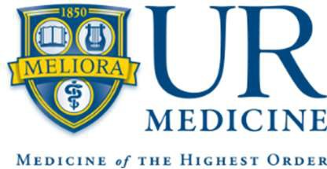

Nursing Practice, Sovie Center, and Department of Health Humanities & Bioethics Application for Ethics Liaison Program
2025/2026

APPLICATION FORM MUST BE RECEIVED BY May 1st, 2025 @ 5:00 PM
Applicants will be notified of decision by May 16th, 2025.

Name: Preferred contact:

Unit/Department: Service: Hospital:

Pathways Level: | II | III | Senior III
 | IV | V | VI

Highest Clinical Degree Level: Associate’s Bachelor’s
Master’s Doctoral (please identify: )

I do not have another kind of clinical degree
Highest non-clinical Degree Level: Associate’s Bachelor’s
Master’s Doctoral (please identify: )

I do not have another kind of degree

Please list any professional certifications you have earned:

Duration of service to unit/department: Duration of service to URMC: Years of clinical experience:

Previous ethics experience/background/coursework:

Please attach a current copy of your resume to this application.

Additional Questions (Limit answer to 100 words for each question):
- What are some ethical challenges or concerns you frequently encounter in your clinical setting?

- Have you observed situations where moral distress impacted patient care or staff well-being? If so, describe briefly.

- Describe opportunities to improve ethics-related discussions, debriefings, or decision-making in your work environment?

- What ethics-related topic or issue are you most interested in exploring further?

- Do you have an idea for a potential project? If so, describe it in a few sentences. If not, what support would help you identify one?

General Overview
By completing this application, the applicant acknowledges the programs requirements, which include:
  - Attendance at in person planned educational and application experiences (2nd Wednesday of the month from 0800-1200).
    - Time to attend these sessions must be negotiated with the direct supervisor IN ADVANCE of the planned sessions.
      - The dates of the program are: 9/10, 10/8, 11/12, 12/10, 1/14, 2/11, 3/11, 4/8, 5/13
    - The duration of the project is 9 months with a completion date of May 13, 2026.
  - Independent reading and investigation of clinical ethics question.
  - Presentation of project to program group and unit/service leadership and staff
  - Opportunity to present project at Annual Schyve Center Bioethics Conference and National Nurses Week poster sessions.

This application will be blinded, scored, and ranked by a committee with members of the Clinical Ethics Team and nursing practice leadership. The Committee will then select the most competitive applicants for inclusion in the Ethics Liaison Program.

I commit to full participation in the nine-month timeframe and activities required for this program.
I commit to two years of employment within my current hospital after completing the internship.

Print Name of Applicant Date

Signature of Applicant

Completed by Manager(s):

I support the applicant’s request for participation in the one-year internship and will facilitate attendance at monthly sessions and provide the support needed for the applicant to successfully complete the internship program requirements.
Please provide feedback on this application. Is the applicant a good fit for this internship? Attach additional sheets, if necessary.

Print Name of Nurse Manager/Supervisor Date

Signature of Nurse Manager/Supervisor

Completed by Director of Nursing/Chief Advanced Practice Officer/Social Work and Patient & Family Services Director/Other:

I support the applicant’s request for participation in the one-year internship.

Please provide feedback on this application. Is the applicant a good fit for this internship? Attach additional sheets, if necessary.

Print Name of Director Date

Signature of Director
If you have further questions or once actual signatures are obtained, send the completed application form to:

Department of Health Humanities & Bioethics Box 676, Attn: Laine DiNoto or via email to laine_dinoto@urmc.rochester.edu

Coordinating instructors:
Shelly Baker DNP, MS, RN, CNL, CCRN, NEA-BC michele_baker@urmc.rochester.edu Laine DiNoto, CPNP-PC laine_dinoto@urmc.rochester.edu

