Health Equity in Education

Primary Objective
As a teaching hospital, the University of Rochester Medical Center trains doctors, nurses, advanced practice providers, and other health care providers who serve patients. To achieve the best health outcomes for all patients, the URMC is working to make education about health equity and community a consistent and exceptional part of all educational programs. The learning programs at URMC are quite diverse, therefore health equity curriculum cannot take a one-size-fits-all approach. Instead, URMC health equity education improvement is centered around a curriculum framework.

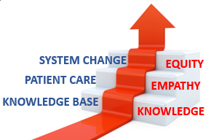
The KEE Curriculum Framework for Health Equity
Objectives | Competency
Improved Health-Related Social Drivers | Learners understand social drivers and strive to address potential detrimental pathways from drivers to disparities in health outcomes.
Optimal Health Care Delivery | Learners transfer concepts of health equity to the day-to-day care of patients so that each patient has an equal opportunity to achieve their highest level of health.
Changing Systems – Pop Health | Learners participate in the design, implementation, or evaluation of health equity strategies based on population data and using quality improvement methodologies and/or policy and systems change.
The KEE (Knowledge, Empathy, Equity) Curriculum Framework for health equity education was created to assist educational programs in building discipline-specific learning tools that are consistent with national competencies and standards for health equity education. To achieve competency, learners must acquire the basic knowledge, apply that learning to patient care, and then work towards system change.

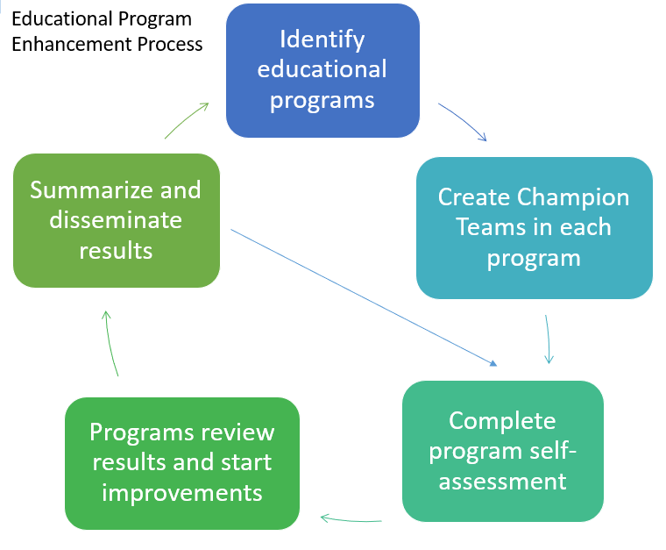
Implementation
Creating a learning environment that facilitates exemplar and replicable education in health equity is critical in supporting equitable health systems. The KEE Curriculum is being implemented throughout educational programs at URMC in Cohorts. Educational programs identify a champion team to take the program self-assessment. Results show opportunities for improvement that champion teams develop improvement plans to address. Results of program health equity improvements are summarized and shared with other programs for duplication.

Health Equity Education
Residency Program
Perinatal Dentistry Residency
ABOUT THE PROGRAM
Cohort #2
Director: Jin Xiao

The Perinatal Dentistry Residency Program at the University of Rochester Medical Center is dedicated to advancing equitable oral healthcare for pregnant individuals. The program integrates interdisciplinary collaboration to address oral-systemic connections and reduce health disparities in maternal and infant populations. Through this focus, the Perinatal Dentistry Residency aims to equip residents with the clinical expertise, communication skills, and health equity mindset necessary to provide compassionate, culturally responsive, and patient-centered care.

IMPROVEMENT PLANS
After reviewing the Knowledge, Empathy, and Equity Curriculum Framework and completing a baseline self-assessment of health equity in efforts in the Perinatal Dental Residency Curriculum, they have submitted the following efforts for improvement planning:
- Patient-Empowered Advisory Committee (PEAC)
- Standardized Patient(s) Simulation

THE PROCESS
The program launched a pilot implementation of Standardized Online Patient for Healthcare Interaction Education (SOPHIE), an interactive communication training tool, to strengthen residents’ skills in managing complex, sensitive, and patient-centered interactions. This initiative aimed to improve residents’ confidence in communication and provide measurable learning outcomes.

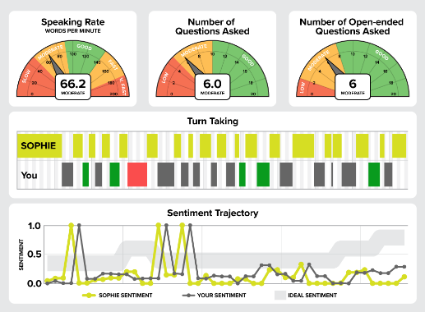
Ten residents participated in the pilot, each completing five immersive perinatal patient scenarios designed to simulate real-world communication challenges. The program used the SE-12 self-efficacy questionnaire to measure residents’ confidence across twelve key communication domains, including active listening, empathy, and shared decision-making. Post-survey results demonstrated meaningful improvement, with more residents reporting increased confidence in managing complex or emotionally sensitive conversations.

In addition, structured focus groups were conducted to capture residents’ reflections on SOPHIE’s usability. Participants consistently described the tool as highly beneficial for practicing communication skills. One resident shared, “it felt like a real patient encounter, but without the pressure of saying the wrong thing.” Overall, this pilot demonstrated that simulation-based learning can significantly enhance residents’ preparedness to deliver equitable, patient-centered oral healthcare.

NEXT STEPS
Moving forward, the Perinatal Dentistry Residency aims to expand and enhance SOPHIE’s functionality through additional funding and development. Planned improvements include incorporating dynamic facial expressions, realistic nonverbal communication, and an expanded library of clinical cases. These enhancements will deepen simulation authenticity and provide residents with more robust opportunities for applied learning. The program also plans to implement longitudinal evaluations to measure sustained communication skill growth.
