Health Equity in Education

Primary Objective
As a teaching hospital, the University of Rochester Medical Center trains doctors, nurses, advanced practice providers, and other health care providers who serve patients. To achieve the best health outcomes for all patients, the URMC is working to make education about health equity and community a consistent and exceptional part of all educational programs. The learning programs at URMC are quite diverse, therefore health equity curriculum cannot take a one-size-fits-all approach. Instead, URMC health equity education improvement is centered around a curriculum framework.

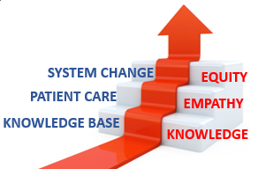
The KEE Curriculum Framework for Health Equity
Objectives | Competency
Improved Health-Related Social Drivers | Learners understand social drivers and strive to address potential detrimental pathways from drivers to disparities in health outcomes.
Optimal Health Care Delivery | Learners transfer concepts of health equity to the day-to-day care of patients so that each patient has an equal opportunity to achieve their highest level of health.
Changing Systems – Pop Health | Learners participate in the design, implementation, or evaluation of health equity strategies based on population data and using quality improvement methodologies and/or policy and systems change.
The KEE (Knowledge, Empathy, Equity) Curriculum Framework for health equity education was created to assist educational programs in building discipline-specific learning tools that are consistent with national competencies and standards for health equity education. To achieve competency, learners must acquire the basic knowledge, apply that learning to patient care, and then work towards system change.

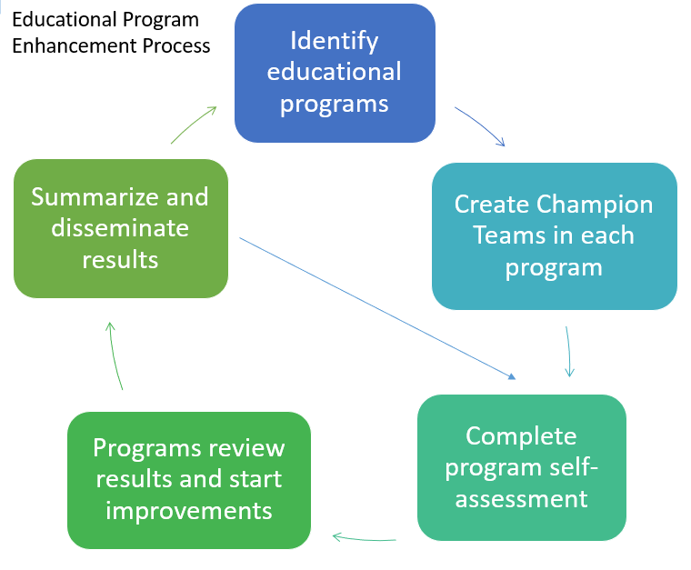
Implementation
Creating a learning environment that facilitates exemplar and replicable education in health equity is critical in supporting equitable health systems. The KEE Curriculum is being implemented throughout educational programs at URMC in Cohorts. Educational programs identify a champion team to take the program self-assessment. Results show opportunities for improvement that champion teams develop improvement plans to address. Results of program health equity improvements are summarized and shared with other programs for duplication.

Health Equity Education
Residency Program
Psychiatry Residency
ABOUT THE PROGRAM
Cohort #2
Director: Jeffrey Iler, M.D.

Department of Psychiatry
University of Rochester Medical Center
300 Crittenden Boulevard
Rochester, NY 14642
Box PSYCH

The Psychiatry Residency Program at the University of Rochester Medical Center has a central focus on holistic and humane care. As the birthplace of the Biopsychosocial Model of care, residents are taught to embrace multidisciplinary perspectives and consider each patient in their own context. Psychiatric residents are set apart by their involvement with community engagement efforts.

The Department of Psychiatry aspires to contribute to measurable improvements in community mental health and well-being, by creating meaningful partnerships among community members. By working together and with members of the community, psychiatric residents are able to utilize their strengths in education, service, and research to reduce mental illness risk factors, improve access to care, and contribute to the betterment on mental well-being.

IMPROVEMENT PLANS
After reviewing the Knowledge, Empathy, and Equity Curriculum Framework and completing a baseline self-assessment of health equity in efforts in the Psychiatry Residency Curriculum, they have submitted the following efforts for improvement planning:
- Community Resource Document
  - Create a singular electronic database that describes various resource options for patients for residents to better refer patients to.
- Experiential Learning
  - Immersive learning for residents at local Rochester community organizations, like cultural centers, assisted living facilities, and houses of worship.

THE PROCESS
The Psychiatry Residency Program focused a majority of their efforts on planning for experiential learning visits for their residents beginning in April 2026. Right now, the members of the Psychiatric Residency team are determining which organizations to collaborate with and how to assess this effort’s impact on their residents and community partners. While the Psychiatric Residency team decided to not create a new community resources document, to avoid duplicative efforts, they are promoting the use of already created community resource documents for their residents to use more frequently.

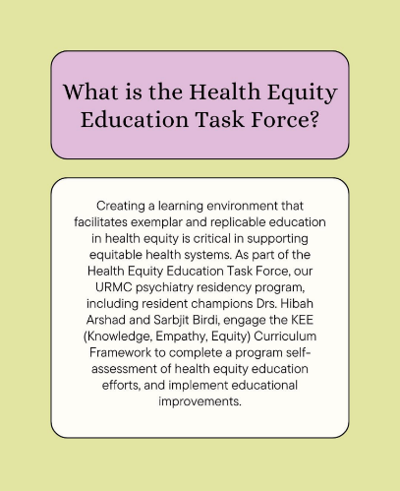
The Psychiatry Residency Program successes was a culmination of consistent meetings and active involvement of their residents, including resident representativeness from their Health Equity Education Task Force. Through their consistent work, the Psychiatric Residency team has already secured time in all residents’ afternoon didactic schedule to have them participate in experiential learning.
