Health Equity in Education

Primary Objective
As a teaching hospital, the University of Rochester Medical Center trains doctors, nurses, advanced practice providers, and other health care providers who serve patients. To achieve the best health outcomes for all patients, the URMC is working to make education about health equity and community a consistent and exceptional part of all educational programs. The learning programs at URMC are quite diverse, therefore health equity curriculum cannot take a one-size-fits-all approach. Instead, URMC health equity education improvement is centered around a curriculum framework.

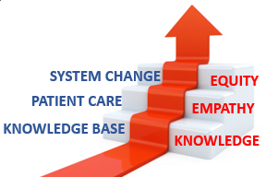
The KEE Curriculum Framework for Health Equity
Objectives | Competency
Improved Health-Related Social Drivers | Learners understand social drivers and strive to address potential detrimental pathways from drivers to disparities in health outcomes.
Optimal Health Care Delivery | Learners transfer concepts of health equity to the day-to-day care of patients so that each patient has an equal opportunity to achieve their highest level of health.
Changing Systems – Pop Health | Learners participate in the design, implementation, or evaluation of health equity strategies based on population data and using quality improvement methodologies and/or policy and systems change.
The KEE (Knowledge, Empathy, Equity) Curriculum Framework for health equity education was created to assist educational programs in building discipline-specific learning tools that are consistent with national competencies and standards for health equity education. To achieve competency, learners must acquire the basic knowledge, apply that learning to patient care, and then work towards system change.

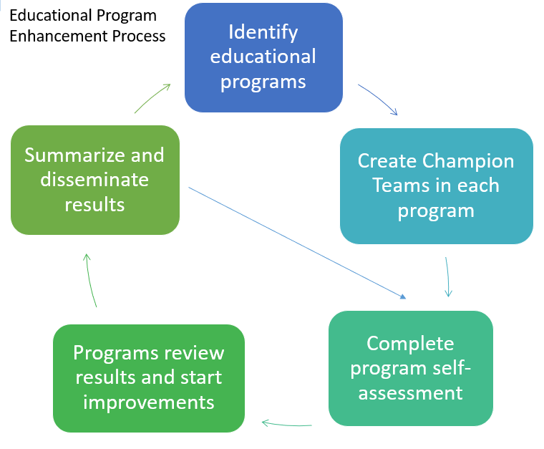
Implementation
Creating a learning environment that facilitates exemplar and replicable education in health equity is critical in supporting equitable health systems. The KEE Curriculum is being implemented throughout educational programs at URMC in Cohorts. Educational programs identify a champion team to take the program self-assessment. Results show opportunities for improvement that champion teams develop improvement plans to address. Results of program health equity improvements are summarized and shared with other programs for duplication.

Health Equity Education
Residency Program
Radiology Residency
ABOUT THE PROGRAM
Cohort #2
Diagnostic Radiology - Director: Akshya Gupta, M.D.
Interventional Radiology - Director: Marco Ertreo, M.D.

Department of Imaging
Sciences Residency Program
University of Rochester
601 Elmwood Avenue
Imaging Sciences - Box 648
Rochester, NY 14642-8648

The Diagnostic Radiology Residency Program at the University of Rochester Medical Center includes an extensive option of rotations, research opportunities, and educational activities in their training curriculum. Their rigorous curriculum contributes to directly to their mission of providing an excellent and supportive training environment, leading to service of the highest order for their patients.

The Interventional Radiology Residency Program at the University of Rochester Medical Center is guided by four key pillars: patient care, education, research, and inclusivity. Through their pillars, they aim to teach their residents on how to provide exceptional patient care, create immersive learning environments, and maintain a robust research environment that allows them to improve patient outcomes.

IMPROVEMENT PLANS
After reviewing the Knowledge, Empathy, and Equity Curriculum Framework and completing a baseline self-assessment of health equity in efforts in the Radiology Residency Curriculum, they submitted the following efforts for improvement planning:
- Create a Lexicon/Glossary of Radiology Terms
  - Providing a resource that defines terms commonly seen in radiology reports.

THE PROCESS
Both radiology groups collaborated on this process and have successfully completed a lexicon of terms for both interventional radiology-specific and diagnostic radiology-specific reports.

Future work will be done to locate an appropriate spot to host the digital lexicon for patient access. Potential ideas involve including a QR Code at the bottom of patient’s reports, which direct them to an online PDF page including the identified terms. Moreover, this page may be house on the University of Rochester Medical Center’s Center for Community Health & Prevention website, specifically on their “Optimizing Health for All” page.

