Health Equity in Education

Primary Objective
As a teaching hospital, the University of Rochester Medical Center trains doctors, nurses, advanced practice providers, and other health care providers who serve patients. To achieve the best health outcomes for all patients, the URMC is working to make education about health equity and community a consistent and exceptional part of all educational programs. The learning programs at URMC are quite diverse, therefore health equity curriculum cannot take a one-size-fits-all approach. Instead, URMC health equity education improvement is centered around a curriculum framework.

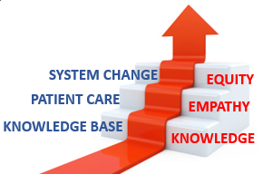
The KEE Curriculum Framework for Health Equity
Objectives | Competency
Improved Health-Related Social Drivers | Learners understand social drivers and strive to address potential detrimental pathways from drivers to disparities in health outcomes.
Optimal Health Care Delivery | Learners transfer concepts of health equity to the day-to-day care of patients so that each patient has an equal opportunity to achieve their highest level of health.
Changing Systems – Pop Health | Learners participate in the design, implementation, or evaluation of health equity strategies based on population data and using quality improvement methodologies and/or policy and systems change.
The KEE (Knowledge, Empathy, Equity) Curriculum Framework for health equity education was created to assist educational programs in building discipline-specific learning tools that are consistent with national competencies and standards for health equity education. To achieve competency, learners must acquire the basic knowledge, apply that learning to patient care, and then work towards system change.

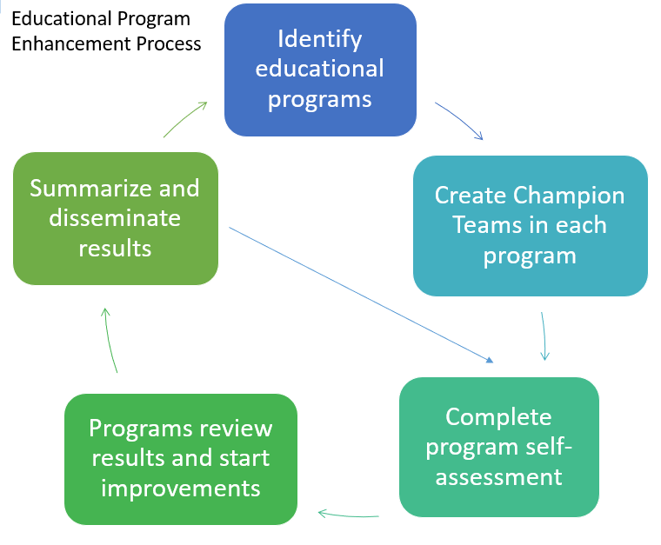
Implementation
Creating a learning environment that facilitates exemplar and replicable education in health equity is critical in supporting equitable health systems. The KEE Curriculum is being implemented throughout educational programs at URMC in Cohorts. Educational programs identify a champion team to take the program self-assessment. Results show opportunities for improvement that champion teams develop improvement plans to address. Results of program health equity improvements are summarized and shared with other programs for duplication.

Health Equity Education
Residency Program
Psychiatry Residency
ABOUT THE PROGRAM
Cohort #2
Director: Hani Rashid, M.D.

Department of Urology
University of Rochester Medical Center
602 Elmwood Avenue
Rochester, NY 14642
Box 656

The Urology Residency Program at the University of Rochester Medical Center is a 6-year program, including 1 year of fully funded research and 5 years of clinical training across all realms of urology.

The Urology Residency Program has built its curriculum with a focus on educational and training experiences that encompass all aspects of urology. These aims are made possible through their use of Grand Rounds, Journal Clubs, the GU Oncology Multidisciplinary Conference, the Urology Resident Room, and many other educational resources.

IMPROVEMENT PLANS
After reviewing the Knowledge, Empathy, and Equity Curriculum Framework and completing a baseline self-assessment of health equity in efforts in the Urology Residency Curriculum, they have submitted the following efforts for improvement planning:
- Social Determinants of Health Screening – Use of the Electronic Medical Record
  - Develop a didactic educational tool to train residents on the use of screening tools within the Electronic Medical Record.
  - After implementing this project for residents, it will be expanded to the entire department.

THE PROCESS
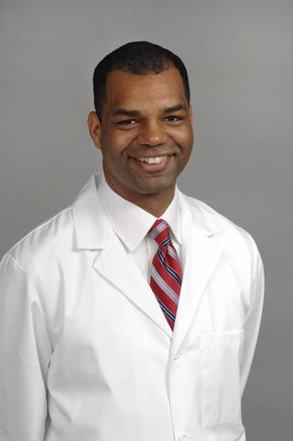
The work of the Urology Residency Program was championed by Gareth Warren, M.D., a Urologist who participated in the Quality & Health Equity Leadership Fellowship program. Each fellow designed and led a project addressing real challenges within the University of Rochester Medical Center’s healthcare system, ultimately aiming to improve outcomes, advance equity, and create improvements that shape the future of care delivery.

Dr. Warren’s project – Increasing Screening for Post-Operative Transportation Barriers in a Urology Clinic –used process mapping, a swim lane diagram, a fishbone diagram, a pareto diagram and run charts of transportation screening rates. A medical record template was developed to document screening completion and referral to transportation resources. Overall, transportation barrier documentation increased from 62% up to 100% in six months.

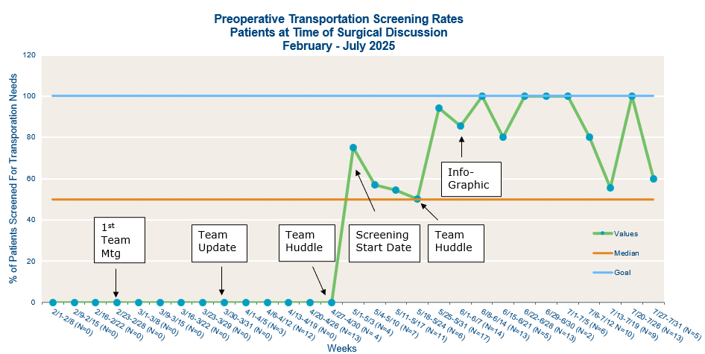

During the screening period, 135 patients were counseled and scheduled for surgery. Documented transportation insecurity screening was 0% during the baseline pre-implementation period and increased to 50% during the implementation period. A total of 6 patients, at the time of surgical decision making, reported transportation insecurity within the last 12 months, and were followed and/or referred to social work services for assistance as their surgical date approached to assure their transportation needs were met for day of surgery.

