Health Equity in Education

Primary Objective
As a teaching hospital, the University of Rochester Medical Center trains doctors, nurses, advanced practice providers, and other health care providers who serve patients. To achieve the best health outcomes for all patients, the URMC is working to make education about health equity and community a consistent and exceptional part of all educational programs. The learning programs at URMC are quite diverse, therefore health equity curriculum cannot take a one-size-fits-all approach. Instead, URMC health equity education improvement is centered around a curriculum framework.

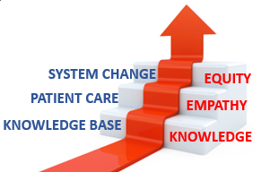
The KEE Curriculum Framework for Health Equity
Objectives | Competency
Improved Health-Related Social Drivers | Learners understand social drivers and strive to address potential detrimental pathways from drivers to disparities in health outcomes.
Optimal Health Care Delivery | Learners transfer concepts of health equity to the day-to-day care of patients so that each patient has an equal opportunity to achieve their highest level of health.
Changing Systems – Pop Health | Learners participate in the design, implementation, or evaluation of health equity strategies based on population data and using quality improvement methodologies and/or policy and systems change.
The KEE (Knowledge, Empathy, Equity) Curriculum Framework for health equity education was created to assist educational programs in building discipline-specific learning tools that are consistent with national competencies and standards for health equity education. To achieve competency, learners must acquire the basic knowledge, apply that learning to patient care, and then work towards system change.

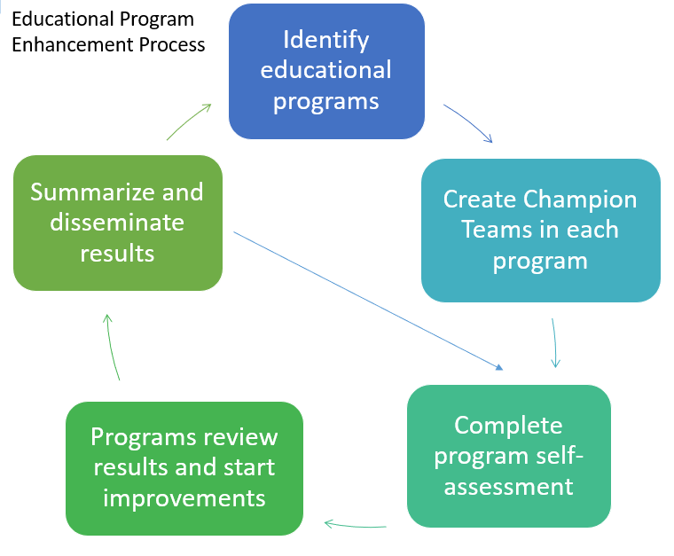
Implementation
Creating a learning environment that facilitates exemplar and replicable education in health equity is critical in supporting equitable health systems. The KEE Curriculum is being implemented throughout educational programs at URMC in Cohorts. Educational programs identify a champion team to take the program self-assessment. Results show opportunities for improvement that champion teams develop improvement plans to address. Results of program health equity improvements are summarized and shared with other programs for duplication.

Health Equity Education
Residency Program
Adult Neurology Residency
ABOUT THE PROGRAM
Cohort #1
Director: Colleen Tomcik, MD

Department of Neurology
University of Rochester Medical Center
601 Elmwood Avenue
Rochester NY 14642-2545
Box 673
(585) 275-2545

The Adult Neurology Residency Program at the University of Rochester Medical Center is one of the most advanced and respected residency programs of its kind, ranking at #14 nationally. Their residency program places emphases on excellence in clinical neurology and shaping their residents into inspired educators.

IMPROVEMENT PLANNING
After reviewing the Knowledge, Empathy, and Equity Curriculum Framework and completing a baseline self-assessment of health equity in efforts in the Adult Neurology Residency Curriculum, they have submitted the following efforts for improvement planning:
- EMR Training for Residents on SDOH
  - The Adult Neurology Residency Program wanted to focus on familiarizing their residents with the social determinant of health tools of the Electronic Medical Record (EMR) and create space in both the inpatient and outpatient care settings to discuss and address issues.

THE PROCESS
The Adult Neurology Residency Program started their improvement planning process by delivering several information sessions on the importance of screening for social determinants of health. In addition, they also introduced their residents to “the project:” building a space in the electronic medical record focused on social determinants of health and creating spaces both in inpatient and outpatient settings to discuss with patients.
Residents were also taught methods of pedagogy to discuss and encourage “brain health” with underserved populations in the Rochester area.
The final version of the Adult Neurology Residency Program’s EMR project went live on February 5, 2024. Residents were asked to begin discussion transportation and food insecurity with clinical patients screening positive in the EMR.

NEXT STEPS
The Adult Neurology Residency Program wants to continue their efforts in the future, centered around a “dot phrase.” Moreover, this will include tips for encouraging healthy living in clinics for after-visit summaries. In addition, they also planned a “Brain Health” booth to be at the 2024 Lilac Festival.

