Health Equity in Education

Primary Objective
As a teaching hospital, the University of Rochester Medical Center trains doctors, nurses, advanced practice providers, and other health care providers who serve patients. To achieve the best health outcomes for all patients, the URMC is working to make education about health equity and community a consistent and exceptional part of all educational programs. The learning programs at URMC are quite diverse, therefore health equity curriculum cannot take a one-size-fits-all approach. Instead, URMC health equity education improvement is centered around a curriculum framework.

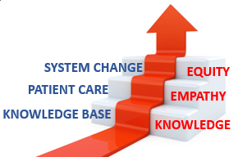
The KEE Curriculum Framework for Health Equity
Objectives | Competency
Improved Health-Related Social Drivers | Learners understand social drivers and strive to address potential detrimental pathways from drivers to disparities in health outcomes.
Optimal Health Care Delivery | Learners transfer concepts of health equity to the day-to-day care of patients so that each patient has an equal opportunity to achieve their highest level of health.
Changing Systems – Pop Health | Learners participate in the design, implementation, or evaluation of health equity strategies based on population data and using quality improvement methodologies and/or policy and systems change.
The KEE (Knowledge, Empathy, Equity) Curriculum Framework for health equity education was created to assist educational programs in building discipline-specific learning tools that are consistent with national competencies and standards for health equity education. To achieve competency, learners must acquire the basic knowledge, apply that learning to patient care, and then work towards system change.

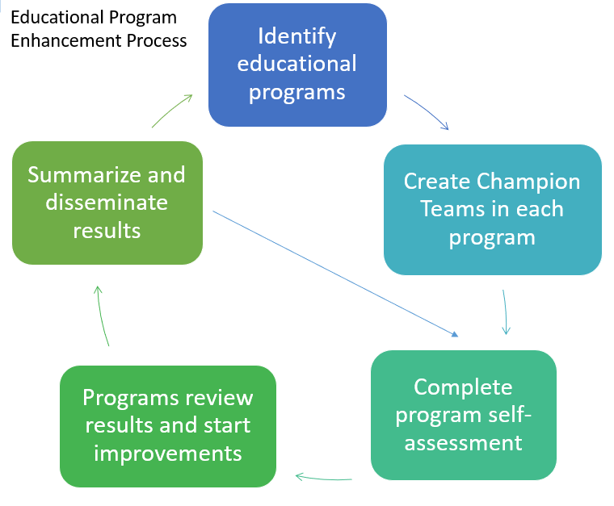
Implementation
Creating a learning environment that facilitates exemplar and replicable education in health equity is critical in supporting equitable health systems. The KEE Curriculum is being implemented throughout educational programs at URMC in Cohorts. Educational programs identify a champion team to take the program self-assessment. Results show opportunities for improvement that champion teams develop improvement plans to address. Results of program health equity improvements are summarized and shared with other programs for duplication.

Health Equity Education
Residency Program
Anesthesiology Residency
ABOUT THE PROGRAM
Cohort #1
Director: Suzanne Karan, MD, FASA

Department of Anesthesiology
University of Rochester Medical Center
601 Elmwood Avenue
Rochester NY 14642
Box 604
(585) 276-4520

The Anesthesiology Residency Program at the University of Rochester Medical Center is dedicated to the education and development of the next generation of anesthesiologists. Their curriculum is developed with innovation in mind: non-clinical residency tracks, protected didactic time, approaches on resident wellness, and an integrated, categorical residency program.
IMPROVEMENT PLANNING
The Anesthesiology Residency Program did not submit a formal improvement plan through our KEE Framework system. However, their program was undertaking several health equity improvement initiatives.
FOCUSES
The Anesthesiology Residency Program wanted to focus on faculty development by improving knowledge in health equity concepts to participate in didactics for a balanced perspective.
- Didactic Sessions
  - 13 Education Day Sessions
  - Flipped Classrooms
- Enhancing Dissemination
  - Presentations at the Society for Education in Anesthesia
- Clinical Care: Rural Anesthesia
  - Creating an Elective Rotation
  - Conference & Publication Involvement
OUTCOMES
The Anesthesiology Residency Program continued their didactic sessions, with various topics: redlining; social determinants of health; the effects of poverty; gender disparities. They have also created an additional didactic component for flipped classrooms, which consist of resident-led discussions on anesthesia-specific editorials and articles surrounding health equity.
The Anesthesiology Residency Program also increased their dissemination efforts. Several residents and program leaders presented at the Spring 2024 Society for Education in Anesthesia conference:
- Infusing the Science of Learning into the Fabric of Addressing Healthcare Disparities in Perioperative Medicine
- Developing Interactive Online Modules to Support an Anesthesiology Residency Curriculum in Health Care Disparities
- Fostering Equity in Anesthesiology: A Progressive Four-Year Residency Curriculum Addressing the Social Determinants of Health

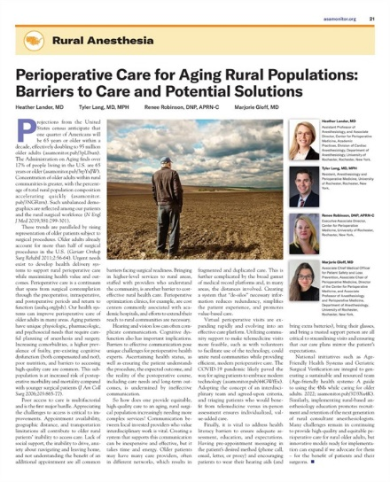
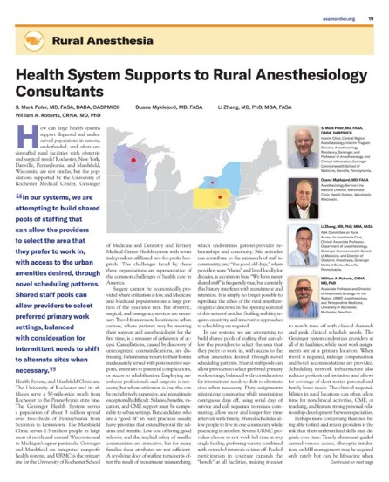
The department had multiple efforts focused on rural anesthesia. An elective rotation was created from February to May 2024 with a focus on impacts of under-resourced settings. The department’s 6th Annual Lawrence Education Symposium was hosted in April of 2023 with a central theme of “Focus on Rural Anesthesiology Practice.” Lastly, multiple residents and faculty members were published on their work around equity solutions for rural populations in ASA Monitor.

