Health Equity in Education

Primary Objective
As a teaching hospital, the University of Rochester Medical Center trains doctors, nurses, advanced practice providers, and other health care providers who serve patients. To achieve the best health outcomes for all patients, the URMC is working to make education about health equity and community a consistent and exceptional part of all educational programs. The learning programs at URMC are quite diverse, therefore health equity curriculum cannot take a one-size-fits-all approach. Instead, URMC health equity education improvement is centered around a curriculum framework.

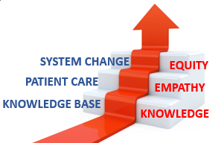
The KEE Curriculum Framework for Health Equity
Objectives | Competency
Improved Health-Related Social Drivers | Learners understand social drivers and strive to address potential detrimental pathways from drivers to disparities in health outcomes.
Optimal Health Care Delivery | Learners transfer concepts of health equity to the day-to-day care of patients so that each patient has an equal opportunity to achieve their highest level of health.
Changing Systems – Pop Health | Learners participate in the design, implementation, or evaluation of health equity strategies based on population data and using quality improvement methodologies and/or policy and systems change.
The KEE (Knowledge, Empathy, Equity) Curriculum Framework for health equity education was created to assist educational programs in building discipline-specific learning tools that are consistent with national competencies and standards for health equity education. To achieve competency, learners must acquire the basic knowledge, apply that learning to patient care, and then work towards system change.

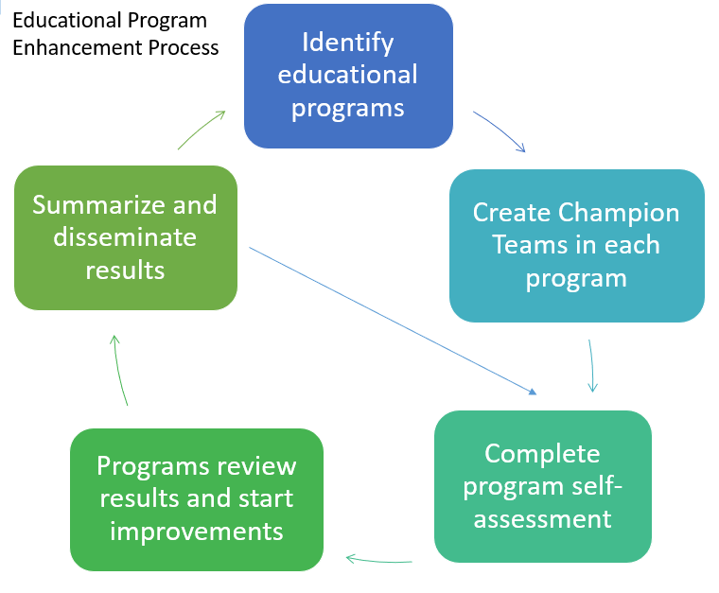
Implementation
Creating a learning environment that facilitates exemplar and replicable education in health equity is critical in supporting equitable health systems. The KEE Curriculum is being implemented throughout educational programs at URMC in Cohorts. Educational programs identify a champion team to take the program self-assessment. Results show opportunities for improvement that champion teams develop improvement plans to address. Results of program health equity improvements are summarized and shared with other programs for duplication.

Health Equity Education
Residency Program
Child Neurology Residency
ABOUT THE PROGRAM
Cohort #1
Robert Thompson-Stone, MD

Department of Neurology
University of Rochester Medical Center
601 Elmwood Avenue
Rochester NY 14642-2545
Box 673
(585) 275-2545

The Child Neurology Residency Program at the University of Rochester Medical Center commits their teachings to be focused on diversity, inclusion, antiracism, and health disparities in neurology patients, with opportunities to get actively involved in the department’s diversity agenda.

IMPROVEMENT PLANNING
After reviewing the Knowledge, Empathy, and Equity Curriculum Framework and completing a baseline self-assessment of health equity in efforts in the Child Neurology Residency Curriculum, they have submitted the following efforts for improvement planning:
- EMR Training for Residents on SDOH
- Implement AAN Anti-Racism Curriculum

THE PROCESS
The Child Neurology Residency Program aimed to education their residents on social determinants of health, how to screen and track this in the electronic medical record, and to create a strategic plan for how their program will teach residents to document this in the electronic medical records.
Throughout the year, the Child Neurology residency had large group sessions on social determinants of health, which included a practical discussion on how the department can address these questions in their clinic. Child Neurology leadership has been working with residents to troubleshoot how the meet social determinants of health documentation goals.
The Child Neurology Residency program also implemented the American Academic of Neurology (AAN) anti-racism curriculum program, using modules and discussion groups to inform their residents.
The Child Neurology residents participated in learning sessions using AAN’s anti-racism education program, where residents watched prepared modules, and then participated in a live group debrief:
- Module #1 – Setting the Stage: Reflections on Race, Identity, and Socialization
- Module #2 – The History of Racism in Neurology: Member Experiences with Bias and Racism
- Module #3 – Patient Care Stories: Vignettes in Clinical and Academic Neurology
- Module #4 – Institutional Structures: Racism in Training and Anti-Racism Leadership

The first session was completed at the beginning of the year, with another session scheduled for June of 2024 to review the second and third of the four modules in this program.

