Health Equity in Education

Primary Objective
As a teaching hospital, the University of Rochester Medical Center trains doctors, nurses, advanced practice providers, and other health care providers who serve patients. To achieve the best health outcomes for all patients, the URMC is working to make education about health equity and community a consistent and exceptional part of all educational programs. The learning programs at URMC are quite diverse, therefore health equity curriculum cannot take a one-size-fits-all approach. Instead, URMC health equity education improvement is centered around a curriculum framework.

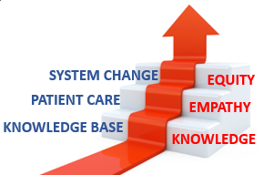
The KEE Curriculum Framework for Health Equity
Objectives | Competency
Improved Health-Related Social Drivers | Learners understand social drivers and strive to address potential detrimental pathways from drivers to disparities in health outcomes.
Optimal Health Care Delivery | Learners transfer concepts of health equity to the day-to-day care of patients so that each patient has an equal opportunity to achieve their highest level of health.
Changing Systems – Pop Health | Learners participate in the design, implementation, or evaluation of health equity strategies based on population data and using quality improvement methodologies and/or policy and systems change.
The KEE (Knowledge, Empathy, Equity) Curriculum Framework for health equity education was created to assist educational programs in building discipline-specific learning tools that are consistent with national competencies and standards for health equity education. To achieve competency, learners must acquire the basic knowledge, apply that learning to patient care, and then work towards system change.

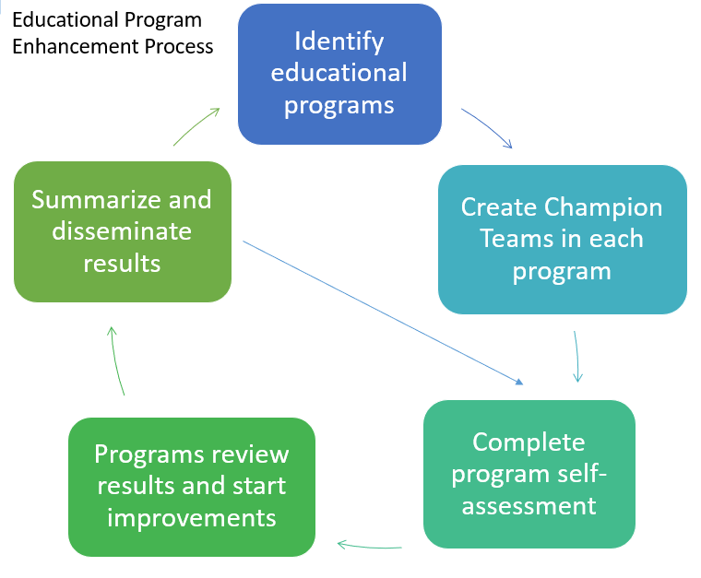
Implementation
Creating a learning environment that facilitates exemplar and replicable education in health equity is critical in supporting equitable health systems. The KEE Curriculum is being implemented throughout educational programs at URMC in Cohorts. Educational programs identify a champion team to take the program self-assessment. Results show opportunities for improvement that champion teams develop improvement plans to address. Results of program health equity improvements are summarized and shared with other programs for duplication.

Health Equity Education
Residency Program
Emergency Medicine Residency
ABOUT THE PROGRAM
Cohort #1
Director: Ryan Bodkin, M.D., M.B.A.

Department of Emergency Medicine
University of Rochester Medical Center
601 Elmwood Avenue
Rochester NY 14642-2545
Box 655
(585) 463-2940
em_residency@urmc.rochester.edu

The Emergency Medicine Residency Program at the University of Rochester Medical Center trains and orients their residents around the bio-psycho-social model, with it serving as the foundation for their residency education. The Emergency Medicine Residency Program believes in teaching their residents one patient a time, with extensive focus on clinical experiences.

IMPROVEMENT PLANS
After reviewing the Knowledge, Empathy, and Equity Curriculum Framework and completing a baseline self-assessment of health equity in efforts in the Emergency Medicine Residency Curriculum, they have submitted the following efforts for improvement planning:
- Utilizing Electronic Health Record (EHR) for Individual, Institution, & Health Systems Data
  - Teaching residents to know where to find and how to understand individual data, as well as institution and health systems data.
  - Instruct residents using didactic instructions around the potential of the EHR, in conjunction with strategic plans and goals from larger systems.

THE PROCESS
The Emergency Medicine Residency Program implemented a 60-miunte lecture delivered by one of their own medical directors, as well as nursing specialists. The lectures focused on the capabilities and uses of “Slicer Dicer,” a tool within the Epic Electron Health Record system, to extract individual practice data and systems level data.
The Emergency Medicine Residency Program also built upon their Health Equity Education curriculum. They have added to their series of lectures and teaching for the 2023-2024 academic year, with a total of 10 scheduled didactic sessions for all residents.
The Emergency Medicine Residency Program also supported two resident projects focused on addressing health inequities: interventions on improving patient care to deaf individuals; and creating doctor badge program for providers who are being professional misidentified.

OUTCOMES
The Emergency Medicine Residency Program have been running a longitudinal health equity education for the past 5 years in their didactic conference and will continue to allot time as well as a dedicated a grand rounds lecture and day surround this these topics.
The residents have also created a “DEI Task Force” that is resident lead who meets quarterly to address the needs of the residents from a health equity education standpoint.
The slicer dicer presentation was given to all residents this this year, and moving forward will be a dedicated Intern lecture. Additionally, the Emergency Medicine Residency Program has a medical director who is board certified in informatics, as well as a nursing specialist who is facile in the use of slicer dicer, to help with individual queries and projects pursued by their residents.

