Health Equity in Education

Primary Objective
As a teaching hospital, the University of Rochester Medical Center trains doctors, nurses, advanced practice providers, and other health care providers who serve patients. To achieve the best health outcomes for all patients, the URMC is working to make education about health equity and community a consistent and exceptional part of all educational programs. The learning programs at URMC are quite diverse, therefore health equity curriculum cannot take a one-size-fits-all approach. Instead, URMC health equity education improvement is centered around a curriculum framework.

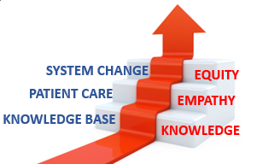
The KEE Curriculum Framework for Health Equity
Objectives | Competency
Improved Health-Related Social Drivers | Learners understand social drivers and strive to address potential detrimental pathways from drivers to disparities in health outcomes.
Optimal Health Care Delivery | Learners transfer concepts of health equity to the day-to-day care of patients so that each patient has an equal opportunity to achieve their highest level of health.
Changing Systems – Pop Health | Learners participate in the design, implementation, or evaluation of health equity strategies based on population data and using quality improvement methodologies and/or policy and systems change.
The KEE (Knowledge, Empathy, Equity) Curriculum Framework for health equity education was created to assist educational programs in building discipline-specific learning tools that are consistent with national competencies and standards for health equity education. To achieve competency, learners must acquire the basic knowledge, apply that learning to patient care, and then work towards system change.

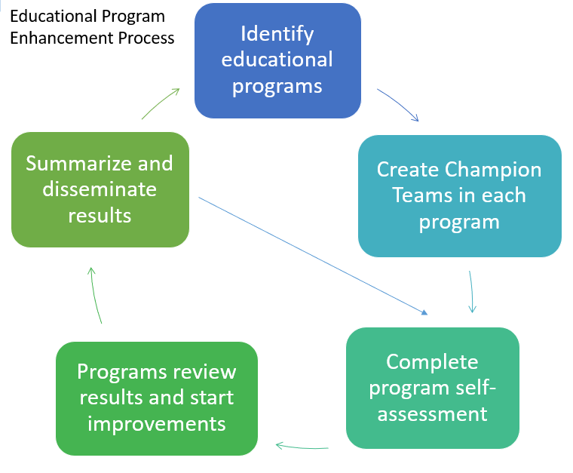
Implementation
Creating a learning environment that facilitates exemplar and replicable education in health equity is critical in supporting equitable health systems. The KEE Curriculum is being implemented throughout educational programs at URMC in Cohorts. Educational programs identify a champion team to take the program self-assessment. Results show opportunities for improvement that champion teams develop improvement plans to address. Results of program health equity improvements are summarized and shared with other programs for duplication.

Health Equity Education
Residency Program
OB/GYN Residency
ABOUT THE PROGRAM
Cohort #1
Director: Courtney Olson-Chen, MD, MSCI

Department of Obstetrics & Gynecology
University of Rochester Medical Center
601 Elmwood Avenue
Rochester NY 14642-2545
Box 668
(585) 275-9042

The Obstetrics & Gynecology Residency Program at the University of Rochester Medical Center is dedicated to educating and training obstetrician-gynecologists, to provide medicine of the highest order. In addition to any technical trainings, OB/GYN residents learn how to use evidence-based medicine and quality improvement to provide optimal patient care; participate in didactics and simulation education programs; and contribute to the program for future residents.
IMPROVEMENT PLANS
After reviewing the Knowledge, Empathy, and Equity Curriculum Framework and completing a baseline self-assessment of health equity in efforts in the OB/GYN Residency Curriculum, they have submitted the following efforts for improvement planning:
- “Poverty” Simulation
  - Residents will meet with many local community services that OB/GYN patient’s access.
- Enhanced Recovery for Obstetric Patients
  - Residents will implement a quality improvement effort to create a uniform treatment standard.
- Creation of Equity-Based Tools as Quality Indicators

THE PROCESS
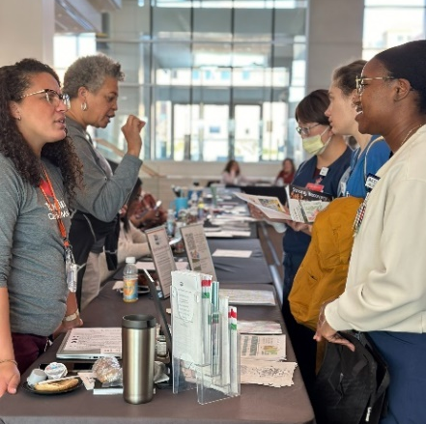
A total of 20 community organizations were present for the immersive simulation experience held in November 2023. OB/GYN residents were able to meet and interact with various agencies serving the Rochester area. Residents participated in four realistic, hands-on, interactive cases that challenged them to navigate patient barriers. The residents applied insights from patient cases to explore an interactive network of diverse organizations, and by engaging with organization representatives they learned about available services, eligibility requirements, and limitations.
The OB/GYN residents also led a quality improvement effort to implement enhance surgery recovery for their obstetric patients. An interdisciplinary group including OB/GYN residents met to discuss the standardization of non-opioid pain medications, created an educational document about goals for postpartum pain, and implemented a systematic way to identify discharge prescription quantity for opioid medications.
OUTCOMES
Prior to the simulation event, 80% of residents reported feeling inadequately educated about the available community resources for addressing social determinants of health and 61% were uncomfortable referring patients to community resources. After the simulation, 100% of residents felt the simulation enhanced their awareness of community resources and 100% believed the in-person simulation substantially increased their comfort with engaging with these community organizations. The OB/GYN Department intends to repeat this simulation experience annually.
To sustain their quality improvement efforts, the OB/GYN Department are aiming to have less than a 10% in racial disparities related to opioid prescription.

