Health Equity in Education

Primary Objective
As a teaching hospital, the University of Rochester Medical Center trains doctors, nurses, advanced practice providers, and other health care providers who serve patients. To achieve the best health outcomes for all patients, the URMC is working to make education about health equity and community a consistent and exceptional part of all educational programs. The learning programs at URMC are quite diverse, therefore health equity curriculum cannot take a one-size-fits-all approach. Instead, URMC health equity education improvement is centered around a curriculum framework.

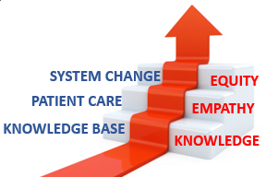
The KEE Curriculum Framework for Health Equity
Objectives | Competency
Improved Health-Related Social Drivers | Learners understand social drivers and strive to address potential detrimental pathways from drivers to disparities in health outcomes.
Optimal Health Care Delivery | Learners transfer concepts of health equity to the day-to-day care of patients so that each patient has an equal opportunity to achieve their highest level of health.
Changing Systems – Pop Health | Learners participate in the design, implementation, or evaluation of health equity strategies based on population data and using quality improvement methodologies and/or policy and systems change.
The KEE (Knowledge, Empathy, Equity) Curriculum Framework for health equity education was created to assist educational programs in building discipline-specific learning tools that are consistent with national competencies and standards for health equity education. To achieve competency, learners must acquire the basic knowledge, apply that learning to patient care, and then work towards system change.

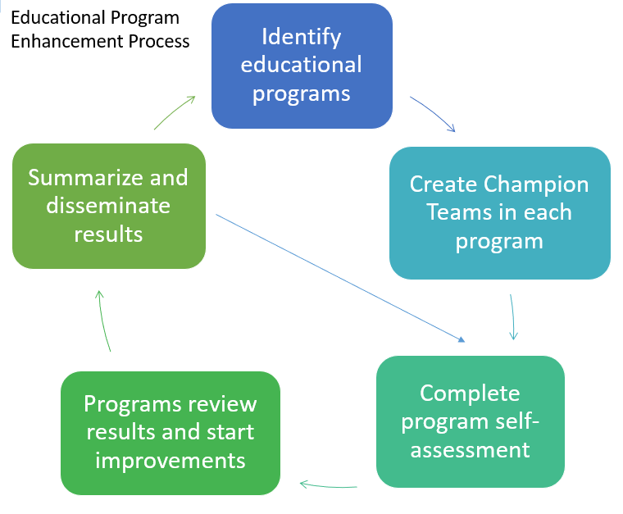
Implementation
Creating a learning environment that facilitates exemplar and replicable education in health equity is critical in supporting equitable health systems. The KEE Curriculum is being implemented throughout educational programs at URMC in Cohorts. Educational programs identify a champion team to take the program self-assessment. Results show opportunities for improvement that champion teams develop improvement plans to address. Results of program health equity improvements are summarized and shared with other programs for duplication.

Health Equity Education
Residency Program
Ophthalmology Residency
ABOUT THE PROGRAM
Cohort #1 -
Director: David DiLoreto, MD, PhD

Flaum Eye Institute
University of Rochester Medical Center
601 Elmwood Avenue
Rochester NY 14642-2545
Box 559
(585) 273-3954

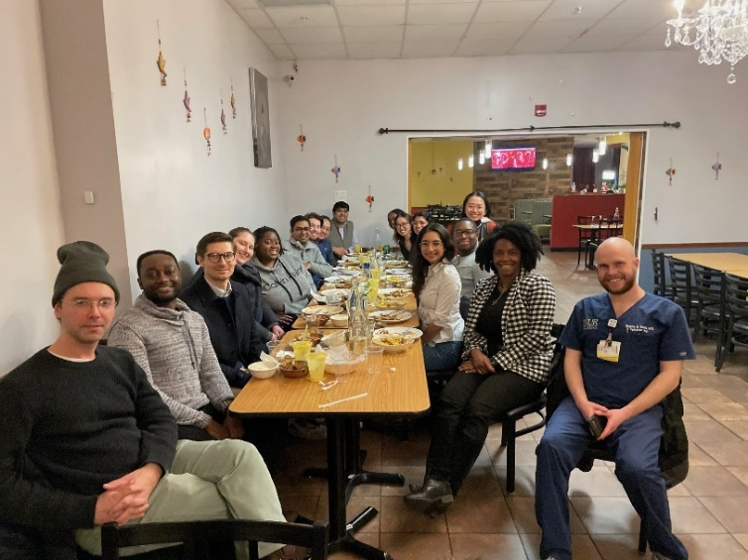
The Ophthalmology Residency Program at the University of Rochester Medical Center trains and orients their residents to be proficient leaders in patient care, research, and education. Residents part-take in various elements of their residency’s education program, including numerous didactic sessions, weekly patient cases, and journal clubs.

IMPROVEMENT PLANS
After reviewing the Knowledge, Empathy, and Equity Curriculum Framework and completing a baseline self-assessment of health equity in efforts in the Ophthalmology Residency Curriculum, they have submitted the following efforts for improvement planning:
- Health Equity Mini-Course
  - 4 in-person journal club styled meetings focused on health equity and population health topics.

THE PROCESS
Over the 2023-2024 academic year, the Ophthalmology Department has instituted a quarterly, in-person journal club focused on heath equity and population health topics. Co-run by Drs. Christine Coward and Rajeev Ramchandran, the last journal club in January 2024 focused on the work being done at LVPrasad Eye Institute in Hyderabad India.
This group also looked at the AAO task force on Health Equity’s summary of the status of health disparities in vision and eye care. The goal was also to bring first-hand experience of domestic and international health equity challenges and give the residents some perspective of how eye care is delivered in various settings. Dr. Vikas Khetan was an invited to speak about his experience in delivering eye care in India. In addition to article readings and subsequent discussions, there were small group sessions led by faculty.

OUTCOMES
These journal-club style sessions ae now required learning from all Ophthalmology residents. In its pilot sessions, all but 2 Ophthalmology residents were able to attend their journal-club sessions. The Ophthalmology Department plans to continue these sessions and include a component for faculty members to share their experiences over dinners, that can be theme-based on the background of the faculty.

