Rochester Hope, Inc.
Rochester Hope Food Pantry
AGENCY DESCRIPTION
Rochester Hope, Inc. is a community-based organization operating in one of the most food insecure zip codes in New York State. The Rochester Hope N. Clinton Food Pantry is a client choice pantry that is open to all individuals and does not require documentation or proof of residence. The organization serves a highly immigrant and refugee population and centers dignity, cultural responsiveness, and community connection in all services provided.

OVERVIEW
Rochester Hope, Inc. was awarded the Community Health Improvement Workgroup mini grant to sustain and expand food access and community support services in response to rapidly increasing food insecurity in Rochester’s inner city. In 2024, the pantry served an average of 300 households weekly, with demand continuing to rise throughout 2025 due to economic instability, immigration related barriers, and disruptions to public benefits such as SNAP.
Mini grant funds supported increased food purchasing, supplies, and operational costs, allowing Rochester Hope to continue serving all households without limiting access or reducing food quality. The funding was particularly critical during the SNAP disruption in October and November, when the number of individuals seeking food assistance nearly doubled.

CONTACT 
Dawn Burdick, Executive Director
Rochester Hope
585-797-4474
869 N Clinton Avenue, NY 14605

HIGHLIGHTS
Throughout the project period, Rochester Hope served approximately 400 households each week. In the last quarter of 2025, an average of 1,900 individuals per week received nourishing food through the pantry and community meal programs. Over the course of the year, more than 3,000 unique households were served, representing over 15,000 individuals, including more than 5,000 children. 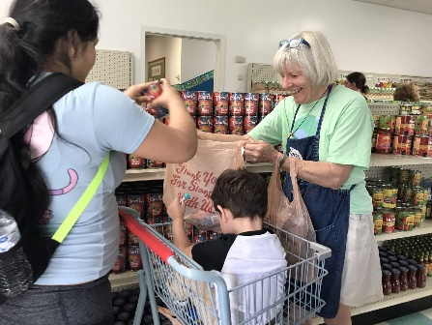
In addition to pantry services, Rochester Hope provided approximately 7,500 prepared meals through weekly community breakfast and lunch programs. Nearly 1,250,000 pounds of food were distributed during 2025.

LESSONS LEARNED & NEXT STEPS
The project highlighted the rapid escalation and unpredictability of food insecurity among Rochester Hope’s service population, particularly during periods of public benefit disruption. Demand for services increased suddenly and significantly, requiring immediate adjustments in food sourcing, volunteer coordination, and service delivery. These conditions reinforced the importance of flexibility, strong infrastructure, and culturally responsive approaches when serving communities experiencing systemic instability.

Looking ahead, Rochester Hope anticipates continued high demand for services. The organization plans to strengthen partnerships with culturally specific food providers, healthcare systems, and social service agencies to better support immigrant and refugee populations. Sustainability efforts will focus on diversified funding, including grants, individual donors, and in-kind food donations, as well as continued collaboration with community partners to support emergency response planning and scalable service models.

