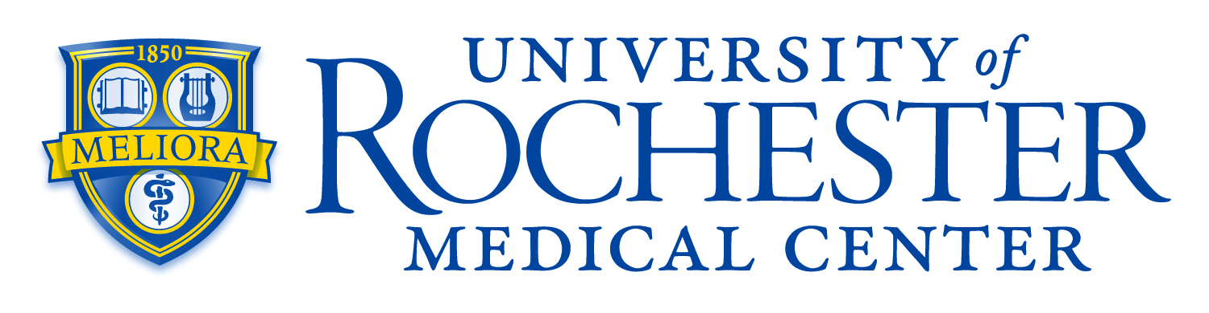
Center for Community Health & Prevention’s Office of Health Equity Research
Request for Proposals: Pilot Studies in Health Equity

The URMC Center for Community Health & Prevention’s Office of Health Equity Research (OHER) is soliciting grant applications to support health equity research pilot projects in community-identified research priority areas of: 1) safe and healthy housing, 2) prevention and management of mental health and substance use disorders, 3) prevention of gun violence, 4) prevention of re-incarceration, 5) prevention and management of chronic disease, and 6) prevention of maternal mortality. All awards are eligible to be co-sponsored by the following University of Rochester units if they also focus on a priority area of the respective unit:
- Institute for Human Health and the Environment
- Department of Orthopaedics
- Department of Neurology
- Department of Obstetrics & Gynecology
- Warner School of Education
The award level is up to $40,000 for one year per award. The goal of this pilot program is to fund novel collaborative research studies that will support future application for funding from NIH, PCORI, AHRQ, CDC, FDA, or other extramural sources. Health outcomes research projects (i.e., studies of the end results of healthcare services and interventions) that use real-world data (e.g., medical records, surveys, claims, etc) to evaluate the actual value and effectiveness of treatments and healthcare systems, incorporate multiple disciplines, involve community members/organizations, and focus on effects that matter to patients like quality of life, satisfaction, and functional status, to help patients, clinicians, and policymakers make informed decisions about care will be prioritized. Projects from emerging investigators who have had less extramural funding are encouraged. Awards will be based on scientific merit, innovation and responsiveness to this RFA.
Full-time UR faculty will qualify only once as a principal investigator and once as a co-investigator per award cycle, and may only hold a single OHER pilot award as a PI at any given time. In addition, OHER will co-fund Quality Institute, Wilmot Cancer Institute Community Outreach and Engagement (COE), and ACT (Activate, Connect, Transform) Center proposals, as they relate to the OHER mission and funds are available.
Proposal
Application is a two-step process. Step 1 consists of a one-page letter of intent (LOI) summarizing the proposed project and NIH format biosketches of the PI and Co-Is involved. The LOI should be submitted in a single PDF document using at least a font size of 11 point, ½ inch margin, single-spaced type. Proposals will be scored by a panel of experts and meritorious applications will be invited for a full submission.
Submission Timeline
Letters of intent are due February 6. Invitations for full submissions will be sent by March 6.
Full submissions (Instructions will be provided) will be due on April 3.
Anticipated start date for successful proposals: July 1.
Letters of intent should be submitted electronically at [https://redcap.link/2025OHERcfp] and questions can be addressed to oher@urmc.rochester.edu.

