Emerging Infections Program (EIP) CP-CRE Report
February 2026

CP-CRE IS ON THE RISE IN MONROE COUNTY, NY
Recent data from the Antibiotic Resistance Laboratory Network and the New York City Health Department show a concerning rise in carbapenemase-producing Enterobacterales (CP-CRE), particularly New Delhi metallo-β-lactamase (NDM)–producing strains. NDM–CRE pose a significant public health concern due to their high transmission potential and limited treatment options.
Nationally, NDM-CRE cases increased by more than 460% from 2019 to 2023¹. Similarly, New York City has sustained growth in NDM-positive CRE since 2019, with NDM now the predominant carbapenemase type².
This newsletter highlights the epidemiology of CP-CRE, including NDM-CRE, in Monroe County, NY, where NDM-CRE was first detected in 2020.
CRE SURVEILLANCE IN MONROE COUNTY, NY THROUGH THE CDC EIP, 2016-2025

Fig 1. Total number of CRE cases identified at clinical laboratories
CP-CRE TRENDS
KPC was the most frequently detected carbapenemase; however, NDM-CRE increased since its first appearance in 2020. By 2025, NDM-producing CRE accounted for 30% of CP-CRE isolates.
Five isolates carried multiple carbapenemase genes, including NDM+OXA-48 and KPC+NDM (Fig 2).
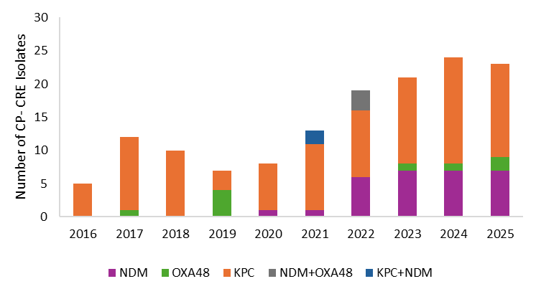
Fig. 2. CP-CRE by carbapenemase type and organism, 2016-2025

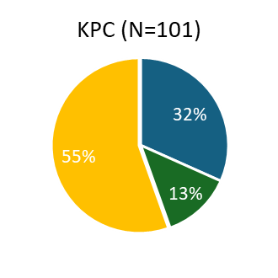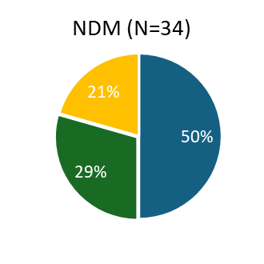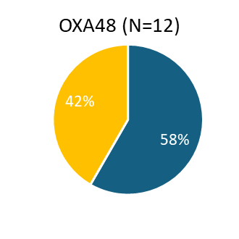
CP-CRE ORGANISMS
The majority of KPC isolates were Klebsiella spp. (55%), while NDM and OXA48 producers were predominantly E. coli (50% and 58%, respectively) (Fig 3). Urine was the most common source of CP-CRE (89%), followed by blood (8%) and other sterile sites (3%).

 | E. coli |  | Klebsiella spp. |  | Enterobacter spp.

Fig. 3. Organism type of CP-CRE
*5 Isolates with 2 carbapenemases (KPC+NDM n=2, NDM+OXA48 n=3)
CP-CRE ANTIBIOTIC SUSCEPTIBILITY TESTING
Table 1 summarizes the antibiotic susceptibility by CP genes, based on testing performed at Wadsworth Center and CDC Labs. NDM-producing isolates were resistant to novel CRE-targeted β-lactam/β-lactamase inhibitor combinations (ceftazidime/avibactam, meropenem/vaborbactam, imipenem/relebactam). Cefiderolcol and aztreonam/avibactam were not tested during this surveillance period.
Carbapenemase** | N* | Ceftazidime/avibactam | Meropenem/vaborbactam | Imipenem/relebactam | Aztreonam | Amikacin | Cefepime | Chloramphenicol | Ciprofloxacin | Colistin | Doxycycline | Gentamicin | Levofloxacin | Minocycline | Polymyxin B | Tigecycline | Trimethoprim/ sulfamethoxazole
KPC | 98 | 94 | 93 | 93 | 0 | 58 | 13 | 64 | 31 | 0 | 74 | 53 | 26 | 78 | 0 | 97 | 20
NDM | 34 | 12 | 15 | 12 | 26 | 53 | 3 | 44 | 21 | 0 | 58 | 50 | 27 | 67 | 0 | 96 | 15
OXA 48 | 12 | 50 | 43 | 25 | 17 | 58 | 9 | 25 | 17 | 0 | 86 | 58 | 25 | 67 | 0 | 100 | 25

Table 1. Percent susceptibility of CP-CRE isolates by carbapenemase type
*Not all isolates are tested for all antibiotics
**5 Isolates with 2 carbapenemases (KPC+NDM n=2, NDM+OXA48 n=3); 3 isolates without AST testing were excluded

OVER HALF OF CP-CRE INFECTIONS AROSE IN THE COMMUNITY






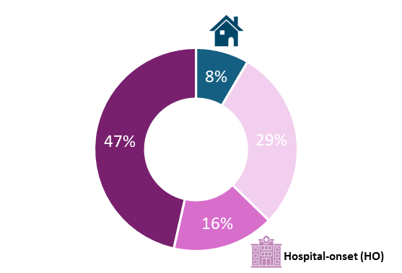
Long-term care facility (LTCF)-onset
Community onset (CO), with recent healthcare exposure
Community-associated (CA), without recent healthcare exposure
International Travel in Year Prior to Culture Date
- 8 cases overall
- 75% were NDM-CRE
- 25% of CA cases (n=3)
- Countries include India, Ghana, Egypt, Italy, Mexico, Yemen, and Jordan

All-cause 90-day mortality
- 15% of cases overall
- 35% of HO cases
Fig 4. CP-CRE cases by infection onset location

HEALTHCARE RISK FACTORS FOR CO AND HO CP-CRE
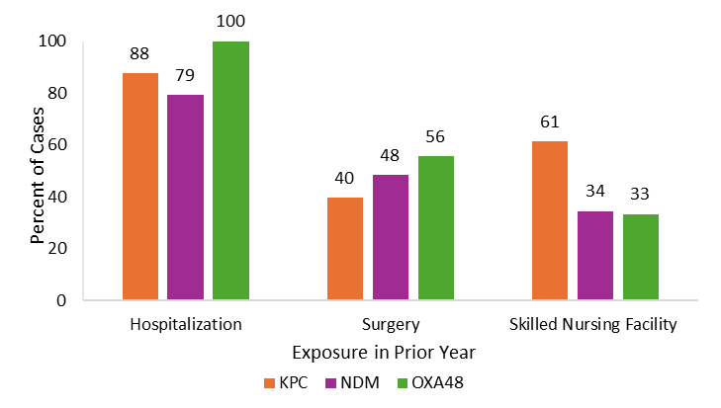
Hospitalization in the prior year was common across all CP-CRE groups.
Prior surgery was less common among KPC-CRE compared to NDM and OXA-48.
Prior SNF stay was most frequent among KPC-CRE compared to NDM and OXA-48.
Fig 5. CO and HO CP- CRE cases with prior healthcare exposure (n=130)
CONCLUSION
The emergence of NDM-producing CRE in Monroe County is concerning. Unlike KPC-producing strains, NDM isolates are often resistant to novel β-lactam/β-lactamase inhibitor combinations, limiting treatment options. Ongoing surveillance, tracking of resistance mechanisms, and expanded susceptibility testing are critical for informing clinical decisions and public health responses. Additional epidemiologic data are available through CDC HAICViz | HAIs | CDC.
ACKNOWLEDGEMENTS
We are grateful to our lab, hospital, and nursing home partners for their continued support and collaboration. Thank you for your invaluable contributions that made this ongoing surveillance possible.
References
- Rankin, D. A., Stahl, A., Sabour, S., Khan, M. A., Armstrong, T., Huang, J. Y., Baggs, J., & Walters, M. S. (2025). Changes in Carbapenemase-Producing Carbapenem-Resistant Enterobacterales, 2019 to 2023. Ann Intern Med, 178(12), 1818-1821. https://doi.org/10.7326/ANNALS-25-02404
- Devinney K, Burton N, Alroy KA, et al. Notes from the Field: Increase in New Delhi Metallo-β-Lactamase–Producing Carbapenem-Resistant Enterobacterales — New York City, 2019–2024. MMWR Morb Mortal Wkly Rep 2025;74:401–403. DOI: http://dx.doi.org/10.15585/mmwr.mm7423a2.`

