
Extended- Spectrum Beta-Lactamase
Enterobacterales Surveillance
Monroe County, NY, 2020-2022

WHAT WE DO
The Rochester Emerging Infections Program (EIP) performs population- and lab-based surveillance for organisms and infections of public health importance in collaboration with the CDC and 11 other state sites across the US.

IN WHERE INFECTIONS CAN HAPPEN

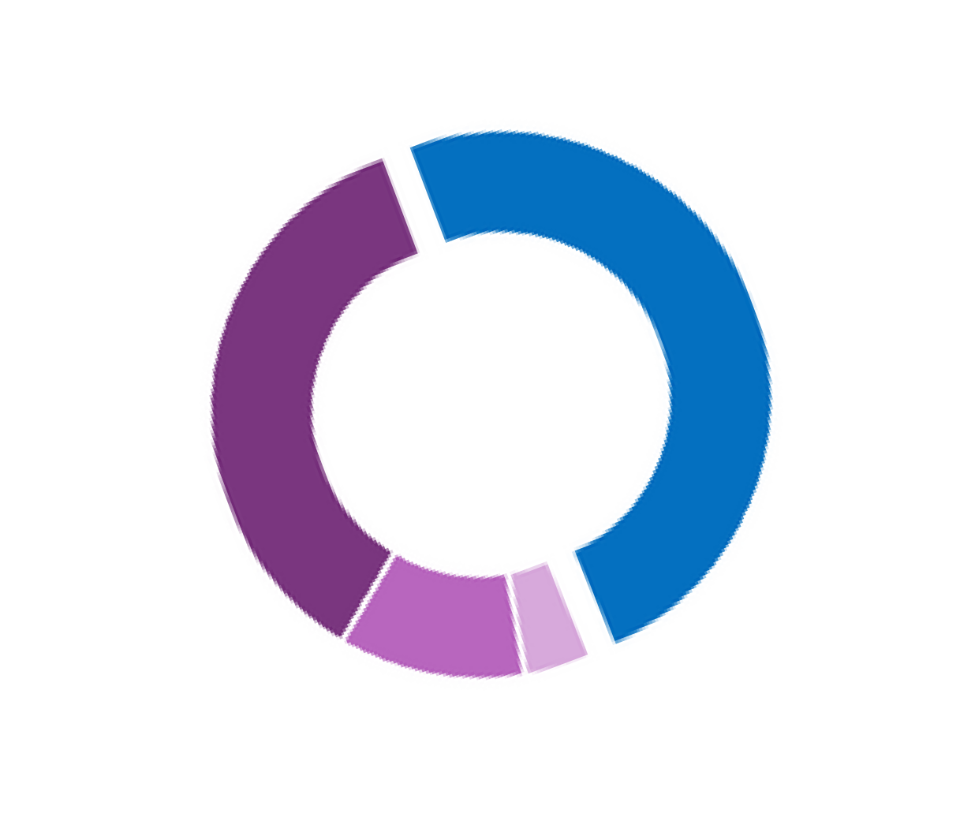

Community -associated
Infection (48%)
Community onset (CO), with a recent healthcare exposure (35%) *

WHAT IS ESBL?
Extended-Spectrum Beta-Lactamase (ESBL)–producing Enterobacterales are bacteria that pose a threat in healthcare and community settings due to their resistance to many common antibiotics. ESBLs are enzymes that break down antibiotics, including cephalosporins, making them ineffective. These organisms can spread rapidly, cause infections in healthy people, and often require IV antibiotic treatment in the hospital rather than oral options.

ESBL SURVEILLANCE
We define ESBL cases based on their antibiotic resistance profile. An ESBL case is 1) non-resistant to carbapenems and 2) resistant to one or more third-generation cephalosporins.
Between 2020 and 2022, our surveillance identified 4,010 ESBL cases in Monroe County. We obtained detailed information for 3,022 (75%) of these cases among 2,498 unique patients. Sixteen percent of patients had more than one ESBL infection.

Long-term care
facility (LTCF)–
onset infection
(11%) *

*CO, LTCF, and HO are classified as Healthcare-Associated Infections (HCA).

Hospital-onset (HO)
infection (6%) *

1 IN 2 ESBL

CASES WERE

COMMUNITY-

ASSOCIATED

9 IN 10 CULTURES WERE FROM URINE
1 %
9 4 %

CASES FROM 2020-2022
Cases of ESBL - producing
Enterobacterales
1500
1,401
1,348
1,261
5 %
 Urine  Blood
 Other Sterile Site*

1000

500

0

2020 2021 2022

* Cerebrospinal fluid, pleural fluid, pericardial fluid,
peritoneal fluid, joint/synovial fluid, bone, internal body site,
muscle, deep tissue, or other normally sterile site

THE MAJORITY OF CASES WERE

FEMALE, NON-HISPANIC, WHITE,

WITH A MEDIAN AGE OF 66 YEARS

Hispanic 8%

Black*

13.1%

* Non- Hispanic

Other * 6.9 %



White* 72%

77%
Female

HEALTH CONDITIONS & RISK FACTORS

Percent of Cases with a Pre- Existing Health Condition
7 0
*A structural or functional
urinary tract abnormality
that leads to obstruction or
retention of urine

CA
HCA
70.0%
60.0%
50.0%
40.0%
30.0%
20.0%
10.0%
0.0%
Percent of Cases (%)
6 0
5 0
4 0
3 0
2 0
1 0
0

Urinary Tract
Abnormalities *
Diabetes Chronic
Pulmonary
Disease
Chronic
K i d n e y
Disease
Congestive
Heart
Failure


4 IN 10 COMMUNITY – ASSOCIATED CASES

HAD RECURRENT UTI
1 IN 3 COMMUNITY - ASSOCIATED CASES HAD NO PRIOR HEALTH
CONDITIONS

ANTIBIOTIC USE WAS COMMON
PRIOR TO A POSITIVE CULTURE
n = 3, 0 1 1

25%
MANY HCA CASES HAD A PRIOR HEALTHCARE EXPOSURE, INCLUDING:


41 %

received 1+

antibiotic in the

30 days prior to

a culture
CA
n = 356

HCA

55%
n = 872
n = 1, 5 7 6

76%


36%

Most common antibiotic classes
1st / 2nd Gen Cephalosporins
CA TMX - SMX
Nitrofurantoin

1st / 2nd Gen Cephalosporins
HCA β - lactam Combinations
Vancomycin
hos pitalized


35%
stayed at a nursing home
had surgery


35%
had a urinary
catheter

OUTCOMES OF AN ESBL INFECTION

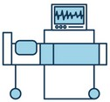
25%

of cases diagnosed in the
community were hospitalized

28%
of cases diagnosed in the hospital were admitted to the ICU


3%
17%
of cases with a positive urine culture died within 30 days *
of cases with a positive blood or sterile site culture died within 30 days *
* a l l - c a u s e m o r t a l i t y

8 IN 10 CASES WERE CAUSED BY E. COLI

K. PNEUMONIAE & K. OXYTOCA WERE

MORE COMMON
AMONG HEALTHCARE - ASSOCIATED CASES
100

80
Percent of Cases (%)

60

40

20

0

CA HCA

 K. oxytoca
 K. pneumoniae  E. coli

TOGETHER, CTX-M ENZYMES & ST131 STRAINS
CAN RAPIDLY SPREAD RESISTANCE
87.5% of isolates tested at CDC labs had the CTX-M ESBL enzyme, which can be shared through DNA between different Enterobacterales species
The most common strain of ESBL E. coli was ST131 (54.3%), which is known to cause more severe infections and spread easily

CONCLUSION
.
Most ESBL cases were caused by E. coli cultured from urine, commonly in females ages 65 years and older, many of whom had a history of recurrent UTI
Half of the ESBL cases had no exposure to healthcare or medical devices

41% of cases were prescribed antibiotics within the 30 days prior to their positive culture.
Understanding ESBL risk factors is crucial for identifying populations at risk and informing targeted preventive strategies, like vaccination

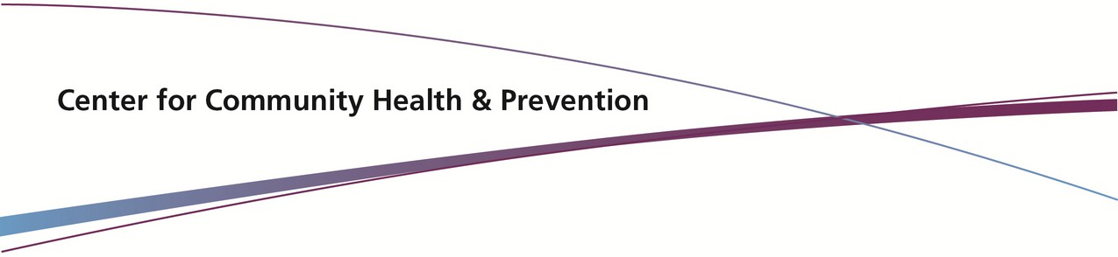
Created by:
Julia Tellerman, MPH
Gabriella Khawly, MPH
Contributions from:
Ghinwa Dumyati, MD
Brenda Tesini, MD

OUR TEAM

Multisite Gram-Negative Surveillance Initiative (MuGSI)
Ghinwa Dumyati, MD, Director
ghinwa_dumyati@urmc.rochester.edu

Rebecca Tsay, MPH, MLS, rebecca_tsay@urmc.rochester.edu
Julia Tellerman, MPH, julia_tellerman@urmc.rochester.edu
Kiki Looi, MPH, MLS, hsioache_looi@urmc.rochester.edu
Christopher Myers, MS, christopher_myers@urmc.rochester.edu
Jenna Dietz, MLS, jenna_dietz@urmc.rochester.edu
Gabriella Khawly, MPH, gabriella_khawly@urmc.rochester.edu

ACKNOWLEDGEMENTS
We would like to express our gratitude to our laboratory, hospital, and nursing home partners for their continued support and collaboration. Thank you for your invaluable contributions that have made this ongoing project possible.

For more information on ESBL: www.cdc.gov/hai/eip/mugsi.html




