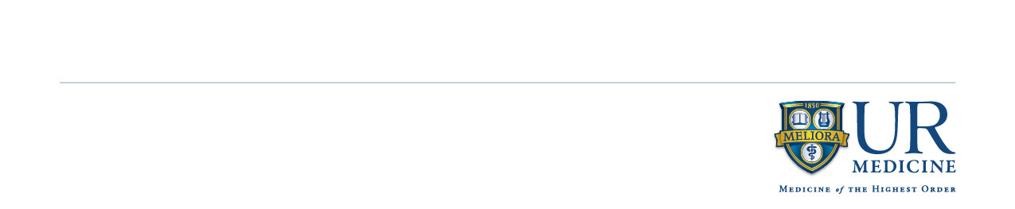

Your initial concussion evaluation will take approximately **3 ½ hours**.

You will first undergo computerized cognitive testing using a program called ImPACT. This 20 minute test lets your concussion care team know how well your brain is working after concussion.

You will then be evaluated by Dr. Bazarian and his nurse practitioner, Pamela Mapstone. They will decide if you need to be on any medications, if you need academic adjustments at school, and when it will be safe for you to return to contact sports. This evaluation will take approximately one hour.

You’ll then be seen by our physical therapy team. They will evaluate your neck muscles and your balance (vestibular system). These systems are sometimes affected by concussion and can cause headache and other symptoms. Our PT team will start you on exercises to fix any problems they detect. They will also test your aerobic capacity on a treadmill. Having you exercise at a safe level is very important for your recovery from concussion. Their evaluation will take approximately one hour.

Next you will be seen by our occupational therapy team. They will evaluate your vision and eye muscle function. Concussion can affect these systems and also cause headache, blurred vision and trouble reading. Our OT team will start you on exercises to fix any problems they detect. They will also review the results of your ImPACT test and recommend the best way to improve your memory and concentration if it has been affected by your concussion.

Please be advised that your physician visit, physical therapy visit and occupational therapy visit are billed as individual office visits. The Specialist copay required by your specific insurances policy applies to all three visits.

If this injury occurred during a school sporting event or other organized sports club you may be eligible for medical coverage or reimbursement from your schools or club. To find out if you qualify for SAP (School Accident Program) or club insurance please contact your school or club.

**What you should bring to the first visit**

1. Comfortable workout clothes and sneakers
2. A small snack such as a granola bar, apple, or banana
3. Copies of any prior ImPACT tests you may have taken.
4. Please complete and bring the enclosed Patient Medical History form to your initial visit

Please feel free to call the clinic at **585-275-3271** should you have any questions.

**UR Medicine Sport Concussion Team**

4901 Lac de Ville Blvd

Building D, suite 250

Rochester, NY 14618

letter

**Welcome to the UR Medicine Sport Concussion Clinic!**

The following is a description of what you can expect during your initial evaluation.