ResearchMatch.org (RM) is a national participant recruitment tool for researchers conducting studies with health-related outcomes. To request the use of RM as a recruitment tool for your study, complete and submit this form to the reviewing IRB. For University of Rochester policy on using RM, click here. If you have any questions about this form or using RM, email ResearchHelp@urmc.rochster.edu.
1. Name of reviewing IRB: Click here to enter text.

2. Has the IRB determined this study to be exempt from review? Click here to enter text.

3. Your study’s assigned CLICK #: Click here to enter text.

4. Study title: Click here to enter text.

5. One of your study’s health-related outcomes: Click here to enter text.

6. Study PI’s name: Click here to enter text.
NOTE: Although the RM system accepts Co-PIs, UR policy requires that only the PI-of-Record (person listed as PI on the IRB approval letter) should be listed as the PI in RM.

7. Person completing the form: Click here to enter text.

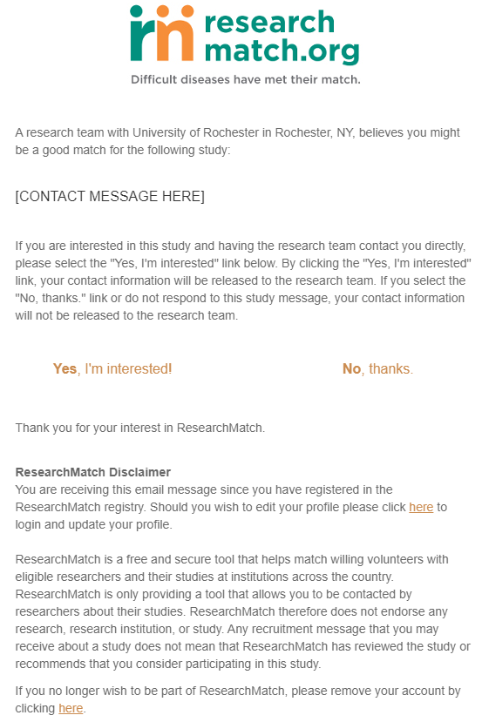
Your contact message will appear inside standardized language that is included on all emails from ResearchMatch. (See image on left.)
NOTE: The contact message must not include any hyperlinks/URLs or any contact information (study team names, emails, or telephone numbers).

8. Contact message you will send to potential volunteers (maximum character length is 2000):
[The purpose of this study is…]
[Why it matters]
[Who is eligible?]
[Study activities]
[Compensation]

9. Will you be entering a URL into RM for a REDCap pre-screening (eligibility filtering) survey?
☐No ☐Yes If “yes,” include the pre-screening survey in this IRB submission if not previously IRB approved.
NOTE: In RM, only “recruitment” studies (face-to-face visits involving clinical or observational interventions) can use this functionality. The REDCap pre-screening survey must be IRB approved.

10. As part of your study’s research activities, will you be entering a URL into RM for a REDCap research survey that participants will need to complete?
☐No ☐Yes If “yes,” include the research survey in this IRB submission if not previously IRB approved.
NOTE: In RM, only “survey only” studies (studies collecting data through electronic survey only) using the REDCap application can use this functionality. The survey instrument must have IRB approval.

Should your study result in publication, you should reference ResearchMatch and the CTSA program
as follows:
Recruitment for the study <<included/was done>> via ResearchMatch, a national health volunteer registry that was created by several academic institutions and supported by the U.S. National Institutes of Health as part of the Clinical and Translational Science Award (CTSA) program. ResearchMatch has a large population of volunteers who have consented to be contacted by researchers about health studies for which they may be eligible. Review and approval for this study and all procedures were obtained from <<enter name of institutional review board>>.

