Health Sciences Center for Computational Innovation (HSCCI)
The intersection of science, medicine, and computational technology holds unsurpassed promise and importance in the 21st century. At that juncture, the Health Sciences Center for Computational Innovation facilitates access to high-performance computational resources for biomedical research. Home to IBM's latest supercomputer, the BlueGene/Q, and a new Linux cluster, BlueHive 2, HSCCI is one of the five most powerful university-based supercomputing sites in the nation. Construction of a state-of-the-art visualization lab was completed in June 2014. The combination of cutting-edge equipment and expert staff allows University researchers to focus on solving health care's most complex problems. HSCCI is the result of a partnership between the University of Rochester, IBM, and New York State. The University seeks to develop the center further through corporate partnerships, institutional support, federal research grants, and New York State programs. The Center for Governmental Research estimates that HSCCI could create 900 jobs in the Rochester area and generate $205 million in new research funding over the next 10 years, ultimately bringing $50 million in economic benefits to the region.
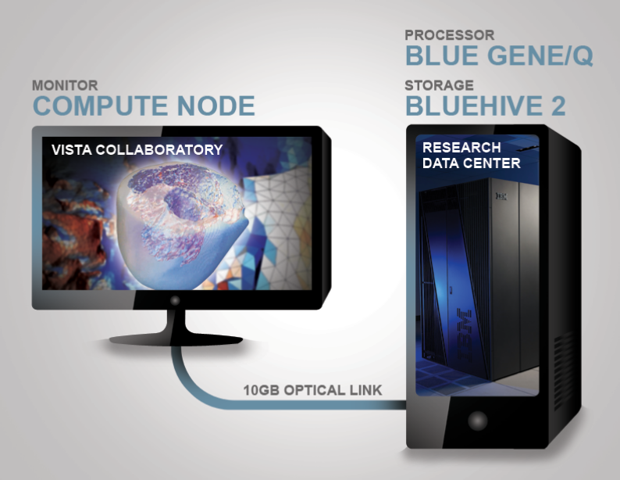
VISTA Collaboratory. Construction of a 1,000-square-foot visualization lab called the VISTA Collaboratory was completed in June 2014. It is equipped with an interactive, tiled-display wall that renders massive data sets in real time, giving faculty researchers the ability to visualize and analyze complex data instantaneously and collaboratively with colleagues and students. At 20 feet wide and 8 feet tall—consisting of 24 displays arranged in a curved 4 x 6 matrix—the display wall creates an immersive experience. Both static and dynamic visual content are clear and crisp at 50-megapixel resolution, driven by a clustered GPU rendering system. The VISTA Collaboratory is located on the first floor of Carlson Library on River Campus. The Center for Integrated Research Computing (CIRC) provides technical support for the VISTA Collaboratory. More information on how to display high-resolution data and lay out presentations for use on the display wall is available on the CIRC's wiki. The VISTA Collaboratory is directly connected to the supercomputers in the Research Data Center over a dedicated 10 GB optical network. It interacts with the Research Data Center like a desktop computer system.
Center for Integrated Research Computing (CIRC).
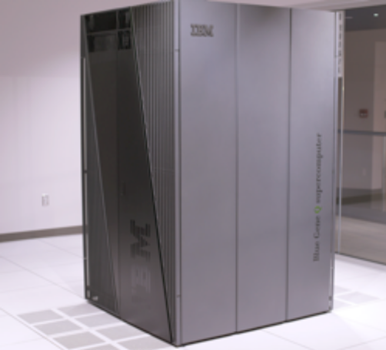
CIRC offers University researchers state of the art computing technology and software including support for the use and implementation of these resources. CIRC currently maintains about 420 TeraFLOPS of high performance computing systems, including the University of Rochester's flagship IBM Blue Gene/Q system.

The Blue Gene/Q system at the University of Rochester consists of one rack of the 209 TFLOPS IBM Blue Gene/Q massively parallel processing (MPP) supercomputer, one IBM System p (POWER 7) front-end node, one IBM System p (POWER 7) service node, and 4 IBM System x I/O nodes connected to a 400 TB IBM GPFS System Storage solution. The Blue Gene/Q system consists of 1,024 nodes, 16,384 CPU cores, 16 TB of RAM, and 400 TB of storage. Each node consists of a 16-core A2 processor with 32 MB of cache and access to 16 GB of RAM. The Blue Gene/Q rack is cooled by a highly-efficient water cooling.
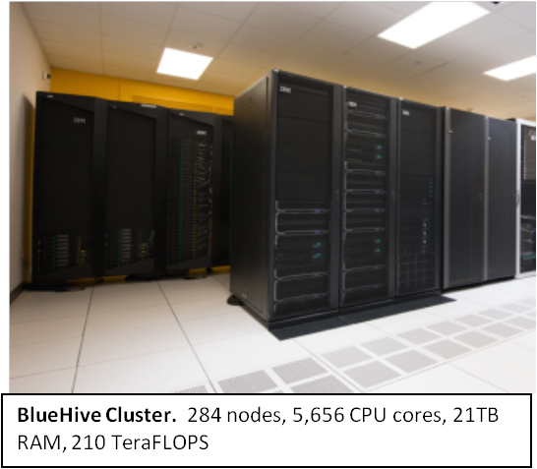
The BlueHive cluster is CIRC's primary Linux cluster for demanding computations, which provides approximately 210 TFLOPS of computing capacity. This system consists of 284 nodes with a high-speed, low-latency, InfiniBand interconnect. The most recent addition to the BlueHive Cluster houses 2 x 12-core Intel Ivy Bridge processors (for a total of 24 cores per node), and ranges in memory from 64 GB to 512 GB. A number of the 64 GB nodes have two dedicated coprocessing cards, including NVIDIA's K20X (Kepler) GPUs and Intel Phi 5110P accelerators. In addition, some nodes of the cluster are dedicated to running “big data” analytics applications, such as Hadoop, with 112 TB of dedicated local storage and a total of 384 GB of RAM. The entire cluster is equipped with rear-door heat exchangers to leverage additional power and cooling savings, provided by the
Blue Gene/Q. The entire BlueHive cluster has an InfiniBand-attached storage system providing almost 2 PB of configurable raw disk within a GPFS file system. 84 nodes with varying capacity have been integrated into the BlueHive cluster for faculty investigators who have purchased additional priority-based compute capacity for the environment. CIRC runs the SLURM resource scheduler and queuing system to optimize usage and to support multiple users of the BlueHive Linux cluster environment. Additionally, users have access to an NX- based technology to connect to BlueHive using a resumable GUI interface.

CIRC Services
• Access to high-performance computing and data analytic systems
• Research collaboration
• Assistance in grant writing
• Individual and group training
• Monthly symposia sessions
• Contributed hardware for priority access

Affiliated Organizations. In support of its mission to enable researchers to take advantage of computing resources at the University of Rochester, CIRC works together with other organizations. A selection of these affiliated organizations is below:
• Clinical and Translational Science Institute
• Data Center
• Health Sciences Center for Computational Innovation (HSCCI)
• Information Technology
• Institute for Data Science
• Miner Library
• River Campus Libraries
• Rochester Informatics
• School of Arts, Sciences, and Engineering
• School of Medicine and Dentistry
• Shared Resource Laboratories

