Tips for Writing Specific Aims
The Specific Aims section is the most vital part of any NIH grant application. In this section, you must quickly gain the reviewers’ trust and confidence while simultaneously convincing them that your work is important to fund. You may think of your Specific Aims page as an abbreviated version of the full grant. Be sure you can complete your Aims within the typical timeframe for your chosen Funding Opportunity Announcement (FOA). For an R01, that’s typically four to five years. Your project should tackle important research within your niche: it must be able to move your field forward. Beware of concepts that can’t be strongly supported with your own preliminary data or published data from other laboratories. Thinking high level, ask yourself what objectives you could reasonably achieve within the timeframe of a grant. Start broadly with an emphasis on significance, and then focus on generating experiments with clear endpoints reviewers can readily assess.
The Introductory Paragraph
In this paragraph, your goal should be to introduce your research subject to the reviewers and quickly capture their attention. This paragraph should describe the significant gap in knowledge that directly relates to the critical need the funding entity deals with. It is critical to know your funding entity’s mission statement and ensure the critical need you are trying to fill fits well within its mission. It should include the following information:
First Sentence/Hook
In this sentence, briefly describe what your proposal will be about. Ideally, this sentence should convey a sense of importance or urgency to your research. Explain quickly WHAT your research topic is and WHY it is critical that you conduct the research (i.e. saving lives, preventing cancer, etc.)
“Readmission or “bounce-back” to the intensive care unit substantially increases the odds of prolonged length of stay and/or death during hospitalization for the patient and results in significant anxiety and distress for their family caregivers.”
State what is known
State what is currently known in the specific field. This part should not be very long (3-5 sentences) but it should ground the reader in the subject of your research. Provide the reader with only the necessary details to understand why you are proposing the work. Remember to be concise and focused on only the key points.
“Causal diagnoses associated with ICU re-admission have been examined primarily in the surgical and cardiology literature, and have included hypotension, respiratory failure, post-procedure hemorrhage, and cardiac arrhythmia [1-5]. Several retrospective studies have identified broad risk factors for ICU readmission, including age, co-morbid conditions, diagnosis, ICU length of stay, time of discharge, abnormal vital signs, and ICU occupancy level all at the time of discharge.”
Gap in Knowledge
The gap in knowledge is the piece of information that is not known. Clearly state the gap in knowledge that needs to be addressed. Convey that your research will fill this gap using the funding that you are requesting.
“However, studies that use high-dimensional data mining and predictive statistical modeling, with both training and validation data sets and real-time prospective testing, are lacking in the literature.”
The Second Paragraph
In this paragraph, your goal should be to introduce the solution that fills the gap in knowledge. It is critical to convince your reviewers that you (and your colleagues) have the solution to address the current knowledge gap and the expertise to accomplish this solution. Keep your wording simple, relevant, and to the point. You will want to address the following points:
- What do you want to do?
- Why are you doing it?
- How do you want to do it?
State your central hypothesis clearly, specifically, and with simple language. You want to demonstrate to the reviewers that you have a hypothesis-driven proposal that is testable. Describe how your project addresses the critical need, and clearly state the proposed solution. In general, avoid vague hypotheses because it will be unclear to the reviewers what you expect to determine with the proposed research.
Hypothetically Speaking
Why do you need a central hypothesis (or multiple hypotheses)? Because that's what reviewers expect and what anchors your different Specific Aims to a common theme, not just a common field of research. Following a central hypothesis also keeps you focused with both writing the proposal and actually doing the research if the grant is funded. Some people write their Specific Aims first and then develop a hypothesis; others do the reverse. The correct method will depend on the approach that works best for you and your proposed research. A strong hypothesis should be well-focused and testable by the Specific Aims and experiments. After you create your hypothesis, go back and take stock again of your prospective reviewers and their level of interest in light of your draft aims and hypothesis.
“To solve this problem we will develop an innovative mouse model system in which to study Tax tumorigenesis using targeting vectors containing wild-type or mutant Tax genes that are silenced by a preceding floxed stop cassette. These vectors will be knocked in to the Rosa26 locus of recipient mice by recombination. After crossing these mice with Lck-CRE mice, the stop cassette will be specifically excised in developing thymocytes where the Lck promoter is active, allowing conditional expression of wild-type or mutant Tax proteins in T cells, the natural target of HTLV-1 infection. The feasibility of our proposed mouse model is supported by the fact that Lck-Tax transgenic mice have been developed and produce a leukemia that closely resembles ATLL. Thus, targeting of Tax expression in cells in which the Lck promoter is active is expected to produce a similar disease in our model. In our improved model system, insertion into the Rosa26 locus will eliminate random integration sites and standardize gene copy number resulting in consistent levels of wild-type and mutant Tax protein expression.”
The Aims
In this section, you will describe briefly each of the aims you will use to test your hypothesis. Ideally, the aims should be related, but not dependent, upon each other. If you do this, the failure of one aim (or an unexpected result from one aim) does not negatively influence any other aim or prevent the completion of the other aims.
Within 2-4 sentences each, you should describe the experimental approach and how each aim will help answer your larger hypothesis. A typical NIH R01 grant will have between 2 and 4 Aims. Plan to describe each aim in a separate paragraph. Additionally, these tips may help you to formulate your aims sections:
- Give your aim an active title that clearly states the objective in relationship to the hypothesis.
- Include a brief summary of the experimental approach and anticipated outcomes for each aim.
- If you have room, you may wish to include a sub-hypothesis (the small portion of the overall hypothesis) and a small description of the pay-off of each aim. Including these is helpful to creating the impression that each aim is valuable, testable, and independent of the others.
- To make it easier for the reviewers to clearly read and understand each aim, it is often helpful to use headings and/or bullets to delineate each specific aim.
“Aim 1: To assemble a large, multi-dimensional data set of potential variables associated with re-admission to the Medical Intensive Care Unit. We will first assemble a test data set of patients admitted to the MICU over a 2 year period, stratified by those who subsequently were re-admitted and those who were not. Extensive data from the electronic medical record will be collected, including demographics, diagnoses, laboratory tests, vital signs, medications, and procedures.
Aim 2: To use high-dimensional data mining and clustering methods to identify factors associated with MICU re-admission and construct a prospective-predictive statistical model. Using data from Aim 1, we will identify high-dimensional signatures (collections of variables) strongly associated with ICU re-admission at several time-points: time of admission, time of discharge, and 24 hours prior to re-admission. From the corollary set of variables developed in Aim 1, we will begin to incorporate categorical variables from MICU personnel, patients and families into the models, as well as non-traditional variables such as nurse:patient ratios, unit census, etc.
Aim 3: To validate the signature(s) developed in Aim 2 using prospective data collection and statistical analysis. Using the risk-signature developed in Aim 2, we will prospectively test the predictive model. This will involve time-dependent data monitoring, and ongoing predictive assessment. We will then model and simulate interventions that could be applied to the predictive model to improved outcomes, as identified in Aim 2. Successful completion of this Aim would include validation of a risk stratification and prediction metric that could be widely used across the national healthcare system to predict and reduce ICU re-admissions.
Aim 4: To develop and refine a visual dashboard based on the signatures and model developed in Aim 2. We will utilize the feedback of providers to create and then further refine a dashboard visualization to assist in decision-making regarding ICU transfers and re-admissions. Once we have a dashboard which is feasible and acceptable to clinicians, we will extend our project to refine the model and dashboard to better represent a broader constituency of critically ill patients, family members, and clinicians (e.g. cardiac intensive care units, surgical intensive care units). Successful completion of this Aim would result in a patentable visualization dashboard for ICU transfer decision making.”
There Are Good Aims and There Are Poor Aims
A common type of Specific Aim might ask a question like “Does A cause B?” However, your project could come to an end if A doesn’t turn out to cause B. It’s better to design an aim where the result doesn’t depend on only one outcome, but where one or more different outcomes would also be of interest. Then the question becomes “Does A cause B or non-B,” so make sure the “non-B” outcomes make sense based on both your central hypothesis and preliminary data. Another common type of Specific Aim is descriptive. For example, “We will measure levels of X in 1,000 samples of Y to characterize the pattern of expression of X." Though this may be very doable, it is rarely a highly significant finding in itself and often should be avoided unless you have no other choice. Such descriptive findings should usually be part of your preliminary data, not part of your proposal.
Assess Your Specific Aims
Here we show you how to put to the test your draft objectives—Specific Aims—you have planned for your project. This step provides a check of your aims in light of the study section you identified and advice on presenting your aims if you propose highly innovative research. Start assessing your Specific Aims by taking a hard look at the significance and innovation of your planned research.
Ask yourself
- Would my reviewers see my proposed project as tackling an important problem in a significant field?
- Would they view my Specific Aims as capable of opening up new discoveries in my field?
- Would my reviewers regard the work as new and unique?
- Would they view my Specific Aims as likely to exert a significant influence on the research field(s) involved?
- Are my Specific Aims written clearly and are they easy to understand?
You'll want to get outside opinions for a fresh perspective. Don't assume others, including your reviewers, will consider a research area to have the same priority that you do. Also discuss your draft aims with colleagues who aren’t in your field. If they can understand your project and get excited about it, you have a better chance your reviewers will as well. It is particularly useful to have your application reviewed by a colleague who has been successful in getting NIH funding, or better yet, has served on an NIH study section. At this point, you may want to go back and reconsider your Specific Aims so you can be as certain as possible that the committee will appreciate your research plans.
A figure is worth a 1000 words
Create a figure that ties your proposed experiments to your specific aims.
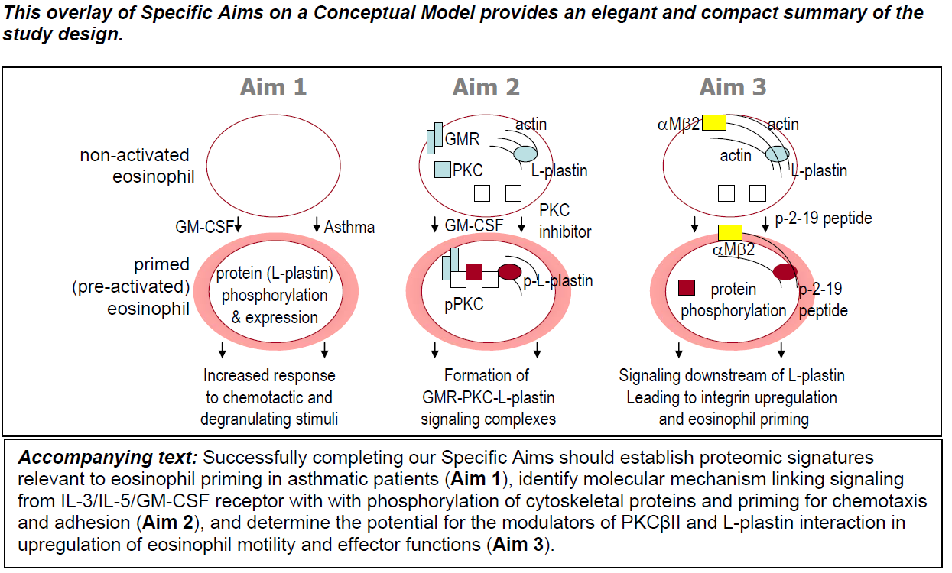
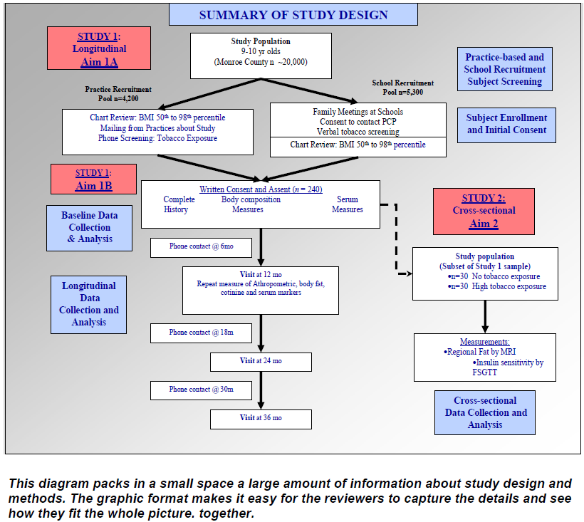
Adapted from http://www.biosciencewriters.com/NIH-Grant-Applications-The-Anatomy-of-a-Specific-Aims-Page.aspx and https://www.niaid.nih.gov/grants-contracts/draft-specific-aims.

