ROCHESTER RESEARCH ROUNDUP

MIND THE GAP:

Supporting Caregivers with a New Autism Spectrum Diagnosis
Conducted at University of Rochester, Drexel University, University of California at Davis, University of California Los Angeles, and University of Pennsylvania

What is the problem? What gap are you trying to fill?

It is critical to access the right services as soon as possible after an autism diagnosis. Families may struggle to navigate the complex service systems for an autism spectrum disorder (ASD). This can lead to delays in services, especially among families from under-represented groups, such as those from racial or ethnic minority groups, or those from lower income households.

How did you study it?
We worked with caregivers of children who:
- had a recent ASD diagnosis
- lived in low-income households
This study aimed to close the gap between getting an ASD diagnosis and receiving services. Because the service systems often have not done a good job engaging all communities, this project asked for community input to design a peer navigator program called "Mind the Gap."
Mind the Gap helps build relationships and support families of young children newly diagnosed with ASD. We used feedback from those involved to make the program better and reduce gaps between research and what actually happens in the community.

Peer navigators are other parents of children with ASD who have experience

Caregivers were paired with peer navigators, and together they met to review topics.
Caregivers picked topics that they wanted to learn more about and chose goals to
with the service system

Topics included:

Social support &

work on. They also got to choose the time, place, and style of meeting (phone, video-conference, or in-person).
Peer navigators helped by sharing information with caregivers, answering their questions, and working through goals together.
ASD knowledge

Stress management
Challenging behavior
Stigma

Communication

System navigation


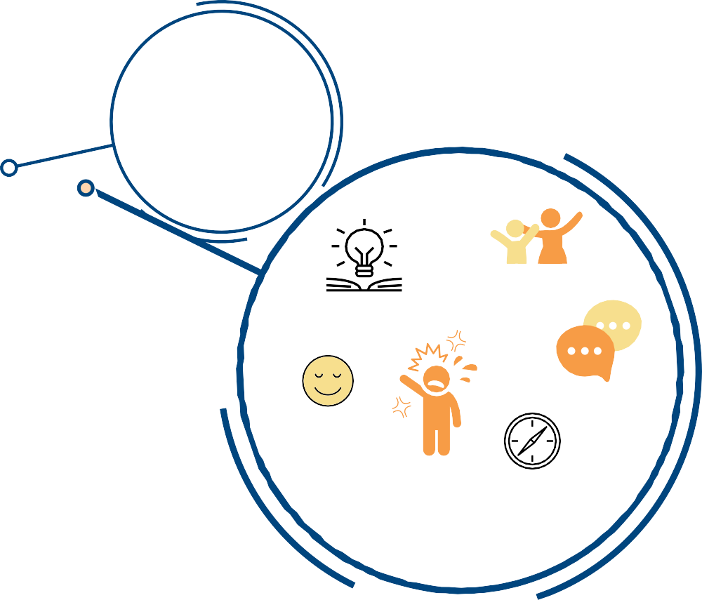








visit us at http://golisano.urmc.edu/dbp




What did you find?
Caregivers said: peer navigators were the most important and helpful part of the program.

Peer navigators were satisfied with the content, helpfulness, and accessibility of the materials, as well as the family-centered nature and variety of topics.

Caregivers were
satisfied with MTG
3.9
out of 4.5 points

Caregivers were
engaged with MTG

7 out of 9
families completed the program

Caregivers wanted a better matching process with peer navigators who had similar experiences based on things like race, ethnicity, or language, among other characteristics. They also suggested reducing the time commitment to make it even easier for both families and peer navigators to complete the program.

What's next?
The research team will take these findings and suggestions from this small pilot study to help make the Mind the Gap program better, and will complete a larger study with more families and peer navigators.

Why does it matter?
Navigating the complex service systems for ASD can be difficult. These systems have especially not done a good job engaging families from diverse racial or ethnic backgrounds, or from lower-income households. There is a growing need for programs like Mind the Gap that can be done effectively in real community settings.


T H E F U L L A R T I C L E C A N B E F O U N D C I T A T I O N B E L O W , O R S C A N T H E Q R C O D E F O R O P E N A C C E S S :
Iadarola, S, Pellecchia, M, Stahmer, A, Lee, HS, Hauptman, L, Hassrick, EM, Crabbe, S, Vejnoska, S, Morgan, E, Nuske, HJ, Luelmo, P, Friedman, C, Kasari, Gulsrud, A, Mandell, DS, & Smith, T. (2020). Mind the Gap: An intervention to support caregivers with a new autism spectrum disorder diagnosis is feasible and acceptable.
Pilot and Feasibility Studies, 6(1), 124-136. https://doi.org/10.1186/s40814-020-00662-6

This project is/was supported by the Health Resources and Services
Administration (HRSA) of the U.S. Department of Health and Human Services (HHS) under AIR-B UA3 MC11055 HRSA (PI: Kasari). The information, content and/or
conclusions are those of the author and should not be construed as the official
position or policy of, nor should any endorsements be inferred by HRSA, HHS or the
U.S. Government.
visit us at http://golisano.urmc.edu/dbp

