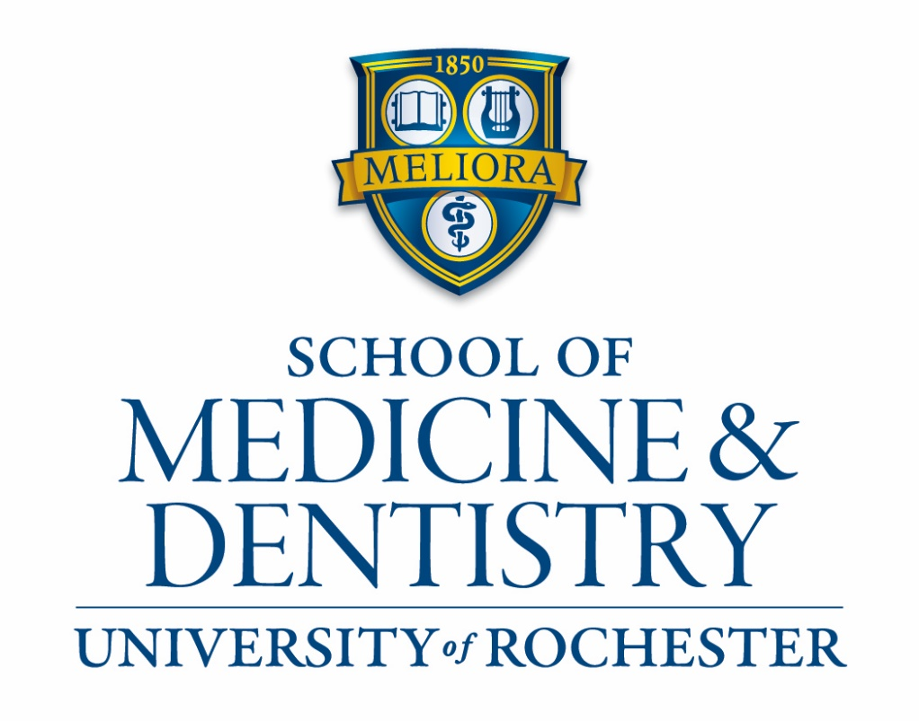

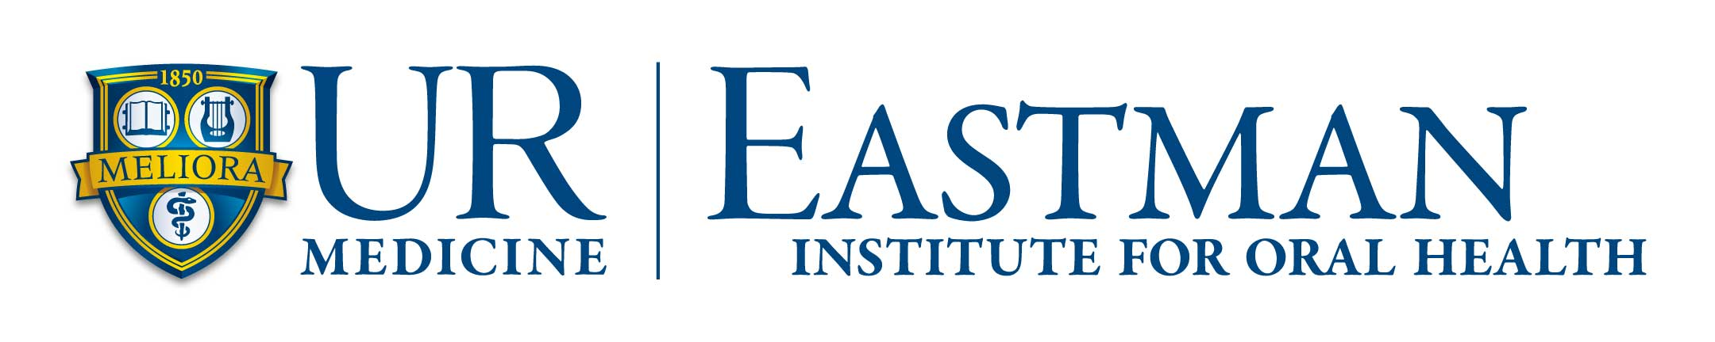

University of Rochester School of Medicine
& Dentistry

University of Rochester Medical Center Eastman Institute for Oral Health

Combined Doctor of Medicine-Oral Maxillofacial Surgery Training Program

The University of Rochester School of Medicine and Dentistry and the University of Rochester Medical Center’s Eastman Oral Institute have a six-year program that awards the MD degree and advanced training in Oral Maxillofacial Surgery (OMFS).

Accepted dentists are enrolled in the MD program half-time in each of the first two years and enrolled in the OMFS program the other half of the time. Breaks during the MD curriculum allow the individual to have dedicated time in the OMFS program.

The MD-OMFS learner must remain in good academic and performance standing in both programs to remain enrolled in this combined program and their performance will be reviewed annually by both programs. The MD-OMFS learner must complete the requirements of both the MD program and the OMFS program to be awarded the MD degree and OMFS certification.

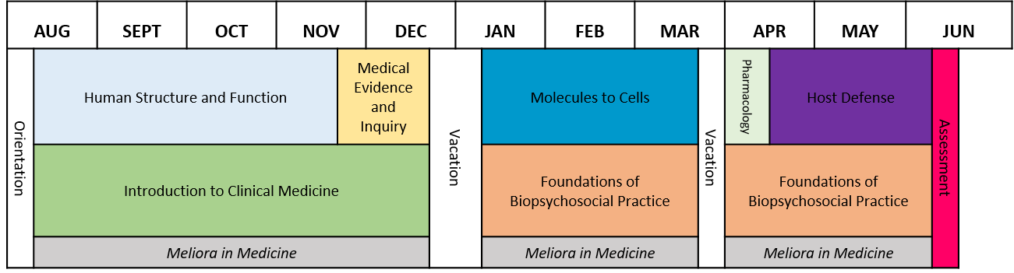
Applicant requirements:
Phase 1

Applications will be considered from graduates or senior dental students of dental schools accredited by the Council on Dental Education of the American Dental Association. Applicants must be U.S. citizens or permanent residents and be eligible for dental licensure in New York State and the U.S. to be considered for the 72-month MD-OMFS program. An interviewed applicant must take USMLE Step 1 by April 30th of the year they plan to matriculate into the program.

Application process:

Applicants must participate in the National Matching Program of the American Association of Oral and Maxillofacial Surgeons and the Postdoctoral Application Support Service (PASS) of the American Association of Dental Schools and the in the MATCH selection process. Contact: PASS, 1625 Massachusetts Ave. NW, Suite 101, Washington D.C. 20036. Applicants assume full responsibility for submitting the required materials to PASS before October 15th in the year prior to matriculation.

Interview Invitation:

Promising candidates will be invited to Rochester for an interview in the beginning of November. The personal interview is required for final consideration. Applicants selected for an interview must complete the American Medical College Application System (AMCAS) application in early December. Applicants to the OMFS- MD program will not be required to complete the Situational Judgement Test administered by CASPER. The AMCAS Deadline is December 1, 2019 and the URSMD secondary application deadline is December 6, 2019.

Interview Day:

Applicant will meet with the oral and maxillofacial surgery faculty, who will answer the applicant's questions about the program. Applicants will also be evaluated by the current OMFS residents.
The evaluation by the OMFS faculty and residents is objective and subjective encompassing many factors such as academic achievements, motivation for a career in oral and maxillofacial surgery, suitability specifically for the URMC oral and maxillofacial surgery residency program, professional demeanor, and future career goals.

Applicants will also meet with select members of the medical school Admissions Committee during this visit. Medical school admissions will focus on suitability for a career in medicine through a holistic lens. Evidence of activities as related to the core values of the School of Medicine will be assessed – please see the URSMD website for more information https://www.urmc.rochester.edu/education/md/admissions.aspx Once selected for an interview, applicants will receive further detailed information about the interview process.

Acceptance:

OMFS match results are releasedon February 24, 2020. Once an applicant matches a conditional acceptance to the School of Medicine will be offered. In order to matriculate to the School of Medicine, the conditionally accepted student must take and pass the USMLE Step 1. The last date an applicant can take the USMLE Step 1 is April 30, 2020. The conditional acceptance to the MD program is contingent upon passing USMLE Step 1 on the first attempt.

Accepted OMFS-MD students must abide by all the deadlines of the School of Medicine in addition to the OMFS Residency Program. The following are examples of deadlines for the School of Medicine and Dentistry:

  - Plan to Enroll through AMCAS – April 30, 2020
  - Commit to Enroll through AMCAS – July 15, 2020
  - Orientation Material – July 15, 2020
  - Registration –August 3 - 7, 2020

Specifics of program participation are outlined below.
Phase 1

Year 1 MD-OMFS Program

The MD-OMFS student will be enrolled in Introduction to Clinical Medicine, Foundations of Biopsychosocial Practice and Meliora in Medicine and Complete the Phase 1 Assessment.

During this time, the MD-OMFS student will be enrolled 50% in the MD program and 50% in the OMFS residency as a PGY-1.

From July 1st to mid-August, the MD-OMFS student will be a full time OMFS resident (6 weeks).

From matriculation to the beginning of Phase 2, it is expected the MD-OMFS student will complete the equivalent of 30 weeks of the OMFS residency (24 week equivalents during Phase 1 of the MD program and 6 following Phase 1).

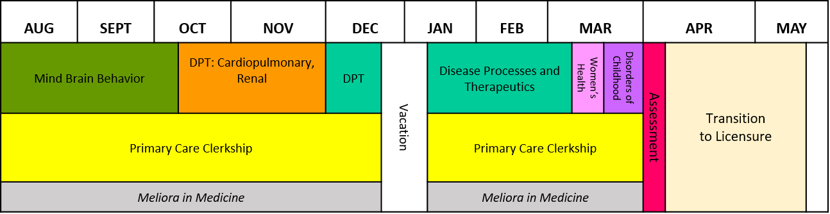
Phase 2

Year 2 MD-OMFS Program

The MD-OMFS student will be enrolled in the Primary Care Clerkship and Meliora in Medicine and Complete the Phase 2 Assessment.

During this time, the MD-OMFS student will be enrolled 50% in the MD program and 50% in the OMFS residency as a PGY-2. During Phase 2 which ends the beginning of June, it is expected the MD-OMFS student will complete the equivalent of 24 weeks of the OMFS residency.

As the MD-OMFS student will have successfully passed USMLE Step 1 prior to matriculation, the student will complete an additional 6 weeks in the OMFS residency as a PGY-2. During this time, it is advised that the individual take vacation time.

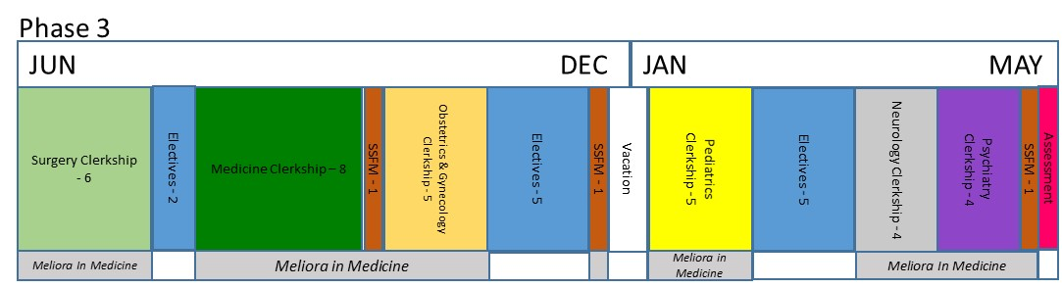

Year 3 MD-OMFS Program

The MD-OMFS student will be full-time in the MD curriculum above however elective time will be utilized to complete OMFS requirements in anesthesia (16 weeks in anesthesia and 4 weeks in pediatric anesthesia are required by the OMFS program). During this period of training, the MD-OMFS student will not receive compensation as a resident.

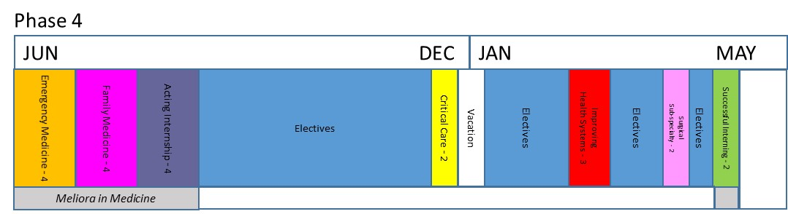

Year 4 MD-OMFS Program

The MD-OMFS student will be full-time in the MD curriculum above however elective time will be utilized to complete any further OMFS requirements in anesthesia (16 weeks in anesthesia and 4 weeks in pediatric anesthesia are required by the OMFS program). During this period of training, the MD-OMFS student will not receive compensation as a resident. The acting internship will be completed on the OMFS inpatient service. The four weeks of acting internship will be applied to the required weeks of the OMFS program. During this period of training, the MD-OMFS student will not receive compensation as a resident.

*During Phases 3 and 4, the MD-OMFS learner will complete 16 weeks of elective in anesthesia and 4 weeks of elective in pediatric anesthesia. The acting internship (4 weeks) will be completed on the OMFS inpatient service.

Year 5 MD-OMFS Program

The MD-OMFS learner will be a full-time intern in the Department of Surgery at the University of Rochester Medical Center’s Strong Memorial Hospital. This is the PGY-3 year of the OMFS program. The learner will receive a full-time salary. Eight weeks of the internship will be part of the OMFS requirements.

Year 6 MD-OMFS Program

The MD-OMFS learner will be a full-time chief resident in the University of Rochester Medical Center’s Eastman Oral Institute Department of Oral and Maxillofacial Surgery as the Chief Resident. The learner will receive a full-time salary as a PGY-4.

The Committee on Dental Accreditation (CODA) requires a total of 120 weeks of OMFS, 16 weeks of anesthesia and four weeks of pediatric anesthesia.

Summary:

Year | Role | Status | Financial
Year 1 | MD Program Phase 1 student/OMFS PGY-1 | 50% time medical student 50% time OMFS Resident | 50% MD tuition, all fees/Salary during PGY-1 time
Year 2 | MD Program Phase 2 student/OMFS PGY-2 | 50% time medical student 50% time OMFS Resident | 50% MD tuition, all fees/Salary during PGY-2 time
Year 3 | MD Program Phase 3* | Medical Student full-time | Full MD tuition, all fees.
Year 4 | MD Program Phase 4* | Medical Student full-time | Full MD tuition, all fees.
Year 5 | OMFS PGY-5 | Surgery Intern | Salary
Year 6 | OMFS PGY-6 | OMFS Chief Resident | Salary

