
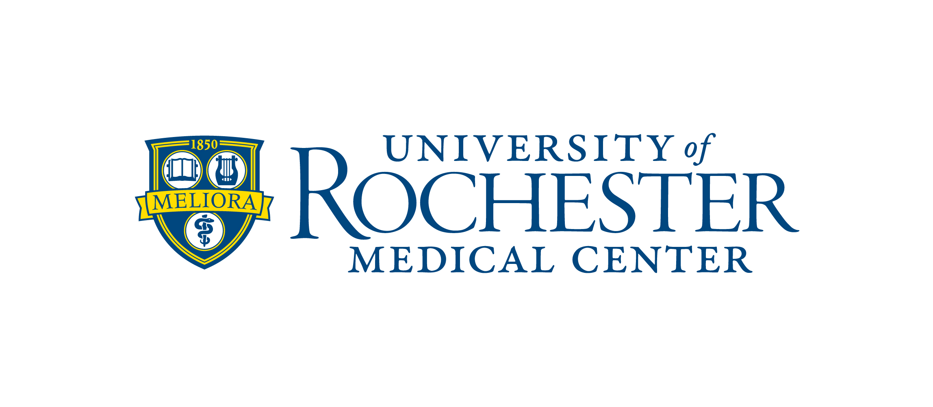
Registrar’s Office
Medicine of the Highest Order

March 2015

Dear Prospective Applicant:

Thank you for your interest in Graduate Medical Education (GME) Residency Training Programs at the Eastman Institute for Oral Health (EIOH) at the University of Rochester Medical Center (URMC)! Our GME Residency Programs are designed for dentists who obtained their dental degree from a dental school in either the United States and/or Canada that is accredited by the American Dental Association’s (ADA) Commission on Dental Accreditation (CODA). GME residents receive a stipend (annual salary) and are eligible for employee benefits. All of our GME Residency programs are fully accredited by the American Dental Association’s (ADA) Commission on Dental Accreditation (CODA) and is recognized by the New York State Department of Education.

This letter provides pertinent information including the approximate number of available positions, eligibility requirements, application process, deadlines, etc. for the Academic School Year 2016-17. The application forms and required documents as well as a listing of all the Eastman Institute for Oral Health training opportunities and a Q&A segment are available on our website. (http://www.urmc.rochester.edu/dentistry/education/)

Important information:

- Application process, deadlines, interview and decision/notification dates: The process on how to apply along with important dates is outlined in the chart below. Please note – your completed application, application fee and all required documents must be received no later than the “Application Deadline” noted for each respective program. Any application that is incomplete after the deadline will not be considered. When trying to decide whether or not to apply please keep in mind the length of time it may take to request certain documents to be produced, sent and received to ensure all documents are received no later than the application deadline.

GME Residency Program |  | PASS | Match | EIOH | Application Deadline  (of year preceding start of program) | Interview Dates  (of year preceding start of program) | Decision/Notification Dates  (after interview)
AEGD @ Eastman Dental * |  | Yes (Code 121 – 1 yr prog)  Yes (Code 150 – 2 yr prog) | Yes (Code 2767 – 1 yr prog)  Yes (Code 2769 – 2 yr prog) | Yes | October 1st | November | Match Day January
GPR @ UR * |  | Yes (Code 628) | Yes (Code 8535) | Yes | October 1st | November | Match Day January
GPR @ RGH * |  | Yes (Code 595) | Yes (Code 8515) | Yes | October 1st | November | Match Day January
Oral & Maxillofacial Surgery |  | Yes (Code 295) | Yes (Code 1991) | No | October 15th | December | Match Day January
Orthodontics & Dentofacial Orthopedics |  | No | No | Yes | August 1st | September/October | November
Pediatric Dentistry |  | Yes (Code 330) | Yes (Code 4563) | No | October 1st | October/November | Match Day January
Periodontology |  | No | No | Yes | August 1st | August | September
Prosthodontics |  | Yes (Code 416) | No | Yes | August 1st | August/September | September
* | These three (3) programs are a part of the Associated General Dentistry Training Programs of Rochester (AGDTPR). The AGDTPR Program provides a common application form enabling candidates to apply to one, two or all three programs and eliminates the duplication of required supporting documents. These programs are fully accredited by the American Dental Association’s (ADA) Commission on Dental Accreditation (CODA).

- Stipends and fees: Annual stipends are provided to GME eligible applicants who match and are accepted. Any expenses associated with an educational program must be paid prior to the start of the program and are subject to change without notice. In addition the fees noted below are estimated as the figures for the School Year 2016-17 will not be available until spring 2016.

Health insurance coverage is purchased based on options chosen through the University of Rochester’s Benefit Office and the amount estimated below is for single coverage. The Health Professions fee noted in the chart below is in addition to health insurance coverage and is mandatory.

STIPENDS & FEE INFORMATION
GME Residency Program | Duration | Approximate Positions Available 2016-17 | Stipend | EIOH/Program  (Yearly) | NYS Permit  (Yearly) | Health Insurance  (Yearly) | Health Professions  (Yearly - Mandatory)
AEGD @ Eastman Dental * | 1 or 2 years | 11 | $49,262 | $1,225 | $185 | $971 | $100
GPR @ UR * | 1 year | 11 | $49,262 | $1,225 | $185 | $971 | $100
GPR @ RGH * | Contact RGH
Oral & Maxillofacial Surgery | 4 years | 2 | $49,262 | $25 | $185 | $971 | $100
Orthodontics & Dentofacial Orthopedics | 2 years | 4 | $27,214 | $3,975 | $0 | $971 | $100
Pediatric Dentistry | 2 years | 6 | $49,262 | $1,225 | $185 | $971 | $100
Periodontology | 3 years | 2 | $27,214 | $4,225 | $0 | $971 | $100
Prosthodontics | 3 years | 2 | $27,214 | $6,225 | $0 | $971 | $100
* Associated General Dentistry Training Programs of Rochester (AGDTPR) – see description above.

- Application completion and submission: The chart below summarizes what documents are required in order to apply for and be considered for any of the GME Residency training program. Please carefully review the additional information provided below for specifics related to each topic noted in the chart.

REQUIRED DOCUMENTS TO APPLY – See Specifics Below
GME Residency Program | Application | Certification Statement | CV | Personal Statement | 2 x 2 Photo | Application Fee | Letters of Recommendation |  | Transcripts | Dental School Diploma | National Boards | TOEFL Scores
AEGD @ Eastman Dental * | Yes | Yes | Yes | Yes | Yes | Yes | Yes |  | Yes | Yes | Yes | No
GPR @ UR * | Yes | Yes | Yes | Yes | Yes | Yes | Yes |  | Yes | Yes | Yes | No
GPR @ RGH * | Yes | Yes | Yes | Yes | Yes | Yes | Yes |  | Yes | Yes | Yes | No
Oral & Maxillofacial Surgery | AS REQUIRED BY PASS
Orthodontics & Dentofacial Orthopedics | Yes | Yes | Yes | Yes | Yes | Yes | Yes | Yes |  | Yes | Yes | No
Pediatric Dentistry | AS REQUIRED BY PASS
Periodontology | Yes | Yes | Yes | Yes | Yes | Yes | Yes | Yes |  | Yes | Yes | No
Prosthodontics | Yes | Yes | Yes | Yes | Yes | Yes | Yes | Yes |  | Yes | Yes | No

- PASS Application – EIOH Admissions Office will download. If any additional documents are needed applicant will be informed of that after application is considered complete by PASS.

- EIOH Application – Follow these steps:
    - Complete application in its entirety, sign and submit the application directly to EIOH at address noted below. (INSERT LINK – Attachment B1b)
    - Include the following items with the application:
      - Certification Statement (Last Page of Application)
      - Curriculum Vitae (CV)
      - Personal Statement
      - 2 x 2 Photo
    - Application processing fee (non-refundable): A $195.00 non-refundable application fee is required at the time of application in order for your application to be reviewed and/or considered. This fee can only be paid by credit card via the following link – http://www.urmc.rochester.edu/dentistry/eioh-registration/. The fee is non-refundable and is not credited toward any charges when an accepted applicant registers.

- Application completion and submission (continued):

- EIOH Application – Follow these steps (continued):
    - Letters of Recommendation – NEW REQUIREMENT – References must be provided electronically via the following link - https://apply-eioh.ur.rochester.edu/loginRec.aspx. Hard copy references will no longer be accepted. In order to complete this requirement, via the link provided above, you will need to have the following information available for each referee: names, email addresses and phone #s for three (3) referees, one of which must be the dean of your dental school; two (2) must be members of your dental school faculty or other supervisory personnel who have had sufficient contact with you to judge your personal and professional qualifications.

    - Additional required supporting documents:
      - Transcripts: dental school transcripts must be sent directly to EIOH from the dental school or college. This is called primary source verification. Transcripts submitted any other way will not be accepted.
      - Dental School Diploma: copies of dental school diplomas must be certified and notarized.
      - National Board Exam Scores: National Boards are not required in order to apply for any GME Residency program. However, they are required to begin. Please have the scores/results sent to Eastman Institute for Oral Health directly from the National Board. Board scores will not be accepted if submitted by the applicant.
      - TOEFL Report: Not required for GME Residency programs.

    - Mailing address: Registrar’s Office (Admissions)
Eastman Institute for Oral Health
University of Rochester
625 Elmwood Avenue, Box 683
Rochester, NY 14620 USA

- Interview Process: Upon receipt of completed application, processing fees and all other required supporting documents your file will be forwarded to the respective program for review and consideration. Selected applicants will be contacted via email to schedule interviews. Therefore, if applying via EIOH Application, it is very important that you include your email address in the appropriate spot on the application (Page 2, #4). Interviews are granted once per cycle and will be conducted in the month(s) as noted above in the year preceding the start of the program for which you are applying.

Our educational goal is to train tomorrow's dental leaders and we are confident that our educational programs will provide you with the necessary skills for a rewarding professional career. Opportunities are also available to participate in graduate programs leading to the MS, MPH, MBA, or PhD degree in the School of Medicine and Dentistry or one of the many other fine local institutions. For information about graduate studies, please visit the following website: http://www.urmc.rochester.edu/education/graduate/prospective-students/admissions/. If you are interested in graduate education, you are encouraged to apply early. Acceptance into any Eastman Institute for Oral Health dental training program does not guarantee acceptance into an academic degree-granting program, as all of these programs have unique requirements for acceptance. Please note the charges (tuition, fees, etc.) associated with these graduate programs are above and beyond the cost of the Training Program with Eastman Institute for Oral Health and are the responsibility of the candidate.

Thank you again for your interest in the GME Residency Training Programs offered in the Eastman Institute for Oral Health at the University of Rochester Medical Center! We look forward to receiving your application.

Sincerely,

Admissions Office
Eastman Institute for Oral Health

