
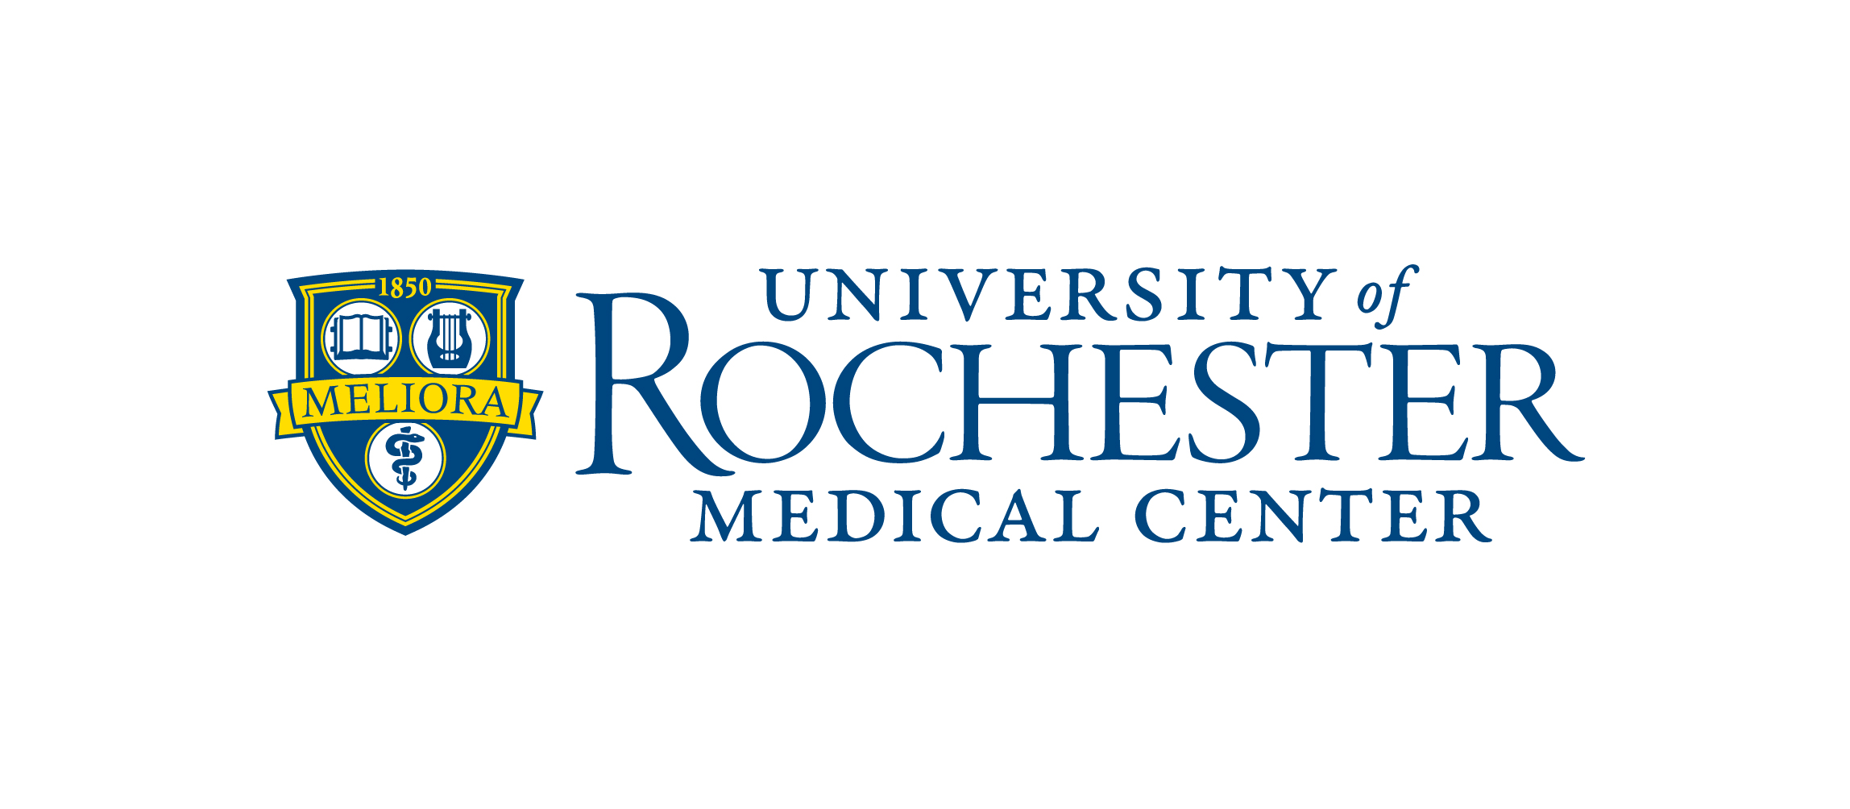
Registrar’s Office
Medicine of the Highest Order

March 2015

Dear Prospective Applicant:

Thank you for your interest in our International Postdoctoral Dental Training Program at the Eastman Institute for Oral Health (EIOH) at the University of Rochester Medical Center (URMC)! Our International Postdoctoral Dental Training Programs are designed for dentists who obtained their dental degree outside the United States from a non-accredited American Dental Association’s (ADA) Commission on Dental Accreditation (CODA) dental school. All of our International Postdoctoral Dental Training Program are fully accredited by the American Dental Association’s (ADA) Commission on Dental Accreditation (CODA) and is recognized by the New York State Department of Education.

This letter provides pertinent information including the approximate number of available positions, eligibility requirements, application process, deadlines, etc. for the Academic School Year 2016-17. The application forms and required documents as well as a listing of all the Eastman Institute for Oral Health training opportunities and a Q&A segment are available on our website. (http://www.urmc.rochester.edu/dentistry/education/)

Important information:

- Application process, deadlines, interview and decision/notification dates: The process on how to apply along with important dates is outlined in the chart below. Please note – your completed application, application fee and all required documents must be received no later than the “Application Deadline” noted for each respective program. Any application that is incomplete after the deadline will not be considered. When trying to decide whether or not to apply please keep in mind the length of time it may take to request certain documents to be processed, sent and received to ensure all documents are received no later than the application deadline.

International Postdoctoral Dental Training Programs | PASS | Match | EIOH | Application Deadline  (of year preceding start of program) | Interview Dates  (of year preceding start of program) | Decision/Notification Dates  (after interview)
Two-Year Training Program in Advanced Education in General Dentistry (AEGD) | No | No | Yes | September 1st | September/October/November | January
Orofacial Pain (formerly TMJD) | No | No | Yes | August 1st | September/October | November
Orthodontics & Dentofacial Orthopedics | No | No | Yes | August 1st | September/October | November
Periodontology | No | No | Yes | August 1st | August | September
Prosthodontics | Yes (Code 416) | No | Yes | August 1st | August | September

- Tuition and fees: Any expenses associated with an educational program must be paid prior to the start of the program and are subject to change without notice and will be at the prevailing rate for subsequent terms. In addition the fees noted below are estimated as the figures for the School Year 2016-17 will not be available until late spring 2016.

- Tuition and fees (continued):

Enrollment in the UR Student’s health insurance plan and the health professions fee are mandatory. The health insurance cost noted in the chart below is for single coverage and includes the mandatory health profession’s fee. Coverage for partner/spouse and dependents are currently under review. Further information will be available late spring 2015. Please review the University Health Service website (http://www.rochester.edu/uhs/) for additional information.

ESTIMATED – TUITION & FEE INFORMATION
International Postdoctoral Dental Training Programs | Duration | Approximate Positions Available 2016-17 | Tuition  (Yearly) | UR/EIOH/Program Fees  (Yearly) | Health Insurance  (Yearly)
Advanced Education in General Dentistry (AEGD) | 2 years | 14 | $11,699 | $1,225 | $3,104
Orofacial Pain (formerly TMJD) | 2 years | 2 | $11,699 | $1,225 | $3,104
Orthodontics & Dentofacial Orthopedics | 2 years | 2 | $36,266 | $3,975 | $3,104
Periodontology | 3 years | 1 | $36,266 | $4,225 | $3,104
Prosthodontics | 3 years | 2 | $36,266 | $1,225 (yearly)  $5,500 (1st year only) | $3,104

- Application completion and submission: The chart below summarizes what documents are required in order to apply for and be considered for any of the International Postdoctoral Dental Training Programs. Please carefully review the additional information provided below for specifics related to each topic noted in the chart.

REQUIRED DOCUMENTS TO APPLY – See Specifics Below
International Postdoctoral Dental Training Programs | Application | Certification Statement | Application Fee | CV | Personal Statement | 2 x 2 Photo | Letters of Recommendation | Transcripts | Dental School Diploma | TOEFL Scores | National Boards
2 Year Advanced Education in General Dentistry (AEGD) | Yes | Yes | Yes | Yes | Yes | Yes | Yes | Yes | Yes | Yes | No
Orofacial Pain (formerly TMJD) | Yes | Yes | Yes | Yes | Yes | Yes | Yes | Yes | Yes | Yes | No
Orthodontics & Dentofacial Orthopedics | Yes | Yes | Yes | Yes | Yes | Yes | Yes | Yes | Yes | Yes | No
Periodontology | Yes | Yes | Yes | Yes | Yes | Yes | Yes | Yes | Yes | Yes | No
Prosthodontics | Yes | Yes | Yes | Yes | Yes | Yes | Yes | Yes | Yes | Yes | No

- Application: To submit your application:
  - Sign and submit the application (INSERT LINK – Attachment B2b) directly to EIOH at address noted below.
  - Include the following items with the application:
    - Certification Statement (last page of Application)
    - Curriculum Vitae (current)
    - Personal Statement
    - 2 x 2 Photo (attached to Page 1 of Application)

- Application processing fee (non-refundable): A $195.00 non-refundable application fee is required at the time of application in order for your application to be reviewed and/or considered. This fee can only be paid by credit card via the following link – http://www.urmc.rochester.edu/dentistry/eioh-registration/. The fee is non-refundable and is not credited toward any charges when an accepted applicant registers.

- Letters of Recommendation:
  - NEW REQUIREMENT – References must be provided electronically via the following link - https://apply-eioh.ur.rochester.edu/loginRec.aspx. Hard copy references will no longer be accepted. In order to complete this requirement, via the link provided above, you will need to have the following information available for each referee: names, email addresses and phone #s for three (3) referees, one of which must be the dean of your dental school; two (2) must be members of your dental school faculty or other supervisory personnel who have had sufficient contact with you to judge your personal and professional qualifications.

- Additional required supporting documents:
  - Transcripts: A “course-by-course” certified evaluation must be completed of your dental school transcripts by either Educational Credential Evaluators (ECE) or World Education Services (WES). The ECE or WES evaluation must be sent directly to EIOH from the respective service. The evaluation will not be accepted if submitted by the applicant.
  - Dental School Diploma: A certified evaluation must be completed of your dental school diploma by either Educational Credential Evaluators (ECE) or World Education Services (WES). The ECE or WES evaluation must be sent directly to EIOH from the respective service. The evaluation will not be accepted if submitted by the applicant. Obviously this can be completed along with your transcripts.
  - TOEFL Reports (School Code is 9487): Required, if English is not your native language. Only exception: foreign dental graduates who have permanent residency status within the United States are not required to take the exam. Minimum score and standard requirements are currently under review; additional information will be posted on EIOH Educational Website. (https://www.urmc.rochester.edu/dentistry/education.aspx)
  - National Board Exam Scores: National Boards are not required in order to apply for any of the International Postdoctoral Dental Training Programs. However, if you have taken them please have the scores/results sent to Eastman Institute for Oral Health directly from the ADA Joint Commission of National Dental Examinations. Board scores will not be accepted if submitted by the applicant.

- Mailing address: Registrar’s Office (Admissions)
Eastman Institute for Oral Health
University of Rochester
625 Elmwood Avenue, Box 683
Rochester, NY 14620 USA

- Interview Process: Upon receipt of completed application, processing fees and all other required supporting documents your file will be forwarded to the respective program for review and consideration. Selected applicants will be contacted via email to schedule interviews. Therefore it is very important that you include your email address in the appropriate spot on the application (Page 2, #4). Interviews are granted once per cycle and will be conducted in the month(s) as noted above in the year preceding the start of the program for which you are applying.

Our educational goal is to train tomorrow's dental leaders and we are confident that our educational programs will provide you with the necessary skills for a rewarding professional career. Opportunities are also available to participate in graduate programs leading to the MS, MPH, MBA, or PhD degree in the School of Medicine and Dentistry or one of the many other fine local institutions. For information about graduate studies, please visit the following website: http://www.urmc.rochester.edu/education/graduate/prospective-students/admissions/. If you are interested in graduate education, you are encouraged to apply early. Acceptance into any Eastman Institute for Oral Health dental training program does not guarantee acceptance into an academic degree-granting program, as all of these programs have unique requirements for acceptance. Please note the charges (tuition, fees, etc.) associated with these graduate programs are above and beyond the cost of the Training Program with Eastman Institute for Oral Health and are the responsibility of the candidate.

Thank you again for your interest in the International Postdoctoral Dental Training Programs offered in the Eastman Institute for Oral Health at the University of Rochester Medical Center! We look forward to receiving your application.

Sincerely,

Admissions Office
Eastman Institute for Oral Health

